200932155우영남

**HW #3_A**

**1. MainActivity.java**

package com.example.hw_3_a_0412;

import android.os.Bundle;

import android.support.v4.app.FragmentActivity;

import android.view.Display;

import android.view.Menu;

import android.view.WindowManager;

import android.widget.LinearLayout;

import android.widget.TextView;

public class MainActivity extends FragmentActivity {

LinearLayout linear;

LinearLayout linearFrag1;

LinearLayout linearFrag2;

TextView resultField;

String result;

@Override

protected void onCreate(Bundle savedInstanceState) {

super.onCreate(savedInstanceState);

setContentView(R.layout.activity_main);

//뷰들을 할당해주는 과정입니다

linear = (LinearLayout)findViewById(R.id.linear);

linearFrag1 = (LinearLayout)findViewById(R.id.linearFrag1);

linearFrag2 = (LinearLayout)findViewById(R.id.linearFrag2);

resultField = (TextView)findViewById(R.id.resultField);

WindowManager wm = getWindowManager();

Display d = wm.getDefaultDisplay();

//화면을 가로로 눞혔을 때의 과정입니다

if(d.getWidth() > d.getHeight()){

linear.setOrientation(LinearLayout.HORIZONTAL);

LinearLayout.LayoutParams param1 = new LinearLayout.LayoutParams(LinearLayout.LayoutParams.WRAP_CONTENT, LinearLayout.LayoutParams.MATCH_PARENT, 2);

LinearLayout.LayoutParams param2 = new LinearLayout.LayoutParams(LinearLayout.LayoutParams.WRAP_CONTENT, LinearLayout.LayoutParams.MATCH_PARENT, 1);

linearFrag1.setLayoutParams(param1);

linearFrag2.setLayoutParams(param2);

}

}

//화면에 있는 값을 저장해 놓습니다

public void onSaveInstanceState(Bundle outState){

super.onSaveInstanceState(outState);

result = resultField.getText().toString();

outState.putString("RESULT", result);

}

//저장해놓은 값을 다시 resultField에 출력해줍니다

protected void onRestoreInstanceState(Bundle savedInstanceState){

super.onRestoreInstanceState(savedInstanceState);

result = savedInstanceState.getString("RESULT");

if(result == null){

return;

}

else{

resultField.setText(result);

}

}

@Override

public boolean onCreateOptionsMenu(Menu menu) {

// Inflate the menu; this adds items to the action bar if it is present.

getMenuInflater().inflate(R.menu.main, menu);

return true;

}

}

**2. Fragment1.java**

package com.example.hw_3_a_0412;

import android.os.Bundle;

import android.support.v4.app.Fragment;

import android.util.Log;

import android.view.LayoutInflater;

import android.view.View;

import android.view.ViewGroup;

public class Fragment1 extends Fragment {

public View onCreateView(LayoutInflater inflater, ViewGroup container, Bundle savedInstranceState)

{

return inflater.inflate(R.layout.fragment1, container, false);

}

}

**3. Fragment2. Java**

package com.example.hw_3_a_0412;

import android.os.Bundle;

import android.support.v4.app.Fragment;

import android.view.LayoutInflater;

import android.view.View;

import android.view.View.OnClickListener;

import android.view.ViewGroup;

import android.widget.Button;

import android.widget.EditText;

import android.widget.RadioButton;

import android.widget.RadioGroup;

import android.widget.TextView;

import android.widget.Toast;

public class Fragment2 extends Fragment{

EditText price;

RadioGroup radioGroup;

RadioButton radio1;

RadioButton radio2;

RadioButton radio3;

EditText otherField;

Button resultButton;

TextView resultField;

double insertedValue;

double calculatedValue;

public View onCreateView(LayoutInflater inflater, ViewGroup container, Bundle savedInstanceState){

return inflater.inflate(R.layout.fragment2, container, false);

}

public void onStart(){

super.onStart();

//뷰들을 할당해주는 과정입니다

resultButton = (Button)getActivity().findViewById(R.id.resultButton);

price = (EditText)getActivity().findViewById(R.id.priceField);

radioGroup = (RadioGroup)getActivity().findViewById(R.id.RadioGroup);

radio1 = (RadioButton)getActivity().findViewById(R.id.fiftyButton);

radio2 = (RadioButton)getActivity().findViewById(R.id.twentyButton);

radio3 = (RadioButton)getActivity().findViewById(R.id.otherButton);

otherField = (EditText)getActivity().findViewById(R.id.otherField);

resultField = (TextView)getActivity().findViewById(R.id.resultField);

int button_check = radioGroup.getCheckedRadioButtonId();

resultButton.setOnClickListener(new OnClickListener(){

public void onClick(View v){

try{

insertedValue = Double.parseDouble(price.getText().toString());

if(insertedValue<=0){

Toast.makeText(getActivity(), "Input the CorrectNumber~", Toast.LENGTH_LONG).show();

price.setText("");return;

}

}

catch(NumberFormatException e){

Toast.makeText(getActivity(), "Not number~", Toast.LENGTH_LONG).show();

price.setText("");return;

}

//라디오버튼에 대한 아이디를 확인하고 기능을 수행하는 과정입니다

int radioId = radioGroup.getCheckedRadioButtonId();

if(radioId==radio1.getId()){

calculatedValue = insertedValue*0.15;

resultField.setText(Double.toString(calculatedValue));

}

else if(radioId==radio2.getId()){

calculatedValue = insertedValue*0.20;

resultField.setText(Double.toString(calculatedValue));

}

else if(radioId==radio3.getId()){

String rateString = otherField.getText().toString();

double rateDouble = Double.parseDouble(rateString);

if(rateDouble<=0){

Toast.makeText(getActivity(), "Input the CorrectNumber~", Toast.LENGTH_LONG).show();

otherField.setText("");return;

}

calculatedValue = insertedValue*(rateDouble/100);

resultField.setText(Double.toString(calculatedValue));

}

else{

Toast.makeText(getActivity(), "Click the Button~", Toast.LENGTH_LONG).show();

}

}

});

}

}

**4. fragment1.xml**

<?xml version=*"1.0"* encoding=*"utf-8"*?>

<LinearLayout xmlns:android=*"http://schemas.android.com/apk/res/android"*

android:layout_width=*"match_parent"*

android:layout_height=*"match_parent"*

android:background=*"#BDBDBD"*

android:orientation=*"vertical"* >

<TextView

android:layout_width=*"fill_parent"*

android:layout_height=*"wrap_content"*

android:gravity=*"center"*

android:text=*"QTip"*

android:textColor=*"#ff47C83E"*

android:textSize=*"30dp"*

android:textStyle=*"bold"* />

<EditText

android:id=*"@+id/priceField"*

android:layout_width=*"fill_parent"*

android:layout_height=*"wrap_content"*

android:background=*"#FFFFFF"*

android:gravity=*"right"*

android:hint=*"Total Amount"*

android:textSize=*"35dp"* />

<LinearLayout

android:layout_width=*"fill_parent"*

android:layout_height=*"wrap_content"*

android:orientation=*"horizontal"* >

<RadioGroup

android:id=*"@+id/RadioGroup"*

android:layout_width=*"wrap_content"*

android:layout_height=*"wrap_content"*

android:layout_gravity=*"center"*

android:layout_marginTop=*"15dp"*

android:orientation=*"horizontal"* >

<RadioButton

android:id=*"@+id/fiftyButton"*

android:layout_width=*"wrap_content"*

android:layout_height=*"wrap_content"*

android:text=*"15%"* />

<RadioButton

android:id=*"@+id/twentyButton"*

android:layout_width=*"wrap_content"*

android:layout_height=*"wrap_content"*

android:text=*"20%"* />

<RadioButton

android:id=*"@+id/otherButton"*

android:layout_width=*"wrap_content"*

android:layout_height=*"wrap_content"*

android:text=*"other : "* />

</RadioGroup>

<EditText

android:id=*"@+id/otherField"*

android:layout_width=*"60dp"*

android:layout_height=*"30dp"*

android:layout_marginTop=*"30dp"*

android:background=*"#EAEAEA"*

android:inputType=*"number"* />

</LinearLayout>

<Button

android:id=*"@+id/resultButton"*

android:layout_width=*"wrap_content"*

android:layout_height=*"wrap_content"*

android:layout_gravity=*"center"*

android:layout_marginTop=*"20dp"*

android:text=*"calculate"* />

</LinearLayout>

**5. fragment2.xml**

<?xml version=*"1.0"* encoding=*"utf-8"*?>

<LinearLayout xmlns:android=*"http://schemas.android.com/apk/res/android"*

android:layout_width=*"match_parent"*

android:layout_height=*"match_parent"*

android:background=*"#FAED71"*

android:orientation=*"vertical"* >

<TextView

android:id=*"@+id/resultField"*

android:layout_width=*"70dp"*

android:layout_height=*"wrap_content"*

android:layout_marginRight=*"10dp"*

android:layout_marginTop=*"20dp"*

android:layout_gravity=*"center_horizontal"*

android:background=*"#FFFFFF"*

android:hint=*"Result"*

android:textSize=*"20dp"* />

</LinearLayout>

**6. activity_main.xml**

<LinearLayout xmlns:android=*"http://schemas.android.com/apk/res/android"*

xmlns:tools=*"http://schemas.android.com/tools"*

android:id=*"@+id/linear"*

android:layout_width=*"match_parent"*

android:layout_height=*"match_parent"*

android:orientation=*"vertical"*

tools:context=*".MainActivity"* >

<LinearLayout

android:id=*"@+id/linearFrag1"*

android:layout_width=*"match_parent"*

android:layout_height=*"wrap_content"*

android:orientation=*"vertical"*

android:layout_weight=*"1"* >

<fragment

android:id=*"@+id/fragment1"*

android:name=*"com.example.hw_3_a_0412.Fragment1"*

android:layout_width=*"match_parent"*

android:layout_height=*"match_parent"* />

</LinearLayout>

<LinearLayout

android:id=*"@+id/linearFrag2"*

android:layout_width=*"match_parent"*

android:layout_height=*"wrap_content"*

android:orientation=*"vertical"*

android:layout_weight=*"2"* >

<fragment

android:id=*"@+id/fragment2"*

android:name=*"com.example.hw_3_a_0412.Fragment2"*

android:layout_width=*"match_parent"*

android:layout_height=*"match_parent"* />

</LinearLayout>

</LinearLayout>

**7. Screen shot**

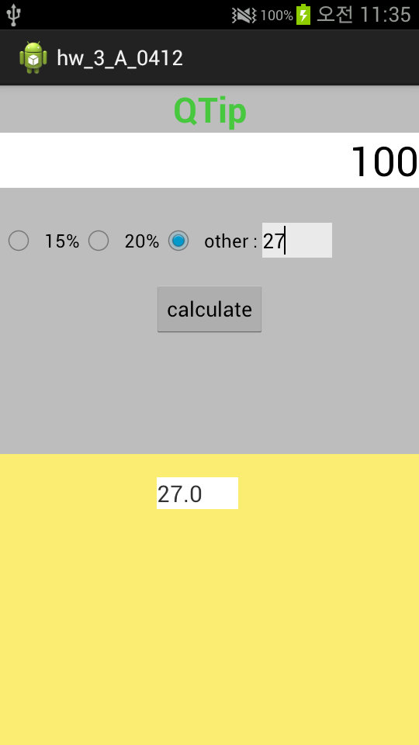

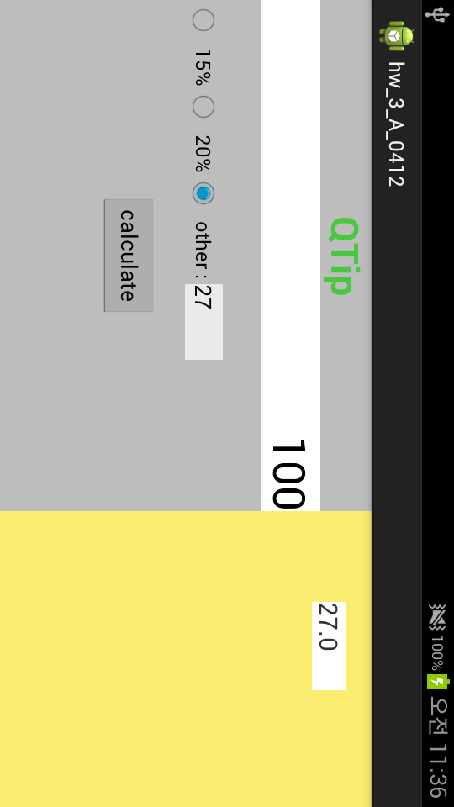

**HW #3_B**

**1. MainActivity.java**

package com.example.hw_3_b_0412;

import android.os.Bundle;

import android.support.v4.app.FragmentActivity;

import android.support.v4.app.FragmentManager;

import android.support.v4.app.FragmentTransaction;

import android.view.Display;

import android.view.Menu;

import android.view.WindowManager;

import android.widget.TextView;

public class MainActivity extends FragmentActivity {

String tempName="";

String tempEmail="";

String tempPhone="";

String tempDescription="";

TextView nameField;

TextView emailField;

TextView phoneField;

TextView descriptField;

@Override

protected void onCreate(Bundle savedInstanceState) {

super.onCreate(savedInstanceState);

setContentView(R.layout.activity_main);

WindowManager wm = getWindowManager();

Display d = wm.getDefaultDisplay();

//세로화면의 경우 Fragment1만 보여줍니다

if(d.getWidth() < d.getHeight()){

FragmentManager fm = getSupportFragmentManager();

FragmentTransaction ft = fm.beginTransaction();

ft.hide((Fragment2)fm.getFragments().get(1));

ft.commit();

}

nameField = (TextView)findViewById(R.id.nameField);

emailField = (TextView)findViewById(R.id.emailField);

phoneField = (TextView)findViewById(R.id.phoneField);

descriptField = (TextView)findViewById(R.id.descriptionField);

}

//화면이 바뀔 때 화면위의 값들 저장

protected void onPause(){

super.onPause();

tempName = nameField.getText().toString();

tempEmail = emailField.getText().toString();

tempPhone = phoneField.getText().toString();

tempDescription = descriptField.getText().toString();

}

//각 값들을 "outState"번들에 저장해 놓습니다

public void onSaveInstanceState(Bundle outState){

super.onSaveInstanceState(outState);

outState.putString("name", tempName);

outState.putString("email", tempEmail);

outState.putString("phone", tempPhone);

outState.putString("description", tempDescription);

}

//번들에서 저장된 값들을 불러옵니다

protected void onRestoreInstanceState(Bundle savedInstanceState){

super.onRestoreInstanceState(savedInstanceState);

tempName = savedInstanceState.getString("name");

tempEmail = savedInstanceState.getString("email");

tempPhone = savedInstanceState.getString("phone");

tempDescription = savedInstanceState.getString("description");

nameField.setText(tempName);

emailField.setText(tempEmail);

phoneField.setText(tempPhone);

descriptField.setText(tempDescription);

}

@Override

public boolean onCreateOptionsMenu(Menu menu) {

// Inflate the menu; this adds items to the action bar if it is present.

getMenuInflater().inflate(R.menu.main, menu);

return true;

}

}

**2. Fragment1.java**

package com.example.hw_3_b_0412;

import java.util.ArrayList;

import android.os.Bundle;

import android.support.v4.app.Fragment;

import android.support.v4.app.FragmentManager;

import android.support.v4.app.FragmentTransaction;

import android.view.Display;

import android.view.LayoutInflater;

import android.view.View;

import android.view.ViewGroup;

import android.view.WindowManager;

import android.widget.AdapterView;

import android.widget.AdapterView.OnItemClickListener;

import android.widget.ArrayAdapter;

import android.widget.ListView;

import android.widget.TextView;

public class Fragment1 extends Fragment {

ListView list;

TextView nameField;

TextView emailField;

TextView phoneField;

TextView descriptField;

ArrayList<person> person_list = new ArrayList<person>();

ArrayAdapter<String> adapter;

public View onCreateView(LayoutInflater inflater, ViewGroup container, Bundle savedInstanceState){

return inflater.inflate(R.layout.fragment1, container, false);

}

public void onStart(){

super.onStart();

//뷰들을 할당해주는 과정입니다

list = (ListView)getActivity().findViewById(R.id.listView);

nameField = (TextView)getActivity().findViewById(R.id.nameField);

emailField = (TextView)getActivity().findViewById(R.id.emailField);

phoneField = (TextView)getActivity().findViewById(R.id.phoneField);

descriptField = (TextView)getActivity().findViewById(R.id.descriptionField);

//사람을 만들어주는 과정입니다

person_list.add(new person("아이언맨","tony@naver.com","01050146434","잘날라다님"));

person_list.add(new person("헐크","hulk@naver.com","01022228888","초파워맨"));

person_list.add(new person("로저스","captain@naver.com","01033339999","오래살음"));

person_list.add(new person("토르","thor@naver.com","01055551234","못을 잘 박음"));

//name_list 어레이에 이름들을 저장해주는 과정입니다

String[] name_list = new String[person_list.size()];

for(int i=0; i<person_list.size(); i++){

name_list[i] = person_list.get(i).getName();

}

//리스트를 구성하는 과정입니다

adapter = new ArrayAdapter<String>(getActivity(), android.R.layout.simple_list_item_1, name_list);

list.setAdapter(adapter);

//setOnItemClickListener를 구현하는 과정입니다

list.setOnItemClickListener(new OnItemClickListener(){

public void onItemClick(AdapterView<?> av, View v, int position, long id){

person p = person_list.get(position);

nameField.setText(p.getName());

emailField.setText(p.getEmail());

phoneField.setText(p.getPhonenumber());

descriptField.setText(p.getDescription());

WindowManager wm = getActivity().getWindowManager();

Display d = wm.getDefaultDisplay();

if(d.getWidth() < d.getHeight()){

FragmentManager fm = getActivity().getSupportFragmentManager();

FragmentTransaction ft = fm.beginTransaction();

//이름클릭시 Fragment1은 숨기고 Fragment2만 화면에 보여주는 과정

ft.hide((Fragment1)fm.getFragments().get(0));

ft.show((Fragment2)fm.getFragments().get(1));

ft.commit();

}

}

});

}

}

**3. Fragment2. Java**

package com.example.hw_3_b_0412;

import android.content.Intent;

import android.net.Uri;

import android.os.Bundle;

import android.support.v4.app.Fragment;

import android.support.v4.app.FragmentManager;

import android.support.v4.app.FragmentTransaction;

import android.view.Display;

import android.view.LayoutInflater;

import android.view.View;

import android.view.View.OnClickListener;

import android.view.ViewGroup;

import android.view.WindowManager;

import android.widget.Button;

import android.widget.TextView;

import android.widget.Toast;

public class Fragment2 extends Fragment implements OnClickListener {

Button emailButton;

Button callButton;

Button smsButton;

Button showlistButton;

public View onCreateView(LayoutInflater inflater, ViewGroup container, Bundle savedInstanceState){

return inflater.inflate(R.layout.fragment2, container, false);

}

public void onStart(){

super.onStart();

emailButton = (Button)getActivity().findViewById(R.id.emailButton);

callButton = (Button)getActivity().findViewById(R.id.callButton);

smsButton = (Button)getActivity().findViewById(R.id.smsButton);

showlistButton = (Button)getActivity().findViewById(R.id.showListButton);

emailButton.setOnClickListener(this);

callButton.setOnClickListener(this);

smsButton.setOnClickListener(this);

showlistButton.setOnClickListener(this);

}

public void onClick(View v){

if(v.getId()==emailButton.getId()){

TextView emailField = (TextView)getActivity().findViewById(R.id.emailField);

Intent intent = new Intent(android.content.Intent.ACTION_SENDTO,Uri.parse("mailto:"+emailField.getText().toString()));

startActivity(intent);

}

else if(v.getId()==callButton.getId()){

TextView phoneField = (TextView)getActivity().findViewById(R.id.phoneField);

Intent intent = new Intent(android.content.Intent.ACTION_CALL,Uri.parse("tel:"+phoneField.getText().toString()));

startActivity(intent);

}

else if(v.getId()==smsButton.getId()){

TextView phoneField = (TextView)getActivity().findViewById(R.id.phoneField);

Intent intent = new Intent(android.content.Intent.ACTION_SENDTO,Uri.parse("smsto:"+phoneField.getText().toString()));

startActivity(intent);

}

else if(v.getId()==showlistButton.getId()){

WindowManager wm = getActivity().getWindowManager();

Display d = wm.getDefaultDisplay();

if(d.getWidth() < d.getHeight()){

FragmentManager fm = getActivity().getSupportFragmentManager();

FragmentTransaction ft = fm.beginTransaction();

//세로화면의 경우 showList버튼을 눌렀을 때 다시 리스트를 보여주는 과정입니다

ft.hide((Fragment2)fm.getFragments().get(1));

ft.show((Fragment1)fm.getFragments().get(0));

ft.commit();

}

else{

Toast.makeText(getActivity(), "Only hightlength mode~", Toast.LENGTH_SHORT).show();

}

}

}

}

**4. person.java**

**package** com.example.hw_3_b_0412;

**public** **class** person {

String name="";

String email="";

String phoneNumber="";

String description="";

**public** person(String name, String email, String phoneNumber, String description){

**this**.name = name;

**this**.email = email;

**this**.phoneNumber = phoneNumber;

**this**.description = description;

}

**public** **void** setName(String name){

**this**.name = name;

}

**public** **void** setEmail(String email){

**this**.email = email;

}

**public** **void** setPhone(String phone){

**this**.phoneNumber = phone;

}

**public** **void** setDescription(String description){

**this**.description = description;

}

**public** String getName(){

**return** **this**.name;

}

**public** String getEmail(){

**return** **this**.email;

}

**public** String getPhonenumber(){

**return** **this**.phoneNumber;

}

**public** String getDescription(){

**return** **this**.description;

}

}

**5. fragment1.xml**

<?xml version=*"1.0"* encoding=*"utf-8"*?>

<LinearLayout xmlns:android=*"http://schemas.android.com/apk/res/android"*

android:layout_width=*"match_parent"*

android:layout_height=*"match_parent"*

android:background=*"#E6FFFF"*

android:orientation=*"vertical"* >

<ListView

android:id=*"@+id/listView"*

android:layout_width=*"match_parent"*

android:layout_height=*"match_parent"* />

</LinearLayout>

**6. fragment2.xml**

<?xml version=*"1.0"* encoding=*"utf-8"*?>

<ScrollView xmlns:android=*"http://schemas.android.com/apk/res/android"*

android:id=*"@+id/verticalScrollView"*

android:layout_width=*"wrap_content"*

android:layout_height=*"match_parent"* >

<LinearLayout

android:layout_width=*"match_parent"*

android:layout_height=*"match_parent"*

android:background=*"#FFFFB0"*

android:orientation=*"vertical"* >

<TextView

android:layout_width=*"wrap_content"*

android:layout_height=*"wrap_content"*

android:text=*"Name : "*

android:textSize=*"20dp"*

android:textStyle=*"bold"* />

<TextView

android:id=*"@+id/nameField"*

android:layout_width=*"wrap_content"*

android:layout_height=*"wrap_content"*

android:text=*""*

android:textSize=*"20dp"* />

<TextView

android:layout_width=*"wrap_content"*

android:layout_height=*"wrap_content"*

android:layout_marginTop=*"20dp"*

android:text=*"E-mail : "*

android:textSize=*"20dp"*

android:textStyle=*"bold"* />

<TextView

android:id=*"@+id/emailField"*

android:layout_width=*"wrap_content"*

android:layout_height=*"wrap_content"*

android:text=*""*

android:textSize=*"20dp"* />

<Button

android:id=*"@+id/emailButton"*

android:layout_width=*"wrap_content"*

android:layout_height=*"wrap_content"*

android:text=*"Send e-mail"* />

<TextView

android:layout_width=*"wrap_content"*

android:layout_height=*"wrap_content"*

android:layout_marginTop=*"20dp"*

android:text=*"Tel : "*

android:textSize=*"20dp"*

android:textStyle=*"bold"* />

<TextView

android:id=*"@+id/phoneField"*

android:layout_width=*"wrap_content"*

android:layout_height=*"wrap_content"*

android:text=*""*

android:textSize=*"20dp"* />

<LinearLayout

android:layout_width=*"wrap_content"*

android:layout_height=*"wrap_content"*

android:orientation=*"horizontal"* >

<Button

android:id=*"@+id/callButton"*

android:layout_width=*"wrap_content"*

android:layout_height=*"wrap_content"*

android:text=*"CALL"* />

<Button

android:id=*"@+id/smsButton"*

android:layout_width=*"wrap_content"*

android:layout_height=*"wrap_content"*

android:text=*"SMS"* />

</LinearLayout>

<TextView

android:layout_width=*"wrap_content"*

android:layout_height=*"wrap_content"*

android:layout_marginTop=*"20dp"*

android:text=*"Description : "*

android:textSize=*"20dp"*

android:textStyle=*"bold"* />

<TextView

android:id=*"@+id/descriptionField"*

android:layout_width=*"wrap_content"*

android:layout_height=*"wrap_content"*

android:text=*""*

android:textSize=*"20dp"* />

<Button

android:id=*"@+id/showListButton"*

android:layout_width=*"wrap_content"*

android:layout_height=*"wrap_content"*

android:layout_gravity=*"center"*

android:text=*"show list"* />

</LinearLayout>

</ScrollView>

**7. activity_main.xml**

<LinearLayout xmlns:android=*"http://schemas.android.com/apk/res/android"*

xmlns:tools=*"http://schemas.android.com/tools"*

android:id=*"@+id/linearId"*

android:layout_width=*"match_parent"*

android:layout_height=*"match_parent"*

android:orientation=*"horizontal"*

tools:context=*".MainActivity"* >

<fragment

android:id=*"@+id/fragment1"*

android:name=*"com.example.hw_3_b_0412.Fragment1"*

android:layout_height=*"match_parent"*

android:layout_width=*"match_parent"*

android:layout_weight=*"2"*/>

<fragment

android:id=*"@+id/fragment2"*

android:name=*"com.example.hw_3_b_0412.Fragment2"*

android:layout_height=*"match_parent"*

android:layout_width=*"match_parent"*

android:layout_weight=*"1"*/>

</LinearLayout>

**8. Screen shot**

