**TO-DO APPLICATION**

RAMAIAH INSTITUTE OF TECHNOLOGY

Bengaluru

# JAVA & J2EE LABORATORY

by

**MANOJ S ( USN- 1MS20IS080 ) KRISHNA BABU ( USN-1MS20IS090) SHIYA SINGH ( USN- 1MS21IS407 )**

**NIKETH KATARI(USN-IMS20IS61)**

RAMAIAH

**I n s t i t u t e o f T e ch n o l o g y**

DEPARTMENT OF INFORMATION SCIENCE AND ENGINEERING

# Description :

TO DO app is a software designed to help individuals or teams organize and manage their daily tasks and activities. These apps typically allow users to create task lists, set deadlines and priorities. TO DO apps can be used for personal time management or for coordinating team activities in a business or project setting. They are often available on mobile devices, desktop computers, and web-based platforms.

TO DO app, also known as a task management app, is a tool used to organize and manage tasks or projects. It allows users to create a list of tasks or projects that need to be completed, set deadlines or reminders, prioritize tasks, and track progress. These apps can be used for personal tasks or for managing tasks within a team or organization.

# Screenshots of Front End :

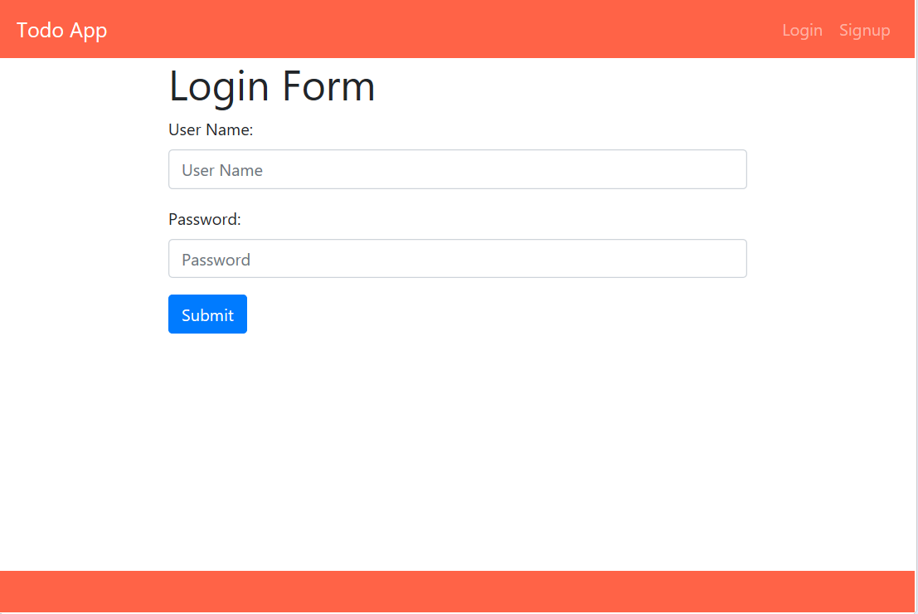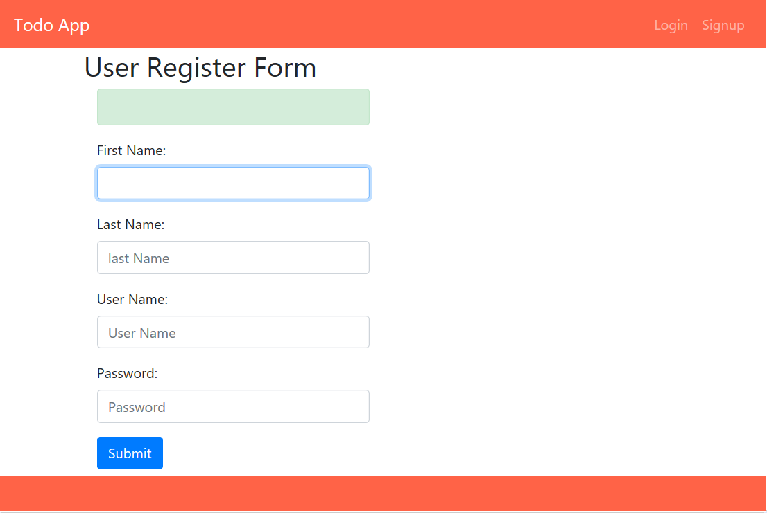

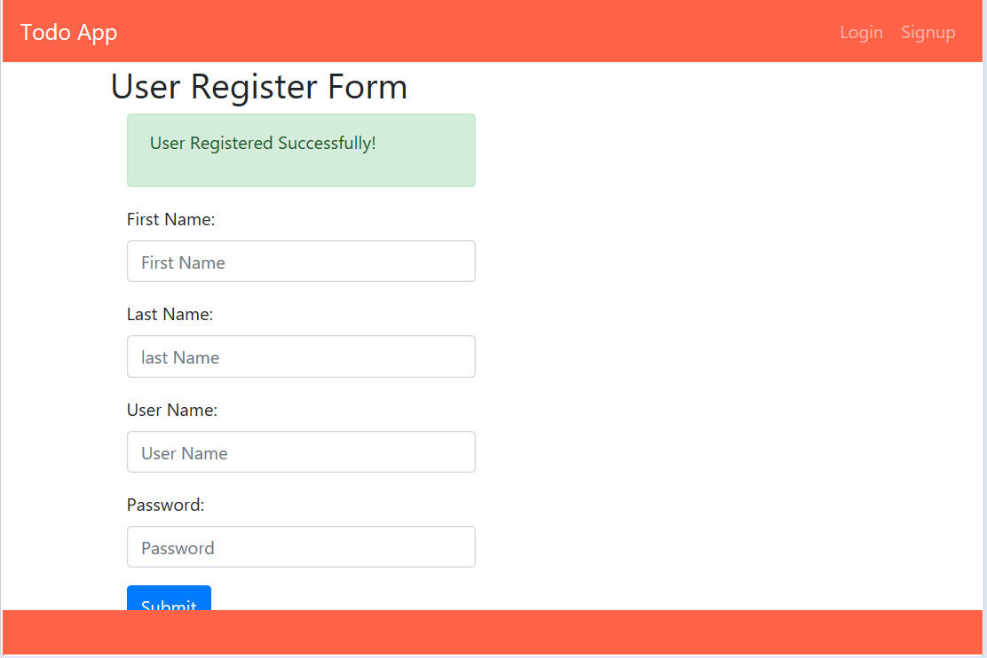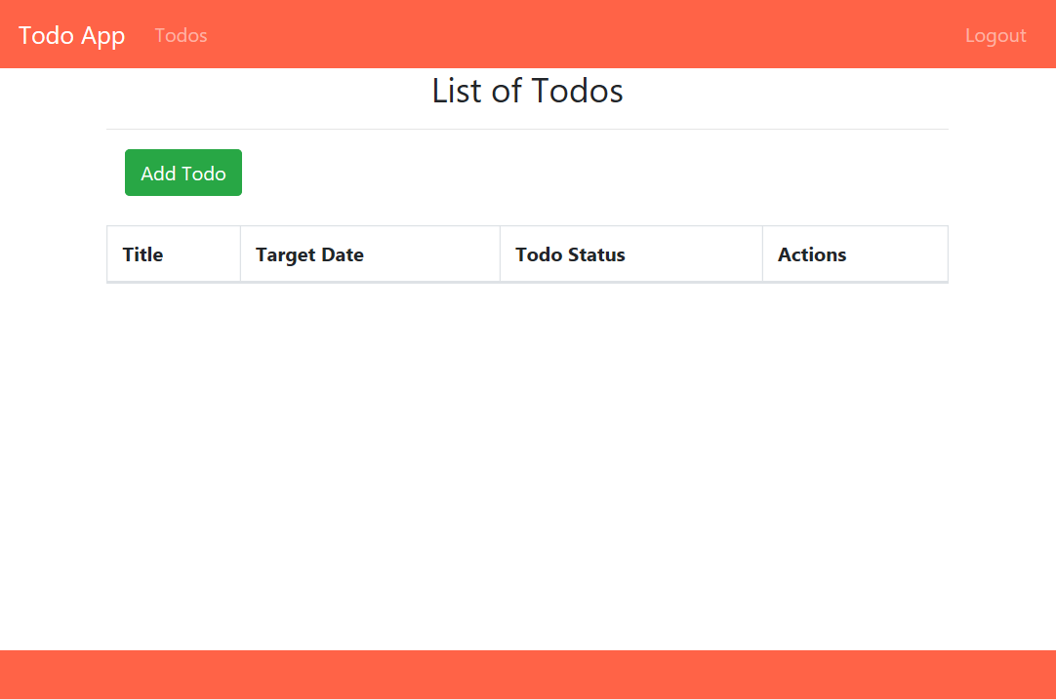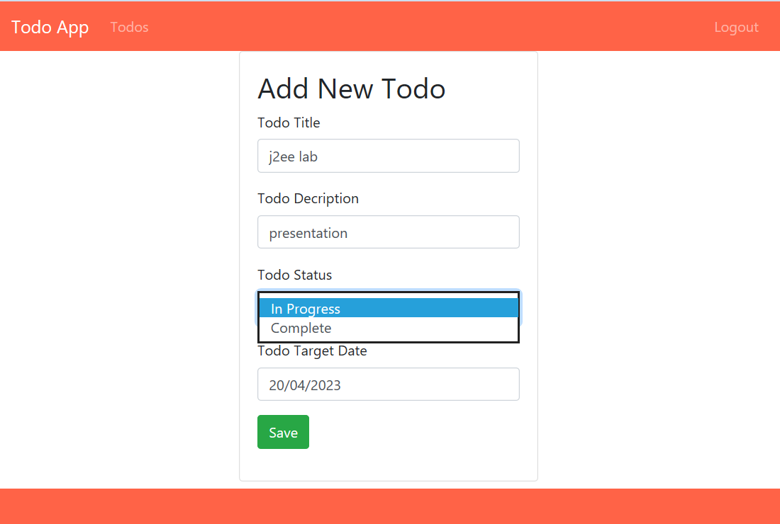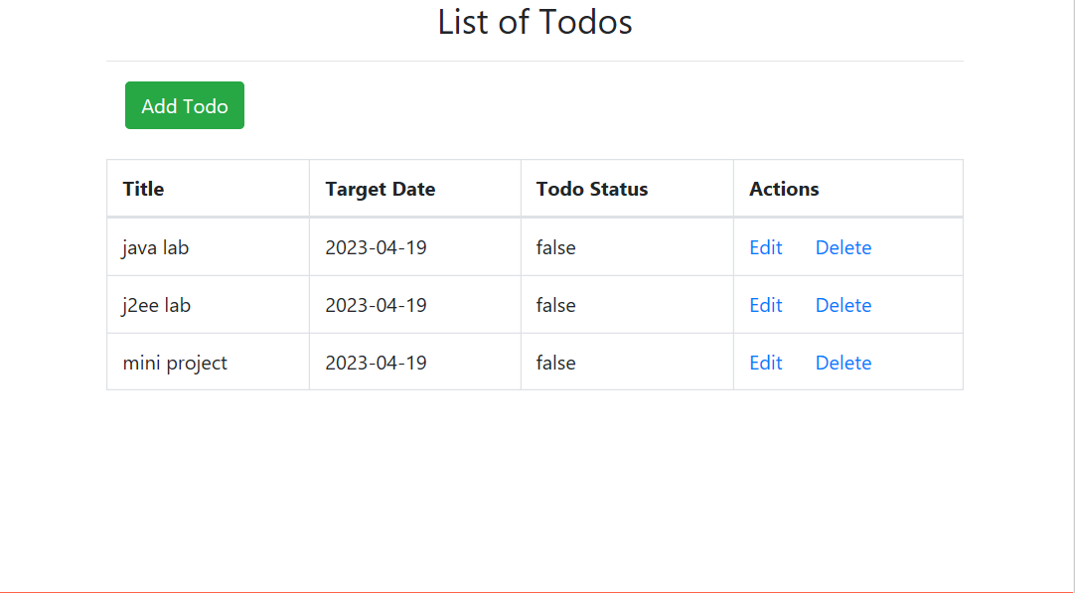

**Screenshots of Back End :**

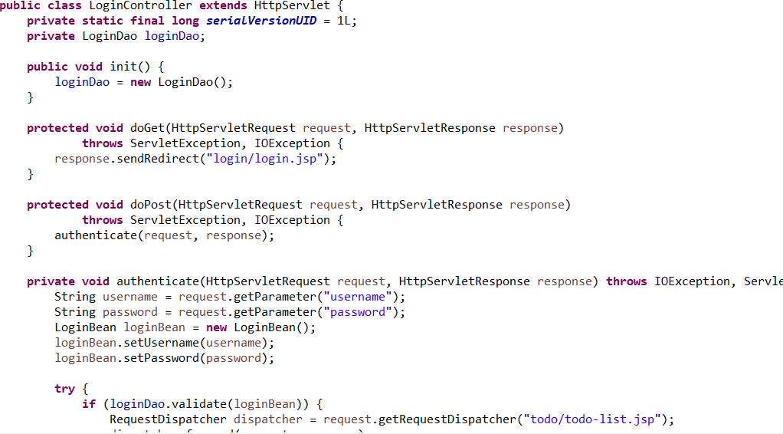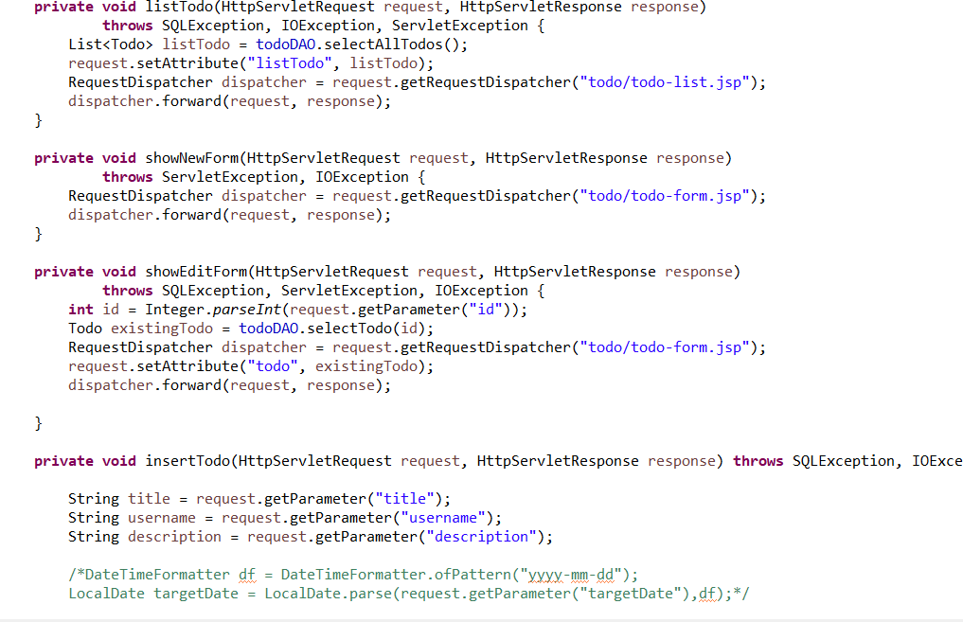

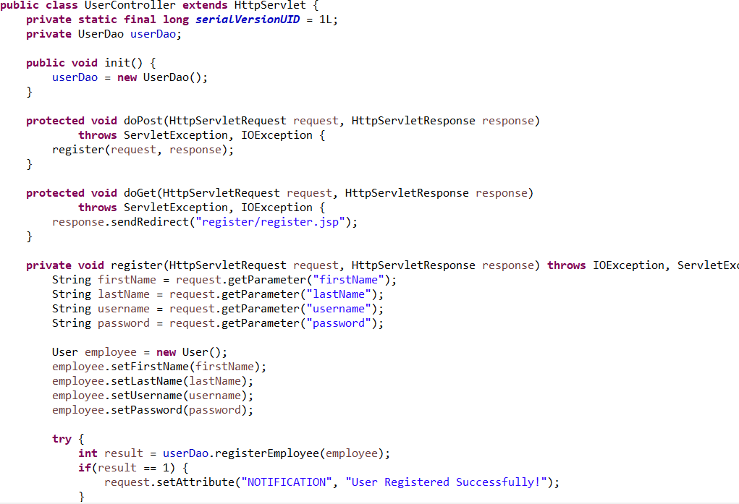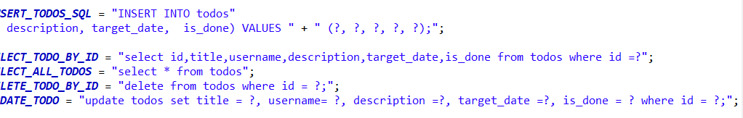

# Schema diagram :

