Lyra Project Manual
Project: Lyra – Autonomous Test Suite

Purpose
The purpose of this document is to outline the functionality of the software through a detailed view of each individual operating area.

Modules

-Login

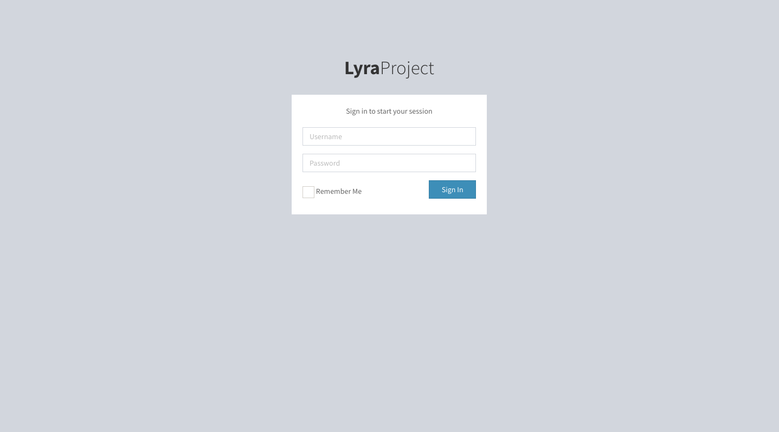

-History

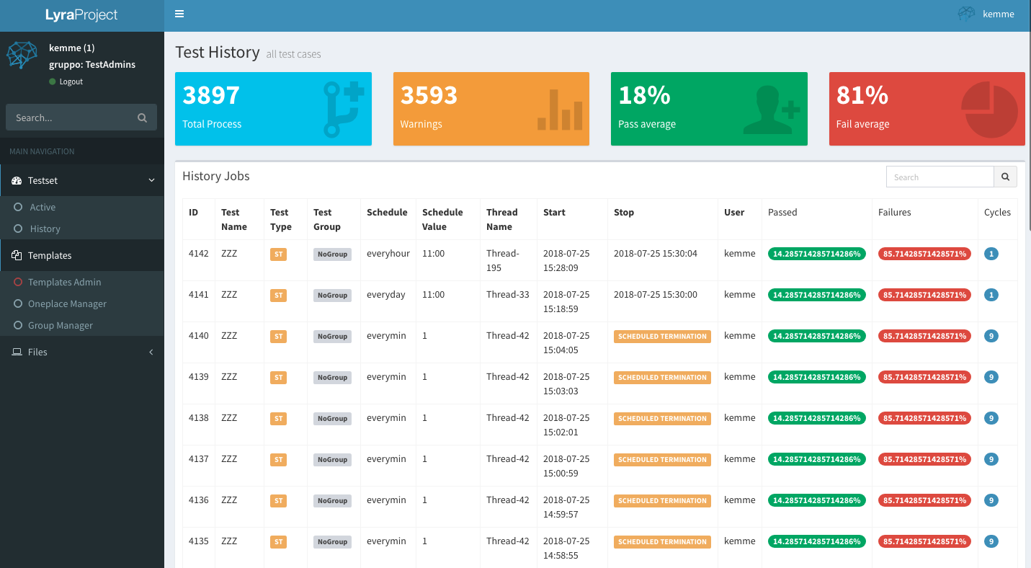

The history tab contains information about the completed test runs, in the specific report in the data column relating to:

ID: Unique identifier of records in the table
Test Name: Name of test
Test Type: Type of test launched, the possibilities are:
ST:Single Test
TG: Test Group
TA: Tag Aggregation
PA: Project Aggregation
Test Group: Reference group for the specific launch of the test
Schedule: Schedule type
Schedule Value: Value of schedule interval
Thread Name: Thread identifier relative to the selected process
Start: Start datetime
Stop: Stop datetime or if scheduled “SCHEDULED TERMINATION” message
User: User who initiated the process
Passed: %of passed steps
Failures: %of not passed steps
Cycles: Total number of cycles performed for specific thread

-Active

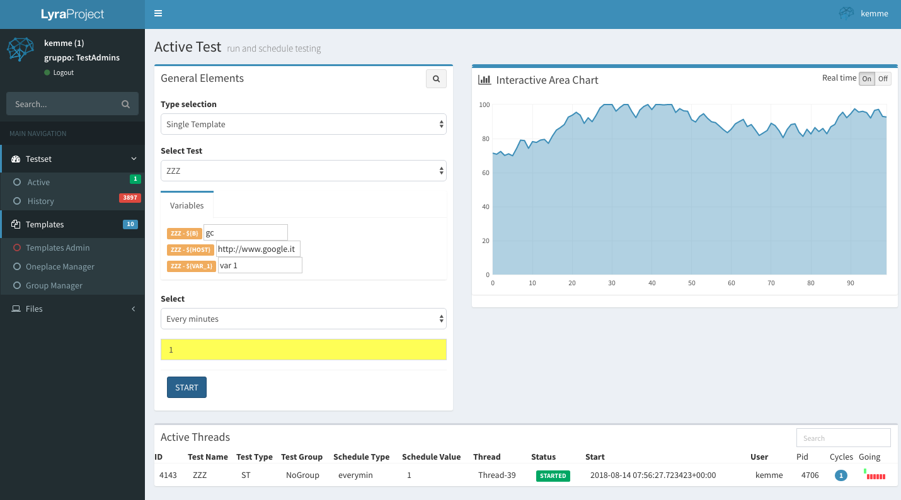

Screen for executing and monitoring active tests on the system.
The upper part of the mask allows to carry out a new simultaneous execution related to a single template or to specific groupings, insert or modify the variables and schedule cycles of execution

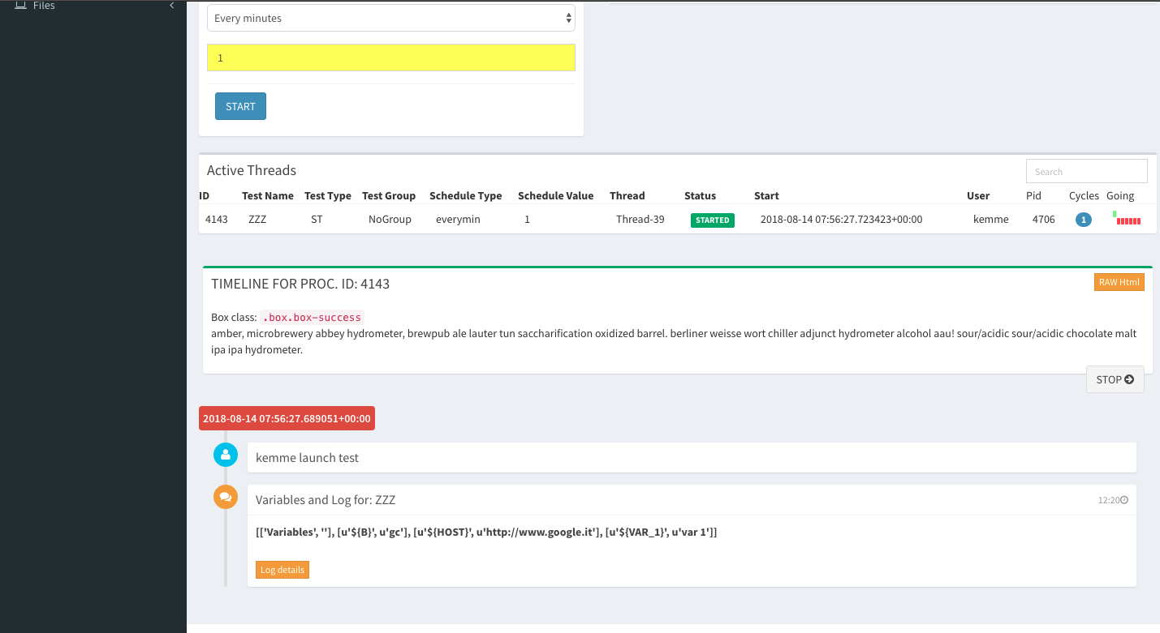

By selecting the relevant thread from the "Active Threads" table it is possible to analyze details such as the HTML structure of the test, the log and the value of the variables for each individual execution of the template.

-TemplatesAdmin

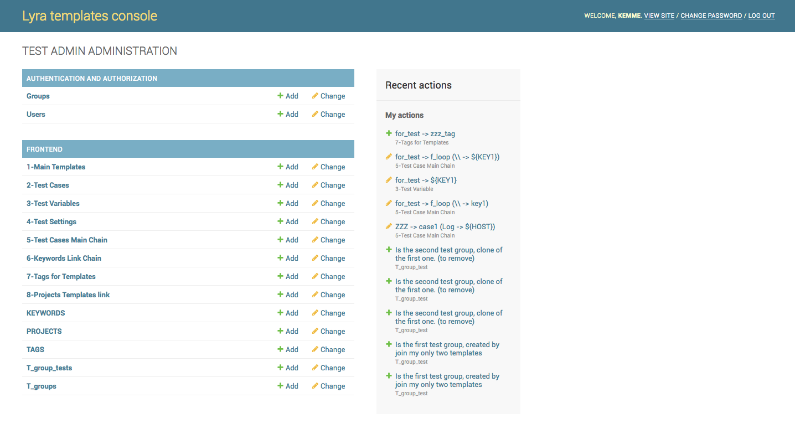
The templates administration area allows you to manage entries or changes in the data relative to the structure and content of the tests.
Through the links present, using the same mechanism for each area you can manage the data present or insert new ones using the "Add" option in the upper right corner.

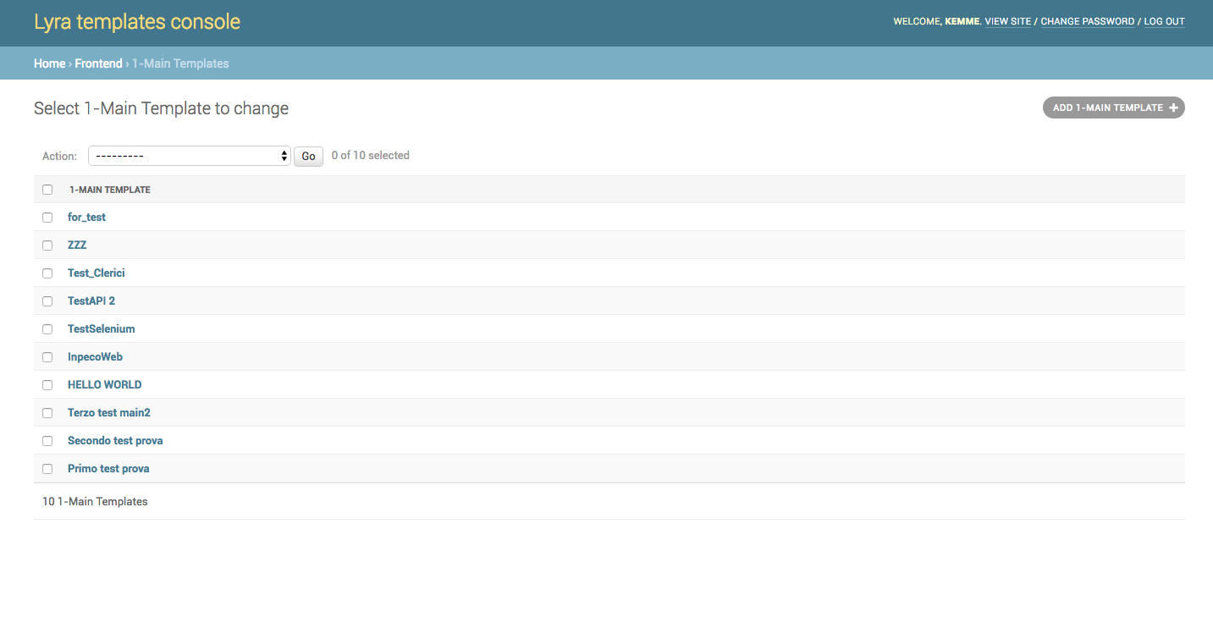
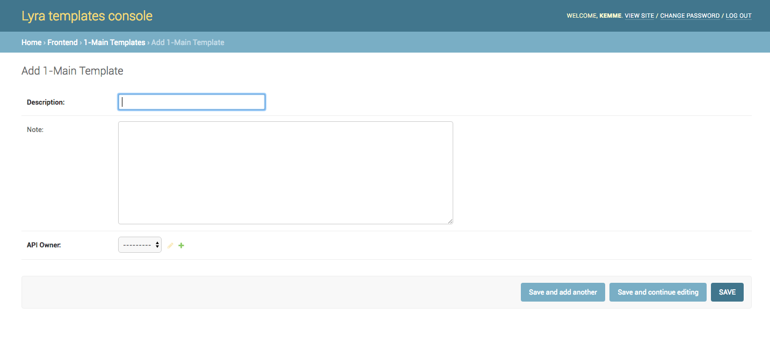
Or simply by opening any structure record, modifying or deleting its contents

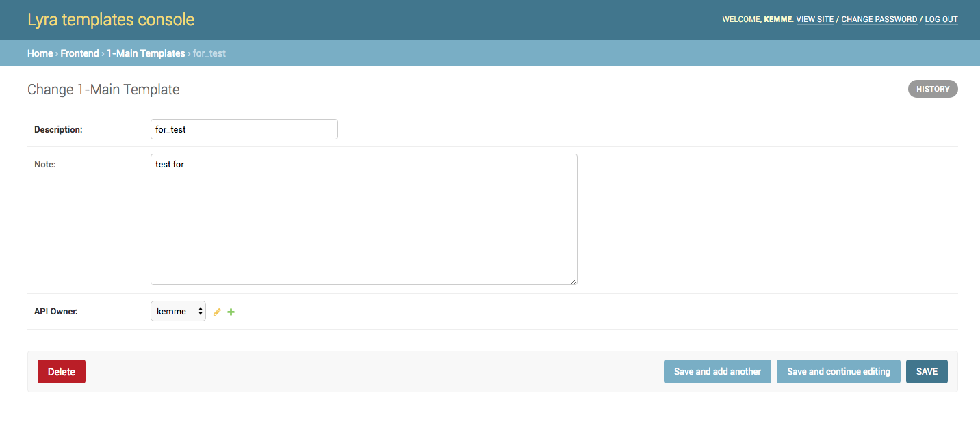

-Group Manager

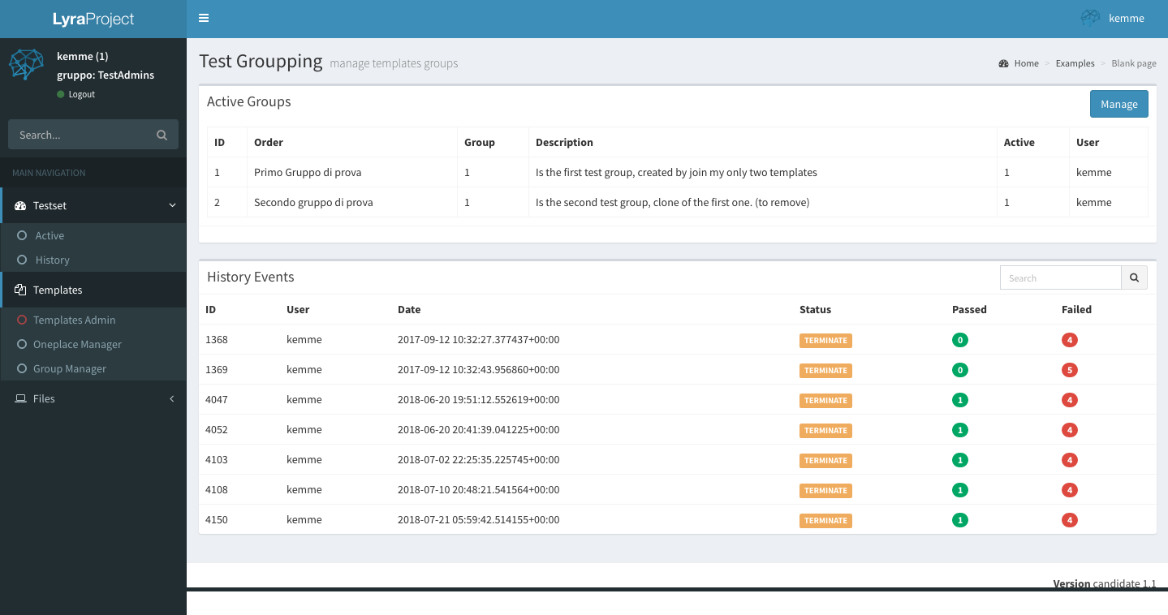

This area collects the details of all the groups created, offering the possibility of management through the “Manage” button
Selecting the group, in the lower table, you can see the details related to the execution made over time.

-Files

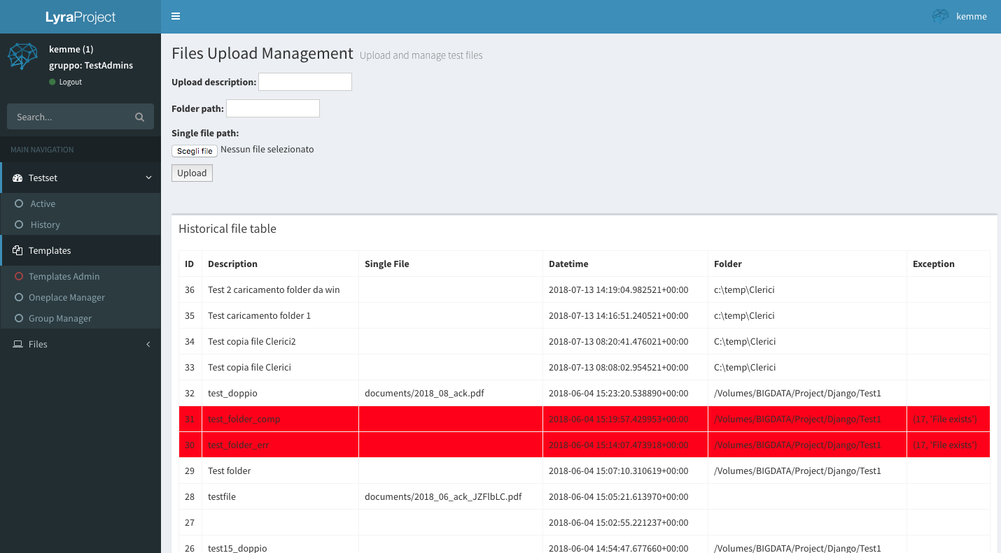

File upload management mask for place data in the system path.
It is possible to recursively load the entire contents of a folder (including subfolders) or a single file.
To use the mask you must enter a description of the upload in the field "Upload description", if you need to load an entire folder insert the complete path in the "folder path", in case you want to upload a single file use the option "Single file path"

The table below shows the individual uploads, with data and any exceptions (red line in case of error)

