**Report**

2013210124

Data chosen:

Once using User.txt, Friend.txt or Word.txt is required it should be fetched form files added by focusing on information provided by each user.

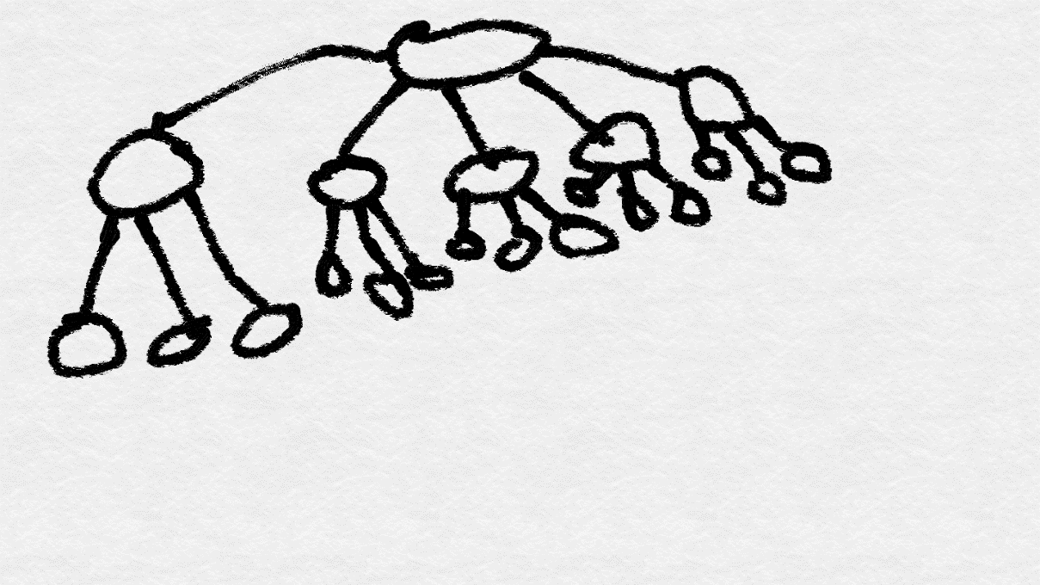

**Expected Performance:**

Information should be sorted based on its type and the process should be efficient and relatively quick.

**Improvements:**

Using Hash Map is effective when processing high number high number of entries but struggles with very small number of entries. Thus, other methods should be implemented depending on number of entries.

**Self Evaluation:**

**120/120 ^_^**