Noble Adike
Dr. Meenakshi Nerolu
Intro to Data Science
April 28, 2026

Understanding Patterns of Car Crashes in Washington DC

Objective
The objective of this project is to analyze car crash patterns in Washington, DC, and identify trends that may point out preventable safety risks. Instead of only looking at just crash counts, this project focuses on when crashes happen, where they are concentrated, and which contributing factors appear most often. The main research question guiding the analysis is: What are the preventable patterns seen in car crash occurrences in Washington, DC? This matters because crashes are not always random, and finding repeated patterns can help support more targeted road safety actions.
Introduction
The data set that I chose for this project contains crash information for the city of Washington, DC. Some of the most important variables in the data set are crash date, report date, ward, location, injury details, vehicle details, and crash-related factors. The reason why this data set is valuable is that it allows us to see how crashes are distributed across different times, locations, and conditions in the city.
The reason why it is important to understand car crash patterns is that crashes are a major public safety issue that can affect drivers, pedestrians, cyclists, and the overall transportation system. By analyzing this data, we can better understand when crashes happen most often, where they are concentrated, and what factors appear the most. This helps reveal patterns that are not immediately obvious and can show where road safety improvements may be needed most.

Method
My analysis of the data set began when I loaded the crash data into Python using pandas. I first looked at the structure of the data by checking the first few rows, column names, data types, missing values, and the overall shape of the data set. This helped me get a surface-level understanding of what information was available and which columns needed to be cleaned before I could create visualizations.
Several data cleaning steps were done to make sure the data was accurate and usable. I dropped columns that were mostly empty or not useful for my analysis, including columns that had too many missing values or repeated information from better columns. I also removed rows that were missing the main crash date because those rows could not be used for time-based analysis.
I handled missing values based on the type of column. For count columns, such as injury or fatality-related columns, I filled the missing values with 0 because blank values usually meant that no count was recorded for that category. For text and location columns, I replaced blanks, nulls, and unknown labels with “Unknown” so those rows could still be included in the analysis.
I also converted the crash date and report date columns into datetime format so I could analyze crashes by year, month, day, and hour. After cleaning the dates, I created new variables such as CRASH_YEAR, CRASH_MONTH, CRASH_DAY_NAME, and CRASH_HOUR. These new columns helped me study trends over time, crash patterns by day of the week, high-risk hours, and reporting delays.
Finally, I created new indicator variables for preventable crash factors, such as speeding crashes, impaired crashes, and pedestrian or bicycle involvement. I also checked for duplicate rows and confirmed that the cleaned data set was ready for analysis. Doing all this allowed me to move from raw crash records into records ready for clear visualizations that were crucial in answering my research question.

Storytelling: Data Visualization and Interpretation

Crash Trends Over Time
A line graph was used to visualize how the number of recorded car crashes in Washington, DC changed by year. We see that crash counts stayed very low in the earlier years of the dataset, then began rising in the later years after 2007 and reached a peak in 2019 with 26,790 crashes. After 2019, there was a noticeable drop in recorded crashes, which may be a result of COVID-era changes such as remote work causing fewer commuters, changes in travel behavior, or less reporting.
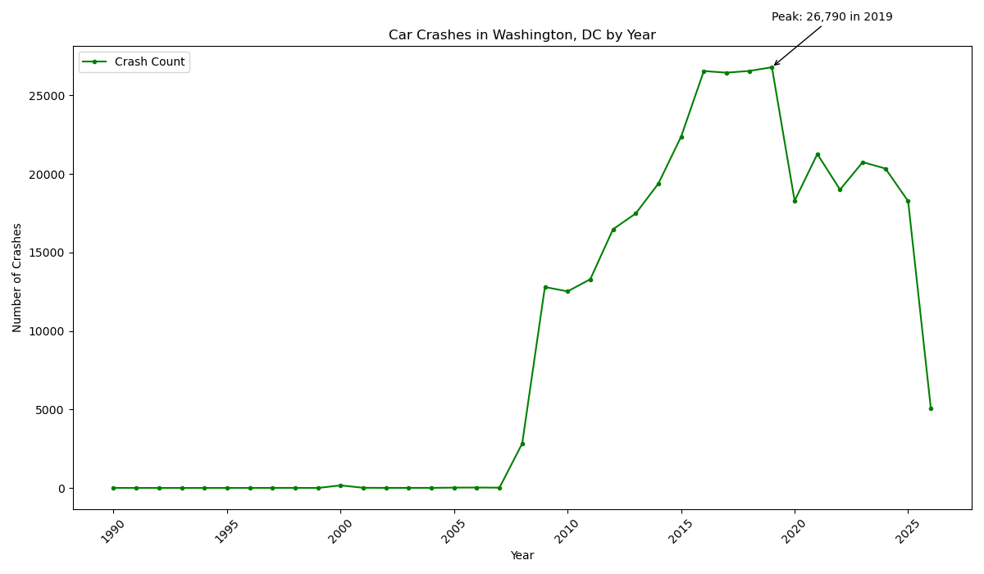

Crash Hotspots Across Washington, DC
An interactive map was used to visualize where car crashes occurred across Washington, DC. The map helps us understand that crashes are not evenly spread throughout the city, but instead cluster around central DC and major travel corridors. This pattern may be connected to heavier traffic, more intersections, more pedestrians and cyclists, and more people commuting through these areas. It shows that location plays a major role in crash risk, and so road safety efforts should focus on repeated hotspot areas instead of treating every part of the city the same.
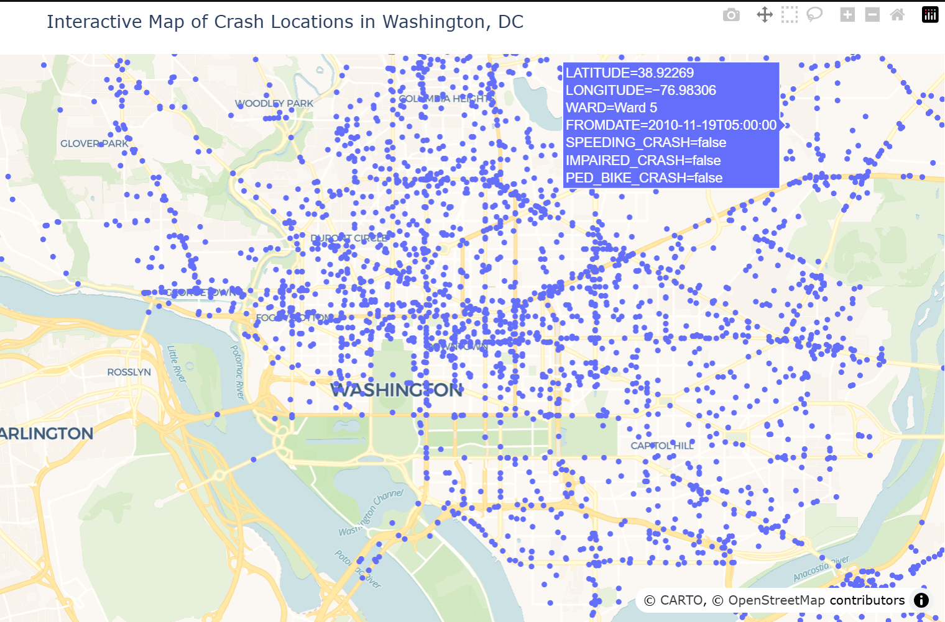

Crashes by Day of the Week
A bar graph was used to compare the number of car crashes in Washington, DC, by day of the week. The graph shows that Friday had the highest number of crashes, with 56,421 crashes, while Sunday had the lowest with 41,231 crashes. This pattern could be related to weekday travel, commuting, school activity, errands, and people beginning weekend plans on Fridays. Sunday being the lowest may suggest that fewer people are commuting or traveling heavily compared to the rest of the week. It shows that crash frequency changes depending on the day, which means road safety should coincide more with weekly travel behavior.

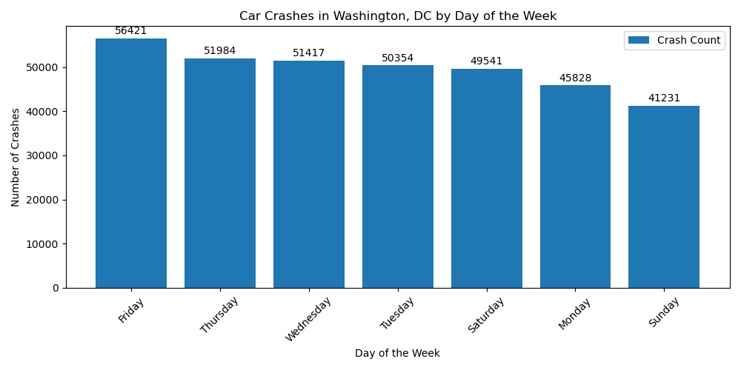H
High-Risk Crash Times
A heatmap was used to analyze car crashes by both day of the week and hour of the day. The main pattern here is that crashes were most concentrated during the evening hours, especially between 4 PM and 10 PM. This may be connected to rush hour traffic, people leaving work or school, and more overall movement on the roads. Crash prevention should not only focus on where crashes happen, but also when they are most likely to happen, and this is what we are shown on this heatmap.
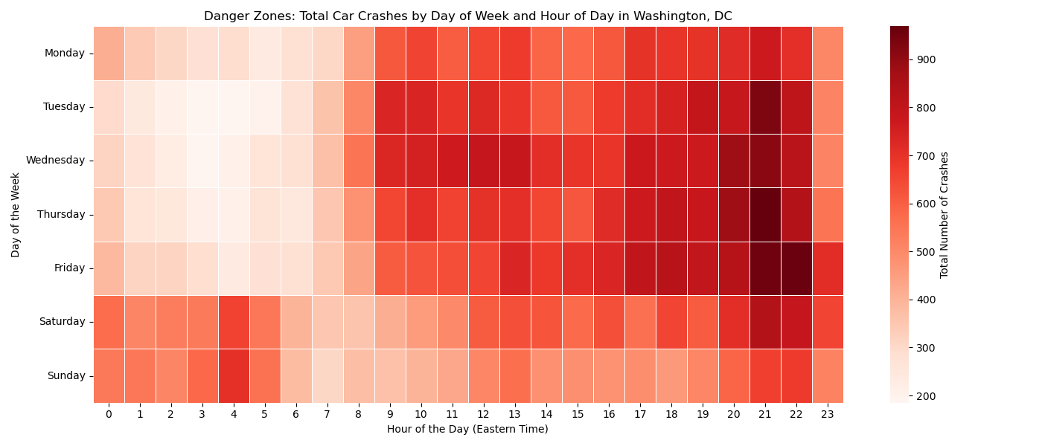

Most Common Preventable Crash Factors
To further solidify the hypothesis that crashes in DC follow preventable patterns, I created a bar graph comparing speeding, impairment, and pedestrian or bicycle involvement. The graph unexpectedly tells us that pedestrian and bicycle involvement had the highest count. The reason it’s a very important finding is that it shows that vulnerable road users are heavily involved in DC crash patterns. It also suggests that road safety efforts should not only focus on drivers, but also on safer crosswalks, protected bike lanes, better intersections, and stronger protections for pedestrians and cyclists.
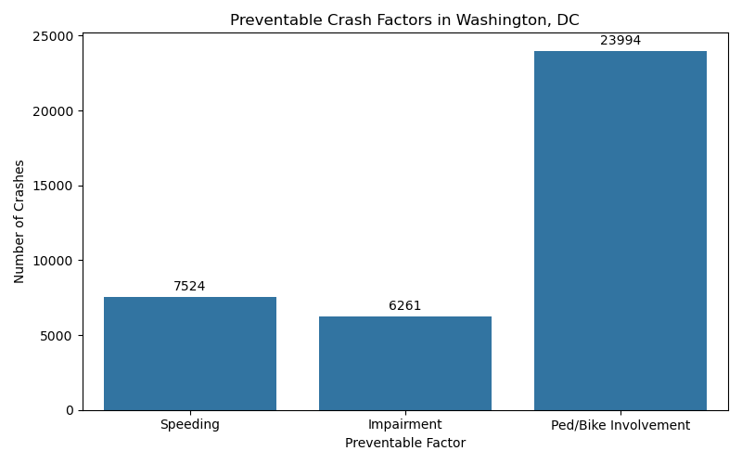

Conclusion
The full analysis revealed that car crashes in Washington, DC are not random and follow clear patterns across time, location, and crash-related factors. Crashes were more common during certain periods, especially weekday evenings from around 4 PM to 10 PM, but the pattern was not the same across every day or area of the city.
Location also plays a critical role in understanding crash activity, with crashes clustering around central DC and major travel corridors. The presence of pedestrian and bicycle involvement as the highest preventable crash factor suggests that vulnerable road users are a major part of DC’s road safety problem.
Overall, the findings highlight that crash prevention should be targeted instead of general. Focusing on high-risk times, hotspot locations, and vulnerable road users can help create safer transportation conditions across Washington, DC.

References
- Open Data DC, Crashes in DC Dataset
- Pandas Documentation
- Matplotlib Documentation
- Seaborn Documentation
- Plotly Documentation
- Jupyter Notebook
- MATH 014 Class Slides and Notes
- ChatGPT for wording and editing support

Acknowledgments
I would like to acknowledge Dr. Nerolu for her guidance throughout the semester and for helping me better understand the tools and build skills used in this project.

