**Battle of the Neighbourhoods:**

**The London Pleasantness Index**

Niamh Kingsley

July 2020

Notebook found at: <https://github.com/kingnif/Coursera_Capstone/blob/master/londonPleasantnessIndex.ipynb>

1. Introduction

London – with a population fast-approaching **9 million** and **73 constituencies** across **33 boroughs**, it’s certainly a big place. It’s not a surprise then that deciding which neighbourhood to rent in, or but a first home in is an especially daunting task. Whether you are looking to settle in London, or are an estate agent trying to market particular boroughs based on their strengths, understanding which boroughs are particularly pleasant can be useful.

It is not difficult to find out which areas are generally good for commuting, or for schools, but what about neighbourhoods that people are happy to live in, that have lots of park space, that are good for socialising? What about boroughs that are just quite “pleasant”?

For this research, I have decided to create a simple *Pleasantness Index* based on three factors:

* Happiness of local people
* Amount of green space (parks and trees)
* Number of coffee shops within walking distance of the centre of the borough

I chose to try and define something that I have not seen before and hope that this would be useful for people who struggle to find a reliable indication of which areas are nice (based on just these factors), *without* considering the usual factors such as whether there are schools nearby, or the number of bus links. Perhaps it could also be leveraged by local councils and estate agents.

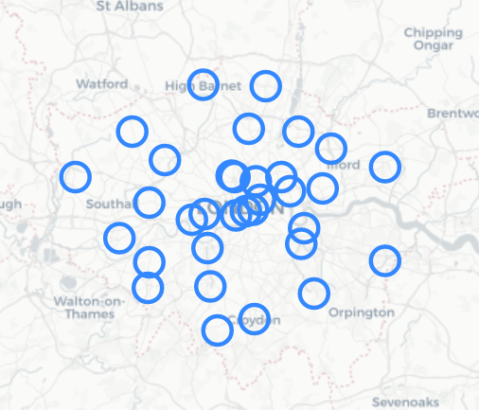

*Figure 1: the 33 boroughs of London represented with folium*

1. Data Selection

I used two different sources to supply data for the three factors.

Firstly, I used recent data (2018/19) from the **London Datastore** to rank each of the 33 London boroughs based on the reported happiness of people who live there. The report provides a mean score based on a scale of 1-10, with 10 being the highest reported score [1].

I also used the London Datastore to find out what percentage of the borough is “green” (based on parks, trees) [2]. I chose these data sets because they are readily available in a consistent .xls or .csv format, and because it is relatively recent.

Secondly, to determine how many coffee shops are within 1km of the centre of the borough, I used the **Foursquare API**. I used a geocoder iteration to define a longitude and latitude for each borough, before passing each unique Foursquare request url to the API. A simple code was leveraged to count the results from each call and assign this back to each borough.

1. Methodology

In order to select the factors, I explored data available on the London Datastore to first understand what good quality, and recent data sets were available for use. I also drew on knowledge of new-build houses, which shows that young first-time buyers look for green spaces in developments, on-site coffee shops, and a friendly local culture. This analysis led me to select three factors that I felt were appropriate for many different stakeholders, and lays the foundation for further research based on additional factors.

To prepare the data, I took mean scores for reported happiness and the percentage of a borough that is “green” and applied ranking code to assign a number to each borough from 1 to 33, with first place being the most positive result for that factor (happiest residents, highest percentage of green space).

In order to pre-process the data for the Foursquare call, I used a geocoder to assign a latitude and longitude to each borough, representing this on a map to check the accuracy. As part of the processing I also dropped any columns not required and made sure the data was usable. One example of where I needed to amend the data was when I first ran the geolocator, I found that some of the results produced were not in the United Kingdom, so I went back and added “, London” to each Borough to ensure that the geolocation produced was based on a more accurate address.

By creating a unique url for each borough based on the search query (“Coffee”), my credentials, and the right latitude and longitude, I was able to make 33 separate calls to the Foursquare API. I then assigned a unique variable to each borough with a count of the results (coffeeResultsCount***n*** where ***n*** is the borough index). This allowed me to then assign a rank to each borough again, this time based on the number of results returned.

1. Results

I found the results to be interesting, as the top five most “pleasant” boroughs are not entirely what I anticipated. That being said, these are five boroughs that I understand to be popular among young people and first time buyers, although there is likely to be quite a large range of house prices across the results.

Each of the boroughs is outside of central London, with Croydon, Havering, Kingston upon Thames, and Hounslow falling largely in zones 5, 6, 6, and 5 respectively. The exception here is Ealing which is largely zone 3 which, although popular for first time buyers does have some notably expensive areas.

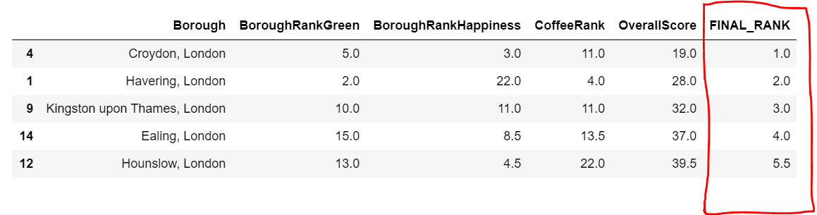

1. Discussion

I would like to take this investigation further, and introduce more factors to the index. I intentionally chose three simple factors, but recognise this is based on my own interpretation of what “pleasant” means. I anticipate the results would be significantly different if rather than considering coffee shops, I had decided to look at kebab shops or hairdressers or Porsche dealerships!

Going forward then, it would be better to define a more standardised meaning of “pleasantness” by surveying people, and then looking to include more factors to meet that expectation. I feel that this index is already fit for purpose and could be useful for renters, first-time buyers, retired people, estate agents or local councils, but it could become much more useful and reflective of a broader interpretation if the developments were included.

1. Conclusion

In conclusion, this investigation is very much a starting point when it comes to understanding which boroughs are “pleasant”. My own bias and research led me to choose three factors that have been important to me when looking to buy a house, and I have no doubt for many other people these factors are much further down the list, or not important at all.

Therefore in order to take this further, I could look to adopt my own recommendations from the discussion and build out a notion of what is “pleasant” based on wider survey. Including more factors will help to narrow down the scores in the boroughs and make the research more useful for potential stakeholders.

[1] Personal Well-being (Happiness) by Borough, Office for National Statistics <https://data.london.gov.uk/dataset/subjective-personal-well-being-borough>

[2] London Green and Blue Cover, Greater London Authority <https://data.london.gov.uk/dataset/green-and-blue-cover>