1. This website is for a small media company in Beijing whose main business is 灯箱广告.

(example: <http://www.superwaymedia.com/SU/fullsize/3.jpg>

)

Therefore the main focus is on the screen of the display ( as shown as 1 in screenshot below).

Whenever user click a menu on area 2, area 1 needs to be updated with a new photo display seamlessly. Sure when a menu on area 2 is clicked, the content in area 4 also got updated.

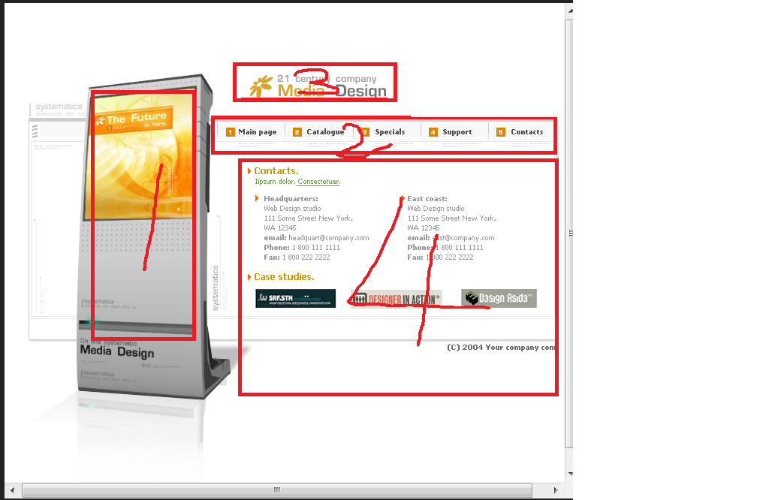

1. Please refer to the following link for the flash template:

<http://www.mb100.net/webmb/us/2010-04-13/17577.html>

You’ll need to register an account with that website for download template.

1. Company name that will be shown in area 3 is 阳光传媒

English name is Sunrise Media

Please pick the right color scheme for the font ( Chinese and English) that matches the webpage.

For the Chinese font style, you can refer to 

You can use the logo from the template.

1. Menus in area 2 to be changed to Chinese style:

阳光传媒 业务介绍 新闻中心 合作伙伴 人力资源 联系我们

Please adjust the background color of the menu to be more vivid

1. For area 1, please replace the icon with a white 灯箱. Try to search such photo from baidu (灯箱广告) or draw a white one.
2. Try to make the area 4 bigger.