SYSTEM ARCHITECTURE BLUEPRINT
Logical, Data, Deployment, Security, and Operations Architecture
DOC-03 | Enterprise Data Lakehouse Platform
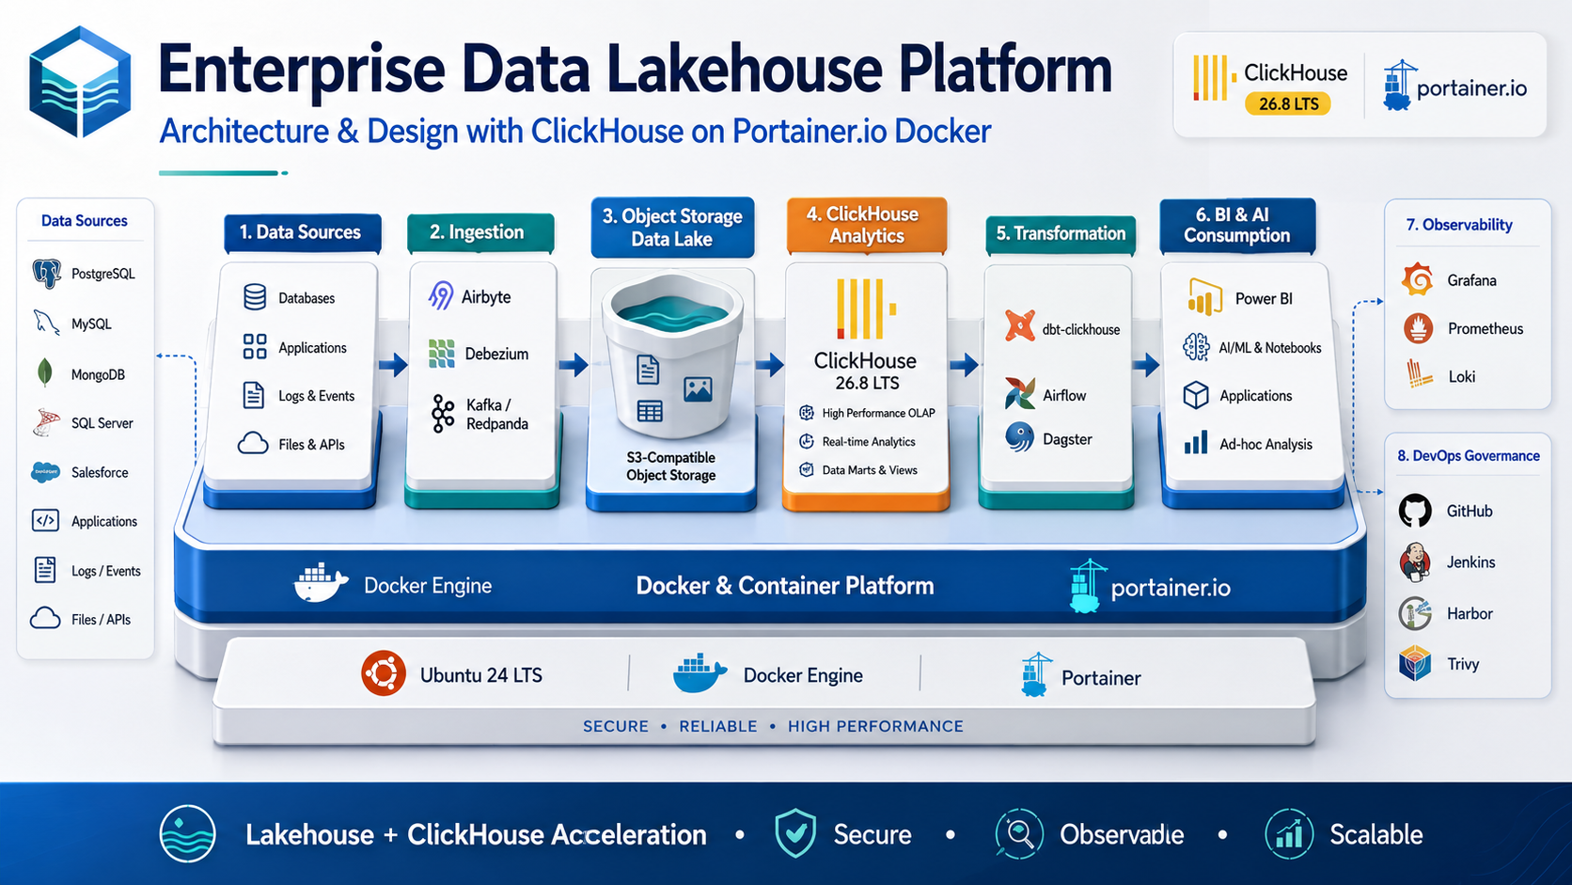
Architecture & Planning Baseline | 2026-09-03
Status: Design baseline - organization-specific TBD values require human approval.

Document Control
Item | Value
Document | System Architecture Blueprint
Purpose | Provide the authoritative conceptual and logical blueprint for the enterprise data lakehouse platform.
Audience | Architects, platform engineers, data engineers, security, SRE, developers, and implementation partners.
Platform baseline | Ubuntu 24 LTS + Docker Engine + Portainer + ClickHouse 26.8 LTS branch
Status | Design baseline
Date | 2026-09-03
Governance source | Repository AGENTS.md is the primary engineering and AI-governance policy.

Control note: technical values marked TBD are intentionally unresolved until workload, security, business continuity, and infrastructure requirements are formally approved.

1. Architecture Principles
- Lake storage and analytical compute are logically separable.
- Object storage is the durable Landing/Bronze/Archive layer.
- ClickHouse is optimized for curated analytical workloads and serving, not OLTP transaction processing.
- Configuration is version controlled and promoted through governed CI/CD.
- Security is defense-in-depth across identity, network, runtime, data, and operations.
- Scale vertically and optimize schemas before adding shards; add distributed complexity only when metrics justify it.
- Every production design includes observability and recovery as first-class architecture components.

Baseline Assumptions and Constraints
- Initial self-managed runtime uses Ubuntu 24 LTS, Docker Engine, Docker Compose, and Portainer.
- ClickHouse is the high-performance OLAP and curated serving engine; object storage remains the durable raw/long-term lake layer.
- DEV/UAT may begin as single-node for evaluation and benchmarking; this topology is not considered high availability.
- Production HA is designed around separate failure domains with ClickHouse replication and a three-member ClickHouse Keeper quorum.
- Git is the configuration source of truth; Jenkins/CI controls validation and promotion; Harbor is the target enterprise registry where available.
- Prometheus, Grafana, and Loki form the baseline observability stack.
- Organization-specific values that have not been approved are marked TBD rather than assumed.

2. Enterprise Logical Architecture
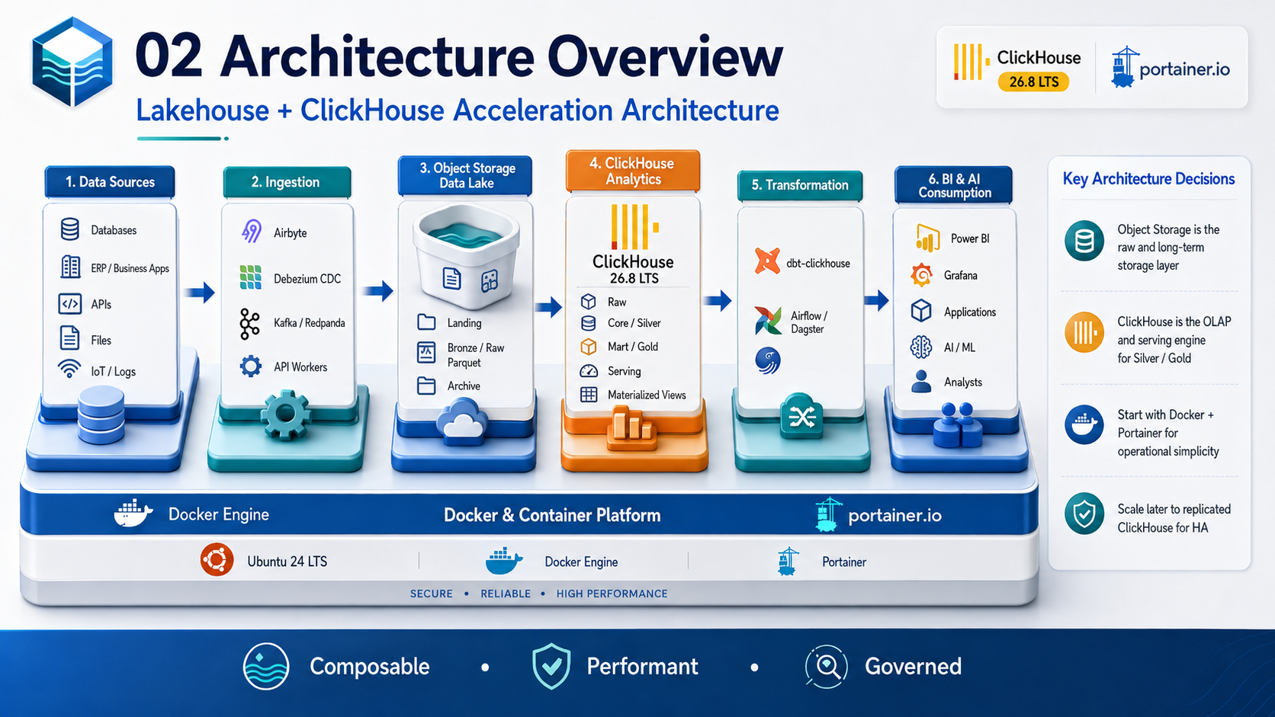
Figure 1 - Logical architecture from enterprise sources through the lake, ClickHouse, transformation, and consumers.
Enterprise Data Sources
|-- SQL Server / PostgreSQL / MySQL / MongoDB
|-- ERP & Business Applications
|-- REST APIs / Files / IoT / Logs
v
Ingestion
|-- Batch: Airbyte / Custom Workers
|-- CDC: Debezium
|-- Streaming: Kafka / Redpanda
v
S3-Compatible Data Lake
|-- landing/
|-- bronze/
|-- archive/
v
ClickHouse
|-- raw
|-- core (Silver)
|-- mart (Gold)
|-- serving
v
Power BI / Grafana / APIs / Analysts / AI & ML

3. Data Architecture Blueprint
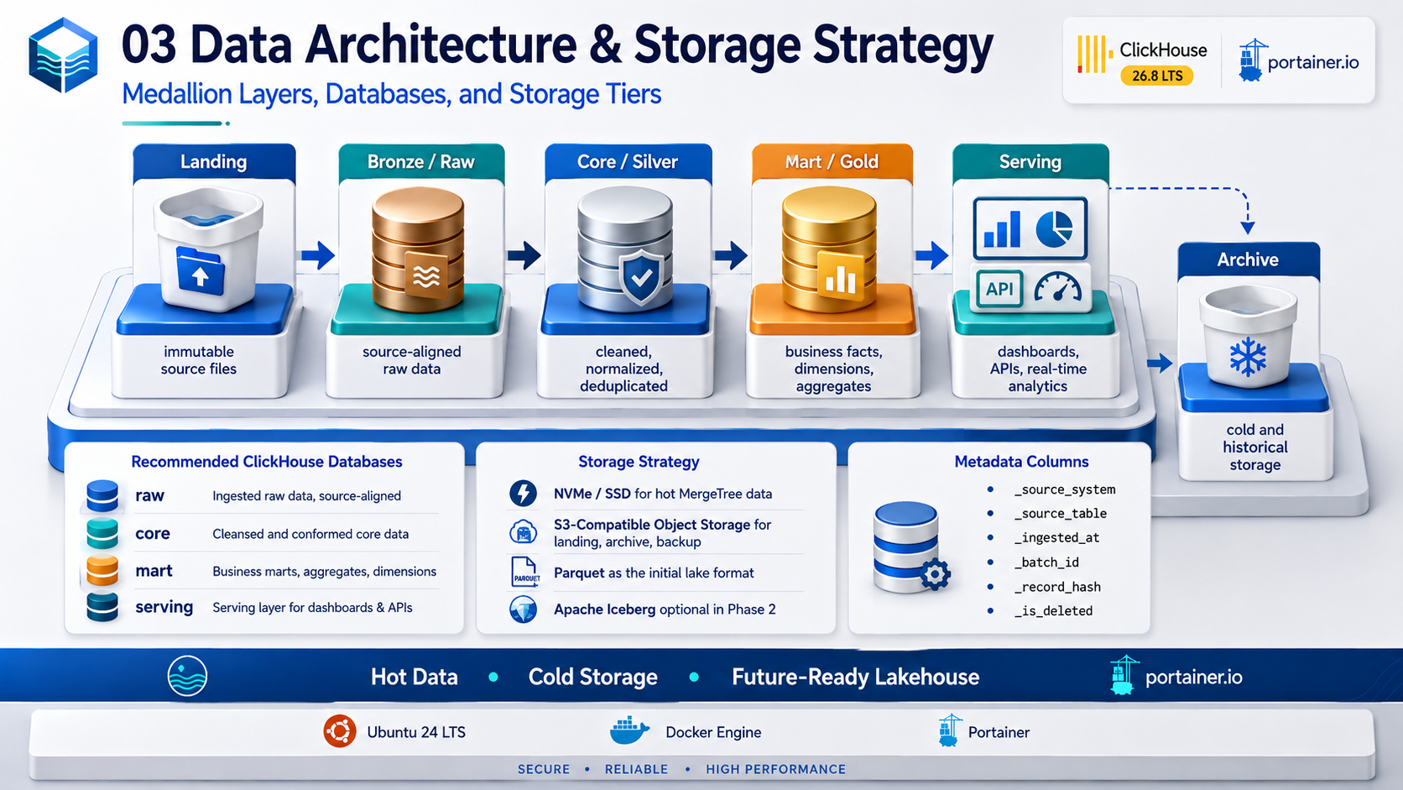
Figure 2 - Data layers, recommended ClickHouse databases, and storage tiers.
Layer | Namespace / Path | Contract
Landing | s3://<lake>/landing/<source>/<entity>/<date>/ | Immutable source receipt; source file and checksum retained.
Bronze | s3://<lake>/bronze/<domain>/<entity>/ | Source-aligned Parquet; ingestion metadata appended.
Raw | ClickHouse raw.* | Fast staging/ingestion when native ClickHouse is useful.
Core / Silver | ClickHouse core.* | Cleaned, deduplicated, conformed entities and keys.
Mart / Gold | ClickHouse mart.* | Business facts, dimensions, KPI aggregates.
Serving | ClickHouse serving.* | Dashboard/API optimized tables/views/materialized views.
Archive | s3://<lake>/archive/... | Cold historical retention with lifecycle policy.

3.1 Standard Technical Metadata
_source_system
_source_table
_ingested_at
_source_updated_at
_batch_id
_record_hash
_is_deleted

4. ClickHouse Logical Database Blueprint
ClickHouse
|-- raw
| |-- erp_sales_raw
| |-- production_raw
| `-- application_events_raw
|-- core
| |-- sales
| |-- production
| `-- inventory
|-- mart
| |-- fact_sales
| |-- fact_production
| |-- fact_inventory
| |-- dim_customer
| `-- dim_product
`-- serving
|-- sales_daily
|-- production_daily
|-- inventory_current
`-- executive_kpi

Workload | Preferred Engine Pattern
Append-only facts/events | MergeTree
Replicated production tables | ReplicatedMergeTree
CDC/versioned entities | ReplacingMergeTree with explicit version semantics
Pre-aggregated state | AggregatingMergeTree
Additive summaries | SummingMergeTree when semantics are valid
Distributed access | Distributed table/routing layer only when sharding is introduced

5. Deployment Blueprint
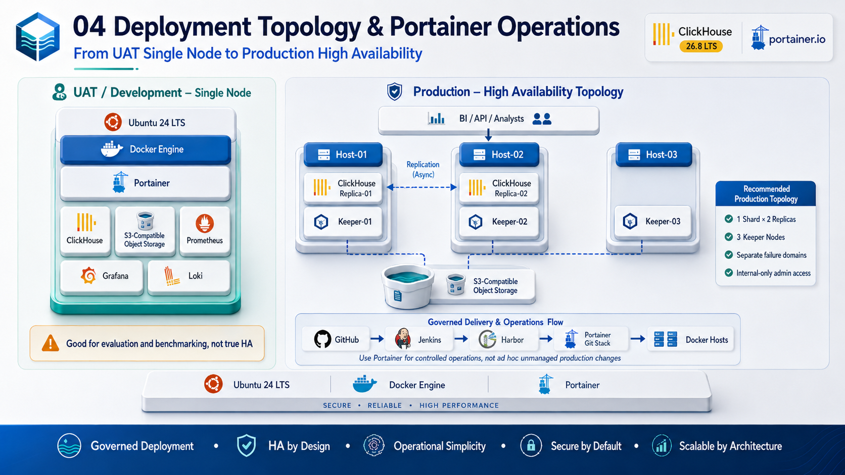
Figure 3 - UAT single-node pattern and recommended production HA topology.

5.1 DEV/UAT Baseline
Ubuntu 24 LTS Host
|-- Docker Engine
|-- Portainer
|-- ClickHouse
|-- S3-Compatible Object Storage
|-- Prometheus
|-- Grafana
`-- Loki
Classification: evaluation / benchmark topology, NOT HA.

5.2 Production HA Baseline
Failure Domain / Host 01
|-- ClickHouse Replica 01
`-- Keeper 01
Failure Domain / Host 02
|-- ClickHouse Replica 02
`-- Keeper 02
Failure Domain / Host 03
`-- Keeper 03
Shared / Independent Services
|-- S3-Compatible Object Storage
|-- Monitoring / Logging
`-- CI/CD / Registry

Production baseline: 1 shard x 2 ClickHouse replicas + 3 Keeper members. Do not describe multiple containers on a single Docker host as high availability.

6. Network and Security Zones
Zone / Network | Typical Members | Allowed Direction
data_ingestion | Airbyte, Debezium, workers, Kafka/Redpanda | Sources -> ingestion -> lake/raw
data_backend | ClickHouse nodes | Trusted clients/ingestion -> ClickHouse only
data_storage | ClickHouse, ingestion, object storage | Controlled storage access only
observability | Prometheus, Grafana, Loki, exporters | Monitoring -> runtime; logs/metrics -> monitoring
management | Portainer, Jenkins deployment endpoint | Restricted admin/CI access only

- No unnecessary public exposure.
- TLS for sensitive traffic.
- Firewall allow-listing between zones.
- Separate human and service identities.
- Production administrative interfaces remain internal unless explicitly justified.

7. Security Architecture
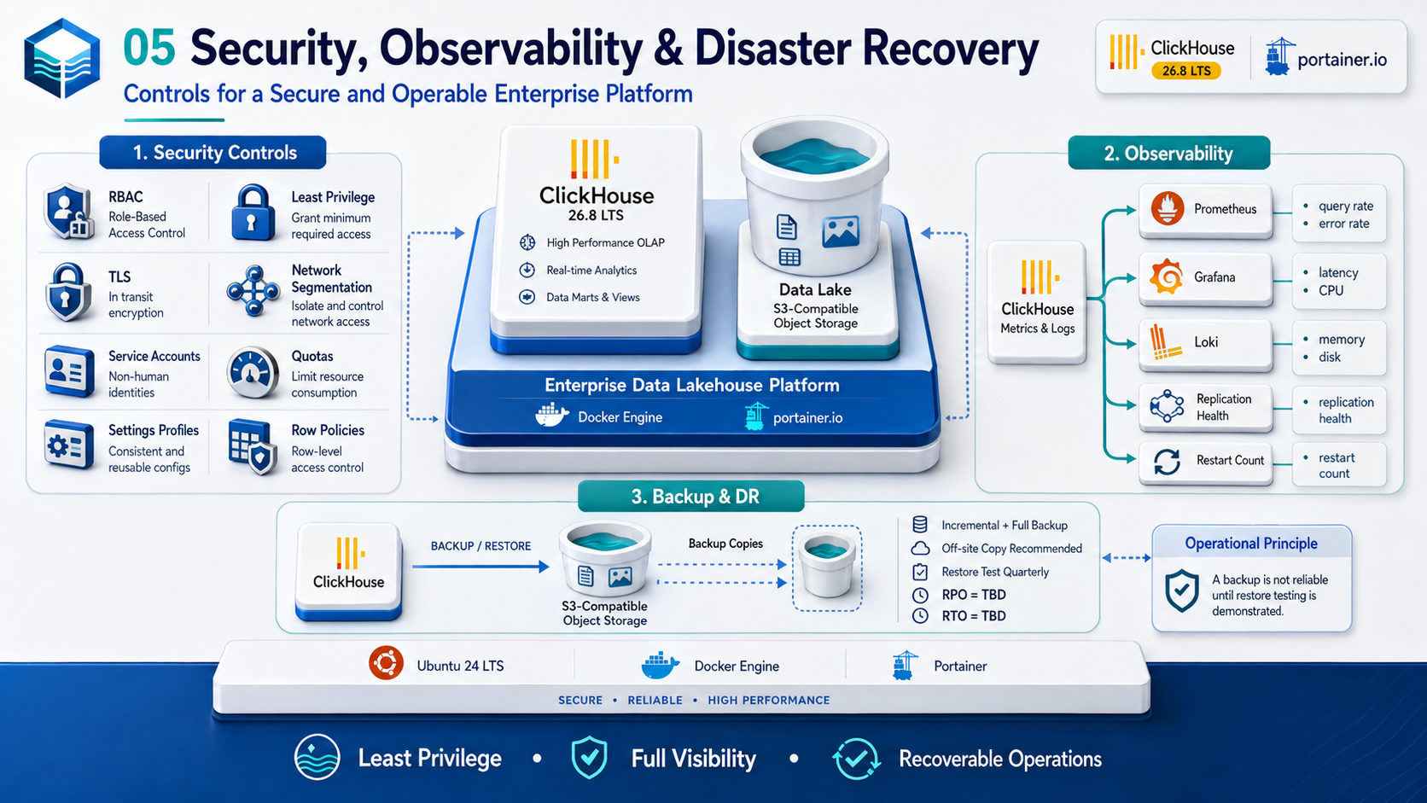
Figure 4 - Security, observability, and recovery architecture.
Control Plane | Required Controls
Identity | Named users for humans; service accounts for workloads; least privilege; periodic review.
ClickHouse authorization | RBAC, role grants, row policies where required, quotas/settings profiles.
Secrets | No secrets in Git/images; protected runtime injection; future Vault/equivalent if justified.
Network | Segmentation, firewall allow-list, internal admin endpoints, TLS.
Container supply chain | Pinned images, Harbor, Trivy scan, SBOM/signing roadmap.
Operations | Auditable deployment, approval gates, emergency change reconciliation.
Data | Classification, retention, masking/row policy as required, minimal PII in logs.

8. Observability Blueprint
Signal | Examples
Availability | Service health, container restart count, Keeper connectivity, replica availability
Query | QPS, error rate, P95/P99 latency, query memory, rejected/queued queries
Storage | Disk usage, part count, merge backlog, object storage errors
Replication | Replica lag, queue size, read-only state, Keeper session health
Ingestion | Rows/sec, batch duration, consumer lag, failed batches, retry count
Recovery | Last successful backup, backup duration/size, last restore drill

9. CI/CD and Portainer Blueprint
Developer / Data Engineer
v
GitHub Pull Request
v
Jenkins Validation
|-- lint / syntax
|-- tests
|-- Trivy / secret scan
|-- image build / SBOM
v
Harbor Immutable Image
v
Approval Gate
v
Portainer Git Stack / Controlled Deployment
v
Health + Smoke + Observability Verification

Portainer is the controlled operations interface and may deploy Git-backed stacks. It must not become an alternative manual production deployment path that bypasses review, security scanning, or release approval.

10. Backup and DR Blueprint
- Backups stored outside ClickHouse compute hosts.
- Full and incremental strategy based on dataset size and recovery requirements.
- Off-site or independent failure-domain copy recommended.
- Restore tests performed on a defined schedule.
- RPO = TBD; proposed starting discussion <= 1 hour.
- RTO = TBD; proposed starting discussion <= 4 hours.
- A backup is not considered operationally reliable until a restore test is demonstrated.

11. Architecture Evolution Path
Trigger | Potential Evolution
More engines need shared tables | Add Apache Iceberg + catalog after operational justification.
Near-real-time business SLA | Introduce Debezium + Kafka/Redpanda CDC/streaming.
Single-node capacity exhausted after tuning | Add replicated cluster / sharding based on benchmark.
Many teams need self-service | Add data catalog, lineage, policy automation, templates, data product ownership.
Container estate/scale exceeds Docker operational model | Evaluate Kubernetes/GitOps/Argo CD, not before.
AI/ML workloads need governed access | Add feature/embedding pipelines, semantic contracts, controlled tool APIs.

References
- ClickHouse 26.8 LTS release overview: https://presentations.clickhouse.com/2026-release-26.8/
- ClickHouse official packages / release channels: https://packages.clickhouse.com/
- ClickHouse documentation: https://clickhouse.com/docs
- ClickHouse Keeper: https://clickhouse.com/clickhouse/keeper
- ClickHouse Amazon S3 integration: https://clickhouse.com/integrations/amazon_s3
- ClickHouse integrations catalog: https://clickhouse.com/integrations
- Portainer: Add a new Docker stack / Git repository deployment: https://docs.portainer.io/sts/user/docker/stacks/add
- Portainer access control: https://docs.portainer.io/advanced/access-control
External references were reviewed for this document set on 2026-09-03. Product behavior and supported patch versions must be re-verified before production implementation.

