MODULES, CAPABILITIES & FUTURE ENHANCEMENTS
Evolution Roadmap for the Enterprise Data Lakehouse Platform
DOC-06 | Enterprise Data Lakehouse Platform
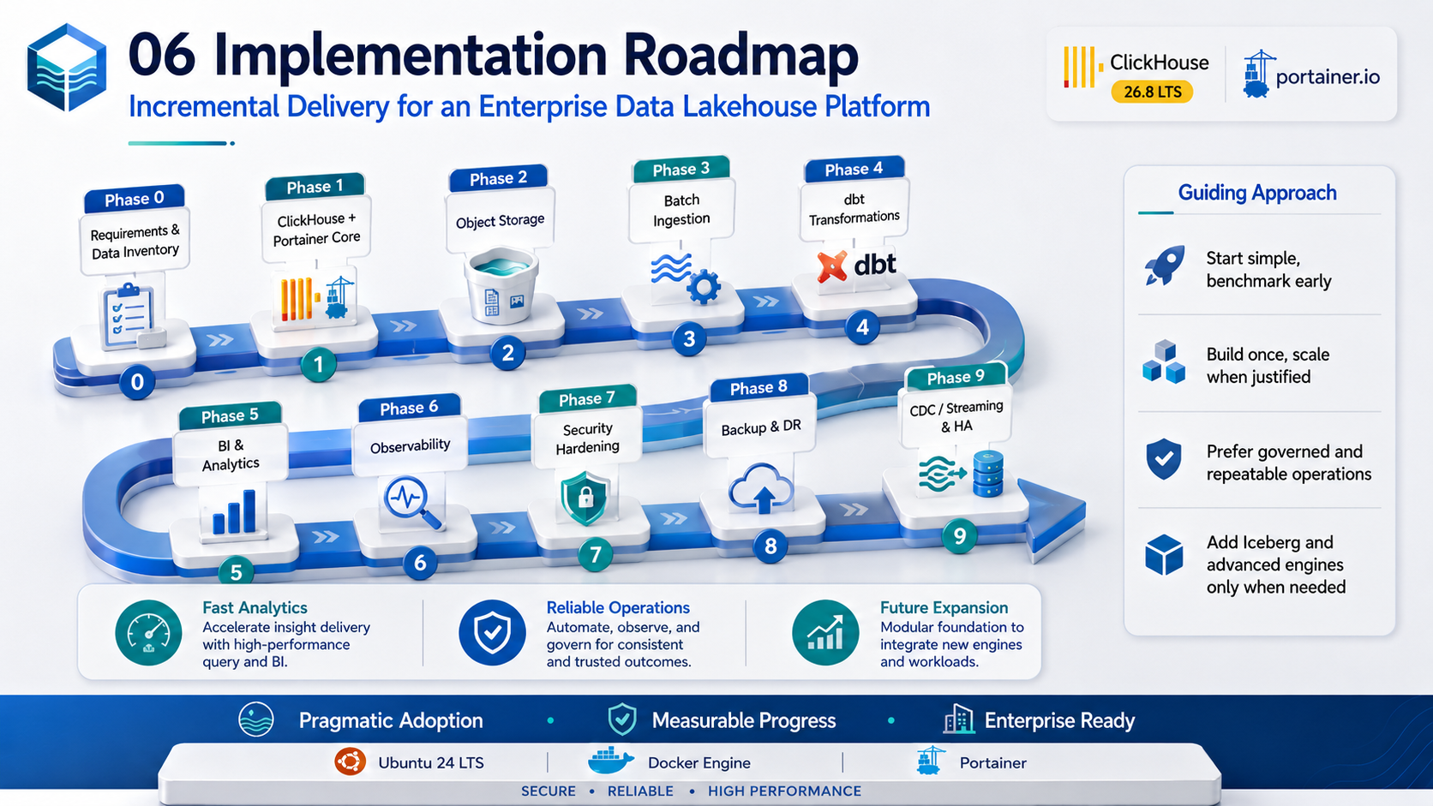
Architecture & Planning Baseline | 2026-09-03
Status: Design baseline - organization-specific TBD values require human approval.

Document Control
Item | Value
Document | Modules, Capabilities & Future Enhancements
Purpose | Summarize platform capabilities, module boundaries, maturity stages, and future enhancement opportunities.
Audience | Architecture, product/data owners, MIS/IT leadership, engineering teams, innovation/AI teams, and roadmap planners.
Platform baseline | Ubuntu 24 LTS + Docker Engine + Portainer + ClickHouse 26.8 LTS branch
Status | Design baseline
Date | 2026-09-03
Governance source | Repository AGENTS.md is the primary engineering and AI-governance policy.

Control note: technical values marked TBD are intentionally unresolved until workload, security, business continuity, and infrastructure requirements are formally approved.

1. Current Target Capabilities
Capability Domain | Baseline Capability
Data ingestion | Batch ingestion from databases, APIs, and files with replay/reconciliation metadata.
Durable lake | S3-compatible Landing/Bronze/Archive with Parquet.
Analytics | ClickHouse high-performance OLAP, marts, materialized views, serving tables.
Transformation | dbt-clickhouse model lifecycle and data tests.
Consumption | Power BI, Grafana, APIs, analysts, future AI/ML consumers.
Security | RBAC, least privilege, network segmentation, TLS, service identities, controlled secrets.
Operations | Portainer controlled operations, Git/Jenkins/Harbor deployment governance.
Observability | Prometheus/Grafana/Loki, query/system/replication/ingestion/backup signals.
Recoverability | Backup/restore design with measurable restore-test evidence.

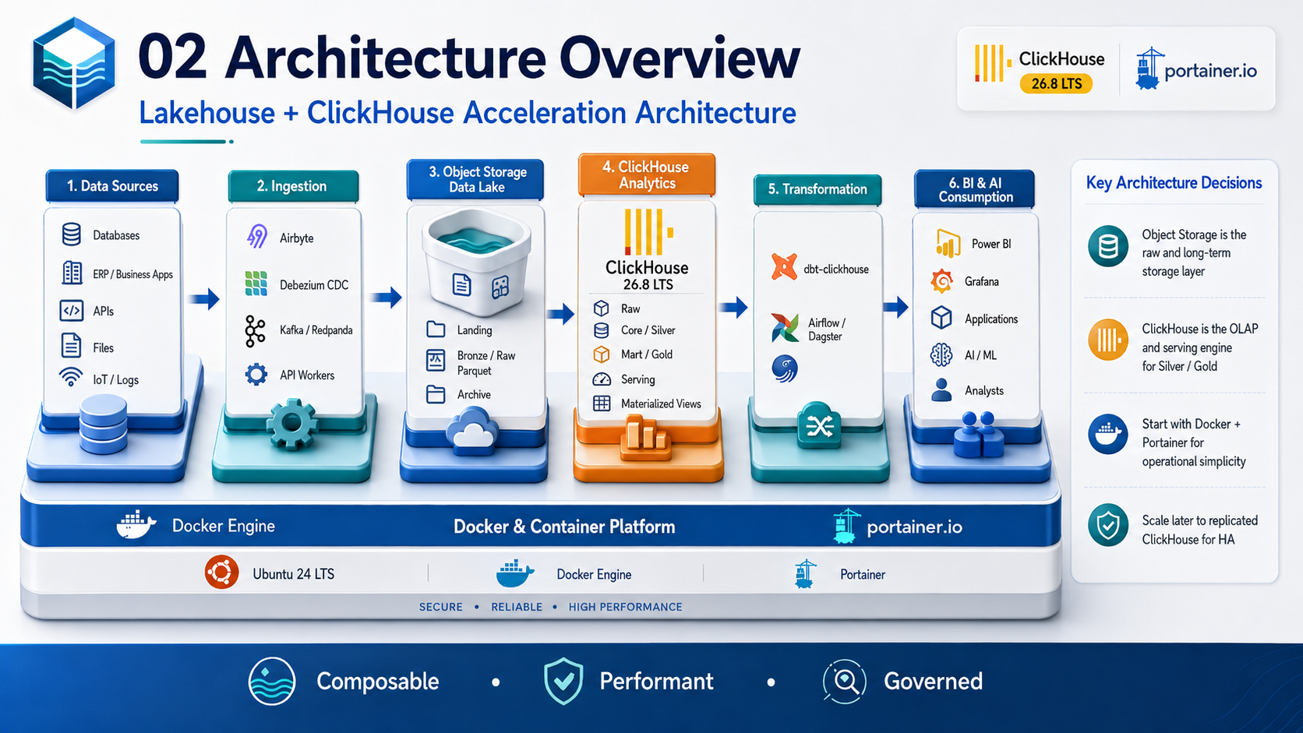
Figure 1 - Baseline platform capability chain.

2. Module Architecture
Module | Responsibilities | Primary Technology
M01 Source Connectivity | Connect enterprise sources; extraction contracts; credential isolation | Airbyte/custom connectors
M02 CDC & Event Ingestion | Capture database changes and event streams | Debezium + Kafka/Redpanda (future/conditional)
M03 Data Lake Storage | Landing/Bronze/Archive, lifecycle, open file formats | S3-compatible object storage + Parquet
M04 Analytical Storage | Raw/Core/Mart/Serving, OLAP, materialized views | ClickHouse
M05 Transformation & Quality | Conformance, business logic, tests, documentation | dbt-clickhouse
M06 Orchestration | Scheduling, dependencies, retries, SLAs | Airflow/Dagster or enterprise scheduler
M07 BI & Data APIs | Dashboards, analytical APIs, governed consumption | Power BI/Grafana/.NET APIs
M08 Security & Governance | RBAC, classification, retention, access review, policies | ClickHouse + platform controls
M09 Observability & SRE | Metrics, logs, alerts, capacity, runbooks, incidents | Prometheus/Grafana/Loki
M10 DevOps & Release | Versioning, scans, immutable artifacts, promotion | GitHub/Jenkins/Harbor/Trivy/Portainer
M11 Backup & DR | Backup, off-site copy, restore drills, recovery evidence | ClickHouse backup + object storage
M12 AI & Advanced Analytics | AI/ML access, RAG/agents, feature/embedding pipelines | Future controlled services

3. Maturity Roadmap
Figure 2 - Pragmatic incremental roadmap.
Stage | Description | Exit Characteristics
Level 1 - Foundation | Single-node UAT, batch ingest, basic lake, initial marts | Repeatable deployment; first business use case.
Level 2 - Governed Analytics | dbt, access model, data quality, observability, backup | Trusted curated datasets and operational visibility.
Level 3 - Production Resilience | Replicated ClickHouse, Keeper quorum, recovery drills | HA topology and measured recovery evidence.
Level 4 - Near Real Time | CDC/streaming where justified | Freshness measured in seconds/minutes for selected domains.
Level 5 - Open Lakehouse | Iceberg/catalog/lineage and multi-engine access | Interoperable governed datasets across engines.
Level 6 - Intelligent Data Platform | AI agents, semantic/metadata services, self-service automation | Governed AI-assisted data operations and analytics.

4. Future Enhancement Backlog
Enhancement | Business/Technical Value | Prerequisite / Trigger | Priority
Apache Iceberg + Catalog | Multi-engine interoperability, schema evolution, table metadata | More than one engine/team needs governed shared lake tables | Future - conditional
Enterprise Data Catalog | Discovery, ownership, glossary, classification | Dataset count/teams grow; governance workload increases | High after core adoption
Automated Data Lineage | Impact analysis and trust | dbt/pipelines standardized | High
Data Quality Service | Central rules, anomaly detection, quality scorecards | Critical datasets and owners defined | High
CDC / Streaming | Lower data freshness latency | Approved real-time use cases and operational ownership | Conditional
Workload Management / Multi-tenancy | Protect shared cluster from noisy consumers | Concurrency/users increase | Medium-High
Semantic Metrics Layer | Consistent KPI definitions across BI/API/AI | Business metric governance established | Medium-High
Feature/Embedding Pipelines | Support ML/RAG/agent retrieval patterns | Approved AI use cases and privacy controls | Future
AI Data Copilot | Natural language assisted data discovery/query | Semantic layer, RBAC, audit, guardrails | Future
FinOps / Chargeback | Cost visibility by domain/team/workload | Usage tagging and cost model available | Medium
Policy as Code | Automated deployment/config/data-policy checks | Governance rules stabilized | Future
Kubernetes/GitOps | Larger-scale orchestration and standardized platform operations | Docker/Portainer limits materially reached | Future - not default
Multi-site DR | Site-level resilience | Business RTO/RPO requires site failure protection | Conditional / high criticality

5. AI and Advanced Analytics Opportunities
- AI-assisted data catalog search and business glossary navigation.
- Natural-language-to-SQL with strict read-only roles, query limits, and semantic guardrails.
- Automated anomaly detection for data freshness, row counts, and KPI deviations.
- AI-assisted incident triage using logs/metrics/query history without exposing secrets.
- RAG over approved operational runbooks, data contracts, schemas, and architecture documents.
- Agent-assisted source onboarding that generates draft mappings/tests but requires human approval.
- Embedding/vector workloads may be evaluated against ClickHouse capabilities or a specialized vector store based on benchmark and retrieval requirements.
AI features should consume governed metadata and curated datasets. They must not bypass existing RBAC, data classification, audit, approval, or privacy controls.

6. Capability Non-Goals
- The platform is not an OLTP replacement for transactional application databases.
- A data lake does not automatically create trusted business definitions; ownership and modeling remain required.
- High availability is not achieved by running multiple replicas on one physical Docker host.
- Backups do not prove recoverability without restore testing.
- Adding Kafka, Iceberg, Kubernetes, or AI tooling is not considered progress unless it solves an approved requirement.

7. Prioritization Framework
Criterion | Question
Business value | Which business decision, SLA, or cost/risk outcome improves?
Data criticality | Does the enhancement protect or serve critical/restricted datasets?
Operational readiness | Can the team support the component 24x7 if required?
Complexity | Does it introduce a new distributed system/control plane?
Evidence | Is there a benchmark, incident, adoption metric, or regulatory requirement supporting the need?
Reversibility | Can the design be adopted incrementally without locking the platform?

References
- ClickHouse 26.8 LTS release overview: https://presentations.clickhouse.com/2026-release-26.8/
- ClickHouse official packages / release channels: https://packages.clickhouse.com/
- ClickHouse documentation: https://clickhouse.com/docs
- ClickHouse Keeper: https://clickhouse.com/clickhouse/keeper
- ClickHouse Amazon S3 integration: https://clickhouse.com/integrations/amazon_s3
- ClickHouse integrations catalog: https://clickhouse.com/integrations
- Portainer: Add a new Docker stack / Git repository deployment: https://docs.portainer.io/sts/user/docker/stacks/add
- Portainer access control: https://docs.portainer.io/advanced/access-control
External references were reviewed for this document set on 2026-09-03. Product behavior and supported patch versions must be re-verified before production implementation.

