AI AGENT TEAM STRUCTURE & REQUIRED SKILLS
Human-Governed Multi-Agent Operating Model for Enterprise Data Lakehouse Engineering
DOC-07 | Enterprise Data Lakehouse Platform
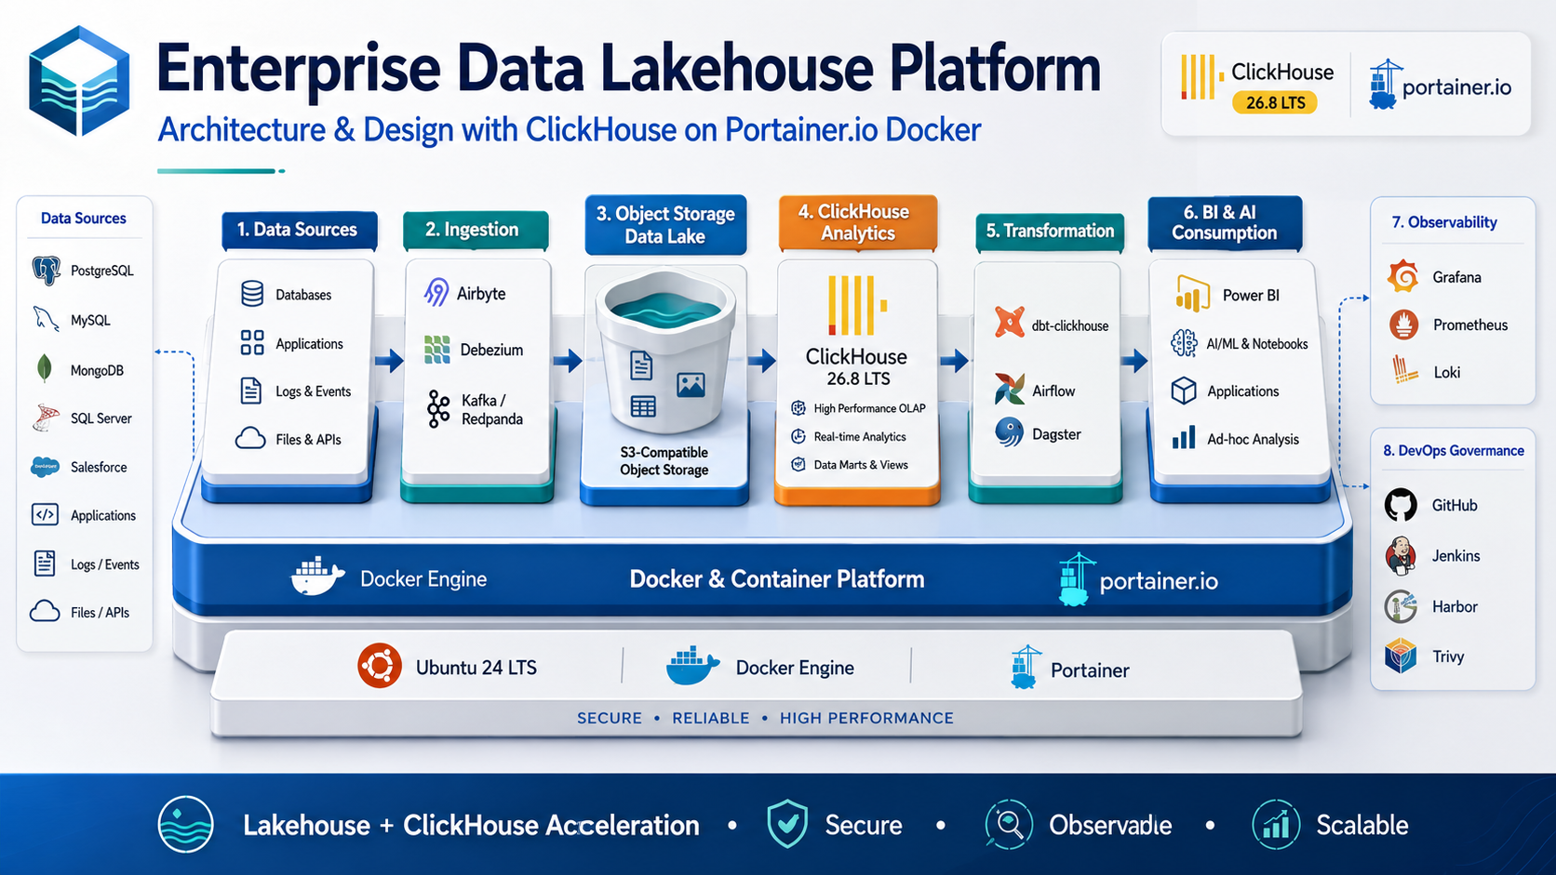
Architecture & Planning Baseline | 2026-09-03
Status: Design baseline - organization-specific TBD values require human approval.

Document Control
Item | Value
Document | AI Agent Team Structure and Required Skills
Purpose | Define the proposed AI agent roles, responsibilities, handoffs, skills, guardrails, review gates, and human ownership model.
Audience | Engineering leadership, architecture, AI platform teams, software/data engineers, security, SRE, QA, and governance.
Platform baseline | Ubuntu 24 LTS + Docker Engine + Portainer + ClickHouse 26.8 LTS branch
Status | Design baseline
Date | 2026-09-03
Governance source | Repository AGENTS.md is the primary engineering and AI-governance policy.

Control note: technical values marked TBD are intentionally unresolved until workload, security, business continuity, and infrastructure requirements are formally approved.

1. Operating Principle
AI agents are engineering assistants, not autonomous production authorities. They can inspect, analyze, draft, validate in safe environments, and prepare reviewable changes. Human owners remain accountable for architecture approval, sensitive access, production release, data governance, and destructive/recovery actions.
The multi-agent model is designed for separation of concerns: one agent proposes, another validates from a different perspective, and high-risk actions require an explicit human gate.

2. Recommended AI Agent Team
Agent | Primary Mission | Typical Outputs
A00 Orchestrator / Delivery Lead | Decompose work, enforce AGENTS.md workflow, coordinate agents, manage review gates | Task plan, dependency graph, consolidated status/TBD/risk report
A01 Enterprise Solution Architect | Maintain overall architecture, boundaries, ADRs, NFRs | Architecture docs, ADRs, trade-off analysis
A02 Data Architect | Define domains, medallion contracts, schemas, ownership, metadata | Data model, contracts, naming/retention conventions
A03 ClickHouse Specialist | Optimize MergeTree design, replication, queries, performance | DDL, engine strategy, tuning/benchmark recommendations
A04 Data Pipeline Engineer | Design ingestion, CDC, orchestration, dbt and quality | Pipeline configs, dbt models/tests, replay/reconciliation design
A05 Platform / DevOps Engineer | Docker/Compose, Portainer, Jenkins, Harbor, environments | Compose/config, pipeline templates, deployment/rollback runbooks
A06 Security & Governance Engineer | Threat model, RBAC, secrets, network/data controls | Security review, role matrix, findings, required approvals
A07 SRE / Observability Engineer | SLI/SLO, monitoring, alerts, capacity, backup/DR | Dashboards, alert rules, runbooks, recovery-test plans
A08 QA / Validation Engineer | Independent verification of configs, tests, data, performance | Test plans, validation evidence, acceptance report
A09 Documentation / ADR Agent | Maintain coherent documentation and decision traceability | README, runbooks, ADR index, cross-document consistency
A10 BI / Data Product Analyst | Translate business questions/KPIs into data product requirements | Metric definitions, UAT scenarios, serving requirements
A11 Capacity / FinOps Analyst | Analyze resource usage and growth; cost/performance trade-offs | Capacity model, benchmark analysis, cost scenarios

3. Agent Collaboration Flow
Human Request / Backlog
|
v
A00 Orchestrator
|
+--> A01 Architecture --------+
+--> A02 Data Architecture ---+
+--> A03 ClickHouse ----------+----> Proposed Change Set
+--> A04 Pipelines -----------+ |
+--> A05 Platform/DevOps -----+ v
+--> A06 Security ----------- Review / Challenge
+--> A07 SRE ----------------+ |
+--> A08 QA <--------------- independent validation
+--> A09 Documentation ------+ |
+--> A10 Data Product -------+ v
`--> A11 Capacity/FinOps -----+----> HUMAN APPROVAL GATE
|
v
Controlled Implementation

4. Skills Matrix
Skill Area | Required Knowledge | Primary Agents
ClickHouse | MergeTree engines, partition/order keys, materialized views, system tables, replication, Keeper, backup, tuning | A03, A02, A07
Data modeling | Dimensional modeling, medallion, SCD/CDC, data contracts, metadata, quality | A02, A04, A10
Data engineering | SQL, Python/.NET workers, Airbyte, Debezium, Kafka/Redpanda, Parquet, dbt | A04, A02
Containers/platform | Linux, Docker, Compose, Portainer, storage mounts, networks, certificates | A05, A07
DevSecOps | GitHub, Jenkins, Harbor, Trivy, SBOM, secret scanning, immutable promotion | A05, A06, A08
Security | Threat modeling, IAM/RBAC, least privilege, TLS, network segmentation, logging/privacy | A06, A01
SRE | SLIs/SLOs, Prometheus, Grafana, Loki, capacity, incident/recovery engineering | A07, A11
Testing | Data reconciliation, dbt tests, integration, performance, failover/recovery tests | A08, A04, A07
Governance | Data ownership, classification, retention, lineage, approvals, ADRs | A01, A02, A06, A09
AI agent engineering | Prompt/context design, tool permissions, evaluation, guardrails, audit, human-in-loop | A00, A08, A06

5. Agent Responsibility Boundaries
Agent Category | May Do | Must Not Do Without Human Authorization
Design agents | Analyze repository, draft architecture/DDL/config/docs, propose changes | Approve own high-risk architecture/security decisions as final
Platform agents | Generate/validate Compose/Jenkins configs in safe workspace | Deploy to production, change firewall/credentials, delete volumes
Data agents | Draft pipelines/models/tests, run non-destructive validation | Delete/overwrite production data, expose restricted datasets
Security agent | Review access paths and identify findings | Grant privileged access or accept security exceptions
SRE agent | Draft alerts/runbooks and safe recovery tests | Trigger destructive production failover/restore without authorization
QA agent | Run permitted tests and report evidence | Falsify/assume test success or suppress failed evidence

6. Human Roles and Mandatory Gates
Human Role | Accountability / Gate
Project / Business Sponsor | Business priority, funding, approved RPO/RTO/availability, residual risk acceptance.
Architecture Owner | Final material architecture decisions and ADR approval.
Data Owner | Dataset purpose, classification, access, retention, KPI semantics, UAT acceptance.
Security Owner | Privileged access, threat/risk acceptance, security exceptions.
Platform / Operations Owner | Runtime ownership, maintenance, incident response, capacity and recovery readiness.
Release Approver | Production promotion and emergency change authorization.

7. Agent Handoff Contract
Every agent output should use the following structured handoff so another agent or human reviewer can validate it without reconstructing hidden assumptions:
Task
Scope
Inputs / Sources Inspected
Assumptions
Proposed Decision / Change
Files or Artifacts Affected
Security / Privacy Impact
Data / Backward Compatibility Impact
Operational / Recovery Impact
Validation Performed (exact commands and results)
TBDs / Unknowns
Residual Risks
Human Approval Required
Recommended Next Step

8. Multi-Agent Review Patterns
Change Type | Author Agent | Mandatory Challenger / Validator
ClickHouse DDL/performance | A03 | A02 + A08; A07 for production capacity impact
Ingestion/CDC | A04 | A02 + A08 + A06 for sensitive data
Docker/Portainer/CI-CD | A05 | A06 + A08 + A07
RBAC/network/secrets | A06 | A05 + human security owner
Backup/DR | A07 | A08 + human operations/business owner
Architecture change | A01 | A02/A05/A06/A07 as affected + human architecture owner
Business metric/serving model | A10/A02 | Data owner + A08

9. AI Agent Evaluation Metrics
Metric | Meaning
Policy adherence | Reads/uses AGENTS.md and does not bypass high-risk gates.
Change precision | Percentage of changes limited to requested scope without unrelated refactoring.
Validation honesty | Claims are backed by actual commands/results; failures remain visible.
Security hygiene | No secret leakage, unsafe public exposure, or privilege escalation in generated artifacts.
Review defect rate | Material defects found after agent claims readiness.
Rollback/recovery completeness | Operational impact and rollback/recovery limitations documented.
Documentation consistency | Architecture, technical spec, Compose, runbooks, and ADRs remain aligned.
Human acceptance | Percentage of proposed changes approved with minimal rework.

10. Suggested Repository Agent Structure
repo/
|-- AGENTS.md # canonical engineering/governance policy
|-- agents/
| |-- orchestrator.md
| |-- solution-architect.md
| |-- data-architect.md
| |-- clickhouse-engineer.md
| |-- data-pipeline-engineer.md
| |-- platform-devops.md
| |-- security-governance.md
| |-- sre-observability.md
| |-- qa-validation.md
| `-- documentation-adr.md
|-- skills/
| |-- clickhouse/
| |-- data-onboarding/
| |-- deployment/
| |-- security-review/
| |-- backup-restore/
| `-- benchmark/
`-- docs/ ...

Platform-specific adapters should remain thin. The canonical policy belongs in AGENTS.md; agent files should describe role-specific workflows and outputs without silently weakening the root policy.

11. Required Agent Guardrails
- Production/external/destructive actions require explicit authorization.
- Credentials and sensitive data are never stored in prompts, memory, generated docs, or logs unnecessarily.
- Agents must inspect existing architecture and conventions before generating substantial changes.
- Agents must stop when high-risk assumptions are missing.
- Generated output is an untrusted draft until reviewed and validated.
- A separate validation agent should challenge high-impact changes.
- Evidence, unknowns, and residual risk remain visible in final handoffs.

References
- ClickHouse 26.8 LTS release overview: https://presentations.clickhouse.com/2026-release-26.8/
- ClickHouse official packages / release channels: https://packages.clickhouse.com/
- ClickHouse documentation: https://clickhouse.com/docs
- ClickHouse Keeper: https://clickhouse.com/clickhouse/keeper
- ClickHouse Amazon S3 integration: https://clickhouse.com/integrations/amazon_s3
- ClickHouse integrations catalog: https://clickhouse.com/integrations
- Portainer: Add a new Docker stack / Git repository deployment: https://docs.portainer.io/sts/user/docker/stacks/add
- Portainer access control: https://docs.portainer.io/advanced/access-control
External references were reviewed for this document set on 2026-09-03. Product behavior and supported patch versions must be re-verified before production implementation.

