RESEARCH AND ANALYSIS REPORT
Enterprise Data Lakehouse Platform with ClickHouse on Portainer.io Docker
DOC-01 | Enterprise Data Lakehouse Platform
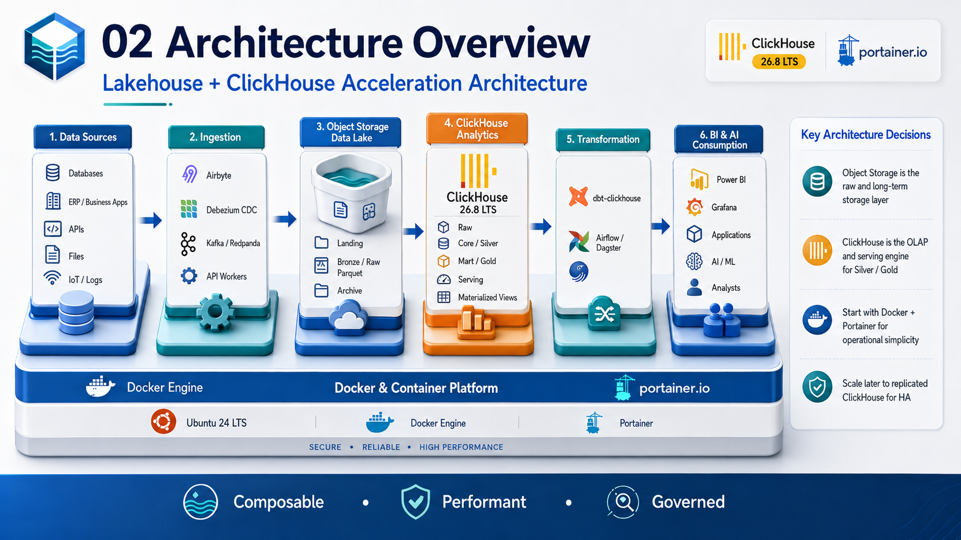
Architecture & Planning Baseline | 2026-09-03
Status: Design baseline - organization-specific TBD values require human approval.

Document Control
Item | Value
Document | Research and Analysis Report
Purpose | Evaluate the technical approach, architecture options, feasibility, risks, and recommended enterprise baseline.
Audience | Enterprise architecture, MIS/IT leadership, data engineering, platform engineering, security, and project sponsors.
Platform baseline | Ubuntu 24 LTS + Docker Engine + Portainer + ClickHouse 26.8 LTS branch
Status | Design baseline
Date | 2026-09-03
Governance source | Repository AGENTS.md is the primary engineering and AI-governance policy.

Control note: technical values marked TBD are intentionally unresolved until workload, security, business continuity, and infrastructure requirements are formally approved.

1. Executive Summary
The recommended architecture is a Lakehouse + ClickHouse Acceleration model. Durable raw and historical data remains in S3-compatible object storage, while ClickHouse provides high-performance OLAP, curated Silver/Gold models, data marts, materialized views, and serving datasets for BI, APIs, and future AI workloads.
The recommended implementation path intentionally starts with a simple Docker/Portainer UAT platform for benchmarking and operational learning. Production high availability is a separate topology that requires replicated ClickHouse nodes and ClickHouse Keeper members distributed across separate failure domains.
Research conclusion: use ClickHouse as the analytics/serving engine, not as the only durable storage layer. Keep the lake independent so that future engines, governance tools, or AI workloads can reuse the same durable datasets.

2. Research Objectives
- Determine whether ClickHouse is suitable as the analytical core of an enterprise data lakehouse.
- Define a deployment model compatible with existing Docker and Portainer operations.
- Compare batch, CDC, streaming, transformation, storage, and observability alternatives.
- Define an incremental roadmap that avoids premature Kubernetes or unnecessary platform complexity.
- Identify security, recovery, performance, governance, and operational risks before production adoption.

Baseline Assumptions and Constraints
- Initial self-managed runtime uses Ubuntu 24 LTS, Docker Engine, Docker Compose, and Portainer.
- ClickHouse is the high-performance OLAP and curated serving engine; object storage remains the durable raw/long-term lake layer.
- DEV/UAT may begin as single-node for evaluation and benchmarking; this topology is not considered high availability.
- Production HA is designed around separate failure domains with ClickHouse replication and a three-member ClickHouse Keeper quorum.
- Git is the configuration source of truth; Jenkins/CI controls validation and promotion; Harbor is the target enterprise registry where available.
- Prometheus, Grafana, and Loki form the baseline observability stack.
- Organization-specific values that have not been approved are marked TBD rather than assumed.

3. Technology Findings

3.1 ClickHouse Release Baseline
ClickHouse 26.8 is a long-term-support release branch. The official package repository listed 26.8.2.7 as the current stable/LTS patch at the time of review. Production deployments should pin an explicit approved patch or immutable image digest rather than rely on the latest tag.

3.2 Object Storage and Data Lake Integration
ClickHouse can query data directly from S3-compatible object storage and can ingest data from object storage into native tables. This supports a separation between durable lake storage and performance-optimized ClickHouse storage.

3.3 Distributed Coordination
ClickHouse Keeper is the ClickHouse-native coordination service used for replicated/distributed deployments. Production quorum design should use an odd number of Keeper members, with three members as the baseline for the initial HA design.

3.4 Portainer Operating Model
Portainer supports stack deployment from Git repositories as well as web-editor/upload methods. For enterprise governance, Git-backed stack definitions and CI-controlled promotion are preferred so that the deployed configuration remains traceable and reviewable.
Figure 1 - Recommended Lakehouse + ClickHouse acceleration architecture.

4. Architecture Options Analysis
Option | Strengths | Risks / Limitations | Recommendation
ClickHouse-only warehouse | Simple runtime; excellent OLAP performance. | Raw/history tightly coupled to one engine; weaker multi-engine reuse; backup/storage pressure. | Not preferred as the enterprise target.
Object storage lake + ClickHouse marts | Durable raw lake, high-performance curated layer, clear hot/cold separation. | Requires ingestion/metadata discipline and two storage tiers. | Recommended baseline.
Open table format first (Iceberg) + multiple query engines | Strong interoperability and future engine flexibility. | Higher operational/catalog complexity before multi-engine need is proven. | Evaluate in Phase 2+ only when justified.
Kubernetes-native data platform from day one | Strong orchestration and elastic patterns at scale. | Significantly higher skills/operations burden for current scope. | Defer until scale and SRE requirements justify it.

5. Component Evaluation
Capability | Initial Choice | Alternative / Future | Decision Basis
Analytical database | ClickHouse | Other OLAP engines if required | High-throughput analytical queries and real-time serving.
Durable lake | S3-compatible object storage + Parquet | Iceberg tables/catalog | Low-cost durable storage and engine independence.
Batch ingestion | Airbyte and/or custom workers | NiFi / other ELT tools | Connector coverage vs custom control.
CDC | Debezium | Native/vendor CDC tools | Open event-based CDC pattern; introduce when real-time need is proven.
Streaming | Kafka or Redpanda | Managed event platform | High-throughput ingestion; Phase 9, not Phase 1.
Transformation | dbt-clickhouse | Custom SQL / orchestration SQL | Versioned transformation logic and testable models.
Orchestration | Airflow or Dagster | Existing enterprise scheduler | Adopt only when pipeline dependency management is required.
Observability | Prometheus + Grafana + Loki | Enterprise monitoring integration | Matches repository baseline and supports operational signals.
CI/CD | GitHub + Jenkins + Harbor + Trivy | Equivalent enterprise toolchain | Traceable artifact promotion and security scanning.

6. Data Architecture Research
A Medallion-style data model is recommended because it creates explicit contracts between ingestion, cleansing, business modeling, and serving. The physical implementation does not need to force every layer into ClickHouse; Landing/Bronze may remain in object storage while Silver/Gold/Serving are materialized into native ClickHouse tables where performance matters.
Layer | Primary Role | Preferred Storage | Key Controls
Landing | Immutable receipt of source extracts/events | Object storage | Original file preservation, checksums, ingestion metadata
Bronze / Raw | Source-aligned normalized files/data | Object storage / raw ClickHouse | Schema capture, batch ID, source timestamps
Core / Silver | Cleaned, deduplicated, conformed entities | ClickHouse native tables | Data quality checks, CDC version rules
Mart / Gold | Business facts, dimensions, aggregates | ClickHouse native tables | Business definitions, reconciliation, performance design
Serving | Dashboard/API optimized datasets | ClickHouse views/materialized views | SLA, query limits, RBAC
Archive | Cold long-term history | Object storage | Retention, legal hold, lifecycle policy

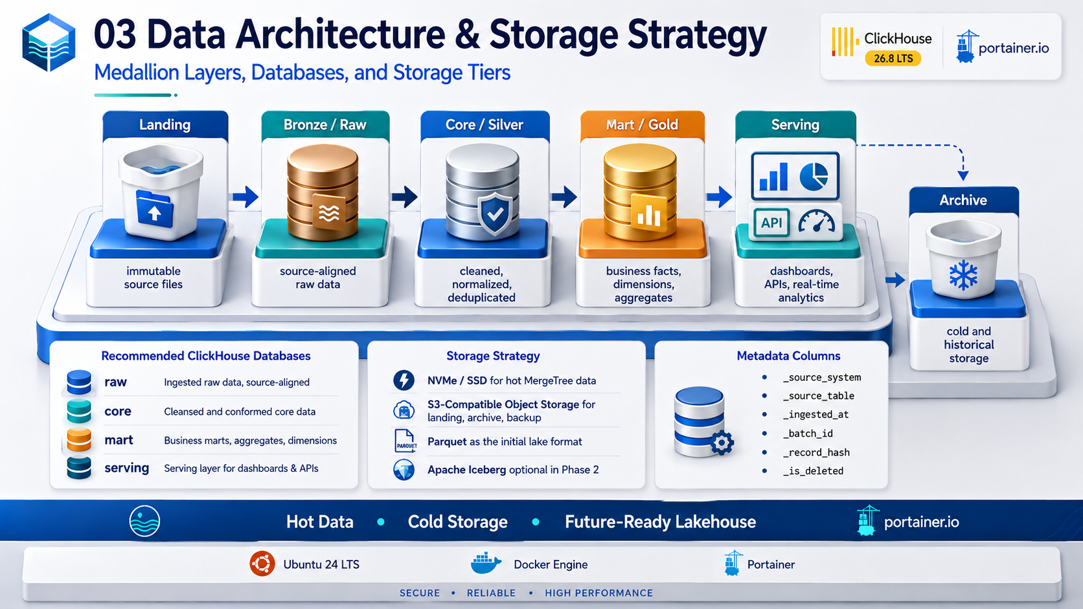
Figure 2 - Medallion data architecture and hot/cold storage strategy.

7. Feasibility Assessment
Dimension | Assessment | Conditions
Technical feasibility | High | Benchmark with representative data/query mix before production sizing.
Operational feasibility | Medium-High | Team must own Docker, ClickHouse operations, backup, monitoring, and incident runbooks.
Security feasibility | High with controls | TLS, RBAC, network segmentation, secret management, audit/change control required.
Scalability | High | Scale up first; add replication and shards based on measured bottlenecks.
Cost predictability | Medium-High | Object storage reduces long-term storage cost; hardware and concurrency still require measurement.
Future interoperability | High | Durable lake can later support Iceberg and additional engines.

8. Principal Risks and Mitigations
Risk | Impact | Mitigation | Owner
Single-host topology mistaken for HA | Critical | Label DEV/UAT clearly; production replicas/Keeper on separate hosts/failure domains. | Platform
Unbounded parts / poor MergeTree design | High | Benchmark partition/order keys; monitor active parts and merge backlog. | Data/ClickHouse
Manual Portainer drift | High | Git-backed stacks; CI/CD approvals; record emergency changes and reconcile to Git. | DevOps
Backup exists but restore unproven | Critical | Scheduled restore drills; measure actual RPO/RTO evidence. | SRE
Sensitive data exposed through broad accounts | High | Service accounts, least privilege, row policies, quotas, network restrictions. | Security/Data
Over-engineering before business value | Medium | Phase-gated adoption; defer Kafka/Iceberg/Kubernetes until justified. | Architecture
Sizing based on generic hardware tables | High | Performance benchmark using production-like data, concurrency, and SLOs. | Platform/Data

9. Recommendation
- Approve a UAT baseline consisting of ClickHouse + S3-compatible object storage + Docker/Portainer + Prometheus/Grafana/Loki.
- Create the Landing/Bronze data lake contract and ClickHouse raw/core/mart/serving database conventions before onboarding many sources.
- Implement one representative source-to-dashboard vertical slice and benchmark ingestion, query latency, storage, and recovery.
- Define production SLO/RPO/RTO and security classification before committing production hardware.
- Deploy production HA only after the UAT benchmark and recovery test provide evidence for topology and sizing.
- Add CDC/streaming, Iceberg/catalog, and Kubernetes only when measurable requirements justify the operational complexity.

References
- ClickHouse 26.8 LTS release overview: https://presentations.clickhouse.com/2026-release-26.8/
- ClickHouse official packages / release channels: https://packages.clickhouse.com/
- ClickHouse documentation: https://clickhouse.com/docs
- ClickHouse Keeper: https://clickhouse.com/clickhouse/keeper
- ClickHouse Amazon S3 integration: https://clickhouse.com/integrations/amazon_s3
- ClickHouse integrations catalog: https://clickhouse.com/integrations
- Portainer: Add a new Docker stack / Git repository deployment: https://docs.portainer.io/sts/user/docker/stacks/add
- Portainer access control: https://docs.portainer.io/advanced/access-control
External references were reviewed for this document set on 2026-09-03. Product behavior and supported patch versions must be re-verified before production implementation.

