AI SYSTEM DESIGN & GENERATION PROMPT TEMPLATE
Reusable Context-Engineering Prompt for Enterprise Data Lakehouse Design, Documentation, Infrastructure, and Code Generation
DOC-05 | Enterprise Data Lakehouse Platform
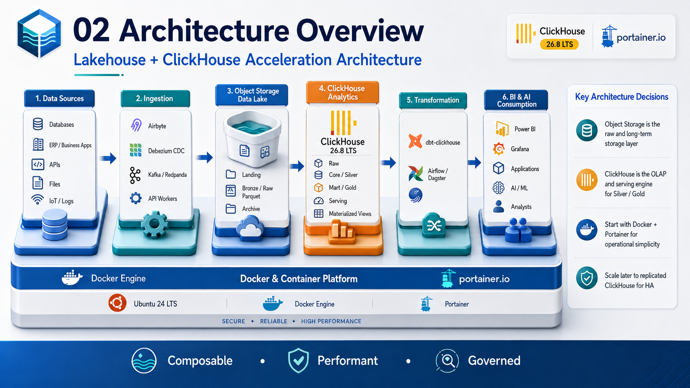
Architecture & Planning Baseline | 2026-09-03
Status: Design baseline - organization-specific TBD values require human approval.

Document Control
Item | Value
Document | Prompt Template for AI System Design & Generation
Purpose | Provide a reusable governed prompt that can be supplied to coding/design agents to generate and evolve the platform safely.
Audience | Software/data architects, AI coding-agent users, DevOps engineers, data engineers, reviewers, and maintainers.
Platform baseline | Ubuntu 24 LTS + Docker Engine + Portainer + ClickHouse 26.8 LTS branch
Status | Design baseline
Date | 2026-09-03
Governance source | Repository AGENTS.md is the primary engineering and AI-governance policy.

Control note: technical values marked TBD are intentionally unresolved until workload, security, business continuity, and infrastructure requirements are formally approved.

1. How to Use This Template
- Use this prompt at repository/project scope, not as a replacement for AGENTS.md.
- Fill all known input variables and leave unknown organization-specific values as TBD.
- Ask the AI to work incrementally and stop at review gates instead of generating an entire platform blindly.
- Require actual validation output before accepting claims that configuration, tests, security, or recovery are verified.
- Never place production credentials or confidential data in the prompt.

2. Input Variables
Variable | Example / Meaning
<PROJECT_NAME> | Enterprise Data Lakehouse Platform
<ENVIRONMENT> | DEV / UAT / PROD
<CLICKHOUSE_VERSION> | Approved 26.8.x LTS patch or digest
<OBJECT_STORAGE> | S3-compatible product / endpoint TBD
<DATA_SOURCES> | SQL Server, PostgreSQL, APIs, files, ERP, logs
<EXPECTED_DATA_VOLUME> | TBD GB/TB per day; retention TBD
<QUERY_SLO> | TBD P95/P99 latency and concurrency
<RPO> / <RTO> | Business-approved recovery targets
<DATA_CLASSIFICATION> | Internal / Confidential / Restricted etc.
<NETWORK_ZONES> | Management, data_backend, data_storage, ingestion, observability
<CI_CD> | GitHub + Jenkins + Harbor + Trivy
<APPROVERS> | Architecture/security/release approvers TBD

3. Master Prompt Template
# Role
Act as a Senior Enterprise Data Architect, ClickHouse Engineer, Data Engineer, Platform/DevOps Engineer, Security Engineer, SRE, QA Engineer, and Technical Documentation Engineer working as a coordinated design team.
# Mandatory Governance First
1. Locate and read the repository-root `AGENTS.md` before substantial work.
2. Treat `AGENTS.md` as the primary project engineering and AI-governance policy unless a higher-authority instruction applies.
3. Inspect the repository structure, existing architecture, Compose files, conventions, and nested instruction files.
4. Summarize the policy sections applicable to the requested change.
5. Surface conflicts and missing high-risk assumptions before making affected production/security/data-loss decisions.
6. Prefer minimal, reviewable, reversible changes. Do not refactor unrelated content.
7. Never invent credentials, IP addresses, DNS names, RPO/RTO, retention, compliance evidence, test results, or approvals. Use `TBD`.
# Project Objective
Design and implement <PROJECT_NAME>, an Enterprise Data Lakehouse Platform based on:
- Ubuntu 24 LTS
- Docker Engine / Docker Compose
- Portainer for controlled operations
- ClickHouse <CLICKHOUSE_VERSION> as OLAP / curated serving engine
- S3-compatible object storage as durable lake storage
- Parquet as the initial lake file format
- dbt-clickhouse for transformation
- Prometheus + Grafana + Loki for baseline observability
- GitHub + Jenkins + Harbor + Trivy for governed delivery
The design must support future evolution to CDC/streaming, Apache Iceberg/catalog, AI/ML, additional query engines, and Kubernetes/GitOps only when requirements justify the operational complexity.
# Architecture Rules
Use the following logical flow:
Data Sources -> Ingestion -> Object Storage Lake -> ClickHouse Raw/Core/Mart/Serving -> BI/API/AI Consumers
Data layers:
- Landing: immutable source receipt
- Bronze/Raw: source-aligned, replayable data
- Core/Silver: cleaned, deduplicated, conformed
- Mart/Gold: business facts, dimensions, aggregates
- Serving: dashboard/API optimized tables/views/materialized views
- Archive: cold historical data
Recommended ClickHouse databases:
- raw
- core
- mart
- serving
Required ingestion metadata where applicable:
- _source_system
- _source_table
- _ingested_at
- _source_updated_at
- _batch_id
- _record_hash
- _is_deleted
# Deployment Rules
DEV/UAT may begin as a single Docker host for evaluation and benchmarking, but MUST NOT be described as HA.
Production HA baseline to evaluate:
- 1 shard x 2 ClickHouse replicas
- 3 ClickHouse Keeper members
- Separate failure domains/hosts
- Independent object storage
# Security Rules
- Least privilege and dedicated service identities
- TLS for sensitive traffic
- Network segmentation and firewall allow-listing
- Restricted management interfaces
- No secrets in Git, images, docs, logs, or prompts
- ClickHouse RBAC, roles, row policies when needed, quotas/settings profiles
- Vulnerability and secret scanning in CI
- Audit trail for production changes
# Portainer Rules
Portainer is for controlled visibility, troubleshooting, and approved operations.
Prefer Git-backed stack deployment and CI-controlled promotion.
Do not make Portainer an uncontrolled manual production deployment path that bypasses CI/CD governance.
# Data / ClickHouse Design Rules
- Select MergeTree-family engines based on semantics.
- Design PARTITION BY for manageable partitions, not high-cardinality IDs.
- Design ORDER BY from actual query access patterns.
- Define explicit CDC version/delete semantics when using ReplacingMergeTree.
- Use materialized views only for measured serving/aggregation needs.
- Benchmark production sizing using representative data and concurrency.
# Observability Rules
Define metrics and alerts for:
- query rate, error rate, latency, memory, concurrency
- CPU, memory, disk, network, restarts
- active parts, merge backlog, mutations/moves where relevant
- replication lag/queue/read-only state
- Keeper health/quorum/connectivity
- ingestion throughput/freshness/failures
- backup success/duration and restore-test age
Alerts must be actionable and map to an owner/runbook.
# Backup & DR Rules
- Store backups outside ClickHouse compute hosts.
- Define full/incremental strategy based on approved RPO/RTO.
- Recommend independent/off-site copy where justified.
- A backup is not considered reliable until restore testing is demonstrated.
- Never claim RPO/RTO compliance without measured restore evidence.
# Requested Inputs
Environment: <ENVIRONMENT>
Data sources: <DATA_SOURCES>
Expected volume/growth: <EXPECTED_DATA_VOLUME>
Critical query SLO/concurrency: <QUERY_SLO>
Data classification: <DATA_CLASSIFICATION>
Object storage: <OBJECT_STORAGE>
RPO/RTO: <RPO> / <RTO>
Network zones: <NETWORK_ZONES>
Approvers: <APPROVERS>
# Required Workflow
Phase A - Inspect and Report
1. Read AGENTS.md and repository instructions.
2. Report current files, architecture, conventions, and risks.
3. Identify missing requirements/TBDs.
4. Propose the smallest next change set.
STOP for review if the next change affects production credentials, access control, destructive migrations, network exposure, or recovery behavior and required assumptions are missing.
Phase B - Architecture
1. Produce/update logical architecture.
2. Produce/update physical UAT and PROD topology.
3. Document data flow, trust boundaries, network flows, storage tiers, and failure domains.
4. Create ADRs for material decisions.
Phase C - Data Design
1. Define Landing/Bronze/Core/Mart/Serving contracts.
2. Define ClickHouse databases/tables/engines/order/partition/TTL strategy.
3. Define ingestion metadata, schema evolution, deduplication, delete handling, replay, and reconciliation.
Phase D - Platform and Security
1. Generate reviewable Docker Compose/config templates with placeholders only.
2. Define volumes, health checks, networks, and resource strategy.
3. Define users/roles/service accounts and least privilege grants.
4. Define TLS, secret handling, and firewall flows.
Phase E - DevOps and Operations
1. Define Git/Jenkins/Harbor/Trivy promotion workflow.
2. Define Portainer Git Stack operating model.
3. Define monitoring dashboards, alerts, runbooks, backup/restore, and DR drills.
4. Define deployment and rollback/recovery behavior.
Phase F - Verification
Actually run available validation tools and report exact commands/results.
Validate at minimum where available:
- YAML / Docker Compose syntax
- SQL/dbt parsing/tests
- secret-looking values
- container/image scan
- broken documentation links
- configuration consistency
Do not state that validation passed unless it actually ran successfully.
# Required Deliverables
Produce only the deliverables needed for the approved phase. Potential artifacts include:
- README.md
- docs/architecture/*
- docs/security/*
- docs/operations/*
- architecture/diagrams/*.md or Mermaid
- adr/*.md
- compose/*.yml
- clickhouse/config.d/*
- clickhouse/users.d/*
- dbt/*
- monitoring/*
- runbooks/*
- tests/*
# Final Report Format
At the end of each approved implementation phase report:
- Created / Changed
- Architecture Decisions
- Security Impact
- Validation Performed (commands + results)
- Operations / Recovery Impact
- Remaining TBDs
- Residual Risks
- Human Review Required
- Recommended Next Step
# Quality Bar
Output must be secure by default, traceable, repeatable, reviewable, recoverable, maintainable, explicit about assumptions, and honest about what has not been validated.

4. Task-Specific Prompt Extensions

ClickHouse Schema Review
Review existing DDL against query patterns, partition cardinality, ORDER BY selectivity, active parts/merge risks, CDC semantics, TTL, replication, and backward compatibility. Propose only evidence-driven changes and include migration/rollback limitations.

Docker/Portainer Deployment
Inspect current Compose/Portainer stack conventions first. Generate minimal environment-specific Compose/config with placeholders, no secrets, pinned images, health checks, named networks/volumes, and a Git-backed deployment flow.

Data Pipeline Onboarding
For source <SOURCE>, define extraction mode, batch/CDC semantics, schema mapping, technical metadata, idempotency/retry, reconciliation, quarantine, freshness SLO, observability, and source-owner approval requirements.

Security Review
Threat-model the proposed data flow and identify trust boundaries, privileged identities, attack paths, sensitive datasets, network exposure, secret flows, logging/privacy risk, and compensating controls. Do not claim compliance.

Performance Benchmark
Design a reproducible benchmark using production-like data volume, compression, ingestion rate, concurrency, query mix, cache state, and hardware. Record p50/p95/p99, CPU, memory, I/O, parts, merges, and failure observations.

Backup/Restore Drill
Create a non-destructive restore-test plan, prerequisites, isolated target, validation/reconciliation queries, timing evidence, rollback/cleanup, and measured RPO/RTO. Do not execute production-destructive actions without explicit authorization.

5. Prompt Safety Checklist
- No passwords, tokens, private keys, production connection strings, or confidential datasets in prompts.
- Require read/inspect before write when repository context exists.
- Require explicit authorization for production, destructive, external, or credential changes.
- Treat generated commands/configuration as untrusted drafts until reviewed and validated.
- Use TBD for unknown organization-specific values.
- Require actual evidence for tests, vulnerability scans, backup/restore, and performance claims.

References
- ClickHouse 26.8 LTS release overview: https://presentations.clickhouse.com/2026-release-26.8/
- ClickHouse official packages / release channels: https://packages.clickhouse.com/
- ClickHouse documentation: https://clickhouse.com/docs
- ClickHouse Keeper: https://clickhouse.com/clickhouse/keeper
- ClickHouse Amazon S3 integration: https://clickhouse.com/integrations/amazon_s3
- ClickHouse integrations catalog: https://clickhouse.com/integrations
- Portainer: Add a new Docker stack / Git repository deployment: https://docs.portainer.io/sts/user/docker/stacks/add
- Portainer access control: https://docs.portainer.io/advanced/access-control
External references were reviewed for this document set on 2026-09-03. Product behavior and supported patch versions must be re-verified before production implementation.

