**Name – Ayush Mondal**

**Course – B.Tech , CSE , 2nd Sem , SEC- A**

**Enroll Id – 2011200001017**

**Registration Id – 200010170880**

**1.Create and insert given data in table customer.**

**create table customer(cust_id int,cust_fname varchar2(100),cust_lname varchar2(100),territory varchar2(100),cred_lmt int,mngr_id int,marital_status varchar2(100),sex varchar2(100),income int);**

**desc customer;**

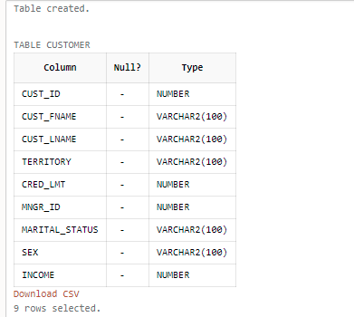

**2. Alter table and Add column stay_from_year**

**insert into customer(cust_id,cust_fname ,cust_lname,territory,cred_lmt,mngr_id,marital_status,sex,income) values(01,'Rahul','Singh','India',10000,112,'Single','Male',65000);**

**select *from customer;**

**insert into customer(cust_id,cust_fname ,cust_lname,territory,cred_lmt,mngr_id,marital_status,sex,income) values(02,'Meg','Sen','India',15000,113,'Married','Male',67000);**

**insert into customer(cust_id,cust_fname ,cust_lname,territory,cred_lmt,mngr_id,marital_status,sex,income) values(03,'George','Matthew','Italy',12000,114,'Single','Male',63000);**

**insert into customer(cust_id,cust_fname ,cust_lname,territory,cred_lmt,mngr_id,marital_status,sex,income) values(04,'Jennifer','Lopez','America',14000,115,'Married','Female',68000);**

**insert into customer(cust_id,cust_fname ,cust_lname,territory,cred_lmt,mngr_id,marital_status,sex,income) values(05,'Robert','Johnson','Austrelia',15000,116,'Married','Male',65000);**

**insert into customer(cust_id,cust_fname ,cust_lname,territory,cred_lmt,mngr_id,marital_status,sex,income) values(06,'Meghna','Chakraborty','India',15000,117,'Married','Female',65000);**

**alter table customer add stay_from_year int;**

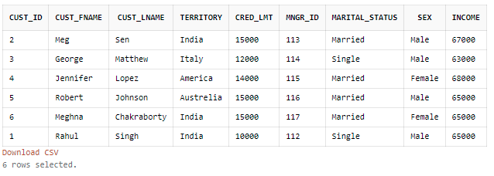

**3. Set value of stay_from_year as 2001 for Italy/America and 2003 otherwise**

**update customer set stay_from_year=2001 where territory in ('Italy','America');**

**update customer set stay_from_year=2003 where territory not in ('Italy','America');**

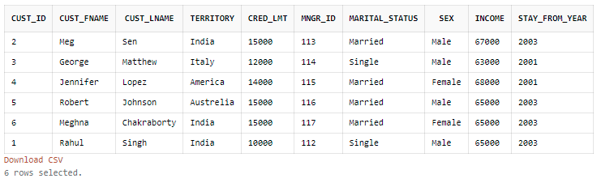

**4. Display credit limit attribute for America**

**select cred_lmt from customer where territory ='America';**

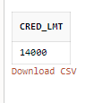

**5. Delete the record corresponding to Meg Sen**

**delete from customer where cust_fname='Meg' and cust_lname='Sen';**

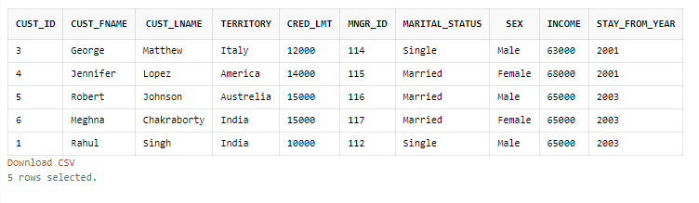

**6. Show all attributes for Italy// Show all data in the territory Italy**

**select *from customer where territory='Italy';**

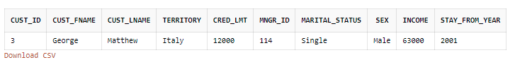

**7. If territory is India and status is Single set value of credit to 7000**

**update customer set cred_lmt=7000 where territory='India' and marital_status='Single';**

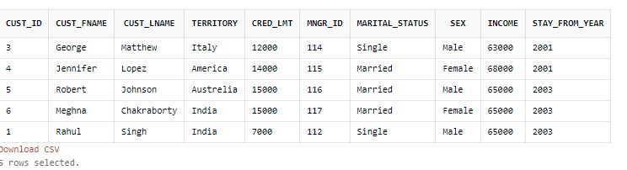

**8. Rename cust_fname to first_name**

**alter table customer rename column cust_fname to first_name;**

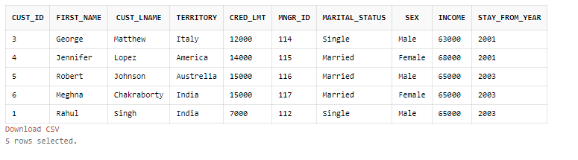

**9. Rename cust_lname to last_name**

**alter table customer rename column cust_lname to last_name;**

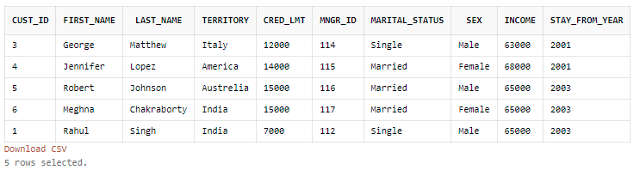

**10. Create table cust1 from the old table customer(copy structure as well as data using CTAS statement).**

**create table cust1 as (select * from customer where 1=1);**

**select * from cust1;**

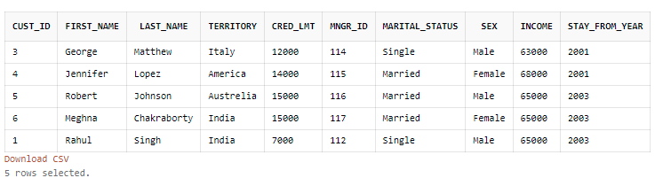

**11.Create tables cust2 without values of cust1 using CTAS statement.**

**create table cust2 as (select * from cust1 where 2=1);**

**desc cust2;**

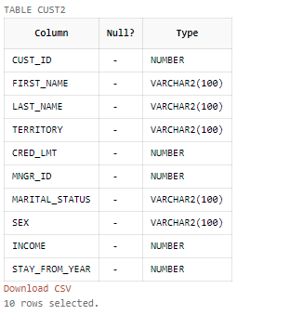

**12.Create tables cust3 with attributes cust_id,cust_fname,cust_lname,income from old customer table only 5**

**rows.(using CTAS statement).**

**create table cust3 as (select cust_id,cust_fname,cust_lname,income from customer where 1=1);**

**select * from cust3;**

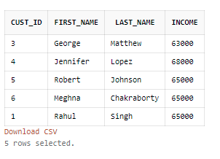

**13.Create tables cust4 with attributes name customer_id,firstname,lastname, income from old customer**

**table(using CTAS statement).**

**create table cust4 (customer_id ,firstname ,lastname , income ) as (select cust_id,first_name,last_name,income from customer where 1=1);**

**select * from cust4;**

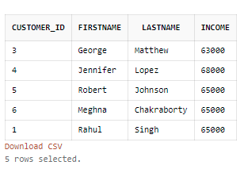

**14. Drop column income from cust1.**

**ALTER TABLE cust1**

**DROP COLUMN income;**

**select * from cust1;**

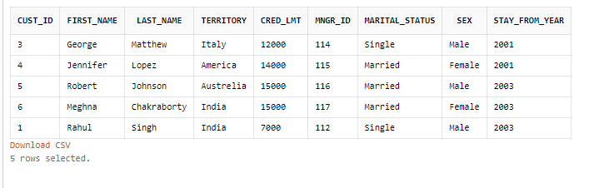

**15. Rename table cust1 to cust_one**

**RENAME cust1 to cust_one;**

**desc cust_one;**

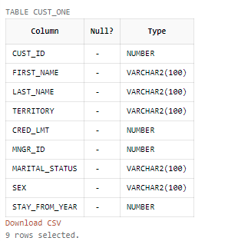

**16. Insert values into cust2 table from customer table**

**INSERT INTO cust2**

**SELECT * FROM customer**

**WHERE 1=1;**

**select * from cust2;**

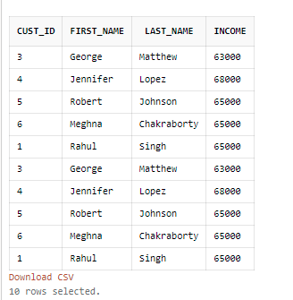

**17. Insert values into cust3 table with attributescust_ id, f_name, l_name,Income from customer table where**

**income > 50000**

**INSERT INTO cust3**

**SELECT cust_id , first_name , last_name , income FROM customer**

**WHERE income > 50000;**

**select * from cust3;**

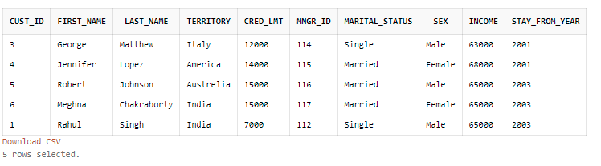

**18. alter the table cust4 change cust id to varchar(6) and income to number(5)**

**DELETE FROM cust4;**

**desc cust4;**

**ALTER TABLE cust4**

**MODIFY customer_id varchar(6);**

**ALTER TABLE cust4**

**MODIFY income number(5);**

**INSERT INTO cust4**

**SELECT cust_id,first_name,last_name,income FROM customer**

**WHERE 1=1 ;**

**desc cust4;**

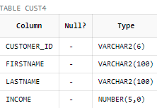

**19. Add new attribute mngr_name to cust4 and insert 5 records**

**ALTER TABLE cust4**

**ADD mngr_name varchar(60) ;**

**insert into cust4(customer_id,firstname ,lastname,income,mngr_name) values('02','Meg','Sen',67000,'dell');**

**insert into cust4(customer_id,firstname ,lastname,income,mngr_name) values('03','George','Matthew',63000,'hp');**

**insert into cust4(customer_id,firstname ,lastname,income,mngr_name) values('04','Jennifer','Lopez',68000, 'toshiba');**

**insert into cust4(customer_id,firstname ,lastname,income,mngr_name) values('05','Robert','Johnson',65000, 'lenovo');**

**insert into cust4(customer_id,firstname ,lastname,income,mngr_name) values('06','Meghna','Chakraborty',65000, 'asus');**

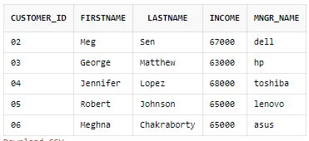

**20. Add attribute territory to cust4**

**ALTER TABLE cust4**

**ADD territory varchar(60) ;**

**desc cust4;**

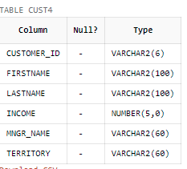

**21. Drop table cust3 and then bring it back.**

**drop table cust3;**

**select object_name, original_name, type from recyclebin;**

**flashback table cust3 to before drop;**

**desc cust3;**

**select * from cust3;**

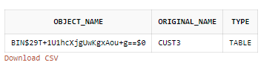

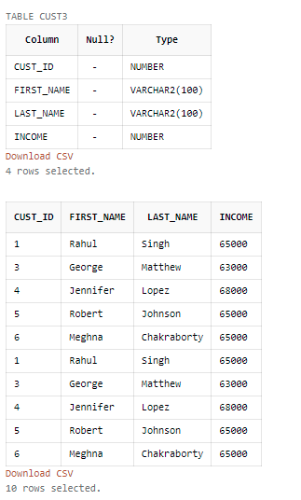

**22. Increase the size of the column custid by 5.**

**desc cust3;**

**CREATE TABLE CUST5 AS(SELECT *FROM CUST3 WHERE 1=1);**

**DELETE FROM CUST3;**

**ALTER TABLE CUST3 MODIFY CUST_ID NUMBER(27);**

**INSERT INTO CUST3 SELECT *FROM CUST5 WHERE 1=1;**

**SELECT *FROM CUST3;**

**desc cust3;**

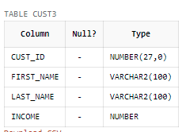

**23. Suppose the customer with id no C63 has changed her last name & now it is just same as the customer**

**with id no C68.**

**24. Update customer set lname=(select lname from customer where cid=C63) where cid=C68.**

**UPDATE**

**customer**

**SET**

**last_name = (select last_name from customer where cust_id = 5)**

**WHERE**

**cust_id = 1;**

**select *from customer;**

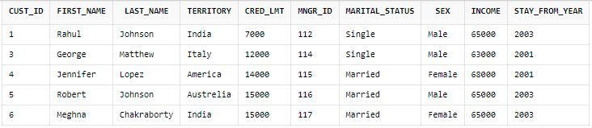

**25. Display the records where territory=America & crd_lmt=25000.**

**select * from customer**

**where territory ='America' and cred_lmt = 25000;**



**26. Display the records of all Indian customers whose income>20000.**

**select * from customer**

**where territory ='India' and income>20000;**

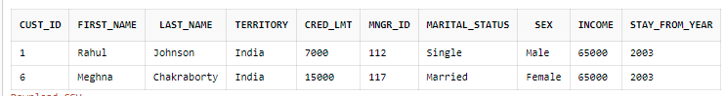

**27. Display the name of the customer having crd_lmt between 2000 and 7000.**

**select * from customer**

**where cred_lmt<7000 and cred_lmt>2000;**



**28. Display the records of the customers having income 20000,24000,300,4500 using only one query.**

**select * from customer**

**where income in (20000,24000,300,4500);**



**29. Display the records in ascending order of first name**

**select *from customer order by FIRST_NAME asc;**

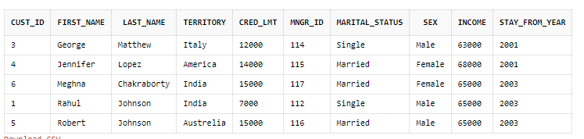

**30. Display the records in descending order of income.**

**select *from customer order by income desc;**

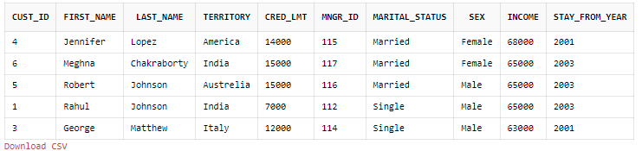

**31> Insert a duplicate record and display all the records.**

**insert into cust_one select *from cust_one where cust_id=6;**

**select *from cust_one;**

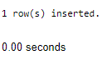

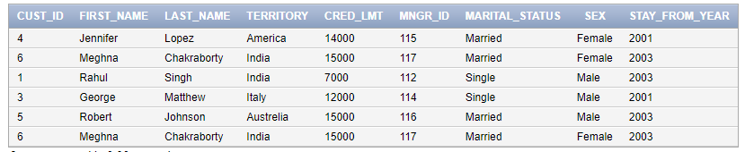

**32> Suppose your friend wants to select a name from the names of the customers. Show the different names of the student.**

**select distinct first_name ||''|| last_name as**

**full_name from cust_one;**

