**Name – Ayush Mondal**

**Course – B.Tech (CSE)**

**Enrollment No – 2011200001017**

**Registration No – 200010170880**

**DBMS (ASSIGNMENT 3)**

1. Create table dept with the following attributes:

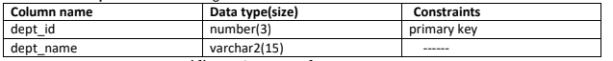

create table dept(dept_id number(3) primary key,dept_name varchar2(15) check( dept_name = initcap(dept_name)));

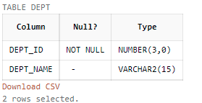

1. Insert 4 depts with names and id’s 90, 69, 100 and 110.

insert into dept(dept_id , dept_name) values(90 , 'Dbms');

insert into dept(dept_id , dept_name) values(69 , 'Os');

insert into dept(dept_id , dept_name) values(100 , 'Daa');

insert into dept(dept_id , dept_name) values(110 , 'Math');

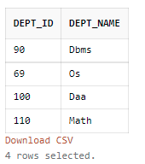

1. Create table cust_100 with the following attributes:

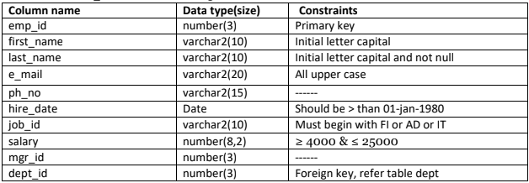

create table cust_100

(

emp_id number(3) primary key,

first_name varchar2(10) check(first_name = initcap(first_name)),

last_name varchar2(10) check(last_name = initcap(last_name)) NOT NULL,

email varchar2(20) check(email = UPPER(email)),

hire_date date check(hire_date > '1-Jan-1980'),

job_id varchar2(20) check(job_id like '%FI' or job_id like '%AD' or job_id like '%IT'),

salary number(8,2) check(salary >= 4000 and salary <= 25000),

mgr_id number(3),

dept_id number(3) references dept(dept_id)

);

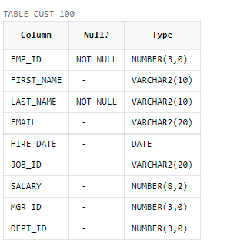

1. Add 10 records to cust_100

insert into cust_100(emp_id ,first_name,last_name ,email,hire_date ,job_id ,salary,mgr_id ,dept_id )

values(1,'Ayush','Mondal','AYUSHMONDAL@GAMIL',to_date('22/07/2002','dd/mm/yyyy'),'FI',25000,123,100);

insert into cust_100(emp_id ,first_name,last_name ,email,hire_date ,job_id ,salary,mgr_id ,dept_id )

values(2,'Ram','Singh','HELLOBOY@YAHOOMAIL',to_date('05/08/2001','dd/mm/yyyy'),'AD',8000,534,69);

insert into cust_100(emp_id ,first_name,last_name ,email,hire_date ,job_id ,salary,mgr_id ,dept_id )

values(3,'Alam','Shah','CRYPTO@YAHOO',to_date('12/04/1999','dd/mm/yyyy'),'IT',15000,443,110);

insert into cust_100(emp_id ,first_name,last_name ,email,hire_date ,job_id ,salary,mgr_id ,dept_id )

values(4,'Jai','Shetty','GOLDEN@YAHOO',to_date('25/12/1992','dd/mm/yyyy'),'AD',22000,345,90);

insert into cust_100(emp_id ,first_name,last_name ,email,hire_date ,job_id ,salary,mgr_id ,dept_id )

values(5,'Dhar','Mann','DMGSTUDIOS@YAHOO',to_date('11/11/2011','dd/mm/yyyy'),'FI',4000,734,110);

insert into cust_100(emp_id ,first_name,last_name ,email,hire_date ,job_id ,salary,mgr_id ,dept_id )

values(6,'Rocky','Bhai','DHAKA@YAHOO',to_date('16/04/1987','dd/mm/yyyy'),'IT',8000,553,100);

insert into cust_100(emp_id ,first_name,last_name ,email,hire_date ,job_id ,salary,mgr_id ,dept_id )

values(7,'Ajay','Devgn','GAANEDO@YAHOO',to_date('02/04/1988','dd/mm/yyyy'),'FI',24000,872,90);

insert into cust_100(emp_id ,first_name,last_name ,email,hire_date ,job_id ,salary,mgr_id ,dept_id )

values(8,'Lola','Chan','CHINESE@YAHOO',to_date('31/07/1993','dd/mm/yyyy'),'AD',8000,875,110);

insert into cust_100(emp_id ,first_name,last_name ,email,hire_date ,job_id ,salary,mgr_id ,dept_id )

values(9,'Chibi','Maruko','CARTOON@YAHOO',to_date('13/09/2009','dd/mm/yyyy'),'IT',10000,934,100);

insert into cust_100(emp_id ,first_name,last_name ,email,hire_date ,job_id ,salary,mgr_id ,dept_id )

values(10,'Jackie','Bhagnani','SELFLOVE@YAHOO',to_date('01/01/2002','dd/mm/yyyy'),'FI',5000,372,110);

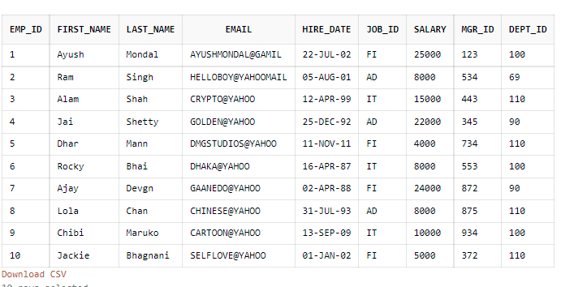

1. Drop column mrg_id

alter table cust_100

drop column mgr_id;

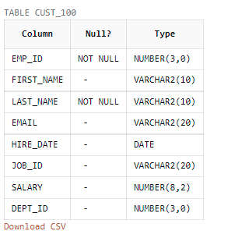

1. Add column mgr_id and make it self referenced such that first 4 id’s correspond to first emp_id, next 4 correspond to fifth emp_id and the last 2 correspond to the ninth emp_id.

alter table cust_100

add mgr_id number(3) references cust_100(emp_id)

update cust_100

set mgr_id = (select emp_id from cust_100 where last_name = 'Mondal')

where emp_id between 1 and 4;

update cust_100

set mgr_id = (select emp_id from cust_100 where last_name = 'Mann')

where emp_id between 5 and 8;

update cust_100

set mgr_id = (select emp_id from cust_100 where last_name = 'Maruko')

where emp_id between 9 and 10;

