**Name – Ayush Mondal (CSE - A)**

**Enrollment number – 2011200001017**

**Registration Number – 200010170880**

**Semester – 4th sem**

1. **A) Display the absolute path of your home directory**

* **pwd**

**B) Create a Directory called “SISTER NIVEDITA UNIVERSITY” inside your home directory**

**=> mkdir "SISTER NIVEDITA UNIVERSITY"**

**C) Create a sub-directory called student inside the sister Nivedita university directory**

**=> cd SISTER NIVEDITA UNIVERSITY**

**=> mkdir student**

**D) Create another new sub-directory called teacher in**

**Sister Nivedita university**

* **mkdir teacher**

**E) Display the Content of the Sister Nivedita University in details**

**=> ls -l**

**F) Delete the teacher Directory => rmdir teacher**

**G) Display the Content of the Sister Nivedita University in details => ls -l**

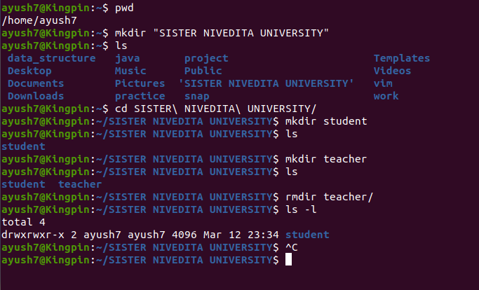

1. **A) Change your current directory to SISTER NIVEDITA UNIVERSITY => cd SISTER\ NIVEDITA\ UNIVERSITY**

**B) Create a New Sub-directory teacher in SNU => mkdir teacher**

**C) Create a new file called ‘my fav’ inside directory student using command and insert two lines in to the file => cat > ‘my fav’**

**1) First line should be your favourite movie = > The recommended line**

**2) Second line should be your favourite food => the recommended line**

**D) Display the content of the file my fav => cat ‘my fav’**

**E) Append two more lines to the file my fav => cat >> ‘my fav’**

**1 ) my_name**

**2) Enrollment Number**

**F) Being in the student directory copy the file my fav to directory teacher and relate it to student fav => for copying the file => cp my\ fav ../teacher**

**For creating a new file => touch ../teacher/student\ fav**

**For relating all content a file to Another one => cat ../teacher/my\ fav >> ../teacher/student\ fav**

**G) Change your working directory to teacher => cd ../teacher**

**H) Display the content of teacher => ls -l**

**I) Display the word line and character count of the file student fav => wc -l -w -c student\ fav**

**J) Delete the file student fav from the directory => rm student\ fav**

**K) Display content of the directory Teacher => ls -l**

