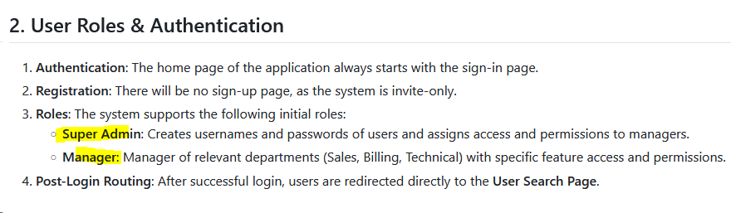
Super Admin will be having all accesses,
Admin: Creates usernames and passwords of users and assigns access and permissions to managers.

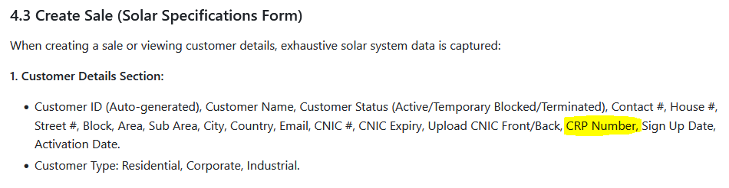
Its CRF Number and will be Auto-generated at the time of submit signup
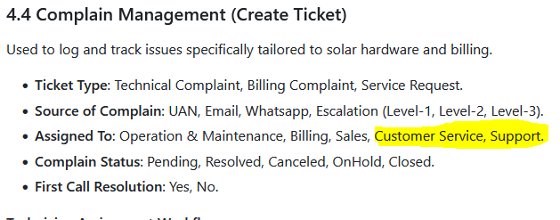
Please change it to “Customer Support”

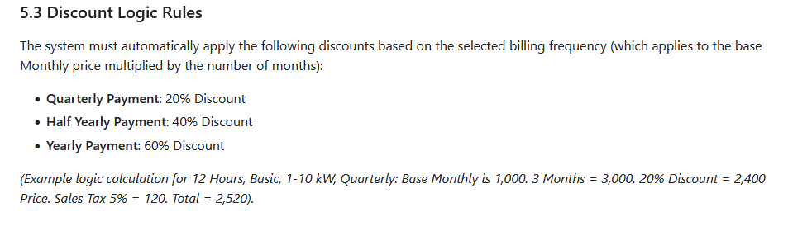
Discounts are revised,
Quarterly @10%, Half yearly @20% and yearly @ 40%.

