1.Print the first 5 rows of flight and airline dataframe

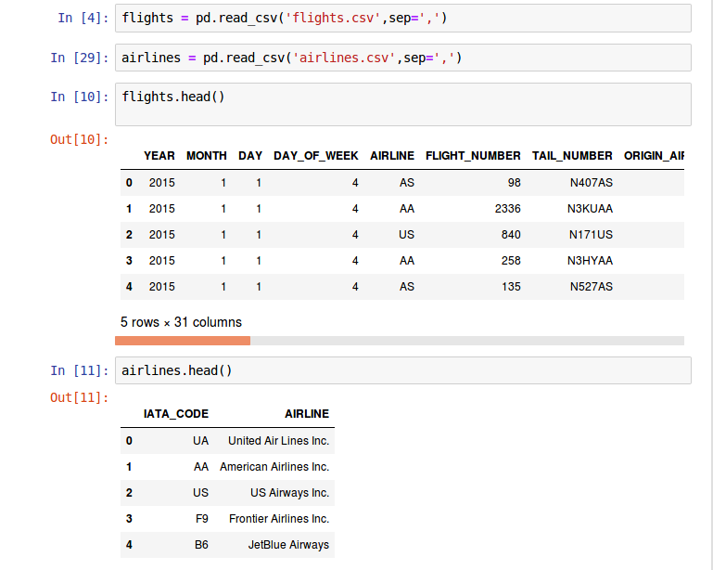

2.How many features in flight.csv and airline.csv



3.How many rows/records in flight.csv and airline.csv



4.How many flight that was cancelled? [ Hint : filter ]



5.Which airline has the most cancelled flight? [ Hint: groupby ]

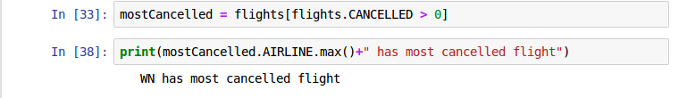

6.What is the maximum, minimum, sd and mean of departure delay and arrival

delay

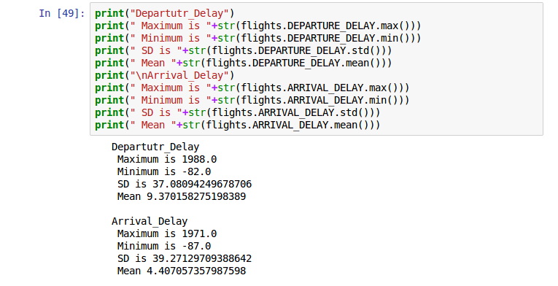

7.Print dataframe after join the data

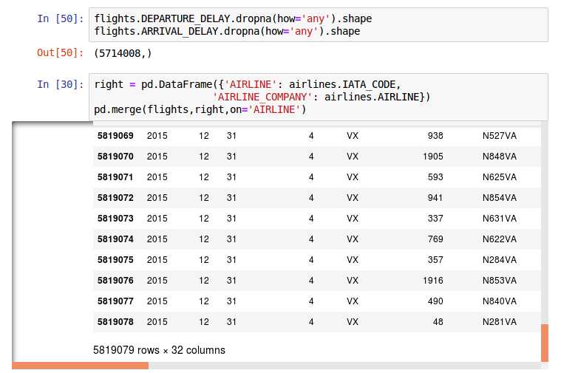

8.Which airline has the highest average departure_delay time and how long ?



9.Which airline has the lowest average departure_delay time and how long ?



10.Which month has the highest number of flight? and how many?



11.In March, which airline has the highest flight? And how many flight?

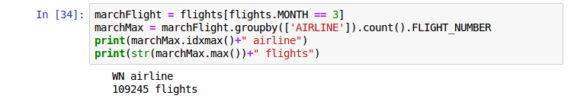

12.Which origin has the most rows? How many ? Which destination has the

most rows? How many ?

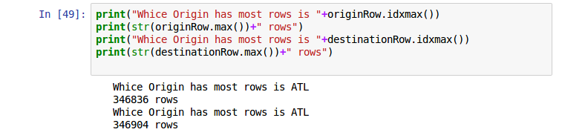

13.Create the new column; if the flight has delay on departure or arrival then the

value will be ‘Delay’ . If not, ‘Not Delay’.

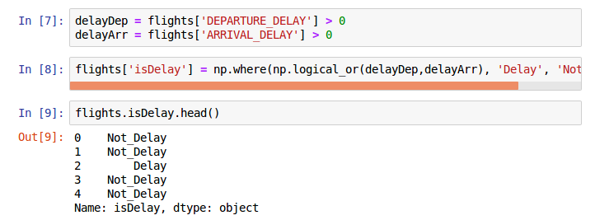

14.How many flights that are delay, how many flight that are not delay?

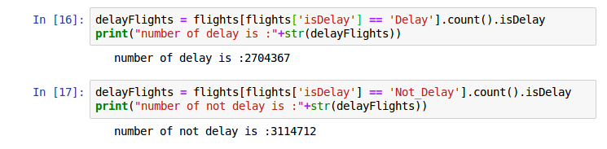

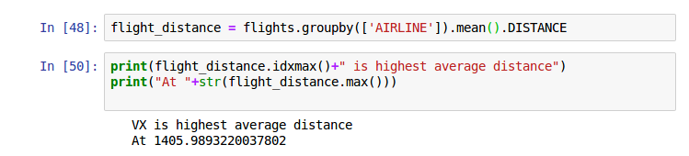15.Create one of your own insight from the data

Which airline has the most average distance flight?