Lorenz, Pascal, 17-705-187, Group 14, Exercise 11

## Task 5

## a

data <- read.table("http://stat.ethz.ch/Teaching/Datasets/banknoten.dat",header=TRUE)  
real <- data$Laenge[1:100]  
fake <- data$Laenge[101:200] #just to make my life a little easier instead of typing it out every time  
t.test(real, mu=215)

##   
## One Sample t-test  
##   
## data: real  
## t = -0.79977, df = 99, p-value = 0.4258  
## alternative hypothesis: true mean is not equal to 215  
## 95 percent confidence interval:  
## 214.8921 215.0459  
## sample estimates:  
## mean of x   
## 214.969

t.test(fake, mu=215) #I use the default two-sided test, becaue we are testing for general differences of the mean, not specifically higher or lower values

##   
## One Sample t-test  
##   
## data: fake  
## t = -5.0262, df = 99, p-value = 2.226e-06  
## alternative hypothesis: true mean is not equal to 215  
## 95 percent confidence interval:  
## 214.7531 214.8929  
## sample estimates:  
## mean of x   
## 214.823

These results show in multiple ways that the money marked as fake is actually fake: 1. The P-value for the mean of the sample of real value is very high (with 0-hypothesis of it being real money with mean length 215), while the P-value for the fake one is low (below 1%) with the same H0. 2. The true mean of 215 is contained within the 95 percent confidence interval, while the interval for the fake money does not overlap 215.

## b

plot(density(fake),type="l",col="red",main="Distribution",xlab="Lenght")  
lines(density(real), col="green")  
abline(v=mean(real), col="green")  
abline(v=mean(fake), col="red")  
legend("topright",c("Real","Fake"), col=c("green","red"),pch=16)

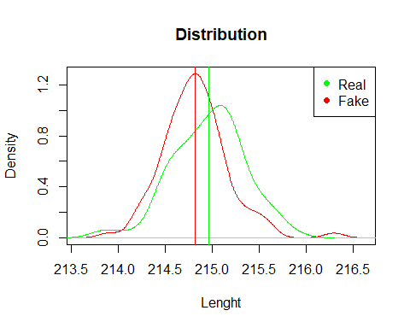

## c

t.test(real,fake, var.equal=TRUE) #var.equal=TRUE because of the task, though the difference is minimal in this case anyways (variance of real and fake money is very close)

##   
## Two Sample t-test  
##   
## data: real and fake  
## t = 2.7879, df = 198, p-value = 0.005822  
## alternative hypothesis: true difference in means is not equal to 0  
## 95 percent confidence interval:  
## 0.04272717 0.24927283  
## sample estimates:  
## mean of x mean of y   
## 214.969 214.823