Lorenz, Pascal, 17-705-187, Group 14, Exercise 9

## Task 4

## 1

rabbits <- rnorm(100000, mean=5.25, sd=1.625)  
hist(rabbits, prob=TRUE, main="Rabbit weight distribution", xlab="Weight",ylab="Proportion")  
lines(density(rabbits), bw = "nrd0") # I don't get the bw part. I understand it's supposed to define how much smoothing should be done on the line, however even when putting in the default value as I did here, I get an error saying that's not a graphical parameter.

## Warning in plot.xy(xy.coords(x, y), type = type, ...): "bw" is not a  
## graphical parameter

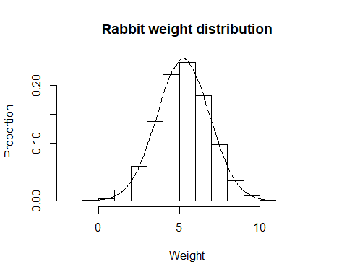

## 2

weigh <- numeric(length = 100)  
for (i in 1:100){  
 weigh[i] <- mean(sample(x=rabbits, size = 5))  
}  
hist(weigh, prob=TRUE, main="Rabbit weight distribution with samples of size 5", xlab="Weight",ylab="Proportion")  
lines(density(weigh), bw = "nrd0")

## Warning in plot.xy(xy.coords(x, y), type = type, ...): "bw" is not a  
## graphical parameter

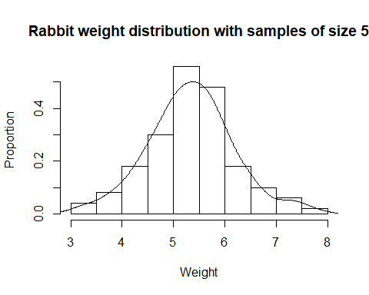

for (i in 1:100){  
 weigh[i] <- mean(sample(x=rabbits, size = 20))  
}  
hist(weigh, prob=TRUE, main="Rabbit weight distribution with samples of size 20", xlab="Weight",ylab="Proportion")  
lines(density(weigh), bw = "nrd0")

## Warning in plot.xy(xy.coords(x, y), type = type, ...): "bw" is not a  
## graphical parameter

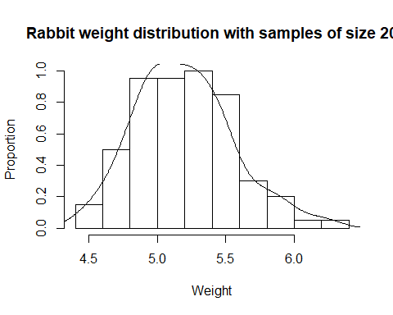

for (i in 1:100){  
 weigh[i] <- mean(sample(x=rabbits, size = 100))  
}  
hist(weigh, prob=TRUE, main="Rabbit weight distribution with samples of size 100", xlab="Weight",ylab="Proportion")  
lines(density(weigh), bw = "nrd0")

## Warning in plot.xy(xy.coords(x, y), type = type, ...): "bw" is not a  
## graphical parameter

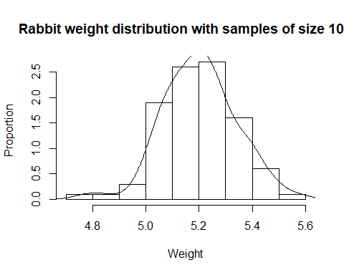

## 3

d1 <- rnorm(50000, mean=4, sd=sqrt(2.5))  
d2 <- rnorm(50000, mean=17, sd=sqrt(14))  
dragons <- c(d1,d2)  
hist(dragons, prob=TRUE, main="Dragon wing length", xlab="length",ylab="Proportion")  
lines(density(dragons), bw = "nrd0")

## Warning in plot.xy(xy.coords(x, y), type = type, ...): "bw" is not a  
## graphical parameter

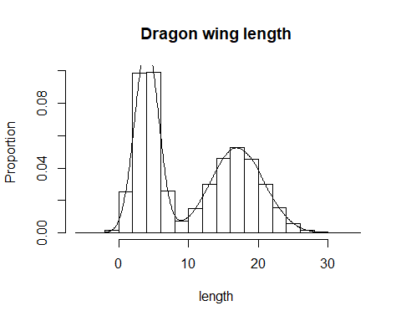

## 4

length <- numeric(length = 100)  
for (i in 1:100){  
 length[i] <- mean(sample(x=dragons, size = 5))  
}  
hist(length, prob=TRUE, main="Wing length distribution with samples of size 5", xlab="length",ylab="Proportion")  
lines(density(length), bw = "nrd0")

## Warning in plot.xy(xy.coords(x, y), type = type, ...): "bw" is not a  
## graphical parameter

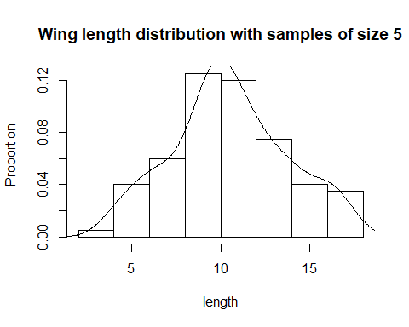

for (i in 1:100){  
 length[i] <- mean(sample(x=dragons, size = 20))  
}  
hist(length, prob=TRUE, main="Wing length distribution with samples of size 20", xlab="length",ylab="Proportion")  
lines(density(length), bw = "nrd0")

## Warning in plot.xy(xy.coords(x, y), type = type, ...): "bw" is not a  
## graphical parameter

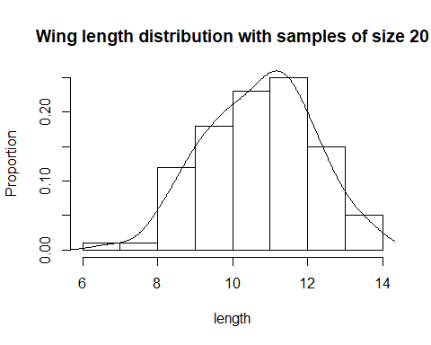

for (i in 1:100){  
 length[i] <- mean(sample(x=dragons, size = 100))  
}  
hist(length, prob=TRUE, main="Wing length distribution with samples of size 100", xlab="Length",ylab="Proportion")  
lines(density(length), bw = "nrd0")

## Warning in plot.xy(xy.coords(x, y), type = type, ...): "bw" is not a  
## graphical parameter

