**Question 1**

**Setup**

Create the directory “CollectionExercises”. **Within** the newly created directory, download the files found at:

<http://faculty.cse.tamu.edu/slupoli/notes/Java/flippedLabs/Collections/Address.java>

Code the Animal class and the Vehicle class, as shown below.

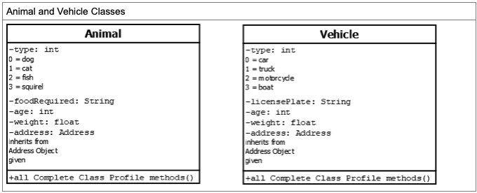

Make sure to do the following:

1. Create the classes with the data members (including Address) show.

2. Give it a full constructor, setters/getters, toString, ***no compareTo****yet.*

3. Create a driver and one full instance of each class.

Submit in a zip file: Vehicle.java, Animal.java and Driver.java

**Question 2**

|  |  |  |  |  |  |
| --- | --- | --- | --- | --- | --- |
|  |  | | | | |
|  | Using the code already developed, create 4 instances for each class and place them into an ArrayList. Create the ability for the ArrayList to be sorted by weight. Using either a Comparator or Comparable is fine. Print out the list before and after the list to prove it works correctly.  Make sure to:  1. Both classes contain functionality to sort.  2. 4 Full instances for each class created and placed into an ArrayList.  3. ArrayList is sorted by weight.  4. The list is displayed BEFORE and AFTER the sort.  Submit in a zip file: Animal.java, Vehicle.java and Driver.java. | |  |  |  |
|  |  |  |  |  |

**Question 3**

|  |  |  |  |  |  |
| --- | --- | --- | --- | --- | --- |
|  |  | | | | |
|  | Create one ArrayList that handles basic Objects such as:  ArrayList<Object> stuff = **new** ArrayList <Object>();  Add all previous items created into the same list. Print the list.  Make sure to:  1. Create an ArrayList of Objects with 8 instances of varying type.  2. List prints all instances.  Submit Driver.java. | |  |  |  |
|  |  |  |  |  |

**Question 4**

|  |  |  |  |  |  |
| --- | --- | --- | --- | --- | --- |
|  |  | | | | |
|  | Simply put, sort the combined list of Animals and Vehicles by State. AK should be first. No other help will be given. Plan accordingly on your sorting design.  As previously, print the list before and after sorting.  Submit the files modified. | |  |  |  |
|  |  |  |  |  |