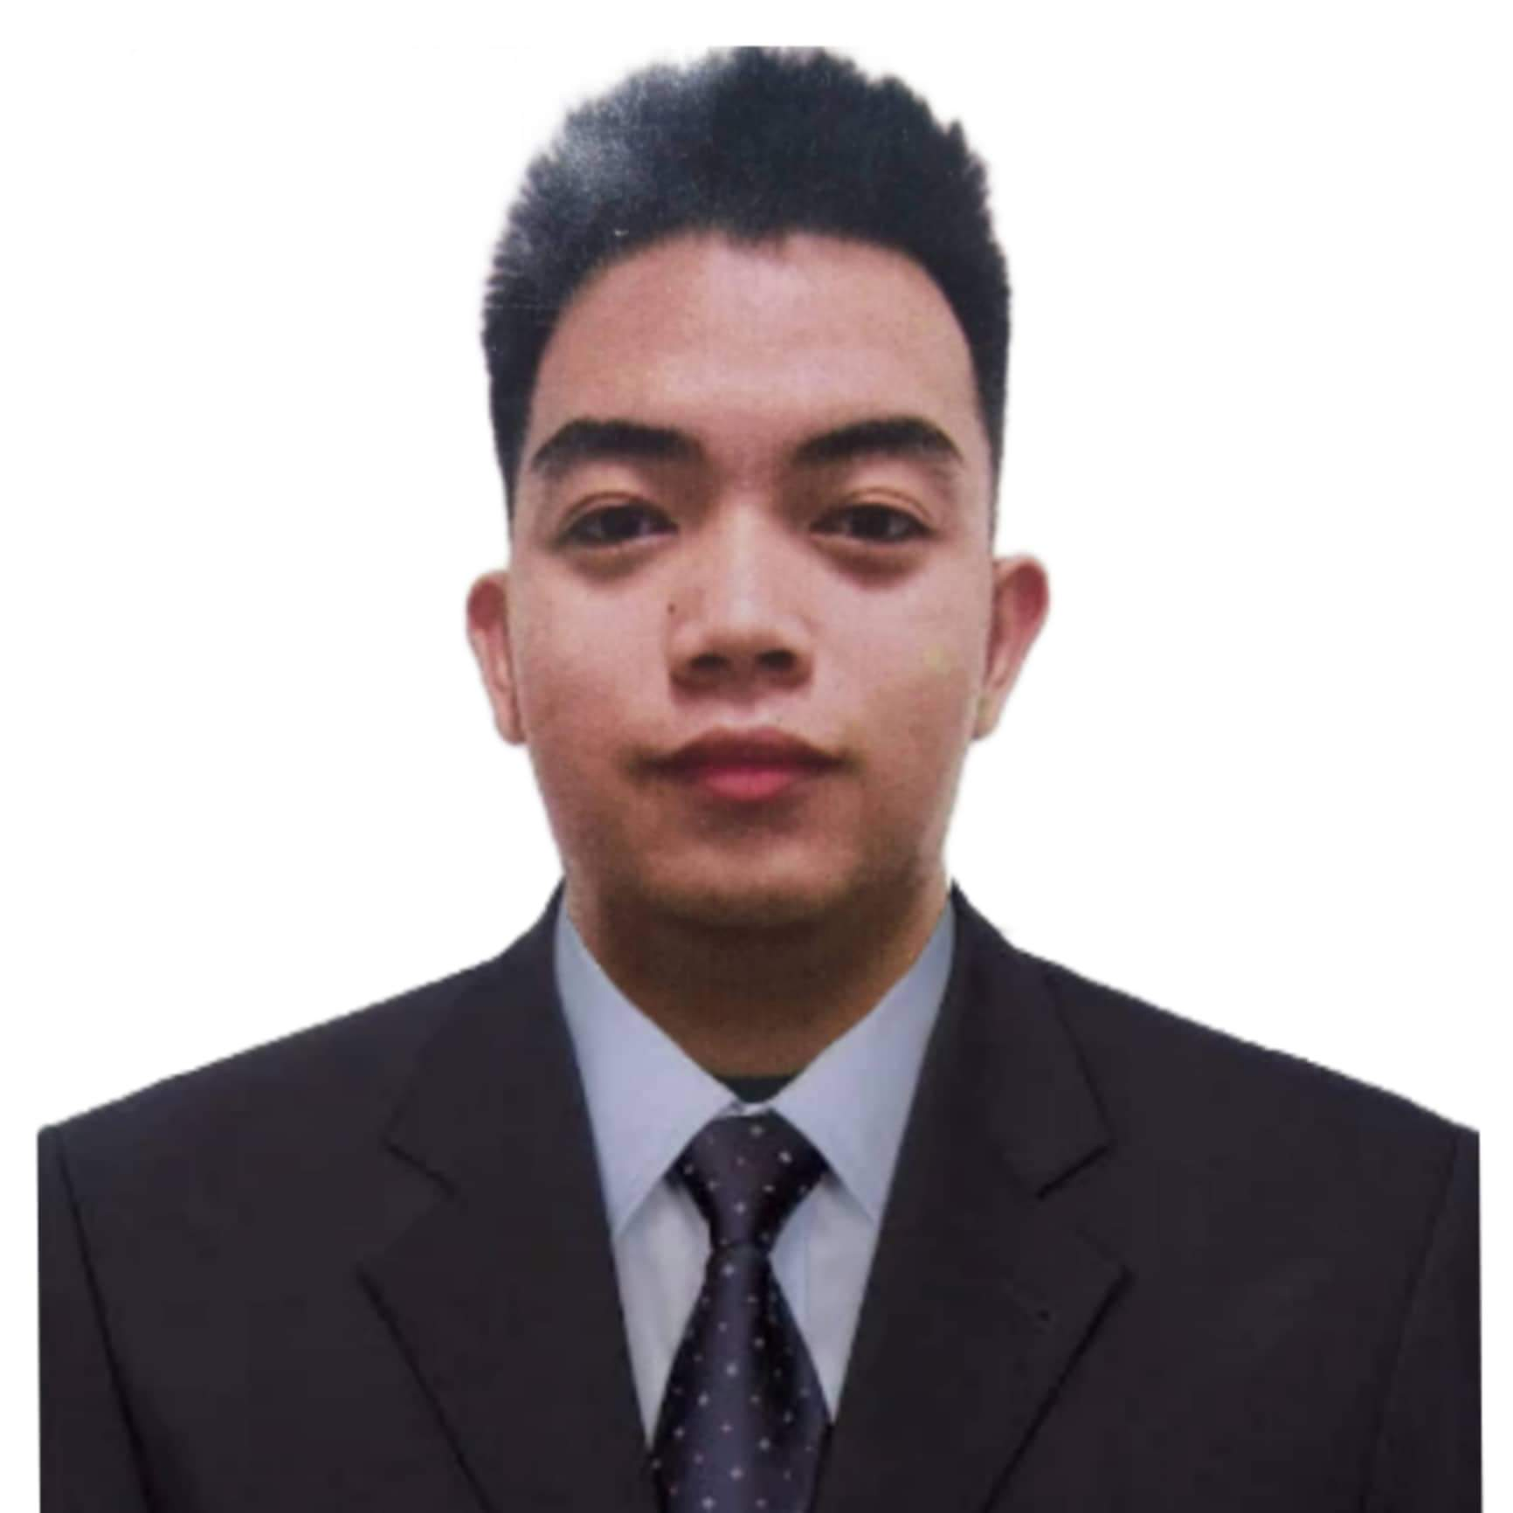**Niel Marveric S. Capundan**

Area B Bagong Buhay III Rancho CSJDM, Bulacan

Mobile +639215003091

Email: capundanmarveric@gmail.com

|  |
| --- |
|  |

**Objectives**

To succeed in an environment of growth and excellence which provides me self-development and helps me achieve personal as well as organizational goals. I will give my best in my professional pursuit for the overall benefit and growth of the company that I serve by facing the challenges. I will show my caliber and gain some experience.

**Employment History**

**Information and Communication Technology DPWH Region 4-B**

OJT in Information And Communication Technology Staff (240 Hours)

**Dyninno Inc**

Call Center Agent ( Non Voice Account - 2021)

**WORK EXPERIENCE**

Work Immersion (2018)

**Educational Background**

**Colegio de San Gabriel Arcangel** (2019 – 2023)

**Bachelor of Science in Computer Engineering**

* Tulong pang Edukasyon Scholarship (2019 – present)

**Competencies**

**Core Competencies:**

Install and configure computer systems

Set-up computer networks

Set-up computer servers

Maintain and repair computer systems and networks

Microcontroller: Arduino

Integrated Development Environment: Arduino IDE

Operating System: Windows11, Windows10, Windows 7

Microsoft Office: Word, PowerPoint, Excel

**Projects**:

I. **Design and Implementation of Reference Frequency Identification (RFID) and Keypad Lock: an Arduino-Based Alert System**

Description: A system about Reference Frequency Identification (RFID), Keypad Lock, and Short Message Service (SMS) Security in which you had to first scan the right tag and then enter the correct one time password (OTP) to open the door lock. Now we are going to add the Sim900 module in that system to make it as Reference Frequency Identification (RFID), Keypad Lock, and Short Message Service (SMS) Security and alert system using Arduino.

Team size: 6

Role played: Documentation of thesis, Designer, and Tester

**Common Competencies:**

Apply quality standards

Perform computer operations

Use hand tools

Terminate and connect electrical wiring and electronic circuits

Test electronic components

**Basic Competencies:**

Participate in workplace communication

Work in team environment

Practice career professionalism

Communication skills (English, and Filipino)

**Senior high school: Colegio de San Gabriel Arcangel  (2017-2019)**

**Junior high school: Alan Holganza Memorial School  (2013-2017)**

**Webinars Attended**

**Programming using Raspberry PI using Python**

Institute of Electronics Engineers of the Philippines (2020)

**Interfacing Digital and Analog Sensor to Raspberry Pi**

Institute of Electronics Engineers of the Philippines (2020)

**Fundamentals of AutoCAD and Digitalized Design**

Institute Of Electronics Engineers of the Philippines (2020)

**Computer Safety**

**Introduction to Machine Learning In Grid Demand Forecasting**

**Character References**

**Jimmy De Vera Roldan, MSIT**

Professor at Colegio De San Gabriel Arcangel in the Philippines

09228628826

**Marvin Yalong Villorente, ECE, ECT, EE**

Professor at Colegio De San Gabriel Arcangel in the Philippines

09751405103

**Glenn Mark Anduiza, CpE**

Java Developer at Collabera in the Philippines

09106121529