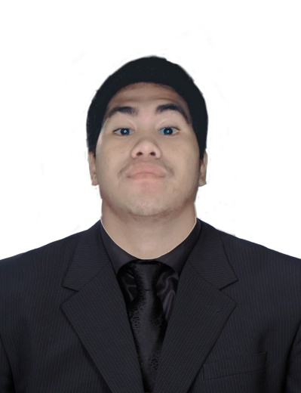**John Rey A. Patente**

Address: Blk 7 Lot 31 Sec 21, PH 3, Pabahay 2000

Bgry Muzon, CSJDM BULACAN

Contact number: 09074063384

Email address: patenterey[@gmail.com](mailto:lmagtaas77@gmail.com)

|  |
| --- |
|  |

**Objectives**

Dedicated and detail-oriented person looking for a job in any organization I will work with. To apply my knowledge, talents, and experience to the creative advancement I will go across to help me achieve and establish my goals as I am carrying out my duties and obligations in the organization.

**Employment History**

**Internship** (240 hours)

**Public Information Office**

City of San Jose del Monte Bulacan, Philippines

Tertiary: Colegio de San Gabriel Arcangel

**Educational Background**

**Colegio de San Gabriel Arcangel** (2019 – 2023)

**Bachelor of Science in Computer Engineering**

* Scholar of Barangay Muzon (2019 – present)

**Competencies**

**Core Competencies:**

Install and configure computer systems

Set-up computer networks

Set-up computer servers

Maintain and repair computer systems and networks

Basic Computer Programming (Javascrip)

Basic Adobe Photoshop

Video Editor

Microcontroller: Arduino

Integrated Development Environment: Arduino IDE

Operating System: Windows11, Windows10, Windows 7

Microsoft Office: Word, PowerPoint, Excel

**Projects**:

I. **Design and Implementation of Reference Frequency Identification (RFID) and Keypad Lock: an Arduino-Based Alert System**

Description: A system about Reference Frequency Identification (RFID), Keypad Lock, and Short Message Service (SMS) Security in which you had to first scan the right tag and then enter the correct one time password (OTP) to open the door lock. Now we are going to add the Sim900 module in that system to make it as Reference Frequency Identification (RFID), Keypad Lock, and Short Message Service (SMS) Security and alert system using Arduino.

Team size: 6

Role played: Member, Documentation of thesis

**Common Competencies:**

Apply quality standards

Perform computer operations

Use hand tools

Terminate and connect electrical wiring and electronic circuits

Test electronic components

**Basic Competencies:**

Participate in workplace communication

Work in team environment

Practice career professionalism

Communication skills (English, and Filipino)

**Colegio de San Gabriel Arcangel** (2013 – 2019)

**Senior High School and Junior High School**

**Webinars Attended**

Introduction to Python and Raspberry Pi (October 24, 2020)

Colegio de San Gabriel Arcangel

Guest Speaker: Neil Christopher Gipaya

Programming with Raspberry Pi using Python (October 24, 2020)

Colegio de San Gabriel Arcangel

Guest Speaker: Neil Christopher Gipaya

Interfacing Digital and Analog Sensor to Raspberry Pi (October 24, 2020)

Colegio de San Gabriel Arcangel

Guest Speaker: Neil Christopher Gipaya

**Character References**

**Jimmy De Vera Roldan, MSIT**

Professor at Colegio De San Gabriel Arcangel in the Philippines

09228628826

**Marvin Yalong Villorente, ECE, ECT, EE**

Professor at Colegio De San Gabriel Arcangel in the Philippines

09751405103