**Reza Shisheie**

**Homework #2**

**Due: March 9th 2017**

Question 1:

**package** homework2_1;

**import** java.util.Arrays;

**public** **class** homework2_1 {

**int** [][] employee_sum = **new** **int**[2][];

**public** **static** **void** main(String[] args){

**int**[][] hours = **new** **int**[][]{

{ 2, 4, 3, 4, 5, 8, 8 },

{ 7, 3, 4, 3, 3, 4, 4 },

{ 3, 3, 4, 3, 3, 2, 2 },

{ 9, 3, 4, 7, 3, 4, 1 },

{ 3, 5, 4, 3, 6, 3, 8 },

{ 3, 4, 4, 6, 3, 4, 4 },

{ 3, 7, 4, 8, 3, 8, 4 },

{ 6, 3, 5, 9, 2, 7, 9 }

};

**int** [][] sum_hours = *emp_sum*(hours);

**int** [][] employee_sort = *emp_sort*(sum_hours);

*print_hours*(employee_sort);

}

**public** **static** **int**[][] emp_sum (**int**[][] hours){

**int**[][] sum_hours = **new** **int** [2][hours.length];

**for** (**int** i=0; i<hours.length; i++){

**int** sum = 0;

**for** (**int** ii=0; ii<hours[0].length; ii++){

sum = sum + hours[i][ii];

}

sum_hours [0][i] = sum;

sum_hours [1][i] = i;

}

**return** sum_hours;

}

**public** **static** **int**[][] emp_sort(**int**[][] array) {

**int** step = array[0].length;

**int** temp_max = array[0][0];

**int** temp_emp = array[1][0];

**int** temp_pos = 0;

**while**(step>1){

temp_max = array[0][0];

temp_emp = array[1][0];

temp_pos = 0;

**for** (**int** i=1; i<step; i++){

**if** (array[0][i] > temp_max){

temp_max = array[0][i];

temp_emp = array[1][i];

temp_pos = i;

}

}

array[0][temp_pos] = array[0][step-1];

array[1][temp_pos] = array[1][step-1];

array[0][step-1] = temp_max;

array[1][step-1] = temp_emp;

step--;

}

/*

if (n == 0) // Base case

return array;

for (int count = n; count>0; count--){

if (array[0][n-1]>temp_max){

temp_max = array[0][n-1];

temp_emp = array[1][n-1];

temp_pos = count;

}

}

int temp1 = array[0][n];

int temp2 = array[1][n];

array[0][n] = temp_max;

array[1][n] = temp_emp;

array[0][temp_pos] = temp1;

array[1][temp_pos] = temp2;

*/

**return** array; // Recursive call

}

**public** **static** **void** print_hours(**int**[][] employee_sort) {

System.***out***.println("The employees hours are sorted as below:");

**for** (**int** i=0; i<employee_sort[0].length;i++){

System.***out***.println("Employee# " + employee_sort[1][i] + " with " + employee_sort[0][i] + " hours");

}

}

}

Question 1 Output:

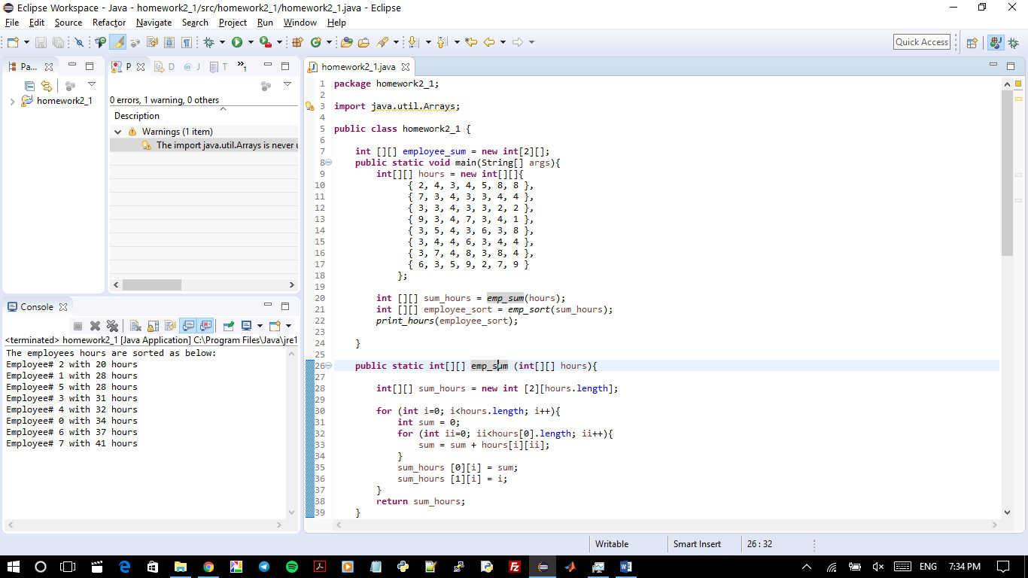

Question 2:

**package** homework2_2;

**import** java.util.*;

**public** **class** homework2_2 {

**public** **static** **void** main(String[] args) {

Scanner input = **new** Scanner(System.***in***);

System.***out***.print("Enter matric 1: ");

String input1 = input.nextLine();

System.***out***.print("Enter matric 2: ");

String input2 = input.nextLine();

*size_check*(*stringSize*(input1), *stringSize*(input2));

**double**[][] MAT_1 = *strinToMatrix*(input1);

**double**[][] MAT_2 = *strinToMatrix*(input2);

**double**[][] multi = *mat_multiply* (MAT_1, MAT_2);

System.***out***.println("The products of Matric#1: ");

*print_mat*(MAT_1);

System.***out***.println("And Matric#2: ");

*print_mat*(MAT_2);

System.***out***.println("is: ");

*print_mat*(multi);

}

**public** **static** **int** stringSize (String input){

String[] inputString = input.split(" ");

**return** inputString.length;

}

**public** **static** **void** size_check (**int** MAT1_size, **int** MAT2_size){

**if** (MAT1_size != MAT2_size){

System.***out***.println(" Matrix size do not match");

}

**if** ((**int**) Math.*sqrt*(MAT1_size) != Math.*sqrt*(MAT2_size)){

System.***out***.println(" Matrix 1 not square");

}

**if** ((**int**) Math.*sqrt*(MAT1_size) != Math.*sqrt*(MAT2_size)){

System.***out***.println(" Matrix 2 not square");

}

}

**public** **static** **double**[][] strinToMatrix (String input){

String[] inputString = input.split(" ");

**double**[] matric = **new** **double**[inputString.length];

**for** (**int** i=0; i<inputString.length; i++){

matric[i] = Double.*parseDouble*(inputString[i]);

}

**int** N = (**int**)Math.*sqrt*(matric.length);

**double**[][] result = **new** **double**[N][N];

**int** counter = 0;

**for** (**int** i=0; i<N; i++){

**for** (**int** ii=0; ii<N; ii++){

result[i][ii] = matric[counter];

counter++;

}

}

**return** result;

}

**public** **static** **void** print_mat (**double**[][] MAT){

**for** (**int** i=0; i<MAT.length;i++){

**for** (**int** ii=0; ii<MAT.length;ii++){

System.***out***.print(MAT[i][ii]+ ", ");

}

System.***out***.println(" ");

}

}

**public** **static** **double**[][] mat_multiply (**double**[][] MAT_1, **double**[][] MAT_2){

**int** N = MAT_1.length;

**double**[][] result = **new** **double**[N][N];

**for** (**int** row=0; row<N; row++ ){

**for** (**int** column=0; column<N; column++ ){

**double** sum = 0;

**for** (**int** i=0; i<N; i++){

sum = sum + MAT_1[row][i]*MAT_2[i][column];

}

result [row][column] = sum;

}

}

**return** result;

}

}

Question 2 Output:

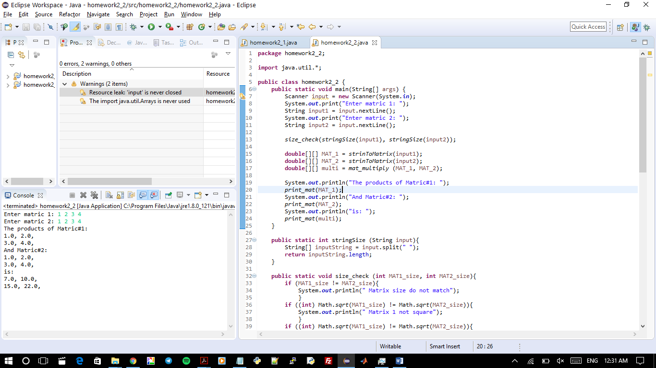

Question 3:

// Homework 2_3

**public** **class** Fan {

**public** **static** **void** main(String[] args){

Fan myfan1 = **new** Fan(3, **true**, 10, "Yellow");

Fan myfan2 = **new** Fan(2, **false**, 5, "bulue");

System.***out***.println(myfan1.toString());

System.***out***.println(myfan2.toString());

}

**private** **int** speed; // 1 is SLOW, 2 is MEDIUM, 3 is FAST

**private** **boolean** weather;

**private** **double** radius;

**private** String color;

**public** Fan(){

**this**.speed = 1;

**this**.weather = **false**;

**this**.radius = 5;

**this**.color = "blue";

}

**public** Fan(**int** speed, **boolean** x, **double** radius, String y){

**this**.speed = speed;

**this**.weather = x;

**this**.radius = radius;

**this**.color = y;

}

**public** **void** set_speed(**int** x){

**if** (x==1 || x==2 || x==3){

**this**.speed = x;

} **else** {

System.***out***.println("Invalid Speed Input");

}

}

**public** **int** get_speed(){

**return** **this**.speed;

}

**public** **void** set_weather(**boolean** x){

**if** (x==**true** || x==**false**){

**this**.weather = x;

} **else** {

System.***out***.println("Invalid Weather Input");

}

}

**public** **boolean** get_weather(){

**return** **this**.weather;

}

**public** **void** set_radius(**double** x){

**if** (x>0){

**this**.radius = x;

} **else** {

System.***out***.println("Invalid radius Input");

}

}

**public** **double** get_radius(){

**return** **this**.radius;

}

**public** **void** set_color(String x){

**this**.color = x;

}

**public** String get_color(){

**return** **this**.color;

}

@Override

**public** String toString(){

**if** (**this**.weather == **true**){

**return** "The fan is on. The speed is " + **this**.speed + " and the color is " + **this**.color + " and the radius is " + **this**.radius;

} **else** {

**return** "The fan is iff. The speed is " + **this**.speed + " and the color is " + **this**.color + " and the radius is " + **this**.radius;

}

}

}

Question 3 Output:

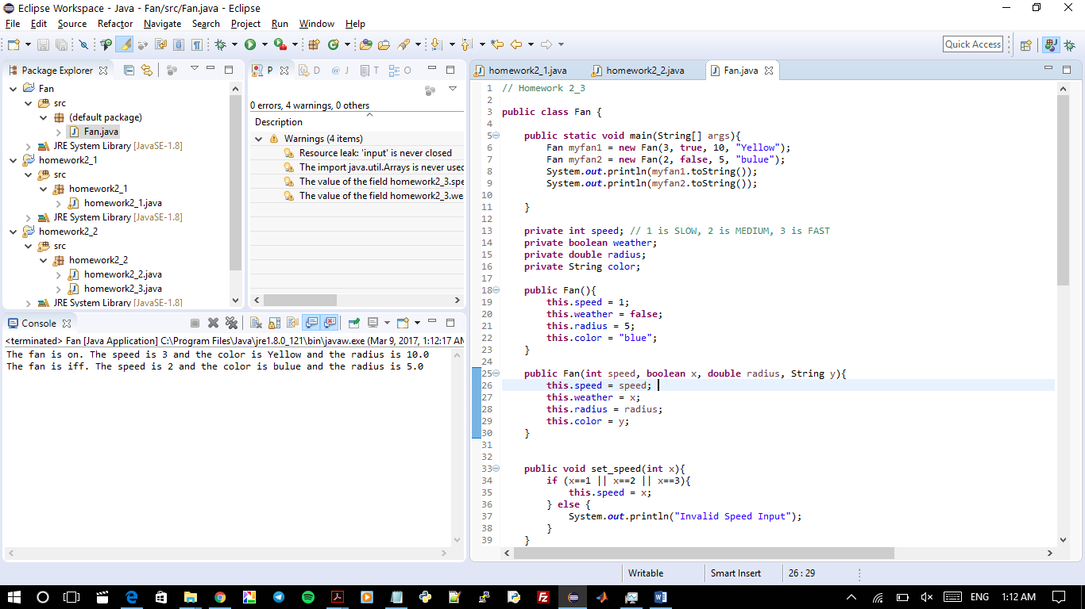

Question 4a:

**package** homework2_4a;

**class** Animal {

**void** walk(){

System.***out***.println("I am walking");

}

}

**class** Bird **extends** Animal{

**void** fly(){

System.***out***.println("I am flying");

}

}

**public** **class** Solution{

**public** **static** **void** main(String[] args){

Bird bird = **new** Bird();

bird.walk();

bird.fly();

}

}

The main takes an instance of the Bird class and Bird is a subclass of Animal which inherit the properties of the Animal class. Once the bird.fly is invoked, it is there in the bird class so it is not a problem. Once the bird.walk is invoked, there is no walk method in the bird class. Since Bird is a subclass, the program goes one step up and search for the walk in the super class and see if it is there and of course walk is there in the Animal class. This it is invoked.

Question 4a Output:

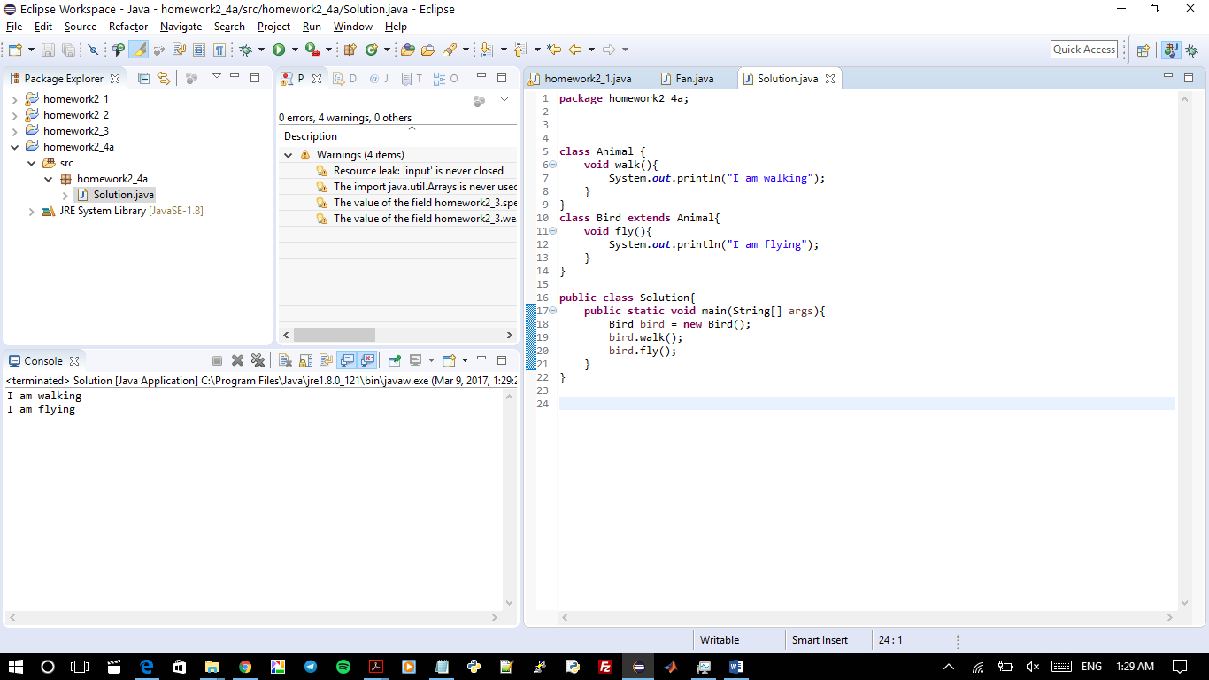

Question 4b:

**package** homework2_4;

**public** **class** Test {

**public** **static** **void** main(String[] args){

System.***out***.println("Hi, ABC, good".matches("ABC ")); // see if the two strings match

System.***out***.println("Hi, ABC, good".matches(".*ABC.*")); //see if the second sting matches with anything in the first string

System.***out***.println("A,B;C".replaceAll(",;","#")); // replace string ",;" with "#". Well there is no ",;" string so the result is the same

System.***out***.println("A,B;C".replaceAll("[,;]","#")); // replace string/character "," and ";" with "#". Now you can find them and replace

String[] tokens = "A.B:C".split("[.:]"); // this part splits the String once "." is ":" is detected and then print with a space in between

**for** (**int** i = 0; i < tokens.length; i++){

System.***out***.print(tokens[i] + " ");

}

}

}

Question 4b Output:

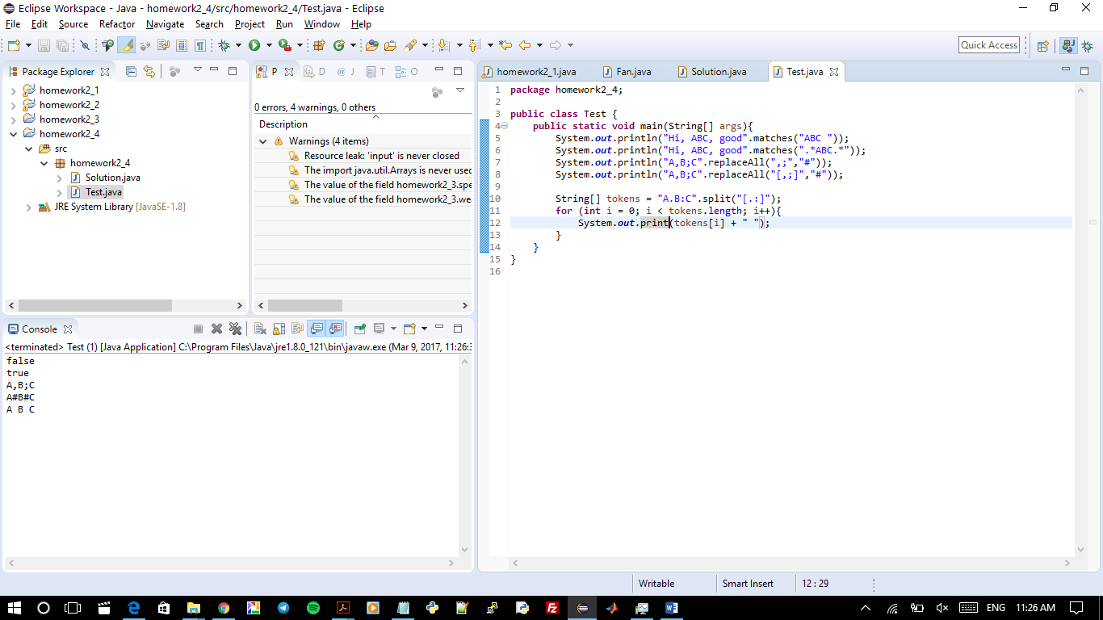

Question 4c:

**package** homework2_4;

**public** **class** Test2 {

**public** **static** **void** main(String[] args){

**new** Person().printPerson();

**new** Student().printPerson();

}

}

**class** Student **extends** Person{

**private** String getInfo(){

**return** "Student";

}

}

**class** Person{

**private** String getInfo(){

**return** "Person";

}

**public** **void** printPerson(){

System.***out***.println(getInfo());

}

}

The class Person is a superclass and the class Student is a subclass. Once **new** Person().printPerson()is invoked, a new instance of “Person” is taken and then it prints the result. The result is **return** "Person" which is directly mentioned in the same class. In the second line, once **new** Student().printPerson() is invoked, a new object using class “Student” is made and the result is printed. In this one, however, the method is not in the subclass, thus the program goes to the superclass and search there. Well, the method is there and once invoked it invokes the method “getInfo” which is in the same class (super class) not the original class (subclass). Thus, both lines print Person.

Question 4c Output:

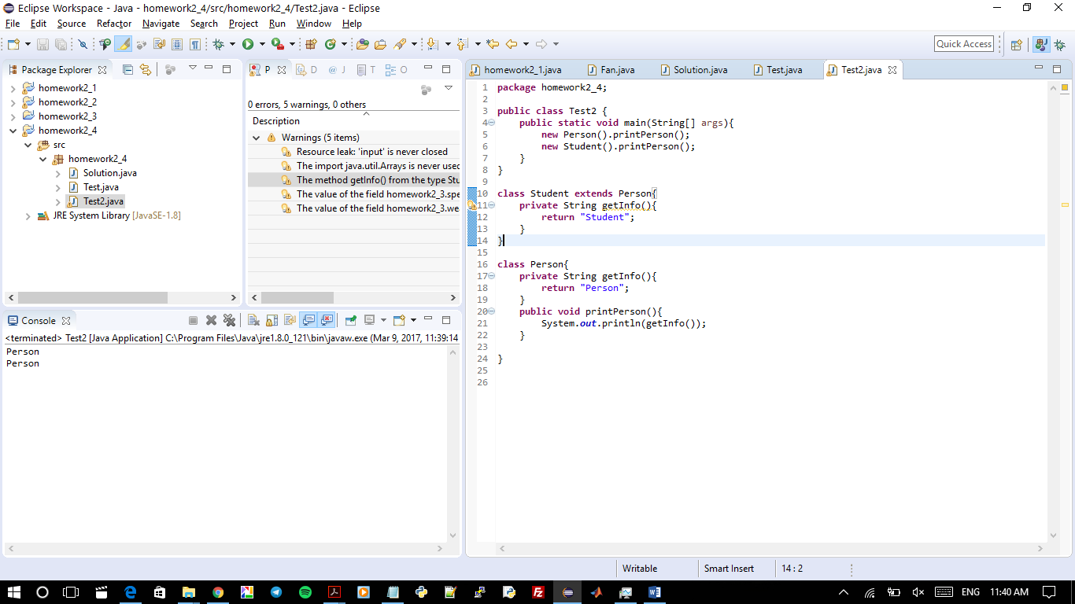

Question 5:

**package** homework2_5;

**import** java.util.Scanner;

**public** **class** homework2_5 {

**public** **static** **void** main (String[] args){

Scanner input = **new** Scanner(System.***in***);

System.***out***.println("Enter a String: ");

String input_string = input.nextLine();

System.***out***.println("Enter a charachter to find: ");

**char** input_char = input.next().charAt(0);

**int** result = *count*(input_string,input_char,input_string.length()-1);

System.***out***.println("The number of occurance of ( " + input_char + " ) in ( " +input_string + " ) is ( " + result+ " ) times" );

}

**public** **static** **int** count(String input_string, **char** input_char, **int** n ){

**int** counter = 0;

**if** (n<0){

**return** 0;

}

**if** (input_string.charAt(n)==input_char){

counter = 1;

}

**return** counter+*count*(input_string,input_char,n-1);

}

}

Question 5 Output:

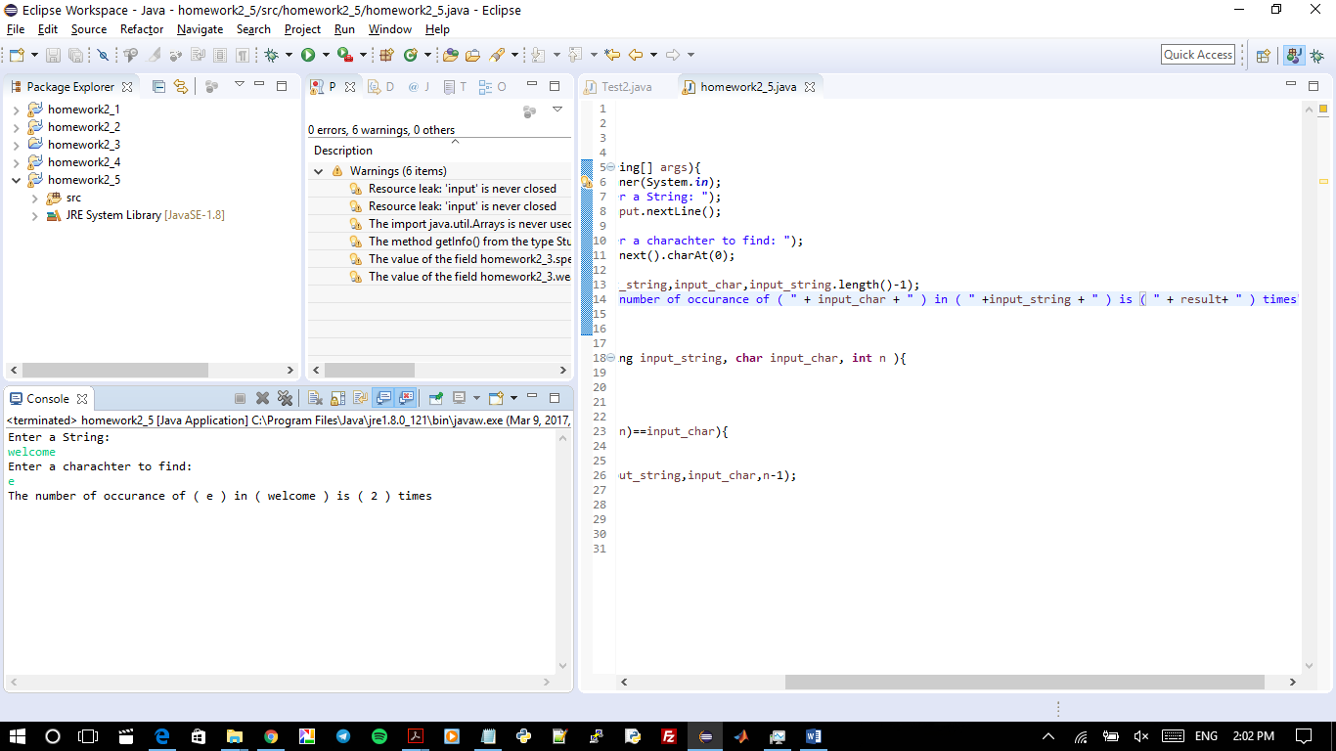

Question 6:

**package** homework2_6;

**import** java.util.Scanner;

**public** **class** homework2_6 {

**public** **static** **void** main (String[] args){

Scanner input = **new** Scanner(System.***in***);

System.***out***.println("Enter a number: ");

String input_string = input.nextLine();

**long** num = Long.*parseLong*(input_string);

**long** sum = *count*(num);

System.***out***.println("The sum of digits of ( " + input_string + " ) is ( " + sum + " )");

}

**public** **static** **long** count(**long** num){

**long** rest = num/10;

**long** remainder = num%10;

**if** (rest == 0){

**return** remainder;

}

**return** remainder + *count*(rest);

}

}

Question 6 Output:

