Reza Shisheie

2708062

CIS620

HW 0


4. here is the photo of the screen after putting the break point at the return and run the makefile and run with 7 seeds

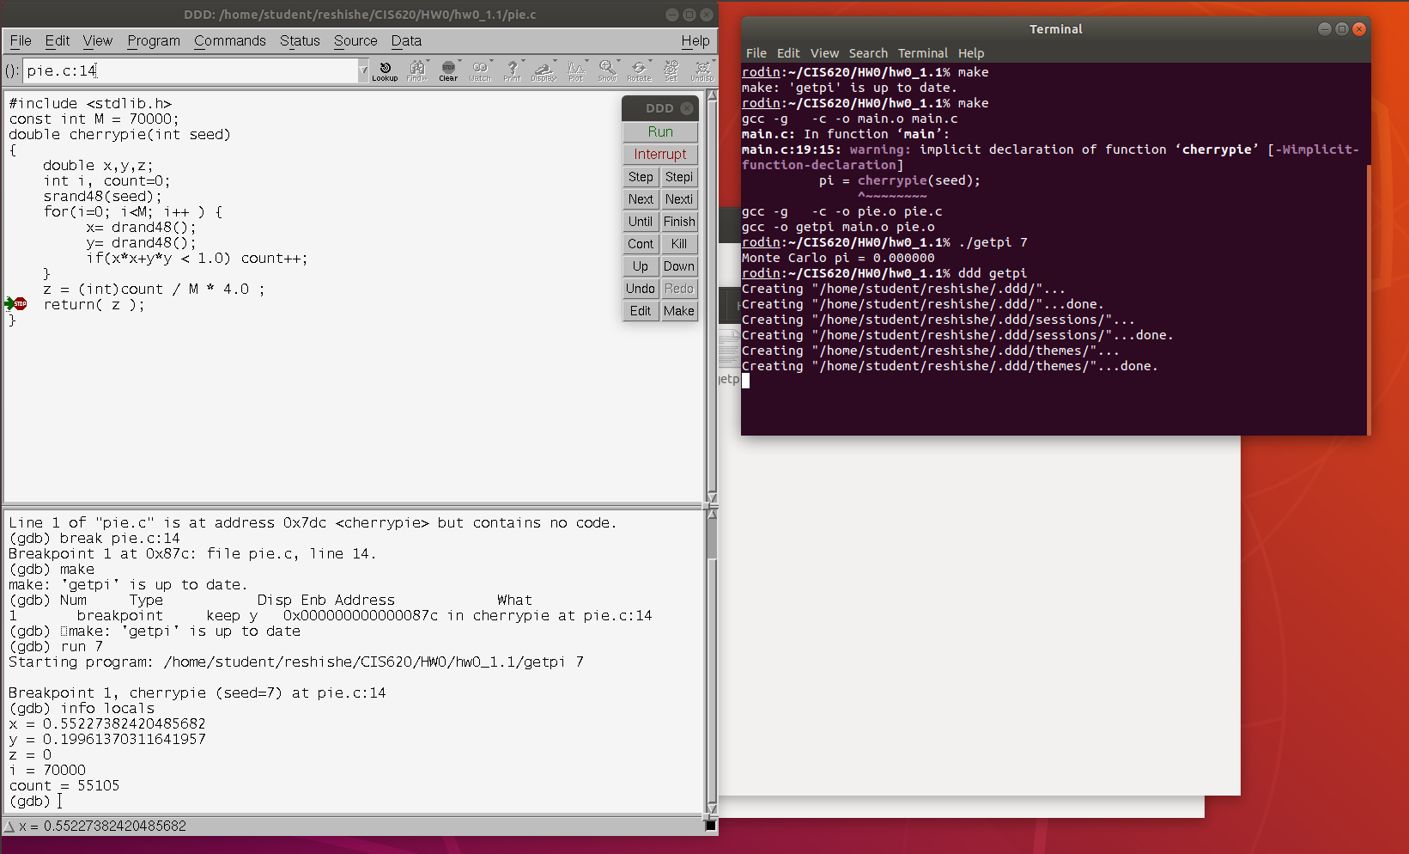

5. the value of count is 55105. This value is reasonable since the equation to calculate pi gives the right result:

z = 55105/70000*4 = 3.148857143

However, The value of z is not reasonable and the reason for it is that there is a missing casting on the line in which z is calculated:

z = count / M * 4.0 ;

the result of z after count/ M should be 0.7872. However, as there is not type casting, compiler assumes it is an integer and divides the number of counts by M and rounds the value down. Since the value is 0.78 and it is less than 1 it will get rounded down to 0 and z is always shown as 0.

6. To resolve this problem count can be multiplied by 1.0 or a type cast used. Multiplying by 1.0 is an option but not readable, thus I use casting:

This time the return value of z would be correct and it shows 3.1488. This is not the most accurate pi but close to what it actually is and good for 7 seeds:

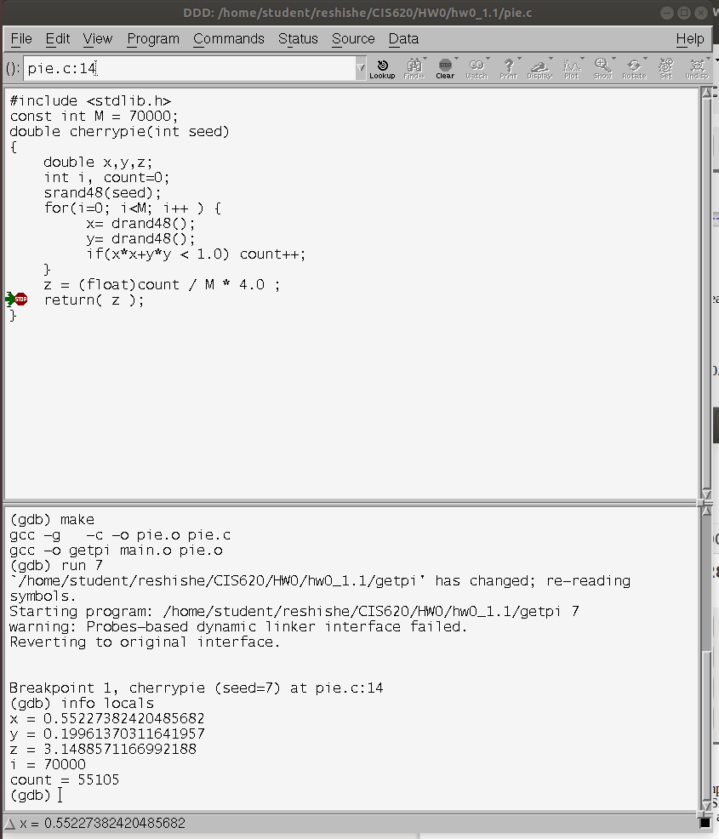

pic.c returns the right value, however, the right value does not get returned to main and main prints something else which is meaningless. It returns 70000 and it is the number of seeds
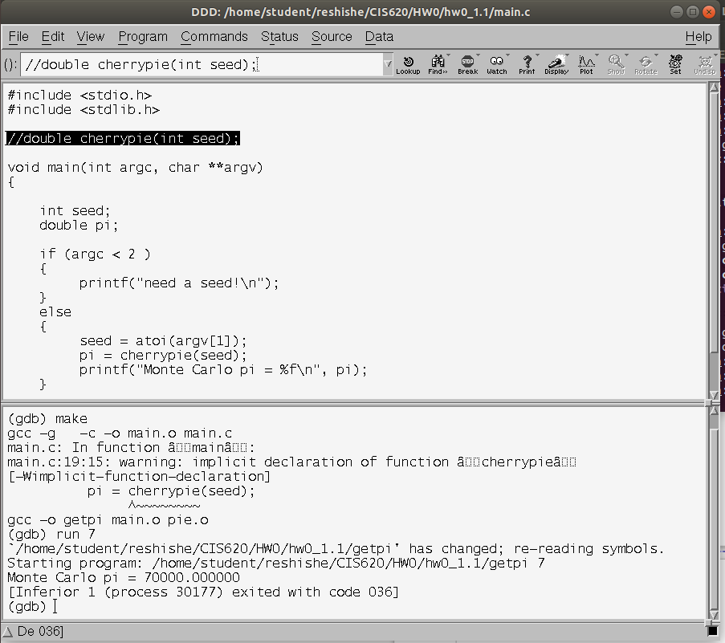
The reason for it is that there is a missing function prototype in main.c. Function prototypes are needed to let the compiler know what the input and output to the function is. If there is not function prototype, compiler assumes it is int by default. As pie.c calculates z, it saves the value into stack as a floating point value. However, when main.c is reading it, as there is no function prototype, the compiler assumes the return value is in the integer register (eax) and checking the eax register reveals that the last value into it was 70000 which is the value of M:

x11170 = d70000

The reason why 70000 is the last value in the eax register goes back to the assembly language and the sequence of operations to calculate z value:

in assembly language every value is placed into registers and then the operation is done. According to the above statement M is the last variable placed into the eax register and since there is not function prototype, the compiler assumes the return value of the pic.c should be saved to eax which is a 32-bit integer register and extracts data from there, while data is floating point and was saved into a 64-bit floating point register like rax.
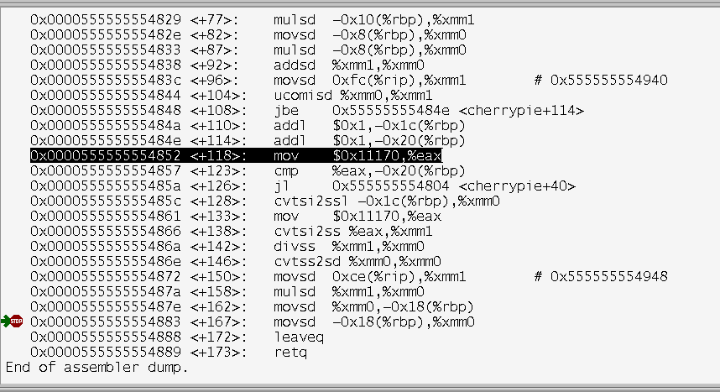
Once you put the function prototype, the return value will be redirected to 64-bit rax register and by declaring function prototype, compiler knows where to go to pick up the right value.

