Reza Shisheie
2708062
CIS620
Project 3
login ID: reshishe

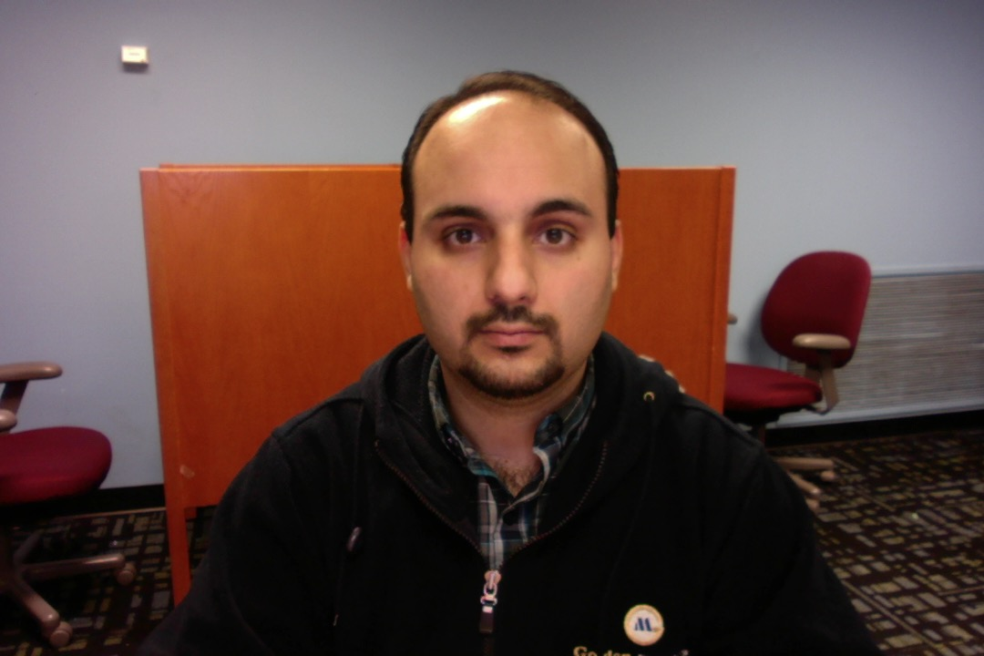
Objective:

In this project 3 files are made which communicate with each other:

- server.c: this is the server file which has access to a binary database and clients can submit queries to it and get requested data back.

  - Upon execution, it opens a TCP port and leaves it open for future clients to contact and request queries.

  - Let the service map know what server IP address and server name is. Clients need to know IP address and port number of serve to be able to make TCP connection to it. Thus, server data has to be stored on publicly accessible file/server to all clients. This file is called servicemap and its port number is “2+4digits of student number”. To send over server address and IP, it opens a UDP connection to service map and sends server’s IP address and port number to it. Upon success, an “OK” will be sent from service map to server.
  - Finally server waits for TCP connection requests from clients to do queries.

- servicemap.go: Service map stores or provides server data through UDP line. Service map has a well known port number known by servers and client.
  - If the query starts with “PUT”, then service map stores the port number as well as IP address of the incoming connection in a dictionary. For instance, an inquiry with the following command “PUT CISBANK 28062” saves the IP address and port number (28062) of server under server name “CISBANK”
  - If the query starts with “GET”, service map searches for a server name which matches with server name query and returns the IP address and port number of the server. For instance “GET CISBANK” asks service map to loop up its dictionary and see if there is any server named CISBANK. If there is one IP address and port number will be returned.

- client.go: client runs in while loop and gets queries from user, submit it to server, get results from server, and prints result:

  - First it makes a UDP connection to service map to ask if there is any server registered with that particular name. This name should already be provided by server to service map and saved in a dictionary.
  - Once IP address and port number of server is received from service map, then a TCP connection is established between client and server to submit queries to server and get results.
Files and code explanation:

server.c:
This file is divided into 3 sections:

- First section: In the first section all related parameters of TCP communication like original socket, new socket, TCP client and server structs, etc are set. Then TCP socket is initialized with TCP (SOCK_STREAM). Server family is set to AF_INET which refers to addresses from the internet, IP addresses specifically. Server is set to INADDR_ANY which means any interface and thus receives from any incoming address. A port number “0” is assigned to it so system would assign a port number automatically. The assigned port number has to be retrieved from system later to be sent to service map. Upon successful binding of server address and the assigned port number, socket name is acquired using getsockname function. A signal handler is set to terminate any child and error if child is not terminated. Up to this point all parameters of TCP connection is set and we would go to the next step.

- Second section: In this section UDP connection to service map is set which broadcasts the port number of server to service map through UDP. In order to do UDP, you need to know the broadcast address (ADDR_NUM) and port number of the service map. The address can be retrieved by invoking ifconfig on terminal window which provides all the details. The broadcast address is what we need and it is the same on all machines in the computer lab. Port number is a system assigned one which was done in last section and should be retrieved. Using sprintf a message is created and ready to be sent to service map. Now we have to setup UDP. A new socket and host is set first and then socket is set to UDP using SOCK_DGRAM. The remote address is set to ADDR_NUM, which is the broadcast address and remote port number is set to a well known unique port number which is “2+last 4 last ID” which is 28062 for my case. The predefined message is sent to service map. Once sent, server has to wait for an “OK” from service map to make sure it is received. Upon success, an “OK” message will be printed on server terminal that the IP address and port number of server is registered on service map. Then close UDP connection socket.

- Third section: In this section server waits for incoming TCP connections. Clients can access service map and get server data and thus they have all information to request for TCP connection. First I defined how many simultaneous TCP connections a server can have. It is maxed to 5 and if it exceeds that it closes socket and prints error. A while loop is set afterwards to just wait for incoming connection. Upon successful connection acceptance, socket is saved into a new socket and a character buffer is set (ip_buff_tcp) to hold IP address of the incoming client so later on it gets printed on server terminal. Then server forks a child, closes the old socket and goes into a while loop which gets data using recv. The while loop runs as long as the length of the incoming data is not zero, which menas there is data coming from client. In the while loop there unit32_t variables were set which will be assigned to the three chunks of 4-byte data coming from client. To know whether the request is a query type or an update type, the first 4 byte are converted and saved into recv1. To do the conversion, recv1 is generated by going through the first 4 characters of the input data from client one by one and then shifting 0bits/8bits/16bits/24bits and summing them together and saving in a buffer. I used bit shifting to save all 4 bytes in the variable and then used ntohls to flip from big endian to little endian. I could also do the bit shifting the opposite way and there would be no need to do ntohls.

  - If recv1 equals “1001” then it is an update request. The second and third pieces of 4-byte variables are also set using the same technique above. Since the last piece is a float an extra piece of conversion should happen which is type casting the uint32_t to float and saving recv3 into a new variable f. Two variable as count and flag are initialized to access data chunks from database and make sure if the requested data exists or not. Flag is set to 0 and once data is found it is set to 1. Count variable starts from 15 which is at the end of the database file and moves toward the beginning of the file with step size of the length of the structure. This structure is defined at the beginning of the server file and has 32 byte length. For each chunk, lseek is set to the beginning of the chunk where account number is stored, and reads the whole chunk and saves it to a temporary structure, my_record. If the account number is the same as the second piece of data from clients then data is found. Once data is found flag is set to 1 to let the rest of program know that data was found. Then the converted float number f is is added to the saved value of the temporary structure. Now the value is updated and the value of database has to be updated. Thus, lseek is set to the beginning of the value section which is 24 bytes after the biggining of each data chunk and then start writing process for 4 bytes. First thing is locking the area to avoid other client make change to that. If locking is not successful return error fail. Otherwise write the updated value there and then unlock. To make sure data is updated, set lseek to the beginning of the chunk again, read data, and saved it in a buffer. Then a new buffer with all pieces of requested data is generated and sent back to client. In case flag is still set to 0, reply back to client with a message that data was not found.

  - If recv1 equals 1000, the request is a query type. Only the second piece of 4-byte variables is set using the same technique above. There is not need to convert the 3rd variable as there is not one sent from client. Like previous section two variables as count and flag are initialized. Count variable starts from 15 which is at the end of the database file and moves toward the beginning of the file with step size of the length of the structure. For each 32byte chunk, lseek is set to the beginning of the chunk where account number is stored, and reads the whole chunk and saves it to a temporary structure. If the account number is the same as the second piece of data from clients then data is found. Once data is found flag is set to 1 to let the rest of program know that data was found. Then put all pieces of requested data in a buffer using sprintf and send it back to client. In case flag is still set to 0, reply back to client with a message that data was not found.

servicemap.go:
In service map a dictionary is initialized using map function first. This dictionary holds all the input data from server including address, port number, and server number. Server name will be used to look up the dictionary. A UDP connection using net.ResolveUDPAddr("udp",":28062") is initialized which has the unique port number set. Then it listens on the UDP connection. Closing UDP is deferred to the end of program. A while loop is used to keep reading from UDP if there exist an incoming message. If one is received, message with the address of incoming request will be printed on service map terminal.

- If message contains “PUT”, this is to update the dictionary with a new server and it is coming from a sever. In this case data is split into name, address, and port and saved into the dictionary. An “OK” is sent back to server to let it know data is received.

- If message contains “GET”, this is a request to get address of a server and it is coming from a client. A while loop is used to go through the dictionary and check the name of all data. If the name of data in dictionary matches with the input data from client then a message with this format is sent back: “address+:+port”. Otherwise nothing will be sent back.

client.go:
This is the client code. Client gets the address and port number of server through UDP and makes connection to server through TCP. Thus, it sets up the UDP server address using the broadcast address of service map and the unique port number using net.ResolveUDPAddr. Then UDP local address is set using the same function with port number “0” just to let device assign a port number automatically. Client uses the local address to listen on UDP. It requests the address of “CISBANK” by sending “GET CISBANK” message. If such server exists, service map reply back with an address and a port number which are displayed on client terminal. A while loop is set next to get data from user, send it to server, get reply back from serer and print on client terminal.

- If the input string contains “query”, client requests server to reply the database data. The message to server contains two 4-byte values. If it is a query message the first 4-byte value is “1000” and the second one is the 32bit integer value of the account number entered by user. Using binary.BigEndian.PutUint32 the two uint_32 values are converted and put into a buffer and then sent back to server. Once received by server, server replies back a message containing all the requested data associated with the account number back to client. Client listens back on TCP to get that data back from server and prints it. If data is not found an error message is replied from server.

- If the input string contains “update”, client generates a message to server containing three 4-byte values. As an update message, the first 4-byte value is “1001”, the second one is the 32bit integer value of the account number entered by user, and the third one is the 4-byte representation of a 32bit float entered by user. Using binary.BigEndian.PutUint32 the three uint_32 values are put into a buffer and then sent to server. Once received by server, server replies back a message containing the update value of data associated with the requested account number back to client. Client listens on TCP to get the updated data back from server. If data is not found an error message is replied from server.

Debugging:
I had the following debugging issues:

- Only port number and server name is sent from server to service map just to compy with the requested for of project. However, The whole IP:PORT could be constructed on server side to send back to service map. IP address of server is acquired on the service map side from the addr structure. I initially did send IP:PORT to service map but it caused some mismatch error on client side.
- Converting 8 or 12 byte data coming from client and converting to uint32_t was also tricky. Some other groups defined three uint32_t at the beginning and put each 4 byte directly into them in a for loop. However, I found bit shifting more intuitive but tricky. Converting hex representation of float into a real float number was also tricky and I finally figured I have to use float casting.
- If you look at data conversion part, each 4 byte is shifted left and then ntohs was used to convert big endian to little endian. I used this conversion since initially I sent data in little endian format. Later on I realized it should be in big endian format. Just to save headache I didn’t really touch the structure that was already working with little endian and just used ntohs to flip order. I could also change byte shifting in opposite and there would be no need to use ntohs. The other reason that I kept ntohs in code was prove that I know what ntohs is and avoid loosing grading points.

Result:

