EEC 693 – Special Topic
Robot Modeling and Control

Homework 6

REZA SHISHEIE
2708062

Due: 5/2/2019
Part 1
For the first part TH arrays is pre-calculated and inserted to model. The one inserted to controller has %10 error in TH array. Rho is calculated based on the norm of the difference and is set in the passivity controller.

Here is the response of the simulink after adjusting L and K gains.
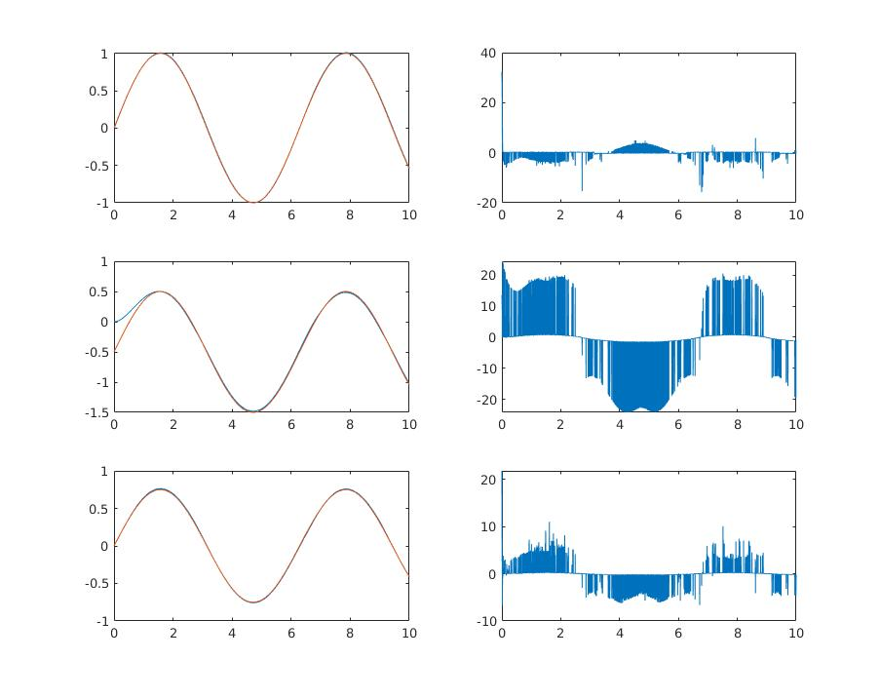
The left graphs are q1, q2 and q4 and the right side are the corresponding control effort
Chattering is shown in the control effort
Part 2
For this section, the fmincon optimization was implemented for both with and without constraints.
2.1. Without constraints
Here s the solution of the optimization method without constrains:
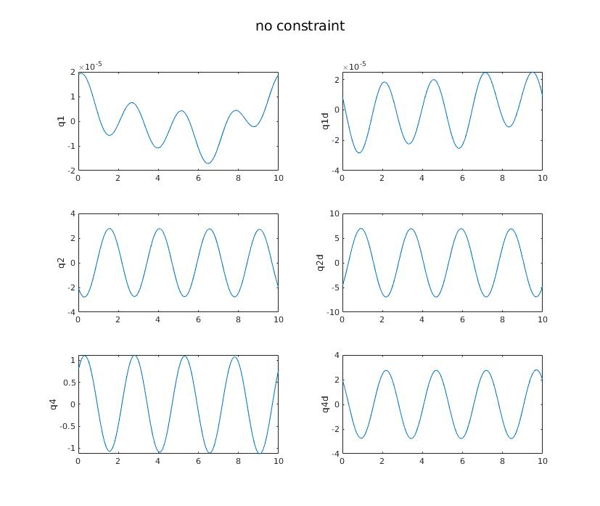
As you see not all constraints are satisfied.
The solution is provided after 126 iteration with the notice that local minimum is possible:

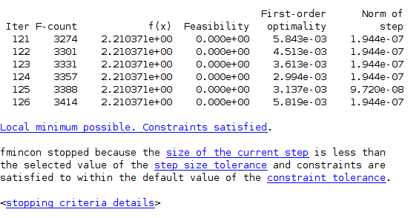

2.2. With constraints
The optimizer did not provide any solution with the suggested constraints saying “Converged to an infeasible point.” Based on fmincon explanation of the error message: “fmincon converged to a point that does not satisfy all constraints to within the constraint tolerance called ConstraintTolerance. The reason fmincon stopped is that the last step was too small. When the relative step size goes below the StepTolerance tolerance, then the iterations end.”
Here is the solution with constraints knowing that the solution is infeasible:
