**EEC 693 – Special Topic**

**Robot Modeling and Control**

**Homework 4**

**REZA SHISHEIE**

**2708062**

**Due: 4/4/2019**

**PROBLEM 1:**

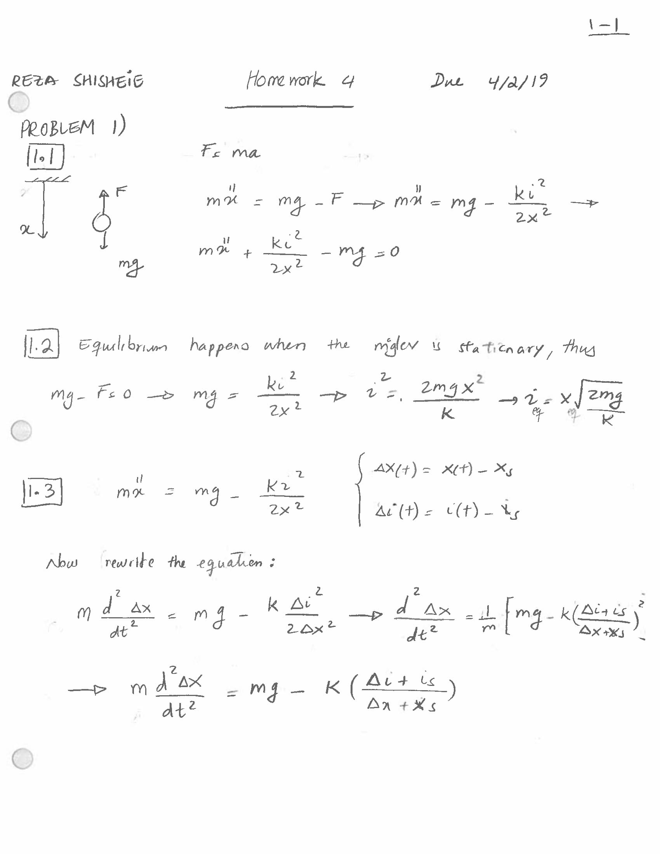

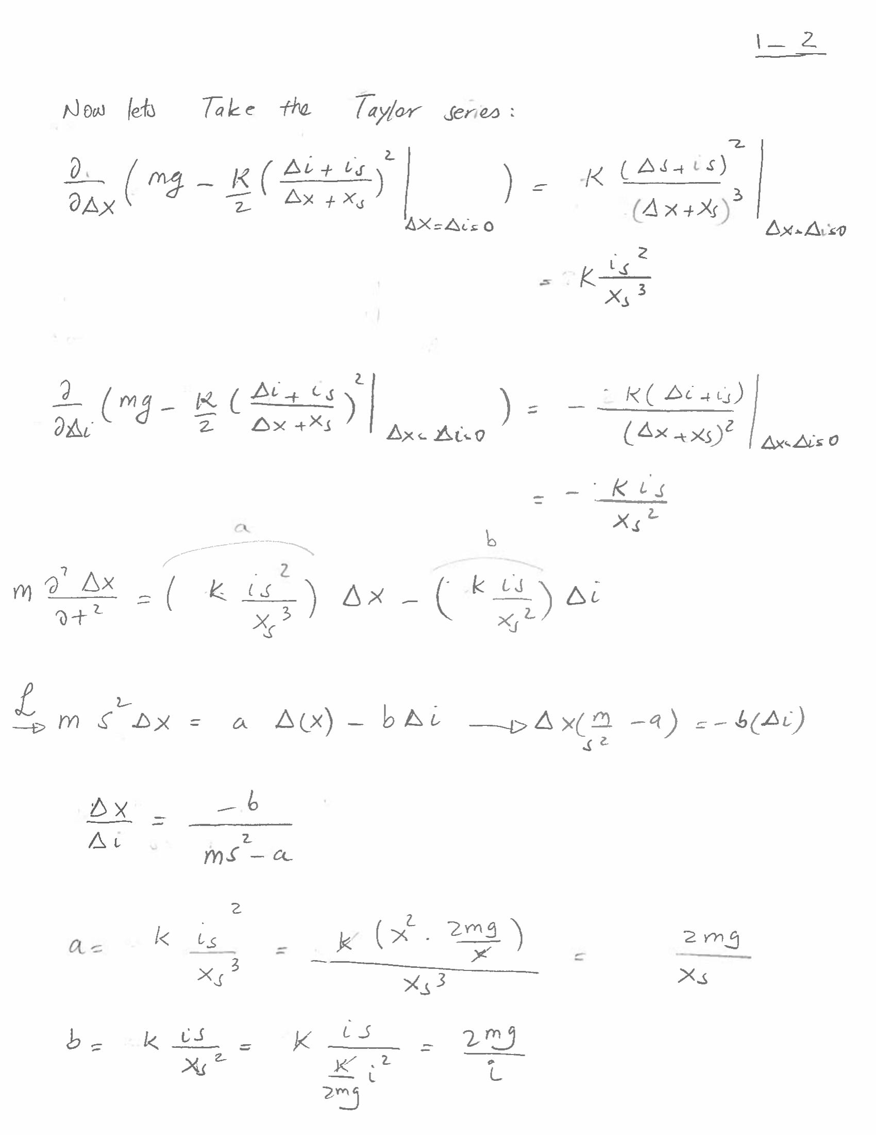

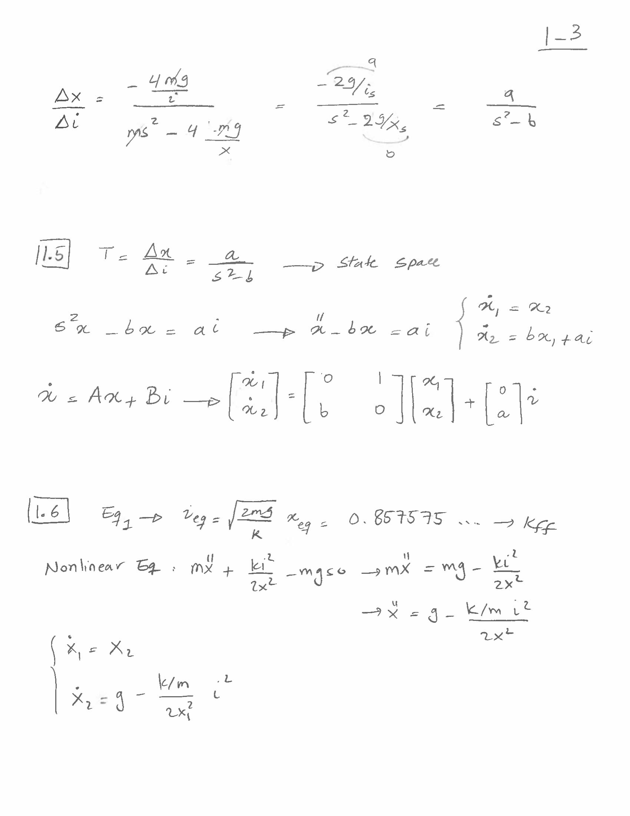

**PART1.1 - Control Design by LQR with step input**

Here are the constraints:

1. Zero steady-state error to step changes in target position.
2. Settling time to a step input of approx. 1 second
3. Overshoot as small as you can.
4. The range of motion is limited between x = 0 and x = 0.014 m. The current must be kept within ±2.5 A.
5. Test for a stable response using a Simulink model. Use the linearized plant and a step input of 1 mm. The settling time should be near 1 second, but the overshoot may be high (100%).
6. Check that the current spike stays within ±1 A for a step input of 1mm.

Here is the model for step input:

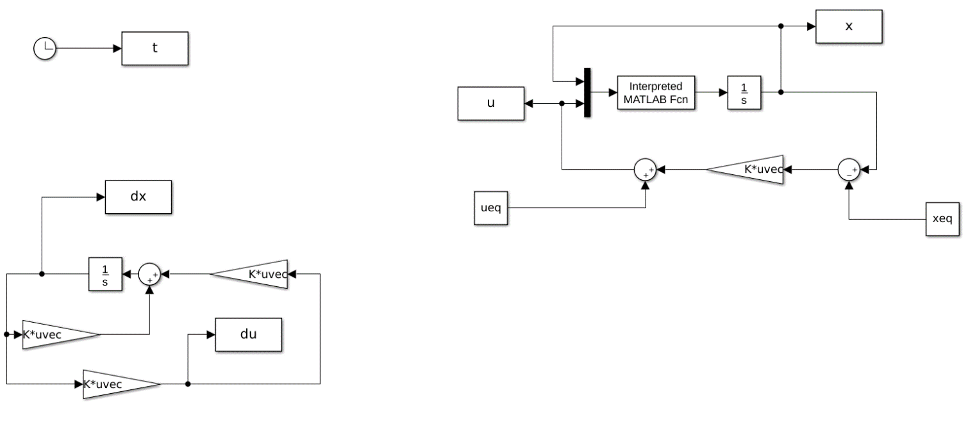

The left side is the linear system and the right side is the nonlinear system with linear feedback.

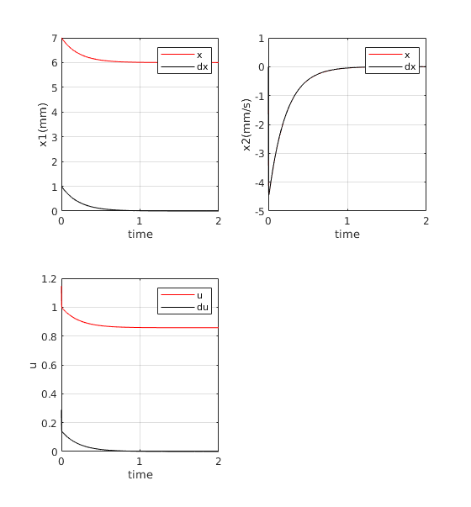

Here are the ­­results and analysis:

1. It has 0 steady state error
2. Settling time is 1 seconds
3. Gains were manipulated to keep overshoot in x1 and x2 minimum.
4. Range of motion is between 0 and 0.014 m. The maximum current is 1.2 A which is within bounds of ±2.5 A.
5. Nonlinear result is in red and linear result is in black

**PART1.2 - Control Design by LQR with ramp input**

Here is the model for ramp input:

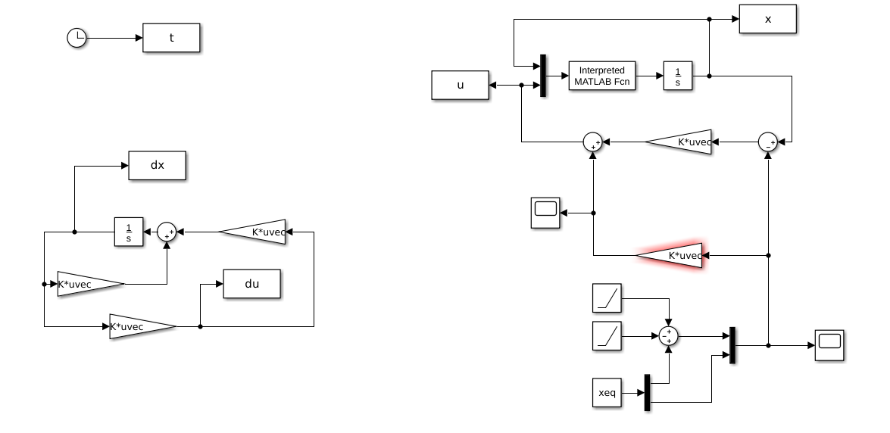

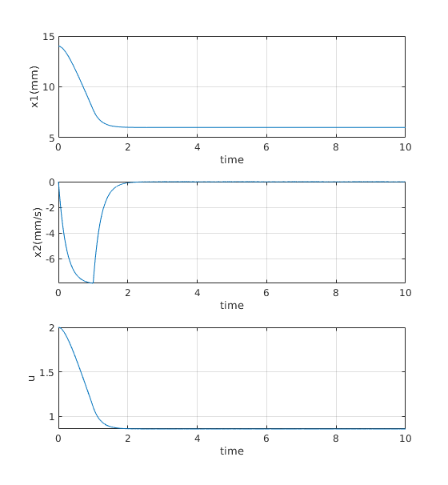

**PROBLEM 2:**

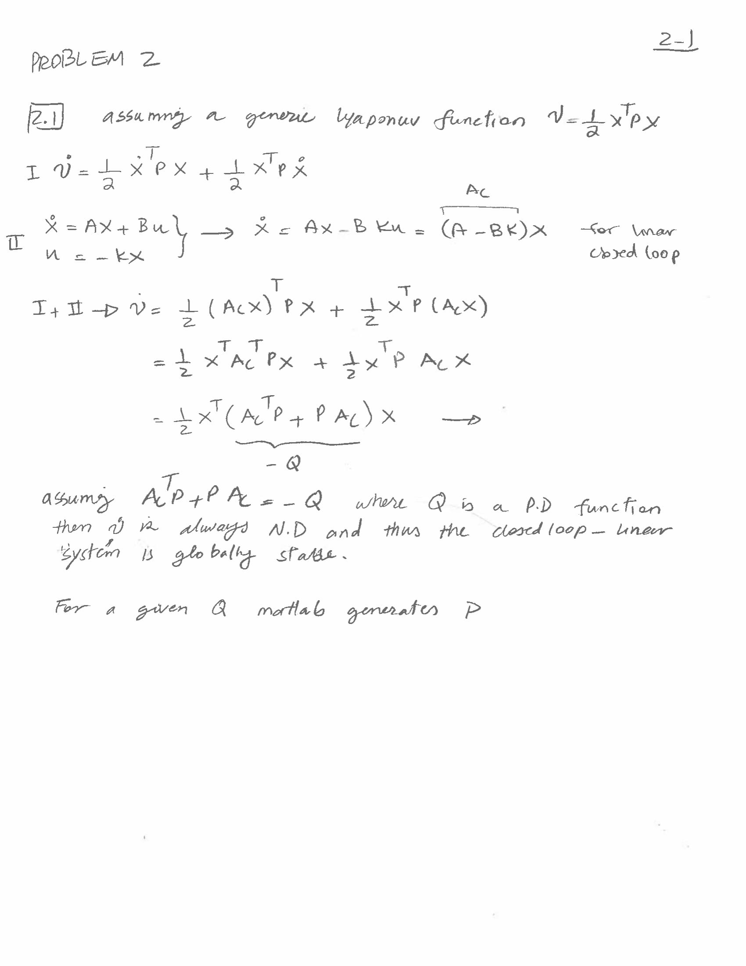

Here is the result of region of attraction wit h 2 different sets of Qs.

Q1=1000*eye(2);// in BLACK

Q2 = [10,2;2,10];// in red

Here is the result of region of attraction:

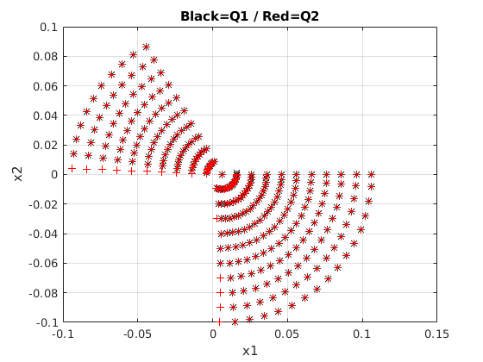

The result in red show improvements on the region of attraction. Now let’s select two points in the regions where Lyapunov function does not guarantee stability:

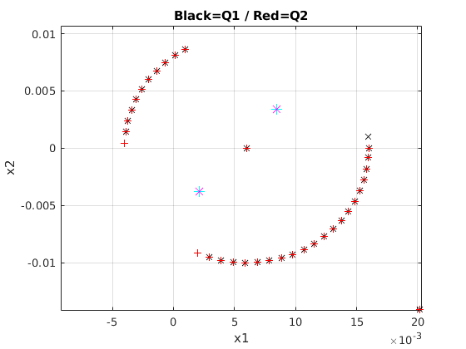

These two points are:

x0_1 = [ 0.008, 0.003 ];

x0_2 = [0.002, -0.003 ];

Here is the result of the first point using file “loadpars_stbl_unstbl_pts.m” for a step input

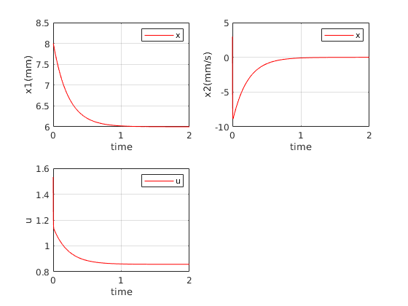

Here is the result of the second point using file “loadpars_stbl_unstbl_pts.m” for a step input

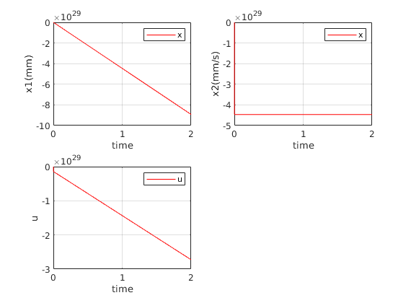

As you see the first set of point which is farther from coil with positive (away from coil) speed is stable but the second set which is close to coil and negative speed (toward coil) is unstable. Thus, there are points in outside the stability region guaranteed by Lyapunov function which is also stable.