**Human Computer Interaction Final Project: Sketchpad**

**Name of the Student:** Rohitashwa Ray Chowdhury

**Name of the University**: Western University

**Name of the course**: Human Computer Interaction

**Course code**: ECE 9020L

**Name of the Instructor**: Prof. Roy Eagleson

The state diagrams/state charts for the given functions of the system are as follows:

1. **Draw a line:**

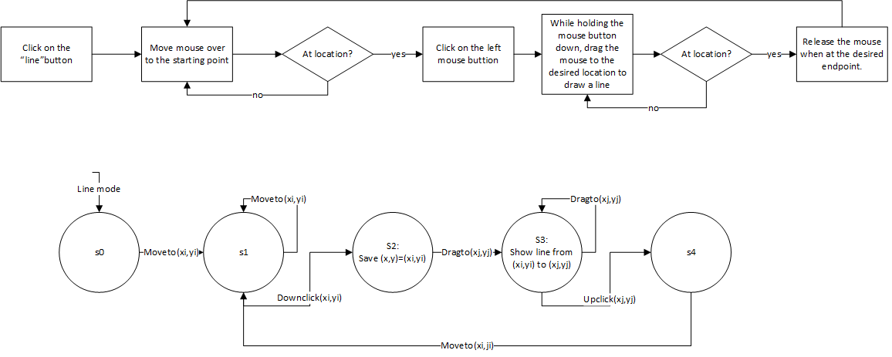

1. **Draw a rectangle/square:**

`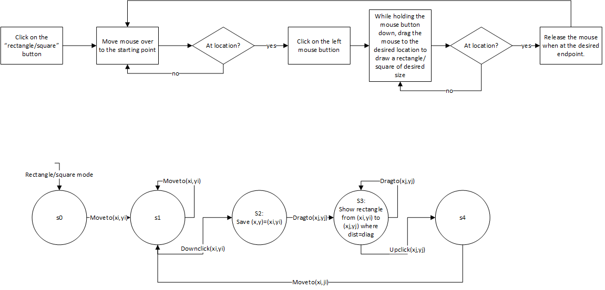

1. **Draw a circle/ellipse:**

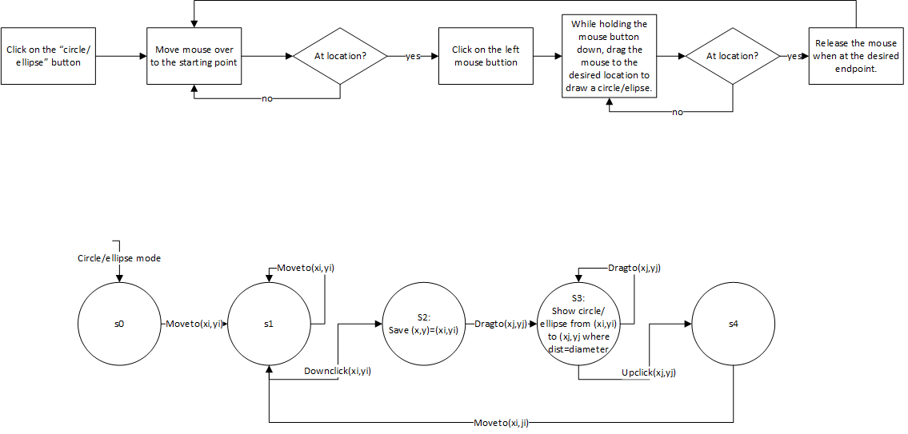

1. **Perform cut and paste operations:**

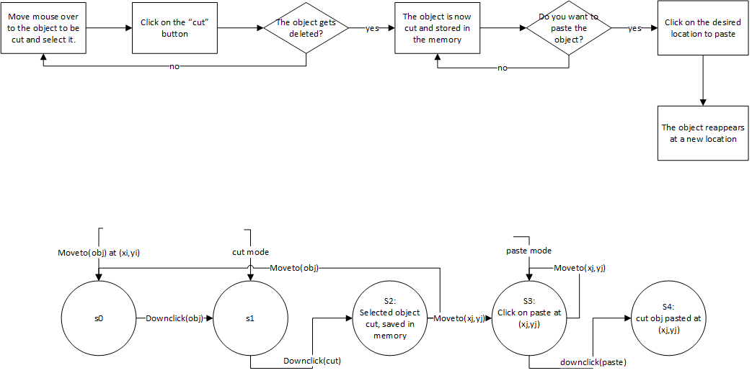

1. **Perform save operation:**

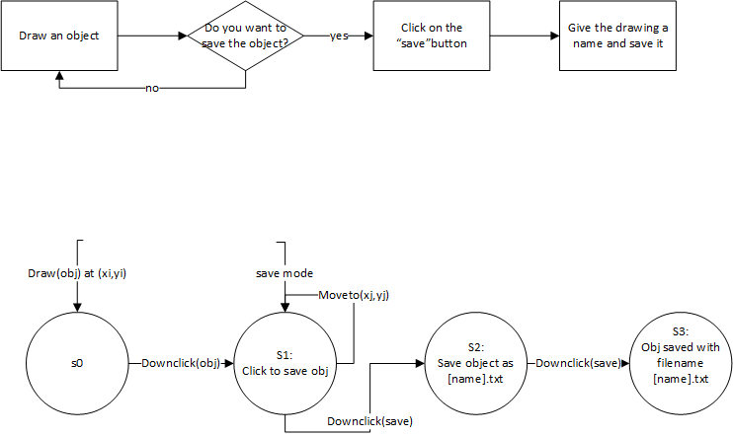

1. **Perform load operation:**

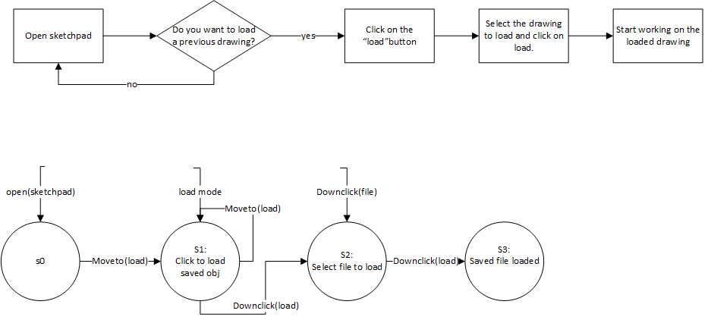

1. **Perform undo and redo operations:**

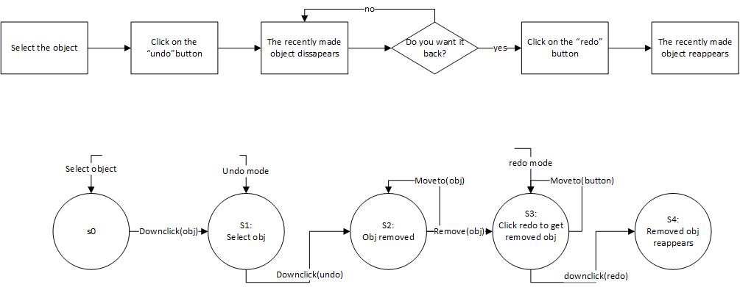

The class diagram and the use case diagram for the system is given below:

1. **Class diagram:**

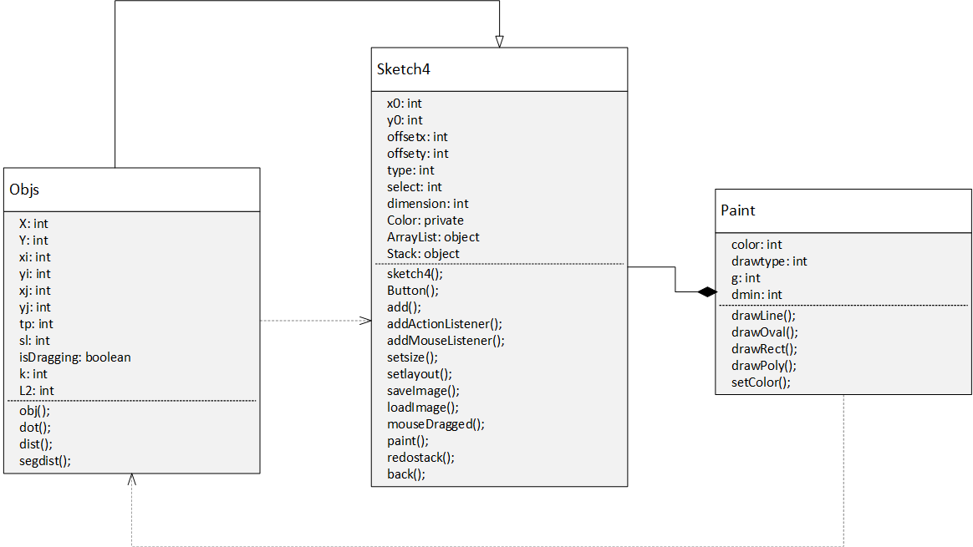

1. **Use case diagram:**

