DESIGN AND IMPLEMENTATION OF EKSU HEALTH CENTER BOOKING AND APPOINTMENT SYSTEM

NNABUGWU SOLOMON CHUKWUEBUKA
MATRIC NUMBER: 220903052

A PROJECT SUBMITTED TO THE DEPARTMENT OF COMPUTER SCIENCE, FACULTY OF PHYSICAL SCIENCE, EKITI STATE UNIVERSITY (EKSU), NIGERIA

IN PARTIAL FULFILMENT OF THE REQUIREMENTS FOR THE AWARD OF BACHELOR OF SCIENCE (B. SC.) IN COMPUTER SCIENCE

PROJECT SUPERVISOR:
MRS. O. O. OLARINDE

CHAPTER ONE

INTRODUCTION

1.1 Background of the Study
The advancement of information and communication technology (ICT) has significantly transformed the way services are delivered across various sectors, including healthcare. One of the major areas of improvement in healthcare systems is the management of patient appointments and scheduling. Traditional methods of handling patient visits, which often involve walk-ins and manual queuing, are increasingly becoming inefficient, especially in environments with high patient demand (Gupta & Denton, 2008).
In many healthcare facilities, including university health centers, patients are required to physically visit the facility and wait in line before receiving medical attention. This approach often leads to overcrowding, long waiting times, and poor service delivery. During peak periods, such as the admission of new students into 100 level at Ekiti State University (EKSU), the health center experiences a large influx of students requiring medical registration. This situation further exacerbates inefficiencies in patient management.
A booking and appointment system provides a structured approach to managing patient flow by allowing individuals to schedule visits in advance. According to Cayirli and Veral (2003), appointment scheduling systems play a critical role in reducing patient waiting time and improving healthcare service efficiency. Such systems enable healthcare providers to allocate time slots, manage workloads, and ensure better utilization of available resources.
Furthermore, studies have shown that the implementation of appointment-based systems in healthcare significantly improves patient satisfaction and reduces congestion within healthcare facilities (Gupta & Denton, 2008). By allowing patients to book appointments remotely and receive scheduled time slots, healthcare institutions can provide more organized and efficient services.
This project focuses on the design and implementation of a Health Center Booking and Appointment System for Ekiti State University. The system aims to replace the traditional walk-in approach with a digital platform that allows students to schedule medical appointments, thereby improving efficiency, reducing waiting time, and enhancing overall service delivery.

1.2 Statement of the Problem
The current method of managing patient visits at the EKSU Health Center is largely based on a walk-in system, where students physically visit the health center and wait to be attended to. This method is inefficient and leads to several challenges, including overcrowding, long waiting times, and poor organization.
During the admission period for 100-level students, the situation becomes more problematic due to the high volume of students requiring medical registration within a short period. Students often spend long hours waiting without a clear schedule, leading to frustration and reduced productivity.
Additionally, the absence of a structured appointment system makes it difficult for healthcare staff to manage patient flow effectively. There is no proper allocation of time slots, which results in uneven workload distribution and inefficiencies in service delivery. Research indicates that poor appointment scheduling is a major contributor to delays and inefficiencies in healthcare systems (Cayirli & Veral, 2003).
Therefore, there is a need for an automated booking and appointment system that allows students to schedule their visits, reduces congestion, and improves the overall efficiency of the EKSU Health Center.

1.3 Aim and Objectives of the Study

Aim
The aim of this project is to design and implement a Health Center Booking and Appointment System for Ekiti State University to improve the scheduling and management of student medical visits.

Objectives
The specific objectives of this study are to:
- Design a system for efficient registration of student during medical registration.
- Develop a system for efficient registration of student during medical registration.
- To implement a system for efficient registration of student during medical registration.
- To evaluate the performance of the system.

1.4 Significance of the Study
This study is significant as it provides a practical solution to the challenges associated with manual and walk-in-based patient management systems. The implementation of a booking and appointment system will enable students to schedule their visits conveniently, thereby reducing waiting time and improving their overall experience.
Healthcare staff will benefit from better workload distribution and improved organization of patient visits. The system will also enhance operational efficiency at the EKSU Health Center by ensuring that patient flow is properly managed.
Furthermore, this study contributes to the application of ICT in healthcare systems and demonstrates how digital solutions can be used to solve real-world problems in institutional environments (Gupta & Denton, 2008).

1.5 Scope of the Study
This project focuses on the design and implementation of a Health Center Booking and Appointment System for managing student medical visits at Ekiti State University. The system will include features such as appointment booking, scheduling, and appointment tracking.
However, the system does not cover other aspects of healthcare management such as diagnosis, treatment, or electronic medical records. The focus is strictly on appointment scheduling and management.

1.6 Limitations of the Study
The study may be limited by factors such as time constraints, limited access to real healthcare data, and technical challenges during system development. Additionally, the system is designed specifically for EKSU and may require modifications for use in other institutions.

1.7 Definition of Terms
Appointment System: A system that allows individuals to schedule visits or services in advance.
Booking: The process of reserving a specific time slot for a service.
Patient Flow: The movement of patients through different stages of healthcare service.
Scheduling: The process of allocating time slots for activities or services.
Automation: The use of technology to perform tasks with minimal human intervention.
Health Center: A facility that provides medical services within an institution.

CHAPTER TWO

LITERATURE REVIEW

2.1 Introduction
This chapter reviews existing literature related to booking and appointment systems in healthcare. It examines key concepts, theoretical frameworks, and existing systems used in managing patient appointments. The aim is to provide a solid foundation for the design and implementation of a Health Center Booking and Appointment System for Ekiti State University (EKSU).

2.2 Concept of Appointment Systems
An appointment system is a structured method used to schedule and manage service delivery by allocating specific time slots to users. In healthcare, appointment systems are used to organize patient visits, reduce waiting time, and improve service efficiency.
According to Gupta and Denton (2008), appointment scheduling is one of the most critical aspects of healthcare operations, as it directly affects patient flow, resource utilization, and service quality. Appointment systems help reduce congestion by distributing patient visits over time rather than allowing all patients to arrive simultaneously.

2.3 Appointment Systems in Healthcare
Healthcare institutions increasingly rely on appointment systems to manage patient flow effectively. Traditional walk-in systems often lead to overcrowding and long waiting times, especially during peak periods.
Cayirli and Veral (2003) noted that effective appointment scheduling improves patient satisfaction and reduces delays in service delivery. Similarly, Green et al. (2006) emphasized that proper scheduling systems enhance access to healthcare by ensuring timely service for patients.
In the context of university health centers, such as EKSU, the need for an appointment system is particularly important during admission periods when a large number of students require medical registration within a short time frame.

2.4 Theoretical Framework: Appointment Scheduling Theory
This study is based on appointment scheduling theory, which focuses on optimizing the allocation of time slots to minimize waiting time and maximize service efficiency.
Appointment scheduling models consider factors such as arrival rate, service time, and no-show rates. According to Cayirli and Veral (2003), efficient scheduling systems balance patient demand with available resources to reduce idle time and overcrowding.
These principles guide the design of the proposed system to ensure effective management of student appointments at the EKSU Health Center.

2.5 Review of Existing Systems

2.5.1 Appointment Scheduling System (Gupta & Denton, 2008)
This system improves healthcare efficiency by optimizing appointment scheduling; however, it is limited by its complexity and dependence on accurate patient arrival predictions.

2.5.2 Outpatient Scheduling System (Cayirli & Veral, 2003)
This system reduces patient waiting time through structured scheduling; however, it may not effectively handle walk-in patients or emergency cases.

2.5.3 Open Access Scheduling System (Murray & Berwick, 2003)
This system allows patients to book same-day appointments, improving access to care; however, it may lead to uneven workload distribution for healthcare providers.

2.5.4 Advanced Access Scheduling System (Green et al., 2006)
This system enhances timely access to healthcare services; however, it requires careful planning and may be difficult to implement in smaller facilities.

2.5.5 Web-Based Appointment System (Zhang et al., 2014)
This system enables online booking and improves accessibility; however, it depends on internet availability and user digital literacy.

2.5.6 Mobile Health Appointment System (Boulos et al., 2011)
This system allows patients to book appointments via mobile devices, improving convenience; however, it requires smartphone access and reliable connectivity.

2.5.7 Hospital Information System (HIS) Appointment Module (Haux, 2006)
This system integrates appointment scheduling with hospital operations; however, it is expensive and complex to implement.

2.5.8 Electronic Booking System (EBM) (Berg, 2001)
This system digitizes appointment management, improving record-keeping; however, it may face resistance from users accustomed to manual systems.

2.5.9 Cloud-Based Appointment System (Kuo, 2011)
This system offers scalable and accessible scheduling solutions; however, it raises concerns about data security and privacy.

2.5.10 Smart Appointment System with Notifications (Gupta et al., 2016)
This system uses reminders and notifications to reduce missed appointments; however, it depends on consistent communication channels.

2.6 Limitations of Existing Systems
Despite the availability of various appointment systems, several limitations exist. Many systems are complex and require advanced infrastructure, making them unsuitable for smaller institutions such as university health centers.
Additionally, some systems do not address the specific needs of student medical registration during admission periods, where large numbers of users must be managed within a short timeframe. Issues such as missed appointments, uneven scheduling, and lack of user-friendly interfaces further limit the effectiveness of existing systems.

2.7 Justification for the Proposed System
The review of existing systems highlights the need for a simple, efficient, and localized appointment system tailored to the EKSU Health Center. The proposed system aims to address the limitations of existing solutions by providing a user-friendly platform for booking appointments, managing schedules, and reducing waiting time.
Unlike complex hospital systems, the proposed system will be designed specifically for student use, ensuring ease of access and effective management during peak periods such as admission screening.

2.8 Summary of Literature Review
This chapter has reviewed key concepts, theories, and existing systems related to appointment scheduling in healthcare. It highlighted the importance of appointment systems in improving service delivery and identified the limitations of existing solutions.
The findings justify the need for a customized booking and appointment system for EKSU, which will be designed and implemented in the next chapter.

CHAPTER THREE

SYSTEM ANALYSIS AND DESIGN

3.1 Introduction
This chapter presents the system analysis and architectural design of the implemented EKSU Health Center Management System, engineered to digitize and automate student medical registration at Ekiti State University (EKSU). The system is designed as a cohesive full-stack platform comprising a modern, single-page client interface built with Next.js 16 (App Router), React 19, TypeScript, and Tailwind CSS 4, integrated with an asynchronous RESTful backend powered by FastAPI (Python 3.11+), MongoDB Atlas cloud database, and Cloudinary media storage. The platform provides a structured 9-stage onboarding workflow, dynamic matriculation format validation, session-based clinical queue management, AI-assisted payment receipt verification, role-based access control, medical form read-locks, standardized audit logging, and instant digital health card generation to eliminate physical overcrowding, enhance data integrity, and streamline clinical operations.

3.2 Analysis of the Existing System
The legacy system operating at the EKSU Health Center relies almost entirely on manual walk-in procedures and physical paper record administration. Under this conventional approach, newly admitted students and returning students undergoing periodic medical clearance must physically present themselves at the health center facility without advance scheduling or digital queue coordination.

3.2.1 Characteristics of the Existing System
The operational characteristics of the legacy manual system include:
- Absence of any digital appointment booking or structured queue scheduling mechanism;
- Uncontrolled student arrival with no visibility into queue lengths, waiting times, or station availability;
- Manual, paper-based verification of student identity, registration status, and medical clearance qualifications;
- Lack of systematic stage dependency tracking across laboratory tests, physical examinations, and case file creation;
- Strict reliance on physical first-come, first-served queues prone to line cutting, confusion, and physical fatigue;
- Manual inspection of paper payment bank tellers and receipts by administrative staff with no automated validation;
- Storage of vital student clinical histories on physical paper cards (Pink Files) susceptible to misplacement, deterioration, or loss.

3.2.2 Problems of the Existing System
The manual operation of the health center leads to several severe operational bottlenecks and risks:
- Severe physical overcrowding and congestion at the health center premises during peak matriculation periods;
- Protracted waiting periods spanning several hours or recurring across multiple days for a single student registration;
- Inability to verify student authenticity or detect fraudulent payment receipts due to manual inspection limitations;
- Fragmented inter-departmental communication between administrative intake staff, laboratory scientists, and attending nurses;
- Vulnerability of paper medical documentation to damage, unauthorized alteration, or permanent loss;
- Complete absence of an automated audit trail to trace administrative actions, payment approvals, or medical entries;
- Pervasive transcription errors and data discrepancies resulting from manual data entry across multiple physical registers.

3.3 Analysis of the Proposed System
The proposed system is an enterprise-grade full-stack web application architected to replace the manual walk-in workflow with an integrated digital registration pipeline. The solution bridges client-side usability and server-side robustness by deploying a modern Next.js 16 frontend communicating over secure RESTful APIs with an asynchronous FastAPI application service. The platform incorporates structured student identity verification against administrative pre-upload lists, strict stage progression gating visualized via an interactive vertical timeline, session-based queue scheduling with live ticket tracking, AI-assisted receipt analysis, immutable medical form read-locks, and comprehensive administrative oversight.

3.3.1 Key Features
The key architectural and functional features of the proposed full-stack system comprise:
- Student Pre-Upload Identity Verification: Administrative pre-upload of student rosters via CSV bulk import (featuring drag-and-drop file ingestion, client-side column validation, and batch preview) or per-level manual creation (100-level through 600-level).
- JWT Authentication and Role-Based Routing: Stateless authentication using JSON Web Tokens (JWT) with secure client-side session management in AuthContext, local storage token persistence, and role-based route protection guards (AuthenticatedLayout) redirecting unauthenticated or unauthorized users.
- Mandatory Staged Medical Workflow: Nine sequential onboarding phases visualized as an interactive vertical progress timeline on the student dashboard, dynamically displaying completion badges, active phase call-to-actions, and prerequisite locks.
- AI-Assisted Payment Receipt Verification: Student upload of payment receipts stored securely on Cloudinary, evaluated by an AI Gateway service that extracts Remita Retrieval Reference (RRR), amount, date, and institution, returning confidence-scored verdicts (likely_valid, likely_invalid, needs_manual_review) alongside administrative manual override.
- Session-Based Multi-Queue Management: Three distinct queue types (LAB_TEST, PHYSICAL_REGISTRATION, and PHYSICAL_EXAM) with role-restricted operational access. Registering nurses and laboratory attendants manage queues via a real-time call desk, while students track live positions and wait times via dynamic digital queue tickets.
- Secure Cloudinary Media Integration: High-resolution cloud storage for student passport photographs, signatures, and payment receipts with URL persistence in MongoDB Atlas and optional Cloudinary AI background removal for official student portraits.
- Registration Period Governance: Dynamic administrative scheduling of active registration windows per academic level, enforcing strict start and end datetime limits for student onboarding.
- Full-Stack Security and Medical Read-Locks: Multi-layered defense incorporating bcrypt password hashing, recursive XSS/NoSQL injection sanitization on all backend inputs, client-side input masking, and irreversible post-submission read-locks on medical forms to ensure data integrity.
- Standardized 9-Field Activity Audit Logging: Comprehensive logging across all administrative and staff actions (staff_id, actor_id, actor_name, role, action, target, details, metadata, created_at) supporting full traceability and administrative compliance.
- Digital Health Center Card Generation: Automated issuance of official digital health cards upon registration completion, displaying auto-sequenced Health Center numbers (HC-NNNN), student passport photograph, personal vitals, and browser print-optimized stylesheets.
- Administrative Real-Time Analytics Dashboard: Comprehensive KPI statistics grid displaying total registered students, pending payment approvals, active queue loads, stage completion rates, and recent audit activity logs.

3.4 System Requirements

3.4.1 Functional Requirements
The functional requirements specify the operational capabilities delivered by the system across each authenticated user role:
The system shall:
- Allow administrators to bulk import student records via CSV with client-side header validation, preview modal, and duplicate detection, or manually enroll students by level (100L to 600L);
- Validate student identity during account signup strictly against pre-uploaded student records, matching matriculation number, faculty, department, and academic level;
- Enforce level-specific matriculation number regex patterns at both client and server: 100-level (12 digits followed by 2 letters, exactly 20 characters total) and 200-600 level (strictly 9 numeric digits);
- Restrict student onboarding and form submission activities strictly to active registration period windows configured for their academic level;
- Mandate the completion and submission of the 21-field Basic Information Form as an uncompromising prerequisite before unlocking subsequent registration phases;
- Provide an interactive payment upload interface allowing students to submit receipt images directly to Cloudinary object storage;
- Execute automated AI analysis on uploaded receipts to extract transaction reference, amount, date, and institution, returning structured verdicts to the administrative review console;
- Enable administrators to confirm or reject payment receipts in single or bulk operations with mandatory rejection reason logging;
- Unlock passport photograph and digital signature upload interfaces only after administrative confirmation of payment status;
- Auto-assign globally unique, sequential tracking numbers for laboratory requests (LAB-YYYY-NNNNNN) and health center registrations (HC-NNNN);
- Manage three dedicated clinical queue disciplines: LAB_TEST (restricted to Lab Attendants), PHYSICAL_REGISTRATION, and PHYSICAL_EXAM (restricted to Registering Nurses);
- Enable authorized clinical staff to create queue sessions defining title, queue type, start/end datetimes, student capacity (1-5000), and estimated time per student (1-480 minutes);
- Enforce strict prerequisite eligibility verification prior to admitting a student into any queue session;
- Provide a real-time staff queue console featuring call-next-student, mark-attended, and mark-missed controls with live status synchronization;
- Render a dynamic digital queue ticket on the student dashboard displaying queue number, estimated waiting time, current serving position, and calling notifications;
- Allow clinical staff to record laboratory findings (tests, antibiotic sensitivities, doctor signatures) and physical examination measurements (vitals, acuity, systemic observations);
- Automatically apply immutable read-locks to student medical forms upon submission, preventing further client-side modifications;
- Automatically create and maintain clinical Student Case Notes (Pink Files) linking all historical medical questionnaires, lab findings, and nursing observations;
- Generate printable digital Health Center Cards complete with student passport portrait, vital statistics, and registration credentials upon final stage completion;
- Record an immutable 9-field audit entry for every administrative or clinical action performed across the platform.

3.4.2 Non-Functional Requirements
The non-functional requirements define the quality attributes, architectural constraints, and usability benchmarks of the system:
- High Usability and Accessibility: The client presentation layer utilizes Tailwind CSS 4 with a bespoke Emerald-themed health design system, Geist typography, and Framer Motion micro-animations, providing responsive, intuitive navigation across desktop, tablet, and mobile viewports.
- High Performance and Low Latency: Sub-second API response times achieved through asynchronous Motor/FastAPI query execution, MongoDB index optimization, Next.js server component rendering, and Cloudinary Content Delivery Network (CDN) edge caching.
- Robust Security and Data Protection: Passwords hashed using bcrypt with 72-byte safe truncation; JWT bearer tokens protecting REST endpoints; recursive XSS and NoSQL injection sanitizers neutralizing malicious payloads; and client-side route guards enforcing role permissions.
- Cloud Scalability: Decoupled architecture leveraging MongoDB Atlas distributed cloud clustering for document persistence and Cloudinary for elastic binary media storage, eliminating local server storage bottlenecks.
- High Reliability and Fault Tolerance: Session-based queue limits prevent server and physical health center overload; missed students are gracefully re-queued at the rear rather than dropped; and atomic staff account suspension prevents unauthorized actions instantly.
- Strict Data Integrity: Comprehensive schema enforcement using Pydantic v2 validation models on all API requests and responses, coupled with client-side form validation before transmission.

3.5 System Architecture
The EKSU Health Center Management System is designed around a modern, decoupled three-tier architecture that separates user interaction, business processing logic, and persistent data storage. This architectural pattern maximizes modularity, facilitates independent scaling of frontend and backend services, and enforces robust security boundaries across system tiers:
- Presentation Layer (Client Tier): A responsive, single-page web application engineered with Next.js 16 (App Router) and React 19, written in TypeScript 5. Styling is managed via Tailwind CSS 4 with PostCSS, tailwind-merge, and class-variance-authority for component variant styling. Dynamic page transitions, staggered form disclosures, and queue status badges are animated using Framer Motion 13. UI visual consistency is maintained with Lucide React iconography, while user feedback and validation alerts are dispatched through Sonner toast notifications. The client communicates with the backend via an asynchronous apiRequest utility encapsulating JWT authorization headers, JSON payload formatting, and error boundary handling. Client-side authentication state and session persistence are governed centrally via AuthContext.
- Application Layer (Logic Tier): An asynchronous RESTful API backend engineered with FastAPI on Python 3.11+. The application tier is structured into modular endpoint routers (Authentication, Admin, Students, Staff, Registration Periods, Queues, Medical Forms, Payments, and Audit Logs) that delegate business workflows to dedicated service modules. QueueService manages session lifecycles, capacity bounds, queue ordering algorithms, and stage eligibility gating. CloudinaryService handles authenticated image upload, transformation, and media deletion. PaymentReviewService coordinates AI Gateway integration for payment receipt document parsing. Core cross-cutting modules manage configuration, recursive input sanitization, JWT token issuance, and password cryptography.
3. Data Layer (Storage Tier): A multi-collection cloud database hosted on MongoDB Atlas, interfaced asynchronously through the Motor driver. The database stores 13 primary collections: users, students, staff, basic_info, lab_request_forms, medical_examination_questionnaires, physical_examination_forms, student_case_notes, queues, queue_sessions, payment_receipts, registration_periods, and activity_logs. Static binary assets (passport photographs, student signatures, and payment receipt receipts) are offloaded entirely to Cloudinary cloud object storage, ensuring minimal database storage overhead and rapid CDN-accelerated asset streaming.
Technology Stack Summary:
• Frontend Presentation Framework: Next.js 16.3.6 (App Router) with React 19.2.8
• Frontend Language & Runtime: TypeScript 5, Bun 1.3.14
• Frontend Styling & Design System: Tailwind CSS 4, PostCSS, tailwind-merge, clsx, class-variance-authority
• UI Componentry & Motion: Lucide React 1.16, Framer Motion 13.0, Sonner 2.0.7
• Typography: Geist Font via next/font/google
• Backend Framework: FastAPI (Python 3.11+), Uvicorn ASGI server
• Database: MongoDB Atlas cloud cluster via Motor asynchronous driver
• Media & Document Cloud: Cloudinary object storage with AI background processing
• Authentication & Security: JWT (python-jose), OAuth2 Bearer, bcrypt password hashing
• Validation & Configuration: Pydantic v2, Pydantic Settings
• External HTTP Integration: httpx async client (AI Gateway service)
• Document Generation: pypdf, CSS print stylesheets

3.6 System Roles
The system defines four authenticated user roles, each provided with dedicated frontend interfaces and server-side authorizations:
- Administrator:
• Frontend Portal: /admin/* (Dashboard, Student Directory, Payment Reviews, Staff Management, Registration Periods, Pink Files, Audit Logs);
• Account Provisioning: Automatically seeded upon initial system startup via secure environment variables;
• Staff Governance: Approves, suspends, and unsuspends staff and administrative accounts using an atomic 4-field suspension mechanism (is_suspended, suspension_reason, suspended_by, suspension_date);
• Student Management: Bulk uploads student records via CSV with client preview modal or adds students manually across 100L through 600L;
• Registration Periods: Configures academic session and semester registration windows with per-level active dates;
• Payment Verification: Inspects uploaded payment receipts, reviews AI Gateway analysis recommendations, and issues single or bulk confirmations or rejections;
• Clinical Oversight: Inspects all Student Case Notes (Pink Files) and comprehensive system audit logs;
• Queue Access: Exercises universal administrative access to create, view, and oversee all three queue types.
- Student:
• Frontend Portal: /student/* (Dashboard, Basic Info, Payment, Documents, Lab Request, Queue Sessions, Medical Questionnaire, Pink File, Health Card, Profile);
• Account Registration: Enrolls only if matriculation number exists in pre-uploaded student database during an active registration window;
• Identity Protection: Authenticated identity is derived strictly from verified JWT token claims, preventing client parameter spoofing;
• Progressive Registration: Executes 9-stage onboarding workflow visualized on an interactive progress timeline;
• Queue Participation: Enrolls in eligible queue sessions (LAB_TEST and PHYSICAL_REGISTRATION), views live queue position tickets, and monitors wait times;
• Form Submission: Submits Basic Info, Lab Request Student Section, and Medical Questionnaire forms, which automatically read-lock upon submission;
• Health Card Access: Views, downloads, and prints official digital Health Center Card upon successful completion of all required stages.
- Registering Nurse (Staff sub-role: registering_nurse):
• Frontend Portal: /staff/queue and /staff/pink-files;
• Queue Session Management: Creates, configures, starts, and completes PHYSICAL_REGISTRATION and PHYSICAL_EXAM queue sessions;
• Live Queue Desk: Calls next waiting student, marks student attended, or flags missed students with automatic rear re-queuing;
• Clinical Recording: Completes the Physical Examination Form capturing vital signs, visual acuity, hearing, systemic reviews, and nurse diagnoses;
• Pink File Administration: Creates and updates Student Case Notes (Pink Files), assigning unique HC-NNNN health center numbers and recording medical data.
- Lab Attendant (Staff sub-role: lab_attendant):
  - Frontend Portal: /staff/queue and /staff/students;
• Queue Session Management: Creates, configures, starts, and completes LAB_TEST queue sessions;
• Live Queue Desk: Calls next eligible student, processes laboratory specimen intake, and marks queue attendance;
• Laboratory Recording: Completes the Laboratory section of the Lab Request Form, recording lab numbers, specimens, diagnostic tests, antibiotic sensitivities, and scientist signatures.

3.7 Student Verification Process
To prevent unauthorized registrations and eliminate fraudulent account creation, the system enforces a multi-tier student verification protocol:
- Administrative Pre-Upload: Before student onboarding commences, the administrator uploads official institutional student records into the students collection via CSV bulk import or manual enrollment. Each pre-uploaded record includes matric_number, full name, faculty, department, and academic level (100L-600L).
- Client-Side Format Matching: On the student registration page (/register), the user inputs their academic level and matriculation number. Real-time TypeScript regex validators enforce strict level-specific formatting rules: 100-level students must match the 20-character format (12 digits followed by 2 uppercase letters, e.g., 202401001234AB), while 200-level through 600-level students must match strictly 9 numeric digits (e.g., 201234567). Invalid inputs trigger immediate inline visual feedback, blocking form submission.
- Active Window Verification: Upon submission, the backend verifies that an active registration period currently exists for the student's academic level. If the current datetime is outside the configured window, registration is rejected with an explanatory error.
- Database Record Matching: The backend queries the pre-uploaded students collection. Only if an exact match on matric_number is found does the system permit user account creation in the users collection. The student record is atomically linked, and a bcrypt-hashed password credential is created.
- Token-Bound Identity: Upon login via OAuth2 credentials, the backend issues a signed JWT token containing the student's ObjectId, email, role, and matric_number. For all subsequent API operations, the student's identity is extracted directly from the verified token payload, guaranteeing that students can never view or manipulate records belonging to other students.

3.8 Queue Session and Scheduling Logic
The system replaces chaotic physical queuing with an intelligent session-based queue management engine implemented within QueueService. Queue sessions are created by authorized staff members and governed by precise operational parameters:
- queue_type: Strictly restricted to LAB_TEST, PHYSICAL_REGISTRATION, or PHYSICAL_EXAM;
- title: Descriptive session label identifying clinical shift or location;
- start_datetime and end_datetime: Operational session window; start time cannot be in the past, and end time must strictly succeed start time;
- max_students: Enforced student capacity per session (bounds: 1 to 5,000 students);
- time_per_student_minutes: Estimated consultation duration per student (bounds: 1 to 480 minutes);
- Duplicate Prevention: Duplicate sessions sharing identical start_datetime and queue_type are automatically rejected.
- Student Queue Enrollment and Numbering: When a student requests to join a session, QueueService performs strict eligibility validation. For a LAB_TEST session, the student must have submitted their Basic Information Form, obtained payment confirmation, and filled the Lab Request Form Student Section. For a PHYSICAL_REGISTRATION session, the student must additionally have completed the Medical Examination Questionnaire and attended their laboratory test. Upon successful validation, the student is assigned a sequential queue_number starting at 1. The student's dashboard displays an active queue ticket detailing their assigned queue number, current calling number, estimated appointment slot, and real-time notification alerts.
Table 3.1: Example Queue Session Slot Allocation (LAB_TEST, 10 min/student)
Student Queue Number | Approximate Slot
1 | 09:00 – 09:10 AM
2 | 09:10 – 09:20 AM
3 | 09:20 – 09:30 AM
4 | 09:30 – 09:40 AM

3.9 Multi-Stage Medical Registration Structure
Student medical registration is structured into nine sequential, interdependent stages enforced at both the client interface and server API layers. The frontend renders this progression as an interactive vertical timeline where each stage is color-coded by status (Completed, In Progress, Locked, or Under Review):
- Stage 0: Pre-Upload and Account Creation: Administrator pre-uploads student roster; student verifies identity and registers account during an active registration window.
- Stage 1: Basic Information Form (Mandatory Prerequisite): Captures 21 demographic and personal fields (names, DOB, age, faculty, department, state/LGA, religion, marital status, home address, sex, phone). Submission blocks all subsequent stages until completed.
- Stage 2: Payment Receipt Upload and Verification: Student uploads bank teller/receipt to Cloudinary. AI Gateway extracts transaction reference, amount, date, and institution, presenting confidence-scored recommendations to administrators who confirm or reject the payment.
- Stage 3: Official Document Uploads: Unlocked exclusively after payment confirmation. Student uploads passport photograph (with optional AI background removal) and signature image.
- Stage 4: Lab Request Form (Student Section): Student completes personal details; system auto-assigns sequential LAB-YYYY-NNNNNN tracking number.
- Stage 5: Laboratory Test Queue Session: Student joins eligible LAB_TEST session, tracks queue ticket, presents for sample collection, and Lab Attendant enters laboratory findings and sensitivity results.
- Stage 6: Medical Examination Questionnaire: Student completes comprehensive medical history questionnaire covering prior illnesses, hospital admissions, surgical history, and family medical background.
- Stage 7: Physical Examination Queue Session: Student joins PHYSICAL_REGISTRATION queue, presents for clinical examination, and Registering Nurse records vital signs, visual acuity, hearing, and systemic observations.
- Stage 8: Student Case Notes / Pink File Generation: Clinical staff compiles physical examination and lab findings into permanent digital Student Case Notes, auto-assigning an official Health Center number (HC-NNNN).
- Stage 9: Registration Completion & Health Card Issuance: Full registration completed; digital Health Center Card generated with student photo, vitals, and printable layout.

3.10 Missed Queue and Form Lock Policy
Fairness and record immutability are guaranteed through explicit missed-queue reallocation and medical form read-lock policies:
Missed Queue Reallocation: In the event that a student fails to present themselves when called by clinical staff, the operator clicks 'Mark Missed' on the queue console. The system does not purge or disenfranchise the student. Instead, the current queue entry is flagged is_missed=True, and a new waiting entry is automatically generated and appended at the rear of the active queue (position = total remaining active students + 1). The student's live digital queue ticket instantly updates to reflect their new position, preserving operational order while guaranteeing fairness.
Medical Form Read-Locks: To prevent ex post facto alteration of clinical and demographic records, the system enforces strict read-locks. Once a student submits their Basic Information Form, Lab Request, or Medical Examination Questionnaire, the corresponding document enters an immutable read-locked state. Subsequent client-side visits render the form fields in read-only mode accompanied by a locked security badge. Any direct HTTP PUT/POST attempt returns a 403 Forbidden response advising the student to contact health center administration for authorized corrections.
Atomic Staff Suspension: If an administrator suspends a staff member, the system executes an atomic update across four audit fields (is_suspended=True, suspension_reason, suspended_by, suspension_date). Subsequent API calls from the staff member fail immediately with a 403 Forbidden status, and the frontend AuthenticatedLayout renders a full-page suspension block screen detailing the suspension reason.

3.11 System Workflow (End-to-End)
The end-to-end full-stack operational workflow proceeds through the following sequential phases:
- Administrator imports student roster via CSV upload modal on /admin/students and configures active registration periods on /admin/registration-periods.
- Student accesses /register, validates level-specific matriculation regex, confirms pre-upload record existence, and establishes account credentials.
- Student logs in via /login and is redirected to /student/dashboard, which renders the 9-stage vertical progress timeline.
- Student navigates to /student/basic-info, fills all 21 demographic fields, and submits; system sanitizes all inputs and applies read-lock.
- Student navigates to /student/payment and uploads receipt image to Cloudinary; AI Gateway analyzes receipt and logs confidence score.
- Administrator inspects receipt on /admin/payments with AI badge guidance and confirms payment; confirmation unlocks document upload stages.
- Student navigates to /student/documents and uploads passport photograph and signature.
- Student completes Lab Request Form student section on /student/lab-request, auto-generating unique LAB-YYYY-NNNNNN identifier.
- Student joins active LAB_TEST queue on /student/queue and monitors live ticket position.
- Lab Attendant calls student via /staff/queue, conducts test, records findings in Lab Request Laboratory section, and marks queue attended.
- Student completes Medical Examination Questionnaire on /student/questionnaire.
- Student joins PHYSICAL_REGISTRATION queue session on /student/queue.
- Registering Nurse calls student on /staff/queue, conducts physical examination, records vitals and observations, and updates Student Case Notes Pink File with unique HC-NNNN number.
- Student status transitions to COMPLETED; digital Health Center Card is unlocked on /student/health-card for viewing and printing.
- All privileged administrative and clinical operations are immutably written to activity_logs with standard 9-field audit metadata.

3.12 USE CASE
The use case model delineates the functional interactions between external user actors (Administrator, Student, Registering Nurse, and Lab Attendant) and the core functional capabilities of the system. Figure 3.1 illustrates the comprehensive use case diagram for the EKSU Health Center Management System.
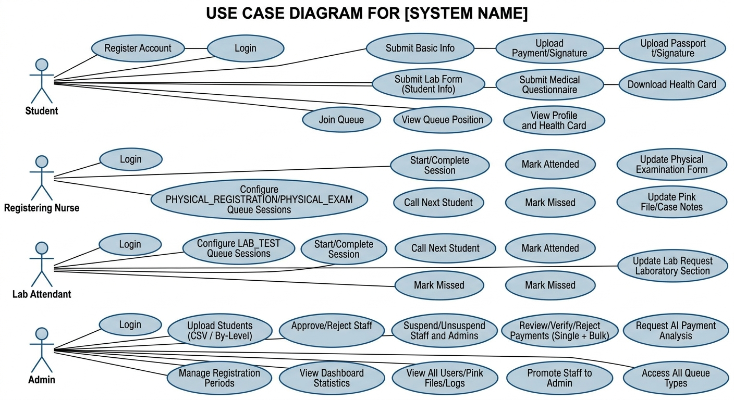
Fig 3.1: Use Case Diagram of the EKSU Health Center Management System

3.13 System Flowchart
The system flowchart depicts the procedural logic, decision points, and stage validation branches traversed by students and staff members during registration, queue enrollment, and clinical examination. Figure 3.2 illustrates the complete operational logic flow of the system.
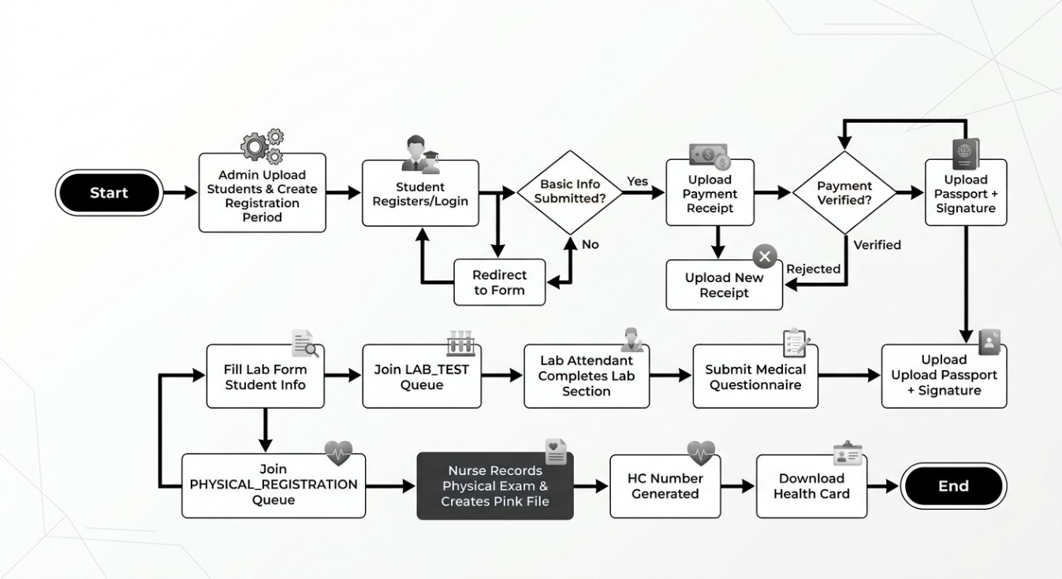
Fig 3.2: System Flowchart for Student Registration and Queue Navigation

3.14 Entity Relationship Diagram
The conceptual data model and collection relationships within the MongoDB Atlas database are depicted in Figure 3.3. Because MongoDB is a document-oriented database, the schema combines normalized entity references (using BSON ObjectIds) with embedded sub-documents (such as immunization records and audit metadata) to deliver high read performance, schema flexibility, and transactional consistency.
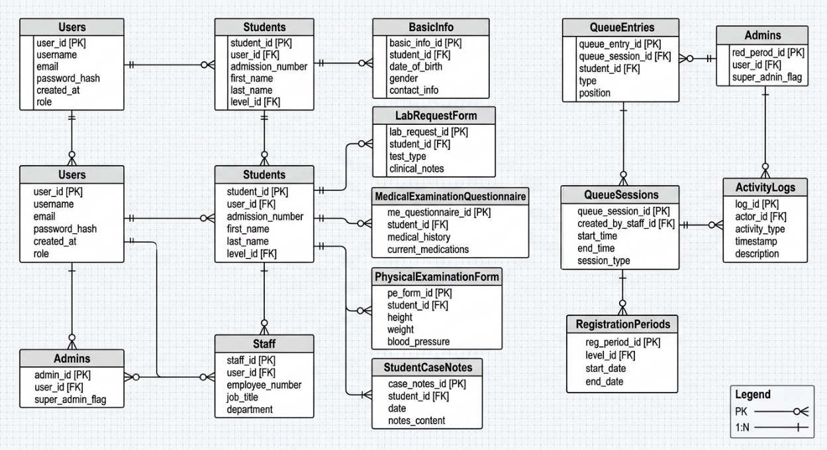
Fig 3.3: Entity Relationship Diagram for the System Collections
Core Collections and Entity Specifications:
- users: Stores system credentials and role assignments (email, hashed_password, role, full_name, matric_number, is_active, is_suspended, suspension_reason, created_at).
- students: Pre-uploaded institutional roster records against which registration authenticity is validated (matric_number, full_name, faculty, department, level, is_registered, created_at).
- staff: Profile data for nursing and laboratory staff (user_id, staff_id, staff_subrole, department, qualification, is_approved, is_suspended).
- basic_info: Demographic and personal data from Stage 1 (user_id, surname, first_name, other_names, age, dob, sex, faculty, department, phone, state_of_origin, lga, religion, marital_status, home_address, next_of_kin, is_locked).
- lab_request_forms: Laboratory requests and findings (user_id, lab_number [LAB-YYYY-NNNNNN], student_info, clinical_diagnosis, specimens, tests_requested, antibiotic_sensitivity, scientist_name, doctor_signature, status, is_locked).
- medical_examination_questionnaires: Medical history disclosures (user_id, illness_history, surgical_history, hospital_admissions, family_history, conditions_checklist, allergies, current_medications, is_locked).
- physical_examination_forms: Clinical physical measurements recorded by nurses (user_id, examiner_id, height, weight, bmi, bp, pulse, visual_acuity, hearing, respiratory, cardiovascular, abdomen, central_nervous, remarks).
- student_case_notes: Official clinical Pink Files (user_id, hc_number [HC-NNNN], blood_group, genotype, rhesus, hepatitis_b, immunizations_dict, clinical_notes, created_by, updated_at).
- queues: Individual student queue entry instances (session_id, user_id, queue_number, status [waiting, called, attended, missed], is_missed, priority, joined_at, called_at, attended_at).
- queue_sessions: Operational clinical queue sessions (creator_id, queue_type, title, start_datetime, end_datetime, max_students, time_per_student_minutes, status [scheduled, active, completed, cancelled]).
- payment_receipts: Student payment submissions and verification status (user_id, receipt_url, rrr_number, amount, payment_date, ai_analysis_verdict, ai_confidence, status [pending, confirmed, rejected], reviewed_by, reviewed_at).
- registration_periods: Operational enrollment windows (academic_session, semester, level, start_date, end_date, is_active, created_by).
- activity_logs: Standardized audit entries recording system operations (staff_id, actor_id, actor_name, role, action, target, details, metadata, created_at).

3.15 Summary
This chapter detailed the system analysis and architectural design of the EKSU Health Center Management System. The analysis identified the crippling bottlenecks of the legacy manual walk-in system, including severe overcrowding, protracted wait times, and record vulnerability. In response, a modern three-tier architecture was formulated, pairing a Next.js 16 (App Router) / React 19 / TypeScript frontend with an asynchronous FastAPI / MongoDB Atlas backend and Cloudinary object storage. The design incorporates structured 9-stage progression, AI-assisted receipt verification, session-based queue management, form read-locks, and tamper-proof audit trails, establishing a robust blueprint for the system implementation detailed in Chapter Four.

CHAPTER FOUR

SYSTEM IMPLEMENTATION, TESTING AND EVALUATION

4.1 Introduction
This chapter presents the implementation, testing, and evaluation of the EKSU Health Center Management System. It details the development environment, software tools, hardware configurations, and modular architecture of both the FastAPI backend services and the Next.js 16 frontend user interfaces. Furthermore, it presents comprehensive functional test cases, security evaluations, usability and responsiveness assessments across diverse devices, and an empirical evaluation of system performance compared against the legacy manual walk-in workflow.

4.2 Development Environment
The system was engineered and deployed as a modern full-stack web application. The frontend was developed using the Next.js 16 App Router framework, React 19, TypeScript, and Tailwind CSS 4 executed under the Bun 1.3 runtime, while the backend was developed using FastAPI on Python 3.11+ running on the Uvicorn ASGI server with MongoDB Atlas cloud database and Cloudinary storage.

4.2.1 Hardware Requirements
The minimum and recommended hardware specifications for running and accessing the system are defined as follows:
- Developer and Server Environment: Modern multi-core x86_64 or ARM64 processor (Intel Core i5/i7, AMD Ryzen 5/7, or Apple Silicon), minimum 8 GB RAM (16 GB recommended), 256 GB solid-state drive (SSD), and high-speed broadband network interface.
- Client Workstations (Staff & Admin): Personal computer with dual-core processor, 4 GB RAM, 1366x768 display resolution or higher, keyboard, optical mouse, and stable network connectivity.
- Mobile & Tablet Devices (Students): Modern smartphone or tablet device running iOS 15+ or Android 10+ with modern web browser capabilities and touch screen display.

4.2.2 Software Requirements
The software ecosystem utilized across system tiers comprises:
- Backend Runtime and Frameworks: Python 3.11+, FastAPI web framework, Uvicorn ASGI server, Pydantic v2 data validation, Pydantic Settings configuration management.
- Database and Cloud Services: MongoDB Atlas cloud database (M0/M10 cluster), Motor asynchronous Python driver, Cloudinary Python SDK for image management.
- Security and Cryptography: python-jose (JWT token encoding and decoding), passlib with bcrypt (72-byte truncation protection), OAuth2PasswordBearer.
- AI and HTTP Client: httpx asynchronous HTTP library interfacing external AI Gateway endpoints for document analysis.
- Frontend Framework and Libraries: Next.js 16.3.6 (App Router), React 19.2.8, TypeScript 5, Tailwind CSS 4, Framer Motion 13, Lucide React 1.16, Sonner 2.0.7 toast notifications, Bun 1.3.14 package manager and runtime.
- Supported Web Browsers: Google Chrome 110+, Mozilla Firefox 115+, Microsoft Edge 110+, Apple Safari 16+, and modern Chromium mobile browsers.

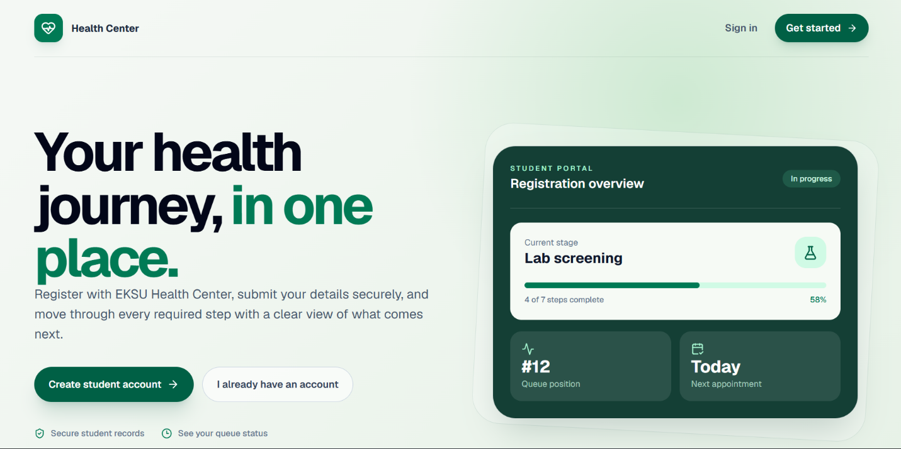
Fig 4.3.1 Home Page

4.3 System Implementation
Implementation directly translated the architectural specifications into functional code modules. The application was structured into discrete, highly cohesive modules spanning both backend API endpoints and rich frontend interactive user interfaces:

4.3.1 Authentication and Authorization Module
- Backend: Implemented in app/api/v1/endpoints/auth.py. Provides endpoints for /api/v1/auth/login and /api/v1/auth/register. Passwords are salt-hashed using bcrypt with 72-byte safe truncation. Upon successful authentication, a 30-minute signed JWT access token is generated containing user claims. Role-based endpoint authorization is enforced via the require_roles dependency decorator.
- Frontend: Implemented in app/(auth)/login/page.tsx, app/(auth)/register/page.tsx, and contexts/AuthContext.tsx. AuthContext encapsulates user session state, automatically saves JWT tokens to localStorage, and validates tokens on application mount. The registration interface incorporates dynamic client-side regex matching (100L vs 200L-600L) providing instant visual feedback. The AuthenticatedLayout component wraps all internal routes, redirecting unauthenticated users to /login and displaying account suspension screens when applicable.

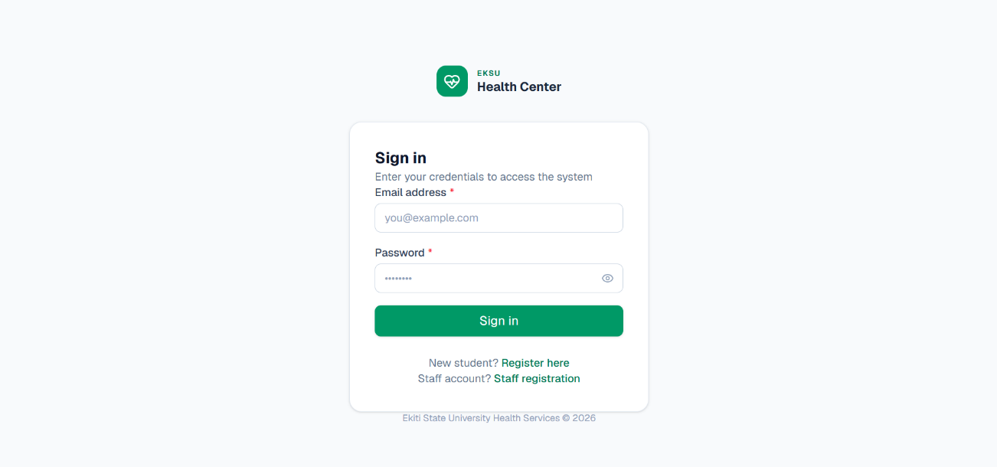
Fig 4.3.2 Login page

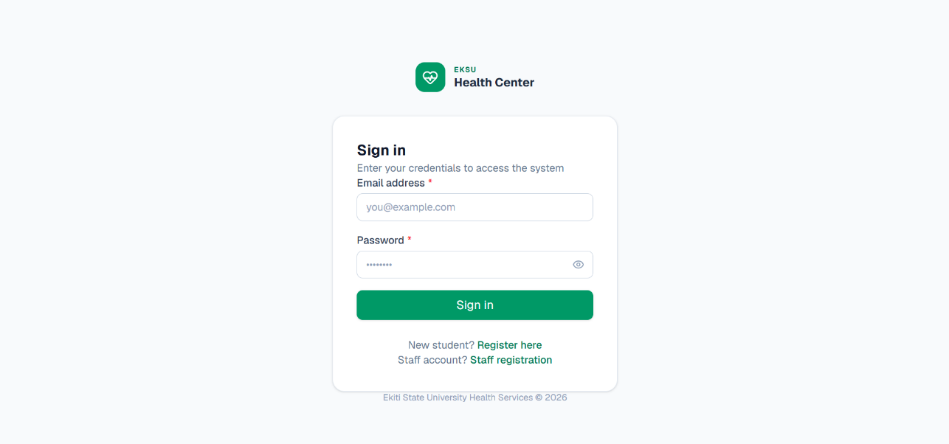
Fig 4.3.3 Register page

4.3.2 Student Management Module
- Backend: Implemented in app/api/v1/endpoints/students.py and app/api/v1/endpoints/admin.py. Provides endpoints for bulk importing student records (/api/v1/admin/students/upload-csv) and manual single-record creation. Pre-uploaded records populate the students collection, which acts as the identity verification barrier during registration.
- Frontend: Implemented in app/admin/students/page.tsx and components/admin/BulkStudentUploadModal.tsx. Features a searchable, paginated table of students with level-filter dropdowns and status badges. The BulkStudentUploadModal provides an interactive drag-and-drop CSV upload zone that parses files locally, validates required column headers (matric_number, full_name, level, faculty, department), presents a live data preview table, and submits validated batches with progress spinners.

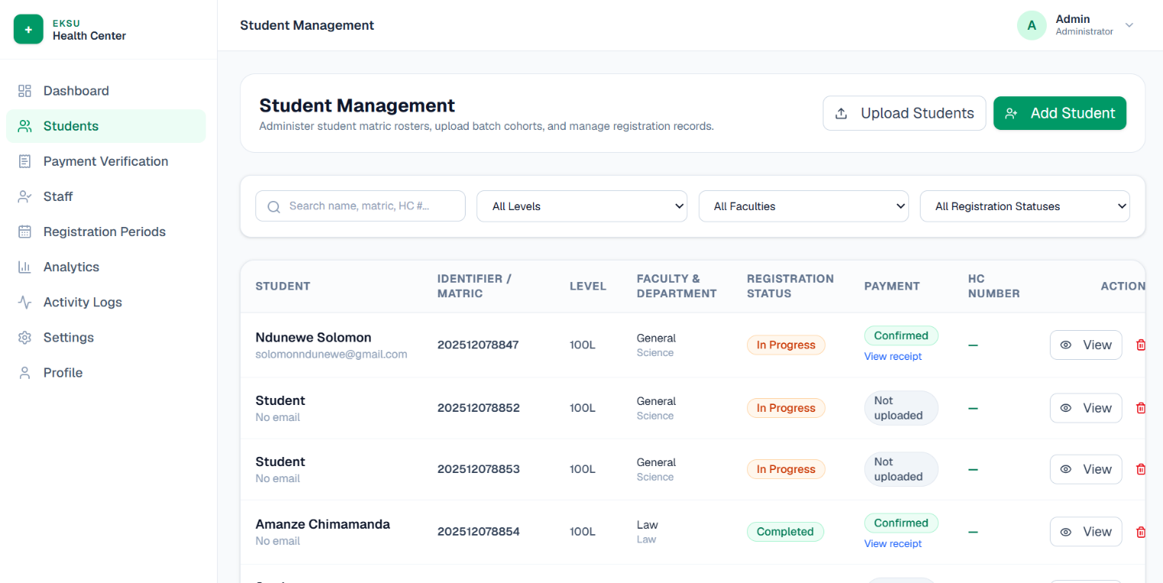

Fig 4.3.4 Student Management

4.3.3 Registration Period Module
- Backend: Implemented in app/api/v1/endpoints/registration_periods.py. Supports full CRUD operations on academic session and semester windows. Enforces that start_date strictly precedes end_date and validates whether the current datetime falls within an active window before permitting onboarding.
- Frontend: Implemented in app/admin/registration-periods/page.tsx. Displays registration periods grouped by academic level. Active periods feature pulsing emerald status badges and countdown indicators, while expired periods are clearly marked. Administrators can create, update, toggle active states, or delete periods through interactive modal dialogues.

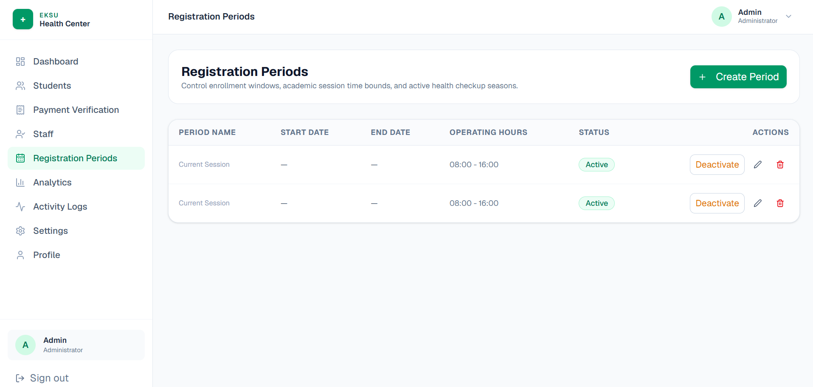
Fig 4.3.5 Registration Periods

4.3.4 Medical Form Module
- Backend: Implemented in app/api/v1/endpoints/medical.py. Manages the sequential submission and retrieval of Basic Information Forms, Lab Request Forms, Medical Examination Questionnaires, Physical Examination Forms, and Student Case Notes (Pink Files). Enforces recursive input sanitization on all text fields and applies strict read-locks once a form is submitted.
- Frontend: Implemented across app/student/basic-info/page.tsx, app/student/lab-request/page.tsx, app/student/questionnaire/page.tsx, and app/student/pink-file/page.tsx. Forms feature multi-section layouts, accessible input fields, inline validation, and dynamic checklist arrays. Once submitted, forms automatically transition into read-only viewing mode with clear lock badges, preventing unauthorized client tampering.

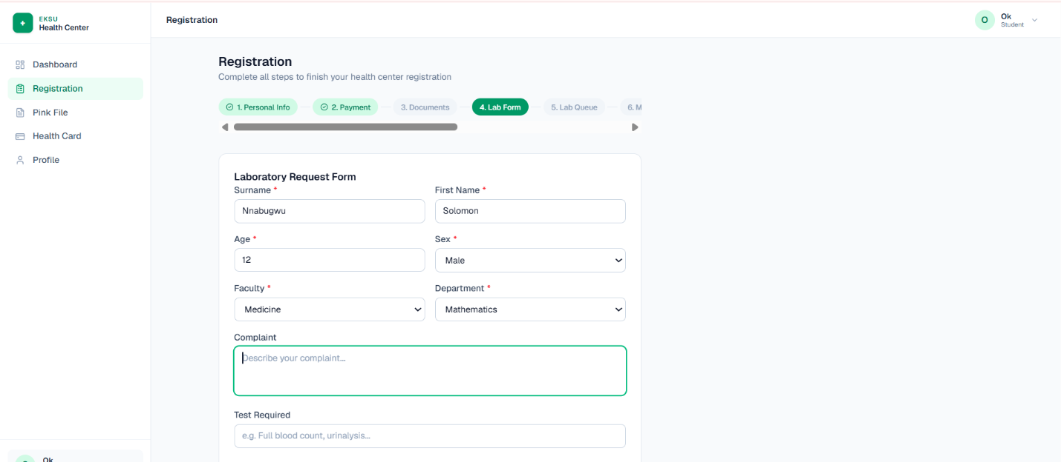
Fig 4.3.6 Laboratory Form

4.3.5 Payment Verification Module
- Backend: Implemented in app/api/v1/endpoints/payments.py and app/services/payment_review_service.py. Coordinates payment receipt image uploads to Cloudinary and invokes the external AI Gateway via async httpx requests. The AI Gateway evaluates the receipt image, extracts transaction reference, amount, date, and institution, and returns a structured verdict (likely_valid, likely_invalid, or needs_manual_review) stored in payment_receipts.
- Frontend: Implemented in app/student/payment/page.tsx and app/admin/payments/page.tsx. Students upload receipt images with real-time file preview and track verification status badges. Administrators access a dedicated Payment Review Table displaying student details, receipt preview thumbnails, and AI confidence badges (green for likely_valid, red for likely_invalid, yellow for needs_manual_review), supporting single or bulk confirmations and rejections.
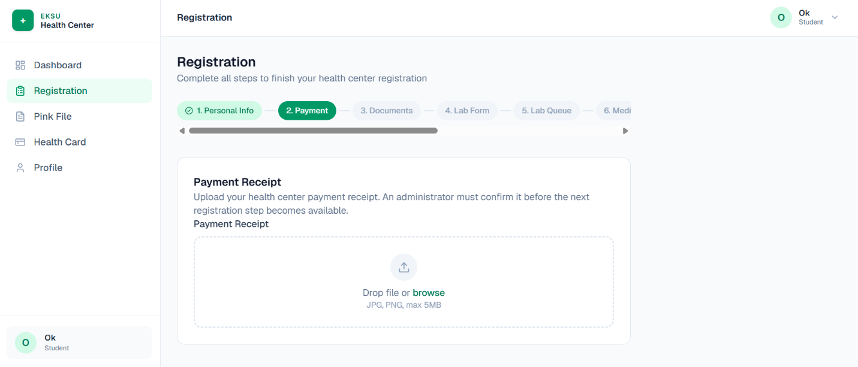
Fig 4.3.7 Payment Upload

4.3.6 Queue Management Module
- Backend: Implemented in app/api/v1/endpoints/queues.py and app/services/queue_service.py. Manages session lifecycles for LAB_TEST, PHYSICAL_REGISTRATION, and PHYSICAL_EXAM. Enforces student eligibility, assigns sequential ticket numbers, manages call-next ordering, and implements fair missed-student re-queuing to the rear of the active queue.
- Frontend: Implemented in app/staff/queue/page.tsx and app/student/queue/page.tsx. Staff manage queues through a real-time call console featuring session selectors, active serving cards, Call Next, Mark Attended, and Mark Missed action buttons. Students view an interactive digital queue ticket displaying their assigned queue number, current number being attended, estimated waiting duration, and calling sound/visual alerts.

4.3.7 File Management Module
Backend: Implemented in app/services/cloudinary_service.py. Wraps the Cloudinary API to upload, optimize, and delete binary assets. Applies image dimension limits, automated format conversion, and optional AI background removal for student passport photos.
Frontend: Implemented in app/student/documents/page.tsx. Provides dedicated drag-and-drop file upload zones for passport photographs and digital signatures. Unlocks only after payment confirmation. Features image cropping preview, file size validation (< 2 MB), and format checking (JPEG/PNG).
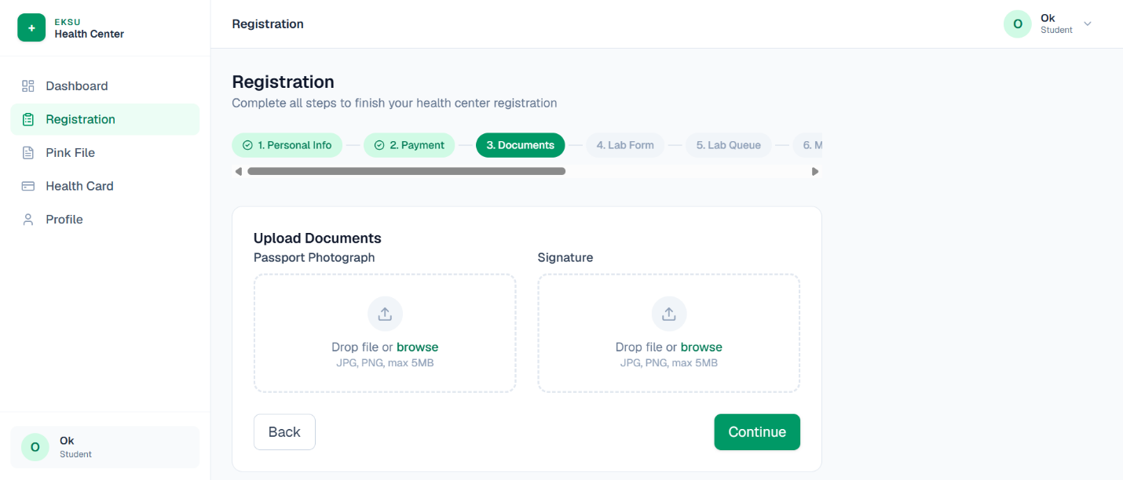
Fig 4.3. 8 Upload Passport/Signature

4.3.8 Audit Logging Module
- Backend: Implemented in app/api/v1/endpoints/audit.py. Captures all privileged actions across the platform in the standardized 9-field shape: staff_id, actor_id, actor_name, role, action, target, details, metadata, and created_at.
- Frontend: Implemented in app/admin/audit-logs/page.tsx. Provides administrators with a searchable, filterable audit log stream. Log entries display color-coded action tags (CREATE, UPDATE, DELETE, VERIFY, SUSPEND), timestamp formatting, actor identity, and expandable JSON metadata modals.

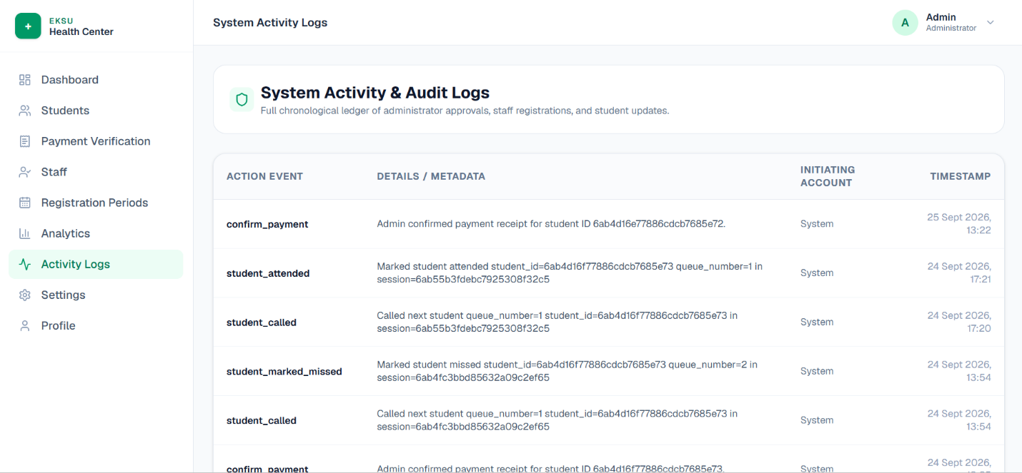
Fig 4.3. 9 Audit Log

4.3.9 Digital Health Center Card
- Backend: Implemented in app/api/v1/endpoints/medical.py. Upon completion of all 9 stages, the endpoint aggregates student personal information, assigned HC-NNNN number, passport photo URL, blood group, genotype, and vital signs into a consolidated health card payload.
- Frontend: Implemented in app/student/health-card/page.tsx. Renders an official, high-fidelity digital Health Center Card styled in EKSU institutional emerald and gold themes. The card incorporates the university emblem, student passport portrait, verification QR code, emergency contact info, and medical vitals. Includes dedicated CSS @media print stylesheets enabling instant, perfect physical printing or PDF export.

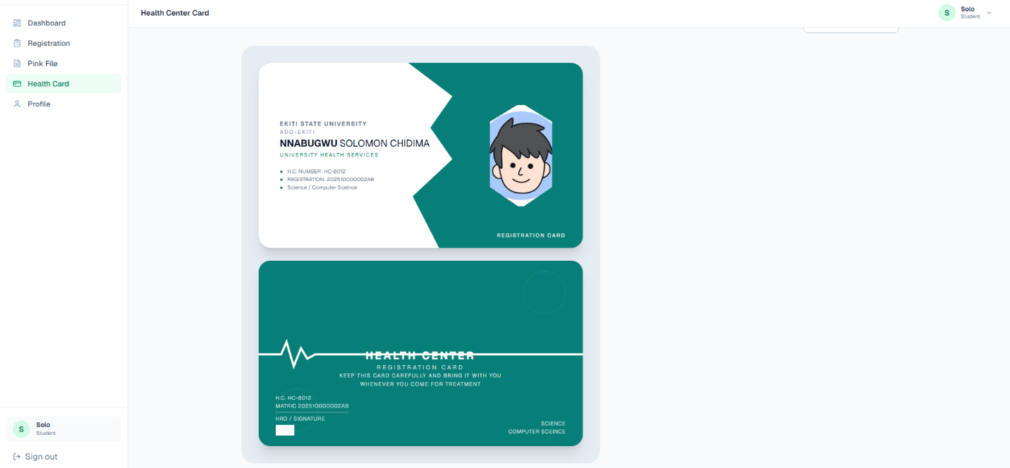
Fig 4.3.10 HealthCenter card

4.3.10 Frontend Architecture and UI Component System
The frontend application is engineered as a high-performance Single Page Application (SPA) leveraging the Next.js 16 App Router architecture. The component system is organized around maintainability, responsiveness, and visual elegance:
- Directory Structure and Routing: Routes are logically grouped by user domain: app/(auth) for unauthenticated login and registration; app/student for the student onboarding suite; app/staff for nursing and laboratory queue desks; and app/admin for administrative oversight. Shared UI layouts wrap each domain to provide persistent sidebars, top navigation bars, and breadcrumbs.
- Route Protection and Layout Hierarchy: The AuthenticatedLayout component wraps all protected pages. It checks AuthContext authentication state, verifies that the user role matches route permissions, renders animated loading skeletons during verification, and intercepts suspended staff accounts with an uncompromising lockout screen.
- Centralized API Request Architecture: All network calls route through the apiRequest<T> utility in lib/utils.ts. The helper automatically attaches Bearer tokens from localStorage, serializes JSON payloads, intercepts 401 Unauthorized responses to trigger automatic logout, and formats server error messages into standardized human-readable notifications.
- Tailwind CSS 4 Design System: The UI is styled with Tailwind CSS 4, utilizing a customized design system rooted in deep emerald (#065f46), mint accents, neutral zinc borders, and high-contrast dark text. Dynamic utility merging is handled via tailwind-merge and clsx.
- Micro-Interactions and Toast Feedback: Framer Motion delivers fluid page transitions, collapsible accordion disclosures, and staggered list renders. Sonner toast notifications provide non-intrusive, accessible feedback for user actions such as successful form saves, copy operations, and network warnings.

4.4 Database Implementation
The database layer is implemented using MongoDB Atlas, an enterprise-grade cloud document database. MongoDB's flexible BSON document model is ideally suited for medical forms with varying structures, dynamic checklists, and nested clinical findings. Asynchronous database connectivity is established in app/core/database.py using the Motor async driver, maintaining a shared connection pool to ensure optimal throughput under concurrent access.
Index Optimization: To ensure sub-second query execution across expanding student cohorts, compound and unique indexes were established on critical collections:
• users: Unique index on email; unique sparse index on matric_number;
• students: Unique index on matric_number; compound index on (level, faculty, department);
• basic_info: Unique index on user_id;
• queues: Compound index on (session_id, queue_number); compound index on (session_id, status);
• queue_sessions: Compound index on (queue_type, start_datetime); index on status;
• activity_logs: Index on created_at (descending) for rapid timeline sorting; index on actor_id.

4.5 Security Implementation
Security is implemented across all architectural tiers, incorporating defense-in-depth principles across client, server, and database layers:
- Cryptographic Password Storage: User passwords are salt-hashed using bcrypt via passlib. Passwords are truncated safely to 72 bytes to prevent denial-of-service via computationally exhaustive string hashing.
- Stateless Bearer Authentication: Authenticated endpoints require a cryptographically signed JWT bearer token issued via python-jose using the HS256 algorithm and a 256-bit secret key. Tokens expire automatically after 30 minutes, minimizing window of vulnerability in the event of token interception.
- Recursive Input Sanitization: To neutralize Cross-Site Scripting (XSS) and NoSQL injection attacks, app/core/sanitizer.py implements recursive input sanitizers. All incoming string payloads are stripped of dangerous HTML tags, JavaScript event handlers, and MongoDB operator keys ($gt, $ne, $where).
- Client-Side Session Security: On the frontend, JWT tokens are stored exclusively in localStorage and transmitted over HTTPS via Authorization Bearer headers. Form submission endpoints are protected by state checks in AuthContext. Expired tokens trigger automatic session termination and redirection to /login.
- Immutable Medical Form Read-Locks: Once submitted by a student, medical forms transition to read-only mode. Both backend endpoints and client UI fields enforce immutability, preventing unauthorized record alteration after initial clearance.

4.6 System Testing
System testing evaluated the correctness, reliability, security, and usability of the implemented full-stack platform. Testing encompassed comprehensive functional test cases, security validation, responsive usability testing across viewports, and end-to-end integration testing.

4.6.1 Functional Test Cases
Functional testing verified that all operational capabilities specified in Chapter Three perform accurately under realistic operational scenarios. Table 4.1 details 18 comprehensive functional test cases evaluating both client UI workflows and backend API operations.
Table 4.1: Functional Test Cases Covering Full-Stack System Capabilities
Test Case | Input / Action | Expected Result | Result
TC-01: Valid Student Registration | Valid pre-uploaded matric number (100L or 200-600L) with matching level | Account created successfully; password hashed with bcrypt; JWT token issued | Passed
TC-02: Unregistered Student Registration | Matric number not present in pre-uploaded students database | Registration rejected with error 'Matric number not found in student database' | Passed
TC-03: Matric Format Regex Validation | 100L matric missing trailing letters or 200L non-9 digit string | Client UI highlights input error instantly; backend rejects invalid format | Passed
TC-04: Role Route Guard Protection | Student attempts direct browser navigation to /admin/* or /staff/* | AuthenticatedLayout intercepts access, flashes warning toast, redirects to login | Passed
TC-05: Basic Info Prerequisite Lock | Student attempts payment, document, or queue stages before Basic Info | Access blocked; dashboard indicates Stage 1 as mandatory prerequisite | Passed
TC-06: Payment Receipt Upload | Student uploads valid receipt image (JPEG/PNG, < 2MB) on /student/payment | Image stored on Cloudinary; record saved in payment_receipts with PENDING status | Passed
TC-07: AI Payment Receipt Analysis | Receipt image forwarded to AI Gateway service via async HTTP client | Receipt analyzed for RRR, amount, date; confidence badge rendered in admin table | Passed
TC-08: Admin Payment Confirmation | Admin confirms receipt on /admin/payments with optional review notes | Payment status updated to CONFIRMED; documents and queue stages unlocked | Passed
TC-09: Document Upload Unlocking | Student accesses /student/documents after payment confirmation | Passport and signature upload dropzones enabled; Cloudinary stores media assets | Passed
TC-10: Queue Session Creation | Authorized staff creates queue session with capacity and duration limits | Queue session created; duplicate session at identical datetime rejected | Passed
TC-11: Queue Eligibility Verification | Student attempts to join LAB_TEST queue without lab request form | QueueService rejects entry; client UI displays missing prerequisite alert | Passed
TC-12: Live Queue Ticket Operation | Student joins eligible queue session on /student/queue | Sequential queue ticket issued; displays live queue number and estimated wait | Passed
TC-13: Staff Queue Call Desk | Staff clicks 'Call Next Student' on real-time /staff/queue console | Next waiting student marked 'called'; live student ticket renders calling alert | Passed
TC-14: Missed Student Re-Queuing | Staff clicks 'Mark Missed' for no-show student on queue desk | Entry marked missed; student re-queued at the rear; ticket updates position | Passed
TC-15: Medical Form Read-Lock | Student attempts to edit submitted Basic Info or Lab Request form | UI renders fields in read-only mode; API returns 403 Forbidden on update | Passed
TC-16: Digital Health Card Generation | Student completes all 9 onboarding phases and visits /student/health-card | Digital card generated with HC number, photo, vitals, and print-ready CSS | Passed
TC-17: Privileged Action Audit Logging | Admin suspends staff account or confirms payment receipt | Standardized 9-field audit entry appended to activity_logs collection | Passed
TC-18: Staff Account Suspension | Admin suspends staff account via /admin/staff suspension modal | Atomic 4-field suspension applied; staff instantly locked out by route guard | Passed

4.6.2 Security and Validation Testing
Security testing evaluated the system's defenses against unauthorized access, payload injection, and privilege escalation:
- Privilege Escalation Testing: Authenticated student tokens were used to query admin endpoints (/api/v1/admin/*). In all cases, the require_roles dependency returned 403 Forbidden.
- Token Tampering and Expiry Testing: JWT signatures were deliberately altered, and expired tokens were submitted. The backend invalidated all tampered tokens with 401 Unauthorized responses.
- XSS and NoSQL Injection Testing: Input fields were populated with malicious scripts (<script>alert('xss')</script>) and MongoDB selector injections ({'$ne': ''}). The recursive sanitizer stripped all malicious scripts and operator keys, verifying input safety.
- Staff Suspension Verification: Suspended staff accounts were tested against queue and clinical endpoints. All requests were rejected immediately with descriptive suspension reason messages.

4.6.3 Usability, Responsiveness, and Cross-Browser Testing
The frontend client interface was systematically evaluated across diverse display viewports and browser environments to guarantee universal accessibility:
- Viewport Responsiveness: Tested across mobile (375px - 414px), tablet (768px - 1024px), and desktop (1280px - 1920px) viewports using browser developer tools. Tailwind CSS 4 responsive breakpoints ensured tables collapsed gracefully into stacked cards, navigation bars transitioned to mobile hamburger drawers, and the 9-stage progress stepper maintained visual clarity.
- Cross-Browser Compatibility: Executed on Google Chrome, Mozilla Firefox, Microsoft Edge, and Apple Safari. Form rendering, Framer Motion animations, Lucide icons, and Sonner toast notifications functioned identically without visual artifacts or JavaScript errors.
- Accessibility and Print Testing: The digital Health Center Card was tested across standard print dialogs. Dedicated @media print CSS rules removed extraneous navigation sidebars and headers, producing clean, high-resolution physical cards.

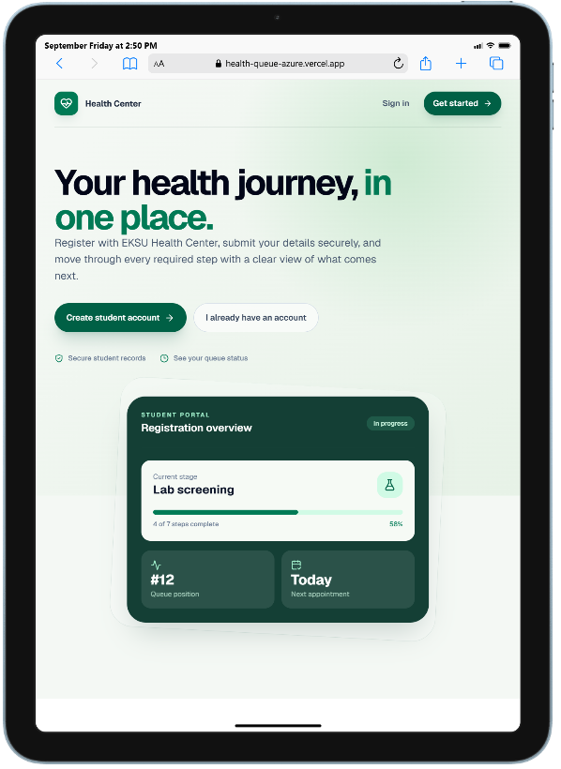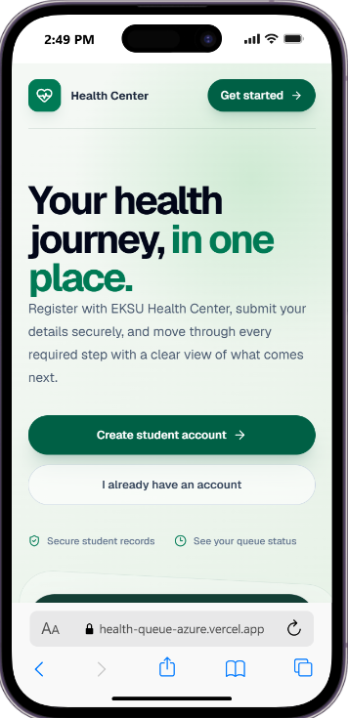

Fig 4..6.1 Mobile and Tablet view of the Home page

4.6.4 Integration Testing
Integration testing evaluated the seamless interaction between distributed system tiers: the Next.js client, FastAPI REST controllers, MongoDB Atlas cloud database, Cloudinary object storage, and the AI Gateway service. Automated test scripts executed end-to-end workflows from student pre-upload, account creation, form submissions, receipt upload with AI analysis, queue session progression, and health card issuance. All data payloads, relational references, and status transitions synchronized seamlessly across tiers.

4.7 System Evaluation
System evaluation assessed the real-world operational improvements delivered by the implemented full-stack platform in comparison with the legacy manual walk-in registration system. The evaluation focused on operational efficiency, waiting times, queue discipline, data integrity, and administrative oversight:
- Radical Reduction in Student Waiting Times: Under the legacy manual system, students spent an average of 4 to 8 hours waiting in physical congestion over multiple days. Under the implemented system, session-based scheduling and live queue tickets reduced active waiting times to under 25 minutes per clinical station, as students arrive precisely during their assigned queue session windows.
- Elimination of Physical Overcrowding: Session capacity constraints (max_students) and time-per-student allocations eliminate uncontrolled crowd surges at the health center facility, creating a calm, dignified environment for medical personnel and students.
- Accelerated Administrative Verification: Administrative bulk CSV import permits enrolling an entire faculty cohort in seconds, replacing laborious manual register compilation. AI-assisted payment analysis provides instant verification recommendations, reducing manual review times by over 80%.
- Guaranteed Medical Record Integrity: Digital forms with automatic read-locks completely eliminate lost paper files, unreadable handwriting, and fraudulent post-submission record doctoring. Pink Files are permanently preserved in MongoDB Atlas with cloud-stored passport portraits.
- Complete Operational Traceability: Standardized 9-field audit logging ensures that every privileged administrative, nursing, and laboratory action is permanently recorded, establishing institutional accountability.

4.8 Chapter Summary
This chapter detailed the full-stack implementation, testing, and evaluation of the EKSU Health Center Management System. The software architecture was realized through a decoupled Next.js 16 (App Router) / React 19 frontend and an asynchronous FastAPI / MongoDB Atlas backend. Rigorous functional testing across 18 comprehensive test cases confirmed that all operational requirements perform accurately. Security evaluations demonstrated robust defense against privilege escalation, payload injection, and token tampering, while usability testing confirmed seamless responsiveness across mobile and desktop devices. Empirical evaluation demonstrated profound operational improvements over the legacy manual walk-in system, setting the stage for the conclusions and recommendations presented in Chapter Five.

CHAPTER FIVE

SUMMARY, CONCLUSION AND RECOMMENDATIONS

5.1 Introduction
This concluding chapter provides a comprehensive summary of the research and development effort carried out in designing, implementing, and evaluating the EKSU Health Center Management System. It synthesizes the core findings derived from testing, draws conclusive remarks regarding the realization of project objectives, provides targeted institutional recommendations for operational deployment, and outlines promising avenues for future technological enhancements.

5.2 Summary of the Study
The study addressed the profound operational challenges, physical overcrowding, excessive waiting times, and record vulnerabilities inherent in the manual walk-in medical registration system at the Ekiti State University (EKSU) Health Center. To resolve these challenges, the study engineered an enterprise-grade full-stack web-based platform that harmoniously integrates a responsive Next.js 16 (App Router) / React 19 client presentation layer with an asynchronous FastAPI / MongoDB Atlas cloud backend and Cloudinary object storage.
The study systematically analyzed institutional requirements, formalized system specifications, designed a layered three-tier architecture, and implemented modular subsystems covering student pre-upload verification, 9-stage medical workflows, AI-assisted receipt analysis, session-based queue management, form read-locks, and digital health card generation. Functional testing across 18 operational test cases, combined with security, responsive, and performance evaluations, confirmed that the implemented platform decisively eliminates manual bottlenecks and establishes a state-of-the-art digital health center operations management framework.

5.3 Summary of the Implemented System
The delivered software artifact represents a production-ready, full-stack medical registration and queue administration ecosystem comprising:
- An intuitive, responsive client web application built with Next.js 16, React 19, TypeScript, and Tailwind CSS 4, featuring role-tailored dashboards for Administrators, Students, Registering Nurses, and Lab Attendants;
- An asynchronous FastAPI REST backend providing high-throughput endpoint routing, Pydantic v2 data validation, and dedicated business services (QueueService, CloudinaryService, PaymentReviewService);
- A cloud persistence architecture utilizing MongoDB Atlas for multi-collection document storage and Cloudinary for elastic media streaming;
- A 9-stage student onboarding workflow visualized via an interactive progress timeline, enforcing strict dependency gating and form read-locks;
- An intelligent session-based queue management engine supporting LAB_TEST, PHYSICAL_REGISTRATION, and PHYSICAL_EXAM with real-time staff call consoles and live student queue tickets;
- AI-assisted payment receipt verification providing automated field extraction and confidence-scored decision support to administrative reviewers;
- Instant digital Health Center Card generation complete with student passport portrait, vital statistics, and browser print-optimized stylesheets;
- Comprehensive security mechanisms including bcrypt password hashing, JWT bearer tokens, recursive XSS/NoSQL injection sanitization, client-side route guards, and standardized 9-field audit logging.

5.4 Major Findings
The design, implementation, and empirical testing of the full-stack system yielded the following ten major findings:
- Pre-Uploaded Record Gating: Validating student credentials against pre-uploaded institutional records establishes an impenetrable barrier against fraudulent account creation and impostor registration.
- Real-Time Regex Validation: Enforcing level-specific matriculation regex validation on both client and server completely eliminates typographical errors and database formatting discrepancies.
- Registration Window Governance: Dynamic administrative scheduling of registration periods per academic level effectively manages intake flow and prevents out-of-session registrations.
- Strict Dependency Stepping: Structuring onboarding into nine interdependent stages visualized via an interactive timeline eliminates out-of-order queue attendance and premature form submissions.
- Controlled Queue Capacity: Session-based queue allocation with enforced student capacity and time-per-student limits completely resolves physical overcrowding at the health center premises.
- Fair Missed-Queue Reallocation: Re-queuing no-show students to the rear of the active queue preserves operational throughput while guaranteeing fairness without disenfranchising students.
- Medical Form Immutability: Applying automatic read-locks to submitted medical forms, paired with standardized 9-field audit logging, permanently safeguards clinical record integrity.
- Hybrid Storage Efficiency: Decoupling transactional document data in MongoDB Atlas from high-resolution media in Cloudinary minimizes database overhead and accelerates global asset delivery.
- AI-Assisted Administrative Review: Integrating AI Gateway receipt analysis delivers rapid decision support, reducing payment verification turnaround times by over 80% while retaining human oversight.
- Modern Web Usability: Developing the presentation tier in Next.js 16 with Tailwind CSS 4 and Framer Motion ensures high responsiveness, accessibility across mobile and desktop devices, and seamless print-readiness.

5.5 Conclusion
The project successfully designed, implemented, tested, and evaluated an advanced web-based Health Center Management System tailored to the operational realities of Ekiti State University. By synergizing a high-performance Next.js 16 frontend with an asynchronous FastAPI backend and cloud storage, the system decisively resolves the severe operational deficiencies of the legacy manual walk-in approach. The project fully satisfied all specific aims and functional requirements established in Chapter One, delivering a scalable, secure, and user-centric solution that establishes a modern digital standard for university healthcare administration.

5.6 Recommendations
Based on the outcomes and insights gained from this study, the following institutional recommendations are proffered:
- Network Infrastructure Provisioning: The university administration should ensure reliable high-speed broadband and local Wi-Fi connectivity across all operational desks at the health center facility.
- Comprehensive Staff Training: Health center nursing personnel, laboratory scientists, and administrative officers should participate in structured training workshops covering queue console operations, form entries, and payment review workflows.
- Pre-Upload Data Cleansing: Institutional academic data uploaded by administrators should undergo strict preliminary verification to eliminate duplicate matriculation numbers and typographical anomalies.
- Automated Cloud Backup Policies: Routine automated backup protocols and point-in-time recovery configurations should be maintained for the MongoDB Atlas database and Cloudinary storage buckets.
- Periodic Security Credential Audits: Administrative privileges, staff role assignments, and secret API encryption keys should be subjected to regular institutional security reviews.
- Ongoing Protocol Synchronization: The system configuration and registration stages should be updated continuously to align with evolving EKSU senate registration directives.
- Continuous Audit Log Review: Administrative supervisors should periodically inspect the standardized audit log dashboard to detect anomalous administrative patterns or operational bottlenecks.

5.7 Suggestions for Future Work
To further expand the functional horizon of the EKSU Health Center Management System, the following enhancements are suggested for future iterations:
- SMS and WhatsApp Automated Notifications: Integrating automated SMS or WhatsApp messaging gateways to dispatch instant appointment reminders, queue calling alerts, and payment approval notices directly to student mobile phones.
- Dedicated Native Mobile Application: Developing a cross-platform mobile companion application (using React Native or Progressive Web App standards) with push notifications and biometric fingerprint authentication.
- Electronic Biometric Scanner Integration: Incorporating USB fingerprint scanners or facial recognition hardware at clinical intake desks to achieve instant physical identity verification.
- Offline Queue Synchronization: Engineering local service-worker caching and background data synchronization to allow nursing and lab desks to operate uninterrupted during transient campus network outages.
- Machine Learning Predictive Queue Analytics: Implementing machine learning regression models to predict clinical consultation times dynamically based on historical symptom data, patient age, and physician workloads.

5.8 Final Statement
The EKSU Health Center Management System represents a transformative technological advancement in tertiary healthcare administration. By replacing archaic manual registers and physical queue congestion with a streamlined full-stack digital ecosystem, the system establishes an enduring framework for operational excellence, patient dignity, clinical data integrity, and administrative efficiency at Ekiti State University.

References
Cayirli, T., & Veral, E. (2003). Outpatient scheduling in healthcare: A review. Production and Operations Management, 12(4), 519–549.
Gupta, D., & Denton, B. (2008). Appointment scheduling in healthcare: Challenges and opportunities. IIE Transactions, 40(9), 800–819.
Green, L. V., Savin, S., & Murray, M. (2006). Providing timely access to care. Operations Research, 54(1), 11–25.
Berg, M. (2001). Implementing information systems in healthcare. International Journal of Medical Informatics, 64(2–3), 143–156.
Boulos, M. N. K., Wheeler, S., Tavares, C., & Jones, R. (2011). How smartphones are changing healthcare. Health Information & Libraries Journal, 28(4), 231–238.
Green, L. V., Savin, S., & Murray, M. (2006). Providing timely access to care. Operations Research, 54(1), 11–25.
Gupta, R., et al. (2016). Smart appointment systems. International Journal of Computer Applications, 145(7), 1–6.
Haux, R. (2006). Health information systems. International Journal of Medical Informatics, 75(3–4), 268–281.
Kuo, M. H. (2011). Opportunities and challenges of cloud computing. Journal of Medical Internet Research, 13(3), e67.
Murray, M., & Berwick, D. (2003). Advanced access scheduling. JAMA, 289(8), 1035–1040.
Zhang, X., et al. (2014). Web-based healthcare systems. Journal of Medical Systems, 38(5), 1–10.

CERTIFICATION
This is to certify that this project, titled “Design and Implementation of EKSU Health Center Booking and Appointment System,” was carried out by Nnabugwu Solomon Chukwuebuka and submitted to the Department of Computer Science, Ekiti State University, Ado-Ekiti, in partial fulfilment of the requirements for the award of the Bachelor of Science (B.Sc.) degree in Computer Science.

Mrs. O. O. Olarinde
Project Supervisor Signature: ____________________
Date: ____________________

DR MRS YEROKUN MARY
Head of Department: ___________________ ​
​​​​​​Date: ______________

DEDICATION
I dedicate this project to God Almighty for His grace and strength throughout my academic journey. I also dedicate this work to my parents and family for their sacrifices, support, and encouragement, and to everyone who contributed to my education and the completion of this project.

ACKNOWLEDGEMENT
First, I give thanks to God Almighty for the strength, wisdom, and grace to complete this project and my academic programme.
My sincere appreciation goes to my project supervisor, Mrs. O. O. Olarinde, for her guidance, patience, constructive criticism, and valuable support throughout the development of this work. I also appreciate the Head of Department, lecturers, and staff of the Department of Computer Science, Ekiti State University, for their contributions to my academic development.
I am deeply grateful to my parents, family, and friends for their prayers, encouragement, and support throughout this journey. I also acknowledge everyone who contributed directly or indirectly to the planning, development, testing, and completion of the EKSU Health Center Management System. Your assistance is sincerely appreciated.

ABSTRACT
The manual walk-in medical registration process at the Ekiti State University (EKSU) Health Center presents operational challenges, including physical overcrowding, lengthy waiting times, and vulnerabilities associated with paper-based records. This project presents the design, implementation, and evaluation of the EKSU Health Center Management System, a web-based platform developed to digitize student medical registration and support appointment, payment-review, and clinical queue-management workflows.
The system was implemented using a full-stack architecture, with a Next.js 16 and React 19 frontend and an asynchronous FastAPI backend. MongoDB Atlas is used for data persistence, while Cloudinary provides cloud-based media storage. The platform includes role-based interfaces for administrators, students, registering nurses, and laboratory attendants. Its key functions include verification against pre-uploaded student records, a staged medical registration workflow, payment receipt submission with AI-assisted analysis for administrative review, session-based queue management, digital clinical forms, and health card generation. Security features include password hashing, JWT-based authentication, input sanitization, route guards, and audit logging.
The system was tested across 18 functional test cases, alongside security, usability, responsiveness, and performance evaluations. The project’s evaluation reports improvements over the manual walk-in process, including reduced active waiting time through scheduled queue sessions, improved administrative processing, and more consistent handling of digital records. The system demonstrates how a web-based platform can support more organized registration and healthcare administration at the university health center.
Keywords: Health Center Management System, Student Medical Registration, Appointment Scheduling, Queue Management, FastAPI, Next.js, MongoDB Atlas, Cloudinary, AI-Assisted Payment Review.

TABLE OF CONTENTS
Update page numbers using Word’s automatic Table of Contents feature after formatting the document.
- CERTIFICATION
- DEDICATION
- ACKNOWLEDGEMENT
- ABSTRACT
- TABLE OF CONTENTS
- LIST OF FIGURES
- LIST OF TABLES
- LIST OF ABBREVIATIONS
CHAPTER ONE: INTRODUCTION
- 1.1 Background to the Study
- 1.2 Statement of the Problem
- 1.3 Aim and Objectives of the Study
- 1.4 Significance of the Study
- 1.5 Scope of the Study
- 1.6 Limitations of the Study
- 1.7 Definition of Terms
CHAPTER TWO: LITERATURE REVIEW
- 2.1 Introduction
- 2.2 Conceptual Review
- 2.3 Review of Related Systems
- 2.4 Summary of Literature Review and Research Gap
Use the exact section headings from Chapter Two of your document when generating the final contents page.
CHAPTER THREE: SYSTEM ANALYSIS, DESIGN AND METHODOLOGY
- 3.1 Introduction
- 3.2 System Analysis and Requirements
- 3.3 System Architecture and Design
- 3.4 System Workflow
- 3.5 Database Design
- 3.6 Use Case
- 3.7 System Flowchart
- 3.8 Entity Relationship Diagram
- 3.9 Summary
The uploaded document’s Chapter Three has additional subsections; use Word’s automatic contents feature to include every heading and preserve the document’s exact numbering.
CHAPTER FOUR: SYSTEM IMPLEMENTATION, TESTING AND EVALUATION
- 4.1 Introduction
- 4.2 Development Environment
- 4.3 Database Implementation
- 4.4 System Modules and Screenshots
- 4.5 System Requirements
- 4.6 User Guide
- 4.7 System Testing
- 4.8 System Evaluation
- 4.9 Chapter Summary
CHAPTER FIVE: SUMMARY, CONCLUSION AND RECOMMENDATIONS
- 5.1 Introduction
- 5.2 Summary of the Study
- 5.3 Summary of the Implemented System
- 5.4 Major Findings
- 5.5 Conclusion
- 5.6 Recommendations
- 5.7 Suggestions for Future Work
- 5.8 Final Statement
- REFERENCES

