Overview
The plan for smashGPT is to leverage Large Multi-Modal Model-based RAG to combine:
Structured Historical Data – Contextual market information over time.
Textual & Visual Insights from Smashelito – A master trader who publishes daily trading plans for assets like /ES and /NQ using market-generated data and order flow. These plans are shared on X (Twitter) and Substack before the overnight session, offering a preview of potential scenarios and key levels.
Image Ingestion & Image-Based RAG – User can upload relevant charts or market snapshots for enhanced context.

How Smashelito’s Daily Trading Plans Help:
Preparation – Each plan interprets the current market structure, highlights essential price levels, and reviews the previous session.
Focus on Real-Time – By outlining scenarios in advance, traders can concentrate on order flow, volatility, and pace during live trading.
Market Awareness – Identifying multiple outcomes fosters a stronger market context, increasing the potential for a sustainable edge.
Routine & Discipline – Smashelito emphasizes a consistent pre-market routine to set professional standards and improve decision-making.
Use SmashGPT to chat about market profile, auction market theory, and to explore Smashelito’s trading insights with greater depth and accuracy.
References:
- https://smashelito.com/

NOTE: Not officially affiliated with Smashelito; just using his free daily reports of /ES
One of the initial and crucial steps in the project plan is to clone the sample-app-aoai-chatGPT.
By starting from a Microsoft sample application, we are building on a semi-established framework, reducing the risk of fundamental errors. Secondly, it accelerates our development process by providing pre-built components and functionalities, allowing us to focus on tailoring the application to meet our specific requirements. With this local working copy, we can seamlessly integrate features such as image ingestion, RAG-based answers, and custom logic orchestrations, as outlined in our comprehensive project plan.

o1-assisted Comprehensive Project Plan

Objectives

Data ingestion & storage
- Ingest images of /ES market breakdowns from Smashelito (including daily and weekly images).
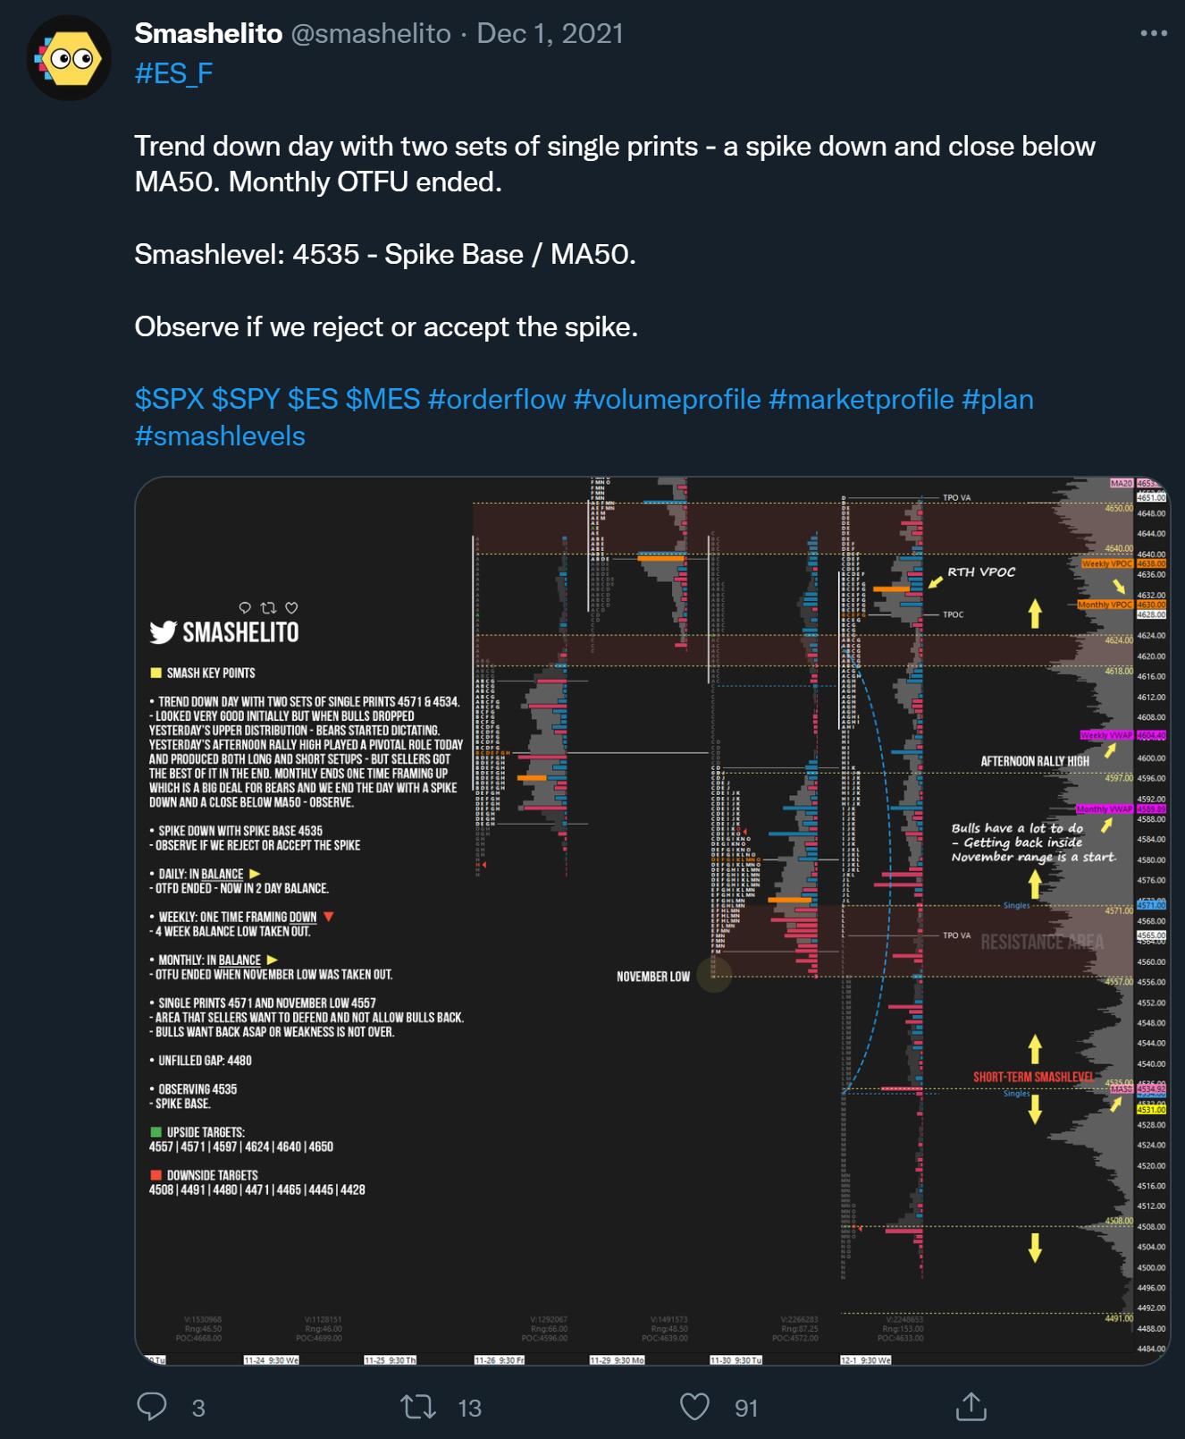
Figure 1 - 2021-12-01 Example of Smashelito Tweet with Drawing and Analysis

- Ingest text-based historical trading data from an Azure SQL database (see ESBOT project).
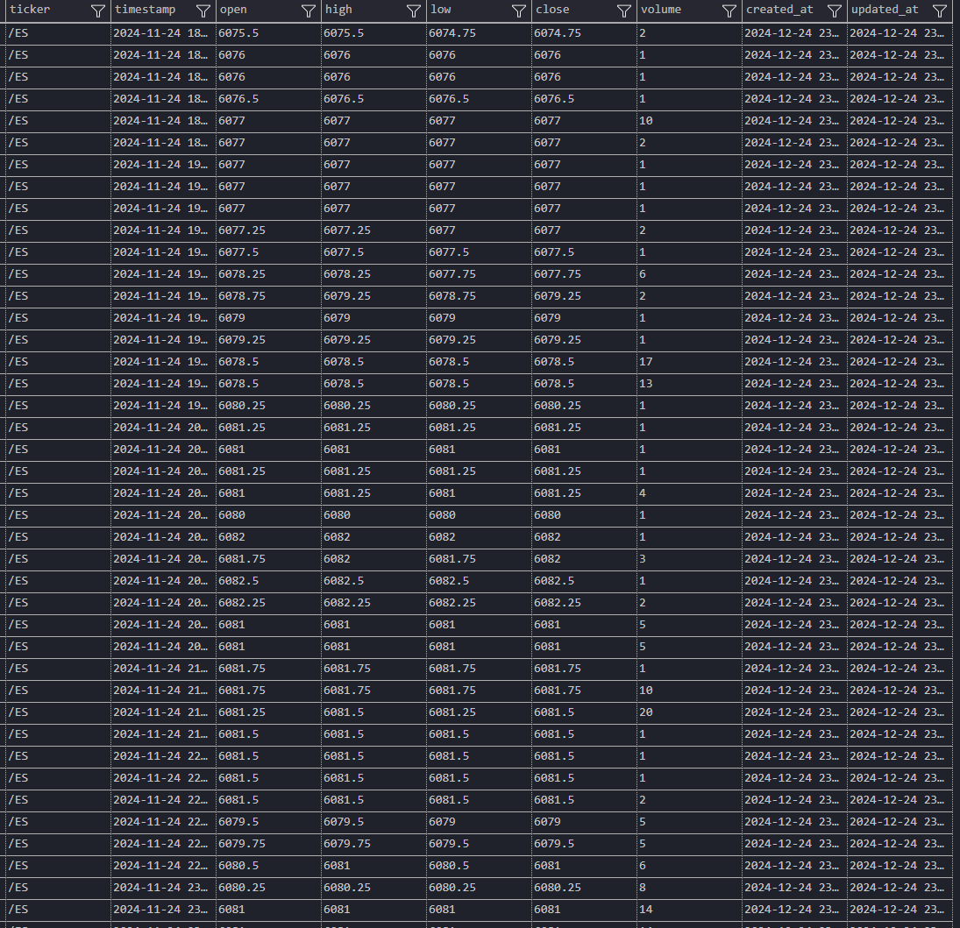
Figure 2 - Example of ESBOT-server /ES data stored in table [market_data].[ohlcv]

Application features
- Upload images via the web app.
- Generate RAG-based answers against these images and the text they contain (plus existing text-based historical data related to Market Profile).
- Use PromptFlow for custom logic or advanced orchestrations.
- Persist and display chat history.
- Provide custom citations.

Data sources
- Azure AI Search Index for textual RAG.
- Azure SQL Server (private preview) to connect with your historical trading data.
Because the Smashelito images contain textual content (charts containing market and volume profiles, commentary, etc.), the immediate question becomes how to “parse” or “extract” text from these images.
Since we need to run queries based on the content of the images (rather than just storing them for reference), we need an OCR step (e.g., using Azure Cognitive Services for Vision or a similar service) to transform image contents into text.
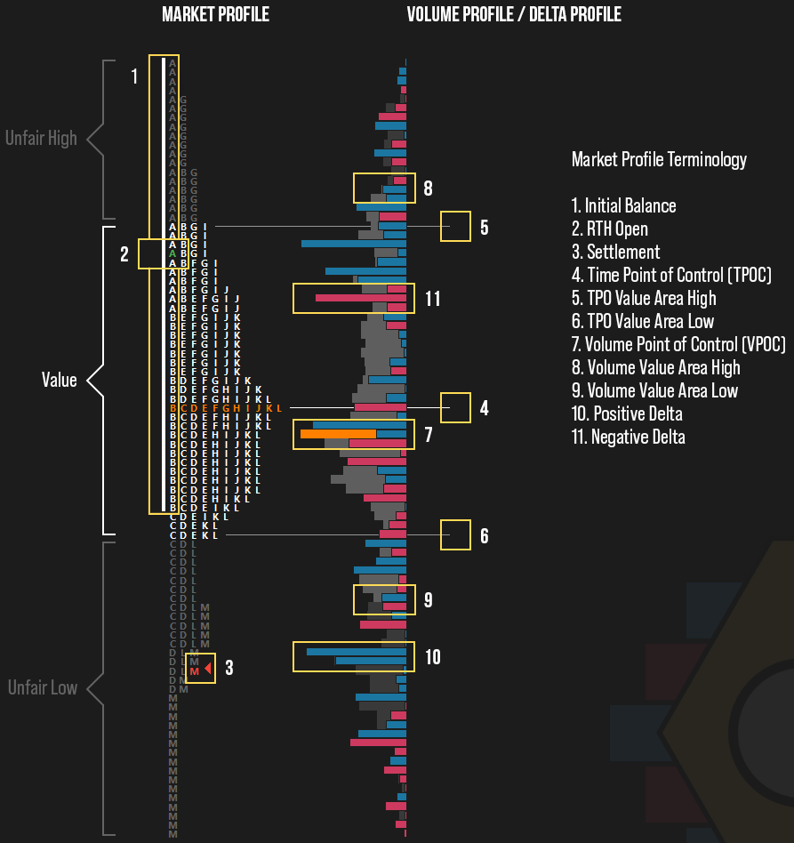
Figure 3 - Example of Smashelito Market Profile Chart - Showing Market Terminology

Architecture Overview
Below is a conceptual architecture that ties together the different services:

Web App (Forked from the sample chat code)
- Frontend built with React + Vite (from the sample).
- Python backend (Flask/FastAPI style) with Gunicorn.

Data Ingestion + Indexing
- (Optional) Azure Blob Storage for storing raw images.
- (Optional) OCR Pipeline (Azure Cognitive Services Computer Vision or Form Recognizer) to extract text from images.
- Azure AI Search or Elasticsearch to store vectorized text.
- Azure SQL Database for your structured historical trading data.

Vector Embeddings + RAG
- Azure OpenAI embedding model (e.g. text-embedding-ada-002).
- Embedded documents stored in your chosen vector index (Azure Search, Elasticsearch, CosmosDB, or MongoDB).

Chat & Orchestration
- PromptFlow for orchestrating complex logic or specialized re-ranking.
- Chat History stored in Cosmos DB (as per the sample app’s instructions).

Phased Project Plan

Phase 1: Repository Setup & Baseline Configuration

Fork/Clone the Sample
- Clone the sample-app-aoai-chatGPT repository to have a local working copy.

Set Up .env
- Determine initial configuration variables (e.g., AZURE_OPENAI_RESOURCE, AZURE_OPENAI_MODEL, etc.).
- Decide on a local run strategy (Docker vs. direct start.cmd).

Spin Up a Minimal Azure Environment
- Azure App Service for hosting your web app.
- Azure OpenAI Resource (already must exist).
- Azure Cognitive Search (if you choose to start with this first).

Local Testing
- Run the app locally (start.cmd), verify you can chat with the base model.
- Configure basic chat only in .env just to confirm everything works.

Phase 1: Key Deliverable
A minimal, functioning “Hello World” style version of the sample chat app deployed to your Azure App Service, capable of connecting to your Azure OpenAI instance.

Phase 2: Image Ingestion + OCR + Indexing

Decide on Storage & OCR Approach
- Raw storage for images: either Azure Blob Storage or a standard file system approach (for local dev).
- OCR (Azure Cognitive Services Computer Vision) to automatically extract text from images:
  - You’ll need a pipeline or function to do this extraction.
  - Output would be text + metadata about the image.

Implement Upload Feature
- In the forked web app’s frontend (React), add a file picker to upload the images.
- On the backend (Python), handle an HTTP POST route that:
- Stores the image in Blob Storage (or whichever approach).
- Calls an OCR service to extract text.
- Produces a JSON document with extracted text, titles, and references to the original image.
- Inserts/Indexes this extracted text into one (or more) of your chosen data source(s) (Azure AI Search, Elasticsearch, etc.).

Vector Embeddings
- For each extracted text chunk, call Azure OpenAI Embeddings (e.g., text-embedding-ada-002) to get a vector.
- Store that vector in your chosen data store (Search/Elasticsearch).

Phase 2: Key Deliverable
End-to-end ingestion pipeline that goes from image upload → image storage → OCR → embedding → storage in your vector database → metadata stored in the index.

Phase 3: RAG-Based Retrieval for Images + Historical Trading Data

Structured Data (Azure SQL)
- If your historical trading data is primarily relational (trades, market events, etc.), keep it in Azure SQL.
- For RAG queries that mix structured data with unstructured text:
  - Option A: Store relevant textual summaries of SQL data in your vector store.
  - Option B: Perform “hybrid retrieval,” where you query the vector store and do direct queries to SQL for certain facts.
- You’ll need to define how the web app queries Azure SQL. For instance, implement an API endpoint on your backend that executes read-only queries based on user input or context from the conversation.

Multi-Source RAG
- Depending on your indexing approach, you could unify references to all content:
  - Index extracted text from images + textual data from SQL in Azure Search or Elasticsearch.
  - Alternatively, keep them separate and do multi-step retrieval.

Configure the .env
- DATASOURCE_TYPE to AzureCognitiveSearch, Elasticsearch, or whichever you prefer.
- If you use Azure SQL for unstructured doc storage (private preview), set DATASOURCE_TYPE=AzureSqlServer.
- Provide any necessary keys, endpoints, vector column details, etc.

Validation
- Upload a test image with known textual content.
- Verify that a user query referencing that text returns the correct snippet.

Phase 3: Key Deliverable
Users can query “smashGPT” with either references to the text from the uploaded images or references to historical trades in your Azure SQL DB, and the app can unify these answers in a single RAG response.

Phase 4: PromptFlow Integration

Understand Where PromptFlow Fits
- PromptFlow can orchestrate advanced steps like custom chain-of-thought, dynamic prompting, or multi-step flows (e.g., “Do an OCR call, then an external API call to get a real-time stock price, then combine them before final answer”).
- If you plan to host a PromptFlow pipeline in Azure Machine Learning, you’ll set USE_PROMPTFLOW=True and point your app to the PROMPTFLOW_ENDPOINT.

Set Up Endpoint
- Deploy your PromptFlow pipeline to Azure ML or wherever PromptFlow is running.
- Acquire the PROMPTFLOW_API_KEY.

Update the Sample App
- In .env, set USE_PROMPTFLOW=True, plus the PROMPTFLOW_ENDPOINT and PROMPTFLOW_API_KEY.
- Adjust the relevant request/response fields for your pipeline if needed (PROMPTFLOW_REQUEST_FIELD_NAME, etc.).

Test
- Confirm that queries route properly through PromptFlow.

Phase 4: Key Deliverable
Your RAG-based queries flow through your PromptFlow pipeline, letting you do complex orchestration or specialized logic for a richer chat experience.

Phase 5: Chat History & Citation Customization

Enable Chat History
- As described in the sample, you can store conversation logs in Azure Cosmos DB.
- Modify the environment variables:
  - AZURE_COSMOSDB_ACCOUNT, AZURE_COSMOSDB_DATABASE, AZURE_COSMOSDB_CONVERSATIONS_CONTAINER, AZURE_COSMOSDB_ACCOUNT_KEY, etc.
- Ensure the correct container schema is set up for the chat messages.

Citation Display
- The sample app shows how citations (source doc references) can be displayed in the UI.
- In frontend/src/pages/chat/Chat.tsx, you can alter how the citation panel is rendered.
- For your images, you might want to store a thumbnail or a direct link.
- Optional: If you want to embed a small screenshot or a link directly to the image in your citations, update the logic (the sample shows how to handle URL fields).

Testing & Refinement
- Verify your custom citations show the correct references (e.g., “This snippet came from Smashelito-2024-12-26.png”).
- Check that previous chat messages are saved and loaded in the UI if you leave and come back.

Phase 5: Key Deliverable
A production-ready UI flow where users see a chat transcript from previous sessions, plus references/citations to either images or database content.

Phase 6: Hardening & Production Deployment

Security & Authentication
- Use Azure App Service authentication (e.g. Microsoft Entra ID) to limit who can access your web app.
- Decide if you want to remove AUTH_ENABLED=False in production so you don’t have an open endpoint.

Performance & Scaling
- Fine-tune the concurrency settings in gunicorn.conf.py.
- Consider using bigger or multiple App Service instances for concurrency.
- Ensure your Search or Elasticsearch clusters have the appropriate replicas/shards.

DevOps / CI/CD
- Set up GitHub Actions or Azure DevOps Pipelines to:
  - Build your front-end, run tests, lint checks.
  - Deploy automatically to your Azure environment.

Monitoring & Logging
- Enable App Service logs, Application Insights, or a similar logging mechanism to track errors and usage.
- Confirm you have alerting set up for cost spikes, model usage, etc.

Phase 6: Key Deliverable
A stable, secure, and scalable environment ready for real-world usage.

Phase 7: Ongoing Enhancements

Feedback Loops
- Implement user feedback for answers. If a user marks an answer as unhelpful, store that feedback in Cosmos DB or your monitoring logs.

Advanced Prompting
- Add more sophisticated “system prompts” or expand on PromptFlow pipelines to handle advanced user scenarios (e.g. “Ask a clarifying question if the user’s question is ambiguous”).

Future Data Sources
- If you need more advanced analytics or want to store embedded images themselves, you might consider using Cosmos DB’s vector indexing or continuing with Elasticsearch.

Documentation & Maintenance
- Update your internal wiki or readme with new environment variables, steps for new team members, etc.

Potential Tech Choices: Pros & Cons
Below are some clarifications to help finalize which data stores to use:

Azure AI Search (Recommended as a Starting Point)
- Native integration with Azure OpenAI on your data.
- Good out-of-the-box vector + hybrid search.
- Built-in security with Managed Identities (Microsoft Entra ID).
- Great for iterative prototyping.

Elasticsearch
- Good if you already have an Elasticsearch cluster or want certain ES-specific features (e.g. advanced custom analyzers, domain knowledge, etc.).
- Still in preview for direct integration with the sample app.

Azure SQL (Private Preview)
- If you absolutely need to store unstructured text in an Azure SQL table for RAG, you can. But typically, Azure SQL is best for structured historical data.
- You can combine your vector-based unstructured data storage with a direct SQL read for structured queries.

CosmosDB Mongo vCore or MongoDB
- If your data needs a flexible schema or you’re heavily reliant on the Mongo API.
- If you want a single DB to store both the raw images (GridFS) and vectors, or if you prefer the NoSQL approach.

Recommendation
- Start with Azure Cognitive Search for textual RAG (since it’s well-documented for “ChatGPT on your data”) plus Azure SQL for your structured trading data.
- If you want to move to or supplement with Elasticsearch for special features, integrate it in a second step.
- If you have an existing Cosmos or Mongo environment, you can unify them with the sample by setting DATASOURCE_TYPE accordingly.

Next Steps
- Create a pilot ingestion pipeline (Phase 2) for a handful of example images.
- Set up your Azure resources (App Service, Azure Cognitive Search, possibly Azure Storage + Computer Vision for OCR).
- Add a minimal upload flow in the sample app’s React UI to test the entire pipeline.
- Iterate until you can chat with the images’ extracted text.
- Incorporate your Azure SQL data for historical queries.
- Add PromptFlow if/when your orchestrations get more advanced.
- Enable chat history and refine the custom citation display.

With this roadmap, you’ll be well on your way to launching “smashGPT” for image-based RAG queries—while also leveraging your historical trading data for deeper insights.

Architecture Diagrams

User Chat Flow
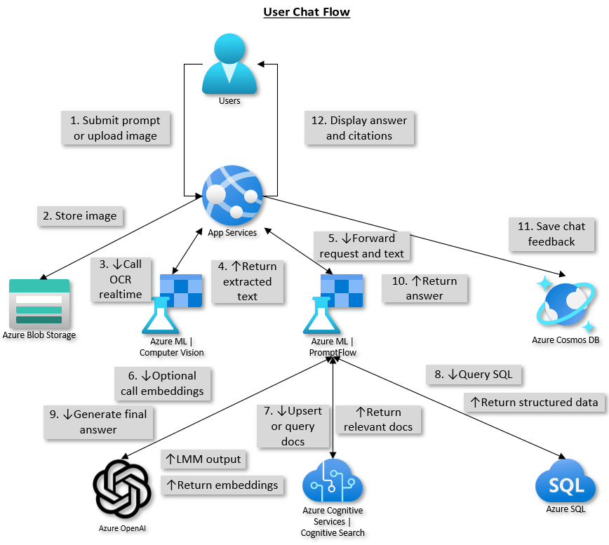
Figure 4 - User Chat Flow Architecture Diagram

Bulk Ingestion Pipeline
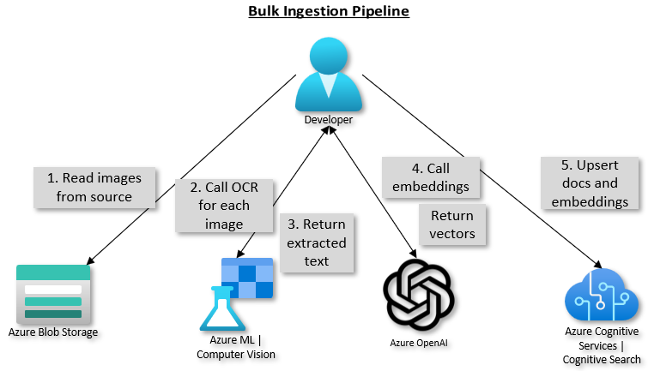
Figure 5 - Bulk Ingestion Pipeline Architecture Diagram

