**Introduction and Objective:**

The purpose of the study was to understand the spectral characteristics of mountain pine beetle infestation in order to detect trees in early stages of infestation that do not display any visual indications of infection. The earlier infection can be detected, the earlier that measures can be enacted to protect adjacent and susceptible trees. The mountain pine beetle is normally innocuous, however they can typically break out into a large-scale epidemic, with the main trees at risk in Western Canada being the lodgepole pine and the ponderosa pine (Safranik and Carrol, 2006). The life cycle of a mountain pine beetle typically lasts one year, with the colonization phase occurring in late July to mid-August (Safranik and Carrol, 2006). Once the trees have been infected they enter early-stage infestation or green attack. After a approximately a year elapses, the now matured pine beetles will move hosts to reproduce. It is at this stage that the visual changes in pigments occur and the trees turn red as the pine beetle damage has damaged the trees’ water transportation systems (Niemann et Al, 2015). These trees are undergoing mature infestation or red attack. It is known that different stages of vegetation health have differences in spectra, with many of the major identifying factors being in the near infrared and short-wave infrared regions of the spectrum (Jones and Vaughan, 2010). Once the trees are infested it is expected that near infrared reflectance will decrease due to decreased scattering in the spongy mesophyll layer. This is due to the inter-cellular air spaces between the mesophyll cells collapsing, resulting in less scattering of near-infrared radiation. In addition, short-wave infrared absorption is expected to decrease due to lower leaf turgidity as the pine beetle damages the water transportation systems of the tree (Jones and Vaughan, 2010). It is hypothesized that after classifying designated pixels as trees with early stage infestation (green attack), trees with mature infestation leading to necrosis (red attack) and uninfected healthy trees, we can use differences in spectra in the near infrared to shortwave infrared regions to identify trees currently undergoing early-stage infestation that cannot be detected visually.

**Data & Study Area:**

Two AISA hyper-spectral images from September 2008 and July 2009 were used in the study. Both images were captured using 366 AISA bands from the visual to shortwave-infrared regions of the spectrum at a 1.5m spatial resolution +/- 2 hours of solar noon. The study area is located in central British Columbia, approximately 44km north of Kamloops and 14km west of the North Thompson River. The site under study is approximately 2.5km² (Niemann et al, 2015). The classification samples collected for this study came from a spatial subset of the study area, a known lodgepole tree farm in the northwest quadrant of the study area to ensure homogeneous sampling. Figure 1.1 shows an approximately 1:1,000,000 scale map of the area and Figure 1.2 shows an approximately 1:100,000 map of the same area.

**Methods:**

The two hyper-spectral AISA images from 2008 and 2009 were loaded separately into ENVI software. Each image was loaded as true color image using AISA band 20, band 65 and band 108 into the BGR displays respectively. These bands were selected because they are each in the median of their respective color regions and they are uniformly placed to represent each color equally.Each image was then loaded as a false color infrared image using bands 65 and 180 again with the addition of band 194. Band 194 was selected as a suitable near-infrared band because it avoids major O₂ and H₂O atmospheric absorption features in the near-infrared region of the spectrum.

Using the false color infrared images, samples for healthy trees were collected on the 2008 image by finding pixels with high near infrared reflectance on both images. The false color infrared image creates a greater distinction between healthy vegetation, shadow pixels and red attack vegetation than its true color counterpart. The selected samples were then corroborated with the same sites in the true color image to ensure accuracy. Next, using the true color images, pixels that had high red reflectance in the 2008 as well as the 2009 image were classified as red attack regions. Finally, using the true color images once more, pixels in the 2008 image that had high green reflectance but conversely in the 2009 image had high red reflectance were selected as the green attack samples. Figure 1.3 shows the spatial distribution of the samples. Approximately 40 samples were taken for each class of interest. After ensuring the samples were adequate and no shadow pixels were selected, a spectral plot (Figure 2.1) was generated from the sample data.

The 2008 image was then reloaded into ENVI as a grayscale infrared image using AISA band 160. A minimum distance classification was then performed on the spatial subset of the study area using the same regions of interest as the spectral plot (Figure 4.1). After this classification, a simple ratio was performed on the same spatial subset using AISA bands 41 and 117. These bands were chosen because they were located at key spectral features. Band 41 was located at the approximate minimum of red reflectance in the 2008 image. Band 117 is located at the “red edge” where NIR reflectance begins to increase exponentially. Band 41 was then divided by band 117 to produce a simple ratio output. The resulting pixel values after performing such a ratio will have a higher degree of separation in red and infrared reflectance. Histograms were produced from the simple ratio output values of each class (Figures 3.1 – 3.3). Using the output from the simple ratio, the spatial subset of the study area was classified again using minimum distance (Figure 4.2).

The final process that was performed using the data from the 2008 AISA image was a minimum noise fraction. After visually analyzing minimum noise fraction output bands 1 through 20, it was determined that bands 11, 13, 15, 17 and 19 contained optimal separation of classes and accuracy of green attack based on regions in the 2009 AISA image. These optimal minimum noise fraction bands and the simple ratio band from the previous classification were used to run a final minimum distance classification on the spatial subset of the study area resulting in Figure 4.3.

**Results & Discussion**

Taking a look at Figure 2.1, the spectra produced from each class ; healthy vegetation, green attack and red attack, it is evident that there is a significant degree of separation in the near infrared and short wave infrared regions of the spectra, specifically at approximately 1100nm and 1700nm. The findings coincide with those of Niemann et al, as there is a pronounced separation in the near infrared region and a less conclusive, yet observable separation in the shortwave infrared region. These are the expected areas of maximum separation as it is predicted that as the effects of mountain pine beetle worsen, there is a noticeable blue shift of the red edge as near infrared reflectance decreases due to decreased scattering in the spongy mesophyll layer as the inter cellular air spaces begin to collapse (Jones and Vaughan, 2010). In addition, as the turgidity decreases, the short-wave infrared reflectance in the mesophyll layer increases however, this is not entirely conclusive from Figure 2.1.

The first minimum distance classification of the study (Figure 4.1) simply used the raw spectral values of the samples ,and its results were not representative of the 2008 AISA image. The main classification error was the over-classification of green attack areas. Looking at Figure 3.1, one would assume that a year later the majority of the area would be overcome by red attack, but taking one look at the 2009 AISA image shows that this is not the case. This is not surprising due to the lack of separation in the shortwave infrared region shown in Figure 2.1, as well as the histograms of healthy vegetation and green attack (Figures 3.1 and 3.2) ,with green attack having the highest standard deviation of separation of 0.353.

In order to increase separation between classes, a simple ratio of red divided by near infrared was performed on the data. The simple ratio certainly increased the classification of healthy vegetation as expected but as evident from Figure 4.2 and the 2009 AISA image, green attack is still over-classified. In order to correct for this and classify the image with maximum separability between classes, a minimum noise fraction was performed, followed by a final minimum distance classification. This classification used the optimal bands from the output of the minimum noise fraction (bands 11, 13, 15, 17 and 19) in addition to the simple ratio band produced in the previous analysis. Figure 3.3 is the result of this classification. Although this final classification is the most representative of the image, green attack was over-classified once more.

**Conclusion**

This study shows that using bands that provide optimal class separation from the output of the minimum noise fraction in addition to the simple ratio band to perform a minimum distance classification allows us to distinguish between between healthy vegetation and green attack using non-visual spectral characteristics with a moderate degree of certainty. The final classification in Figure 4.3 contrasted with the 2009 AISA image predicts a fairly accurate classification of green attack however, there are too many errors when contrasting with the 2009 AISA image to conclude that this method is valid. The separation of green attack and healthy vegetation is a product of water loss and the degradation of chlorophyll pigments (Mullen, 2016). These measurable features may not have been resolvable by the sensor. There are many ways errors could have been introduced such as user misclassification or the accidental selection of shadow pixels. More samples may have increased accuracy but it is unclear. In addition, different bands selected for the simple ratio or a different band ratio could have resulted in greater separation. Usage of a spectral vegetation index would have been more effective at reducing the influence of background pixels such as shadow and soil. It is uncertain whether ichanging procedures, an increase in sampling or any other changes in data selection would have resulted in a more accurate classification. In conclusion, the non-visual infrared spectral characteristics used in this study were not distinct enough to separate trees undergoing early-stage mountain pine beetle infestation from healthy vegetation with certainty.

**References**

Jones, H. G., & Vaughan, R. A. (2010). *Remote sensing of vegetation: Principles, techniques, and applications.*

Mullen, Kyle Edward (2016).Early Detection of Mountain Pine Beetle Damage in Ponderosa Pine Forests of the Black Hills Using Hyperspectral and WorldView-2 Data*. All Theses, Dissertations, and Other Capstone Projects. 665.*

Niemann, K. O., Quinn, G., Stephen, R., Visintini, F., & Parton, D. (2015). Hyperspectral Remote Sensing of Mountain Pine Beetle with an Emphasis on Previsual Assessment. *Canadian Journal of Remote Sensing, 41(3)*, 191-202. doi:10.1080/07038992.2015.1065707

Safranyik, L., & Wilson, B. (2006). *The mountain pine beetle: A synthesis of biology, management, and impacts on Lodgepole Pine*. Victoria, B.C.: Pacific Forestry Centre.

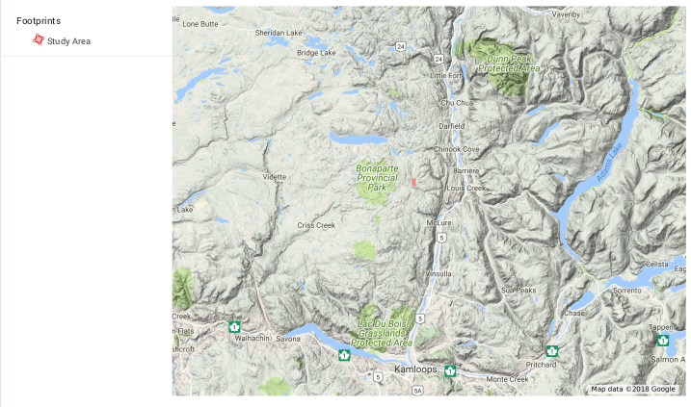**Figures and Tables**

  
Figure 1.1: Map of Study Area: ~ 1:1,000,000 scale

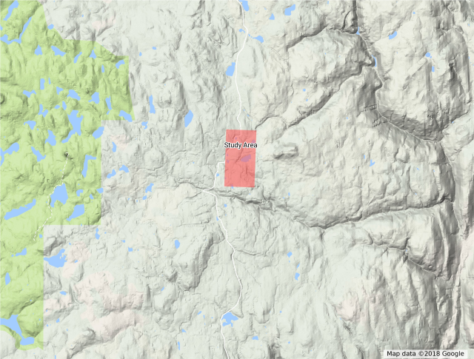  
Figure 1.2: Map of Study Area: ~ 1:100,000 scale

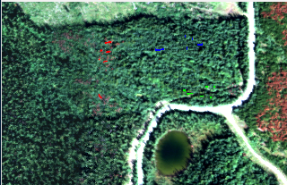  
Figure 1.3: Spatial Distribution of Regions of Interest

Healthy Vegetation

Red Attack

Green Attack

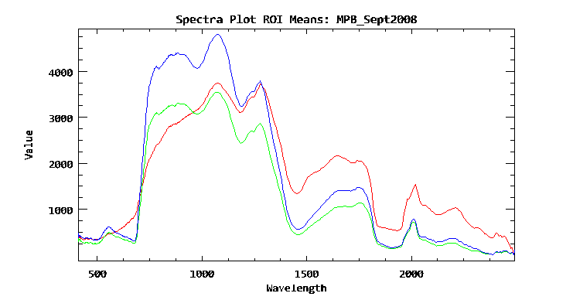  
Figure 2.1: Spectral Plot 2008 AISA image Regions of Interest

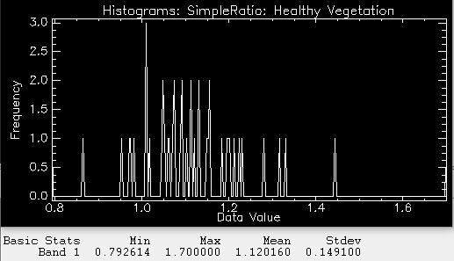  
Figure 3.1: Healthy Vegetation Simple Ratio Histogram

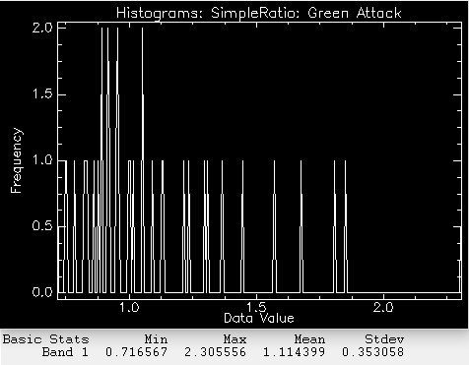  
Figure 3.2: Green Attack Simple Ratio Histogram

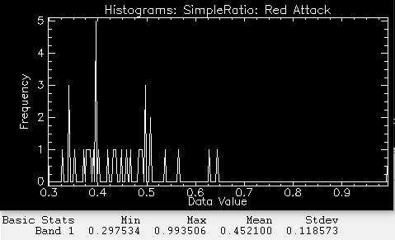  
Figure 3.3: Red Attack Simple Ratio Histogram

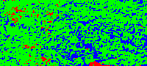  
Figure 4.1: ROI classification

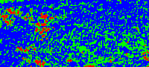  
Figure 4.2: Simple Ratio classification

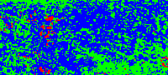  
Figure 4.3: MNF classification

Healthy Vegetation

Red Attack

Green Attack

GEOG 319 B01

Lab 3: Vegetation: Mountain Pine Beetle Study - BC Interior

Submitted By: Connor Schultz (V00872923)

Submitted to: Terri Evans

Date of Submission: Oct. 26, 2018

Words: 1949

List of Figures:

Figure 1.1: Map of Study Area: ~ 1:1,000,000 scale

Figure 1.2: Map of Study Area: ~ 1:100,000 scale

Figure 1.3: Spatial Distribution of Regions of Interest

Figure 2.1: Spectral Plot 2008 AISA image Regions of Interest

Figure 3.1: Healthy Vegetation Simple Ratio Histogram

Figure 3.2: Green Attack Simple Ratio Histogram

Figure 3.3: Red Attack Simple Ratio Histogram

Figure 4.1: ROI classification

Figure 4.2: Simple Ratio classification

Figure 4.3: MNF classification