1.

Cyanobacteria are photosynthetic prokaryotic organisms that have unique spectral characteristics primarily due to the presence of Chlorophyll-a (chl-a) and Phycocyanin (PC). Photosynthesis occurs in the photosynthetic lamellae that exist within the cell (Clifford). Cyanobacterial blooms can have negative effects on the ecosystem including blocking sunlight to photosynthesizing aquatic plants and producing toxins that can harm marine animals and plants (Klemas). The presence of chl-a results in absorption increases in the red and blue regions of the visible light spectrum, specifically at the 465nm and 665nm areas (Klemas). Figure 2.1, the spectra plot of water and cyanobacteria shows a sharp increase in pixel DN values at the blue/green edge between bands 2 and 3 and a sharp decrease at the green-red edge between bands 3 and 4. The maximum DN value occurs at approximately 525nm which is to be expected due to the high reflectance of green light by chl-a. Alternatively, PC has a maximum absorption feature at 625nm in the red region spectrum (Yacobi et al). Figure 2.1 does show a decrease in pixel DN value between bands 4 and 5 however, it is not possible to distinguish the PC absorption feature from the chl-a absorption feature in the red region. Cyanobacteria are also expected to have increased reflectance in the near infrared region relative to a water sample as nearly all irradiant infrared energy is absorbed by water immediately. Figure 2.1 does show an increase in pixel DN values in the NIR region between bands 5 and 6 however, it is quite insignificant.

The lakes under study are case II, inland waters. These waters have different spectral properties than pure water and case I waters. As seen in lecture, pure water with no constituents has high absorption in all regions of the spectrum with the deepest penetration occurring in the ultraviolet and blue regions of the spectrum. However as seen by Figure 2.1, the increased DN values from bands 1 – 4 are hypothesized to be from constituents in the water such as organic and inorganic materials, specular reflectance off the surface of the water as well as atmospheric constituents. Overall, these constituents and conditions will make distinguishing the cyanobacterial blooms from water in Elk and Beaver lakes much more difficult.

2.

There were two band ratios that were selected for this study; a simple ratio of red/green and a custom ratio of NIR/red+blue. These ratios offered the best visual distinction between cyanobacteria and water in addition to the best data quality with high degrees of separation between water and cyanobacteria. The first ratio, red/green can be viewed in grayscale in Figure 6.1. The ratio is very simple and is a ratio of reflectance to absorption by chl-a.The ratio appeared to do a good job at separating visually so it was decided that the ratio would be used for the threshold. A +/- 3 standard deviation threshold was applied to the image. The output of the 2017 image produced a fairly accurate classification seen in Figure 7.1 however applying the same threshold to the 2016 image results in the classification seen in Figure 7.2, which is much less accurate. Water was unable to be classified as none of the values fell within +/- 3 SD of the mean.

The next ratio, NIR/red+blue was an attempt at further distinguishing reflectance and absorption by chl-a. The NIR reflected by the cyanobacteria would contrast with the absorption of red and blue in theory and water pixels would have low values do the absorption by water. The ratio worked well visually as seen in Figure 6.2 and the same +/- 3 SD threshold was applied to the 2017 image. This result was Figure 8.1. Figure 8.1 similar to Figure 7.1 shows an accurate classification of cyanobacteria and water in the 2017 image however, one again in the 2016 image, applying the same threshold results in an inaccurate classification (Figure 8.2).

After reviewing the study and reading other studies, it seems that a better ratio could have improved results drastically. In their study of cyanobacterial blooms in the Gulf of Finland, Kuster claims that a band ratio of 624nm/648nm is recommend to estimate phycocyanin concentration. Kuster also claims that vegetation indices such as NDVI can be used to estimate chl-a in water bodies. In addition, The usage of a hyper spectral sensor could have allowed for more precise ratios and a better estimation of pyhcocyanin, resulting in better classification.

3.

The process of attempting to classify cyanobacterial blooms in the 2016 image first required data collection and the usage of band ratios on the 2017 image. First, the two band ratios with the best apparent separation, red divided by green and NIR divided by red plus blue were performed. Training areas were then selected on a false colour infrared image. These training sites can be seen in Figure 5.1. Pixels with high NIR reflectance were selected as cyanobacteria sites and pixels with high NIR absorption were selected as the water sites.

Figures 3.1 and 3.2, histograms and statistics of each ratio were produced and analyzed. Next, thresholds were chosen for each ratio that will be used for classification. A +/- 3 standard deviation was chosen for both ratios because the mean pixel values of water and cyanobacteria in both instances allowed for a +/- 3 standard deviation threshold without any data being classified in both categories. This can be determined by the maximum and minimum values of the data obtained from the training sites. These thresholds were then used to classify the 2017 image. Figures 5.1 and 5.2 show the output of the thresholds on the 2017 image. From purely visual analysis the 2017 image classification in both ratios resulted in a accurate output when comparing to the 2017 true colour image.

In order to produce the 2016 outputs in Figures 6.1 and 6.2, the same thresholds were applied on to the 2016 image. As seen by the 2016 outputs, the result was not able to accurately distinguish between cyanobacteria and water. In both ratios, water was completely unclassified due to none of the images values falling within the +/- 3 standard deviation range of either water threshold. There were also areas of pixels in Beaver Lake that were classified as cyanobacteria that were classified as water in the 2017 image.

In conclusion, the ratios and thresholds derived from the 2017 image were not enough to conclusively determine that there was a cyanobacterial bloom in 2016. This is not entirely unexpected, as the more advanced studies of cyanobacteria by scientists such as Simis and Kutser use much more involved formulas that utilize variables such as absorption coefficients and specific absorption features. These algorithms allow for a much more separability then the ones seen in Figures 6.1 and 6.2. In the classification performed in this study there are many sources of potential error, primarily due to the high turbidity of Elk and Beaver lakes. The complexity of these waters results in uncertainty in the cyanobacteria and chl-a classification due to presence of many other water constituents such as sediment and other organic materials (Klemas). In addition, since the study area is relatively small with few potential data points, atmospheric constituents on each day could have a potential impact. It is important to note that 2017 was a record breaking year for forest fires in BC, with over 1.2 million hectares being destroyed by fires. Comparatively, 2016 was a below average forest fire year according to the wild fire season summaries posted by the BC government. Forest fires produce large amounts of atmospheric constituents that could certainly effect the spectral characteristics of an image. In conclusion, the composition of the waters of Elk and Beaver lake as well as unknown atmospheric conditions are major sources of error in the classification of the 2016 image and a much more involved and mathematical approach would need to be taken to produce an output cyanobacterial classification with a great degree of accuracy.

4.

The studies that will be reviewed include Quantitative Detection of Chlorophyll in Cyanobacterial Blooms by Satellite Remote” by Kuster and “Remote sensing of the cyanobacterial pigment phycocyanin in turbid inland water” by Simis, Peters and Gons. In each study the methods and results will be analyzed, as well as their implications and insights on the study of Elk and Beaver lakes.

In the study performed by Kuster, data obtained from the hyper spectral satellite Hyperion was used to identify chlorophyll in cyanobacterial blooms in the western region of the Gulf of Finland. Although this study is not conducted on inland waters similar to Elk and Beaver lakes, Kuster claims that a high spatial resolution is crucial in detecting cyanobacterial blooms. A finer spatial resolution, such as the 30m resolution produced by Hyperion may have helped the classification of Elk and Beaver lakes. The interesting part of Kusters study is the emphasis on the effects of the vertical distribution in addition to the horizontal distribution of cyanobacterial blooms. He concludes that truly accurate chlorophyll concentration in cyanobacterial blooms cannot be determined with available technology because the current sensors available are too low resolution as “significant changes in chlorophyll concentration occur at an even smaller spatial scale than the 30m resolution of Hyperion” (Kuster). Furthermore, in situ data collection by research vessels destroys the natural distribution of the cyanobacterial blooms and cannot provide accurate chlorophyll values (Kuster). In summary, the estimation of chlorophyll concentration in cyanobacterial blooms is limited by the coarse spatial resolution of satellite sensors relative the fine spatial phenomena present in the blooms (Kuster).

The study performed by Simis et al took a much different approach to that of Kuster. It was conducted on two highly turbid inland lakes using a mass imaging spectrometer. Another difference to Kuster was that Simis et al used the presence of phycocyanin in cyanobacterial blooms as the main identifying feature, instead of chlorophyll. The group creates a formula to detect PC concentration and its derivation can be found on pg. 238. Although quite complex, the result is that PC concentration is the result of dividing the absorption coefficient of phycocyanin at 620nm by the specific absorption of phycocyanin at 620nm. The study was successful at accurately classifying cyanobacterial blooms however, the group admits the model falls short when the phytoplankton community does not consists primarily of cyanobacteria (Simis et al). Utilizing the unique spectral properties of cyanobacteria such as the absorption feature of phycocyanin in the red region to construct a more involved band ratio could have resulted in a more accurate classification of the cyanobacteria at Elk and Beaver lakes.

5.

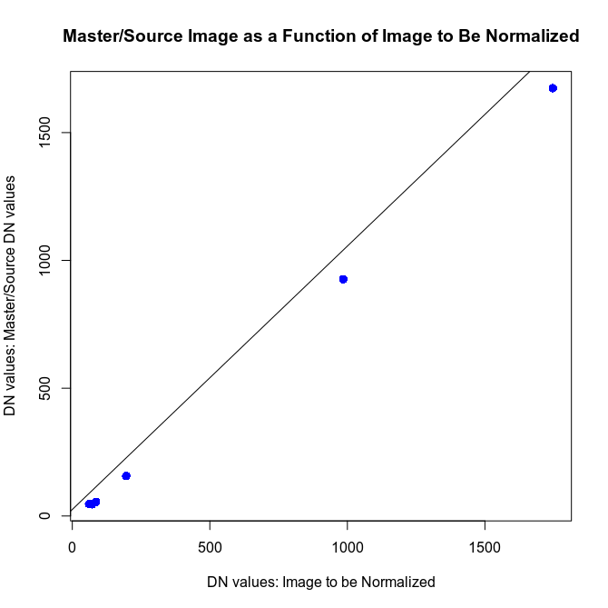  
Figure q5.1: Plot with Line of Regression for Band 3 data

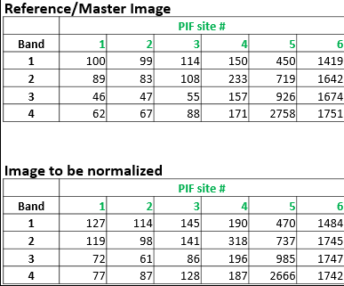  
Figure q5.0: Data

Residuals:

1 2 3 4 5 6

-1.036 -13.067 3.690 8.595 5.258 -3.441

Coefficients:

Estimate Std. Error t value Pr(>|t|)

(Intercept) 25.640480 4.484716 5.717 0.00463 **

y 1.030347 0.005717 180.214 5.69e-09 ***

---

Signif. codes: 0 ‘***’ 0.001 ‘**’ 0.01 ‘*’ 0.05 ‘.’ 0.1 ‘ ’ 1

Residual standard error: 8.643 on 4 degrees of freedom

Multiple R-squared: 0.9999,Adjusted R-squared: 0.9998

F-statistic: 3.248e+04 on 1 and 4 DF, p-value: 5.687e-09

Figure q5.2: Regression test output statistics

Equation: y = 1.030347x + 25.640480

R^2: 0.9999, 0.9998 adjusted

Figures:

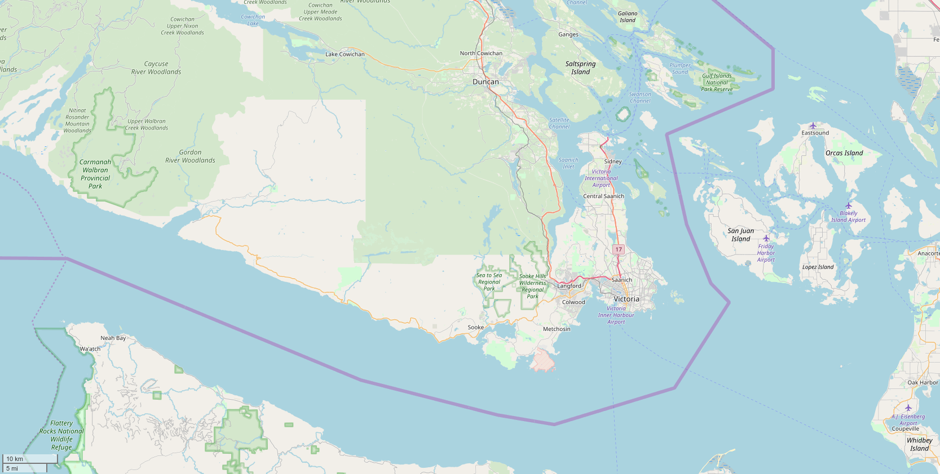  
Figure 1.1: Small Scale Map of Study Area: Elk/Beaver Lake, Victoria, BC, Canada

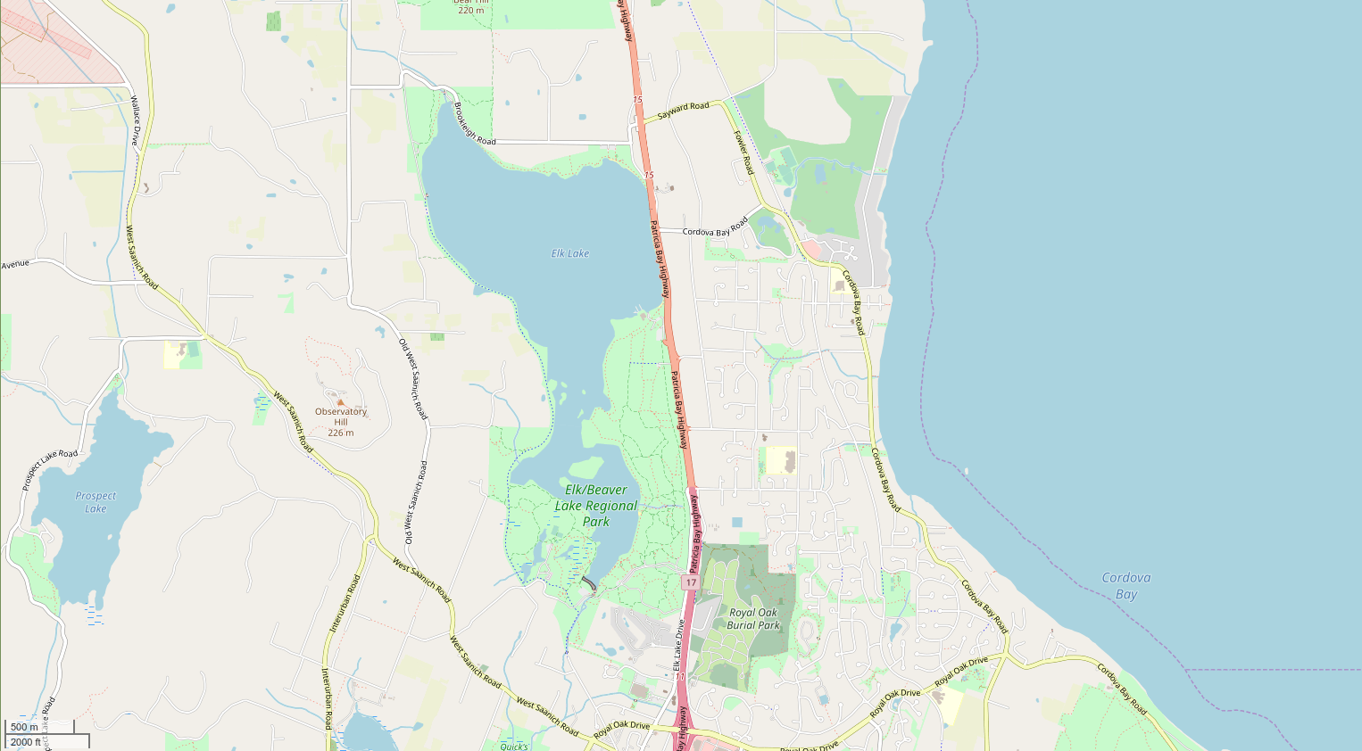  
Figure 1.2: Large Scale Map of Study Area: Elk/Beaver Lake, Victoria, BC, Canada

Cyanobacteria and Water Training sites Spectra Plot

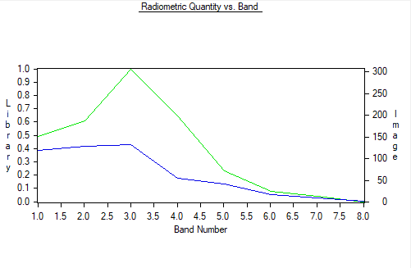  
Figure 2.1: Spectra Plot of Cyanobacteria and Water samples



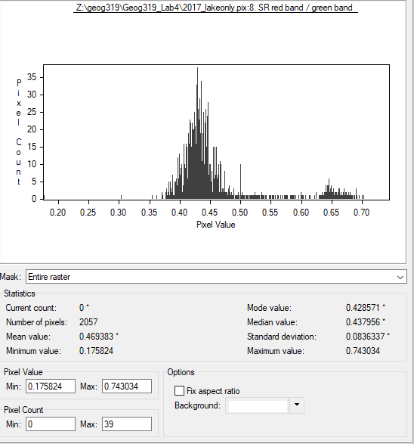  
Figure 3.1: Histogram with Statistics: red/green

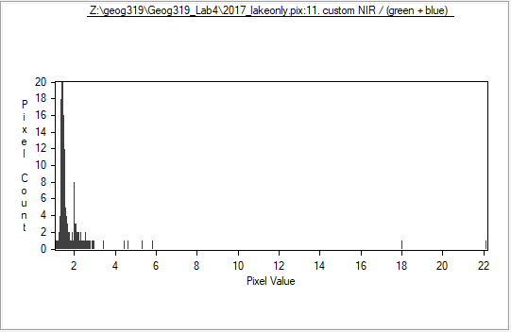  
Figure 3.2: Histogram: NIR/red+blue

1: red band/green band: **%9 = %4/%3**

2: NIR band/red band: **%10 = %5/%4**

3: (red band+NIR band)/green band: %11 = **(%4+%5)/%3**

4: NIR band/(red band+blue band): %12 = **%5/(%4+%2)**

Figure 4.1: EASI modelling equations

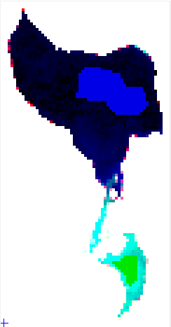  
Figure 5.1: ROI's Elk/Beaver Lake: Victoria, BC, Canada

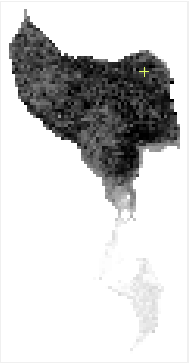  
Figure 6.1: Grayscale image red/green ratio

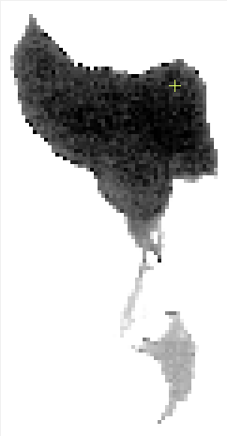  
Figure 6.2: Grayscale image NIR/red+blue ratio





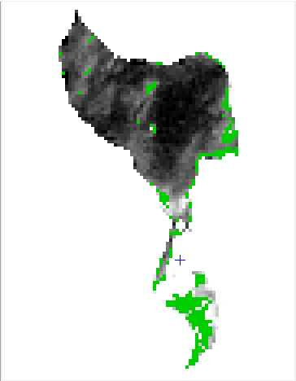  
Figure 7.2: 2016 red/green ratio output

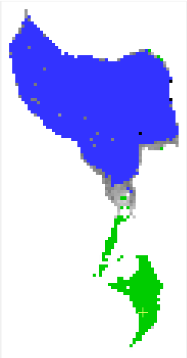  
Figure 7.1: 2017 red/green ratio output

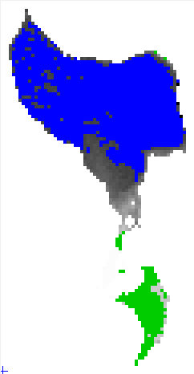  
Figure 8.1: 2017 NIR/red+blue ratio output



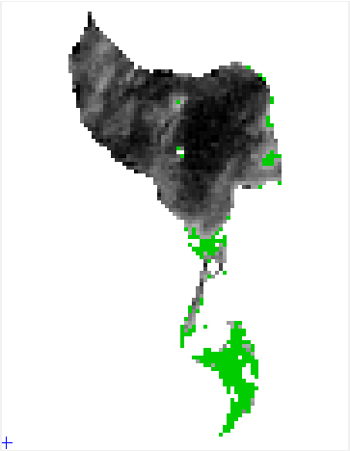  
Figure 8.2: 2016 NIR/red+blue ratio output

References:

Clifford, C. B. (n.d.). Alternative Fuels from Biomass Sources: 10.2 What are Algae? Retrieved November 14, 2018, from <https://www.e-education.psu.edu/egee439/node/693>

Klemas, V. (2012). Remote Sensing of Algal Blooms: An Overview with Case Studies. *Journal of Coastal Research,278*, 34-43. doi:10.2112/jcoastres-d-11-00051.1

Kutser, T. (2004). Quantitative detection of chlorophyll in cyanobacterial blooms by satellite remote sensing. *Limnology and Oceanography,49*(6), 2179-2189. doi:10.4319/lo.2004.49.6.2179

Piepen, H. V., & Doerffer, R. (1991). Remote sensing of substances in water. *GeoJournal,24*(1), 27-48. doi:10.1007/bf00213054

Sellner, K. G. (1997). Physiology, ecology, and toxic properties of marine cyanobacteria blooms. *Limnology and Oceanography,42*(5part2), 1089-1104. doi:10.4319/lo.1997.42.5_part_2.1089

Simis, S. G., Peters, S. W., & Gons, H. J. (2005). Remote sensing of the cyanobacterial pigment phycocyanin in turbid inland water. *Limnology and Oceanography,* *50*(1), 237-245. doi:10.4319/lo.2005.50.1.0237

Yacobi, Y. Z., Köhler, J., Leunert, F., & Gitelson, A. (2015). Phycocyanin-specific absorption coefficient: Eliminating the effect of chlorophylls absorption. *Limnology and Oceanography: Methods,13*(4). doi:10.1002/lom3.10015

GEOG 319 B01

Lab 4: Remote Sensing of Cyanobacteria in Elk/Beaver Lake

Submitted By: Connor Schultz (V00872923)

Submitted to: Terri Evans

Date of Submission: Nov. 16, 2018