Causal Model for FSHS Support

Kingsford Onyina

# Loading the data  
library(haven)

## Warning: package 'haven' was built under R version 4.3.3

clean_data <- read_dta("~/GitHub/ppol1802/clean_data.dta")  
  
  
# Convert labeled variables back to factors  
clean_data <- as_factor(clean_data)

# **1. Theoretical Model**

This model examines the relationship between partisanship (p_afil) and support for Ghana’s Free Senior High School (FSHS) (index_bin). It includes confounders, mediators, and colliders.

dag <- dagitty('dag {  
 p_afil -> index_bin  
 p_afil -> access_info -> index_bin  
 p_afil -> civic_engagement -> index_bin  
 p_afil -> trust_index -> index_bin  
 p_afil -> political_participation -> index_bin  
 p_afil -> trust_ruling -> index_bin  
  
 hh_size -> index_bin  
 hh_size -> p_afil  
 age -> index_bin  
 age -> p_afil  
 urban -> index_bin  
 urban -> p_afil  
 employment -> index_bin  
 employment -> p_afil  
 corruption -> index_bin  
 corruption -> p_afil  
  
 education -> p_afil  
 education -> index_bin  
}')

ggdag(dag)

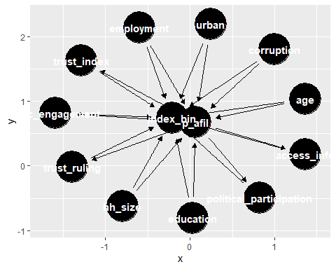

## **1. Confounders**

* **hh_size** (Household Size)
* **age**
* **urban** (Urban or Rural location)
* **employment** (Employment status)
* **corruption** (Perception of Corruption)

## **2. Mediators**

* **access_info** (Access to information which is an index from a battery of questions from radio, TV, newspaper, internet, media)
* **civic_engagement**(An index from a battery of questions that depicts civic engagement: protesting, attending community meeting, contacting traditional leader, contacting local government, raising issues)
* **trust_index** (Trust in institutions is an index created from a battery of questions on trust in presidency, court system, parliament, electoral commision etc. )
* **political_participation** (An index from a battery of questions that depicts political participation: voting, disucssion of politics, attending rallies, contacting political party officials)
* **trust_ruling** (Trust in ruling party)  
  + **education** (No primary education, primary, secondary and tertiary)

## **3. Collider**

* Didn’t find any collider unfortunately.

# **3. Identify Minimal Adjustment Set**

adjustmentSets(dag, exposure = "p_afil", outcome = "index_bin")

## { age, corruption, education, employment, hh_size, urban }

# Highlighting the minimal adjustment set in the DAG  
ggdag_adjustment_set(dag, exposure = "p_afil", outcome = "index_bin") +  
 theme_minimal() +  
 labs(title = "Minimal Adjustment Set for Estimating Causal Effect of Partisanship on FSHS Support")

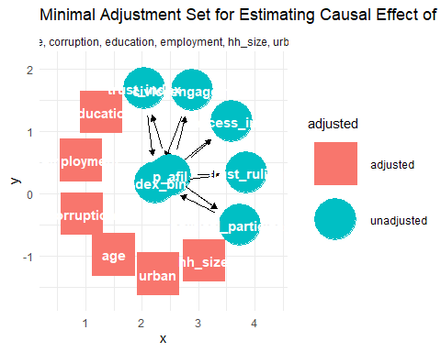

# **Description of the Minimal Adjustment Set**

The **minimal adjustment set** consists of the **confounding variables** that we need to **control for** to estimate the causal effect of p_afil (partisanship) on index_bin (support for FSHS) **without bias**.

* **age**: Older or younger individuals may have different perspectives on FSHS.
* **corruption**: Perception of corruption could influence both trust in government and policy support.
* **education**: Higher education levels might impact both political alignment and views on FSHS.
* **employment**: Employment status affects economic perspectives, which may shape policy support.
* **hh_size**: Household size may influence economic strain and support for education policies.
* **urban**: Urban vs. rural residence can shape access to information and political views.

Since **these variables confound** the relationship, they need to be **adjusted for**, or controlled for.