Multiple Linear Regression

Kingsford Onyina

# Loading the data  
library(haven)

## Warning: package 'haven' was built under R version 4.3.3

clean_data <- read_dta("~/GitHub/ppol1802/clean_data.dta")  
  
  
# Convert labeled variables back to factors  
clean_data <- as_factor(clean_data)

Based on my minimal adjustment set, I estimate a simple multiple linear regression below.

library(dplyr)

## Warning: package 'dplyr' was built under R version 4.3.3

##   
## Attaching package: 'dplyr'

## The following objects are masked from 'package:stats':  
##   
## filter, lag

## The following objects are masked from 'package:base':  
##   
## intersect, setdiff, setequal, union

# Convert age and hh_size to numeric  
clean_data <- clean_data %>%  
 mutate(age = as.numeric(as.character(age)),  
 hh_size = as.numeric(as.character(hh_size)))  
  
# Run the adjusted model  
lm_model <- lm(index_bin ~ p_afil + age + corruption + education + employment + hh_size + urban, data = clean_data)  
summary(lm_model)

##   
## Call:  
## lm(formula = index_bin ~ p_afil + age + corruption + education +   
## employment + hh_size + urban, data = clean_data)  
##   
## Residuals:  
## Min 1Q Median 3Q Max   
## -0.84072 -0.18227 0.01674 0.20205 0.59966   
##   
## Coefficients:  
## Estimate Std. Error t value Pr(>|t|)   
## (Intercept) 3.736e-01 3.853e-02 9.697 < 2e-16 ***  
## p_afil1. NPP 1.417e-01 1.828e-02 7.751 2.22e-14 ***  
## age 1.111e-03 5.733e-04 1.938 0.05294 .   
## corruption2. Increased somewhat 7.911e-02 2.521e-02 3.139 0.00175 **   
## corruption3. Stayed the same 5.700e-02 2.346e-02 2.430 0.01528 *   
## corruption4. Decreased somewhat 1.476e-01 2.373e-02 6.221 7.22e-10 ***  
## corruption5. Decreased a lot 1.723e-01 3.776e-02 4.562 5.70e-06 ***  
## education2. Primary 7.735e-02 2.769e-02 2.794 0.00531 **   
## education3. Secondary 2.807e-02 2.570e-02 1.092 0.27496   
## education4. Tertiary 2.723e-02 3.352e-02 0.812 0.41692   
## employment1. Employed -1.411e-02 1.711e-02 -0.825 0.40962   
## hh_size 1.762e-05 3.553e-03 0.005 0.99604   
## urban1. Urban 3.218e-02 1.731e-02 1.859 0.06334 .   
## ---  
## Signif. codes: 0 '***' 0.001 '**' 0.01 '*' 0.05 '.' 0.1 ' ' 1  
##   
## Residual standard error: 0.2636 on 1006 degrees of freedom  
## (1381 observations deleted due to missingness)  
## Multiple R-squared: 0.1552, Adjusted R-squared: 0.1451   
## F-statistic: 15.4 on 12 and 1006 DF, p-value: < 2.2e-16

The results show that partisanship is strongly associated with FSHS support, with NPP affiliates 14.2 percentage points more likely to support the policy. Perceptions of corruption remain significant, as those who believe corruption decreased somewhat (7.9 percentage points) or significantly (17.2 percentage points) show higher support. Age, now treated as continuous, shows a small but significant positive association (0.1 percentage points per year), suggesting older individuals are slightly more supportive. Education and urban residence are marginally significant, with those having primary education (7.3 percentage points) showing higher support, while urban dwellers exhibit a weak positive association (3.2 percentage points). Household size and employment status are not significant predictors. The model, now correctly aligned with the minimal adjustment set, explains 15.5% of the variation in FSHS support, confirming that other unobserved factors influence public opinion.

# **Does the Model Deviate from the Minimal Adjustment Set?

My model aligns with the minimal adjustment set, but some confounders seem unnecessary. Household size and employment status do not significantly influence the relationship between partisanship and FSHS support, reducing efficiency without adding value. Urban residency shows only marginal significance, suggesting a weak impact. Age remains significant, showing a small positive association, while corruption perception plays a crucial role, reinforcing its importance. Although the model supports my adjustment strategy, removing non-significant confounders could enhance precision without compromising validity.

# **Multicollinearity Check (VIF Test)

library(car)

## Warning: package 'car' was built under R version 4.3.3

## Loading required package: carData

## Warning: package 'carData' was built under R version 4.3.3

##   
## Attaching package: 'car'

## The following object is masked from 'package:dplyr':  
##   
## recode

vif(lm_model)

## GVIF Df GVIF^(1/(2*Df))  
## p_afil 1.159374 1 1.076742  
## age 1.054655 1 1.026964  
## corruption 1.148515 4 1.017459  
## education 1.198548 3 1.030645  
## employment 1.058261 1 1.028718  
## hh_size 1.074293 1 1.036481  
## urban 1.098370 1 1.048031

This insniates absence of of multicollinearity since all the VIFs are < 10

# **Based on the reading, I opted for the residual plots.

# Residuals vs. Fitted Plot (Linearity & Homoscedasticity)  
plot(lm_model, which = 1, main = "Residuals vs. Fitted")

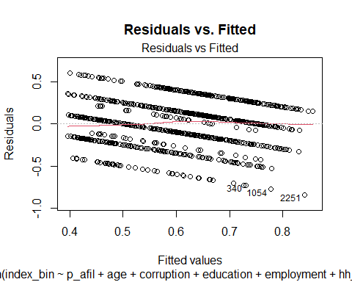

# Normal Q-Q Plot (Normality of Residuals)  
plot(lm_model, which = 2, main = "Normal Q-Q Plot")

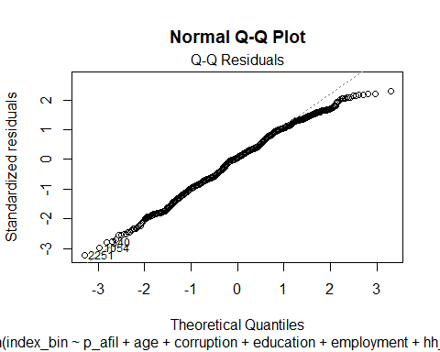

# ***Interpretation

The Residuals vs. Fitted plot shows a structured pattern rather than random scatter, suggesting potential heteroskedasticity or non-linearity in the model. The residuals are not randomly distributed around zero, indicating that some variance is not well captured by the model.

The Normal Q-Q plot shows deviations from normality at both extremes, particularly in the lower and upper tails. This suggests that the residuals are not perfectly normally distributed, which could impact inference and standard errors.

# **Heteroskedasticity Test (Breusch-Pagan Test)

library(lmtest)

## Warning: package 'lmtest' was built under R version 4.3.3

## Loading required package: zoo

## Warning: package 'zoo' was built under R version 4.3.3

##   
## Attaching package: 'zoo'

## The following objects are masked from 'package:base':  
##   
## as.Date, as.Date.numeric

bptest(lm_model)

##   
## studentized Breusch-Pagan test  
##   
## data: lm_model  
## BP = 11.759, df = 12, p-value = 0.4652

With the p-value being insignificant insinuates that the standard errors are robust.

# **Normality of Residuals

shapiro.test(residuals(lm_model)) # Shapiro-Wilk test

##   
## Shapiro-Wilk normality test  
##   
## data: residuals(lm_model)  
## W = 0.99081, p-value = 5.51e-06

hist(residuals(lm_model), breaks = 30, main = "Residuals Histogram") # Histogram

