The output in VM’s termal after mapping and reducing testfile1 &testfile2:

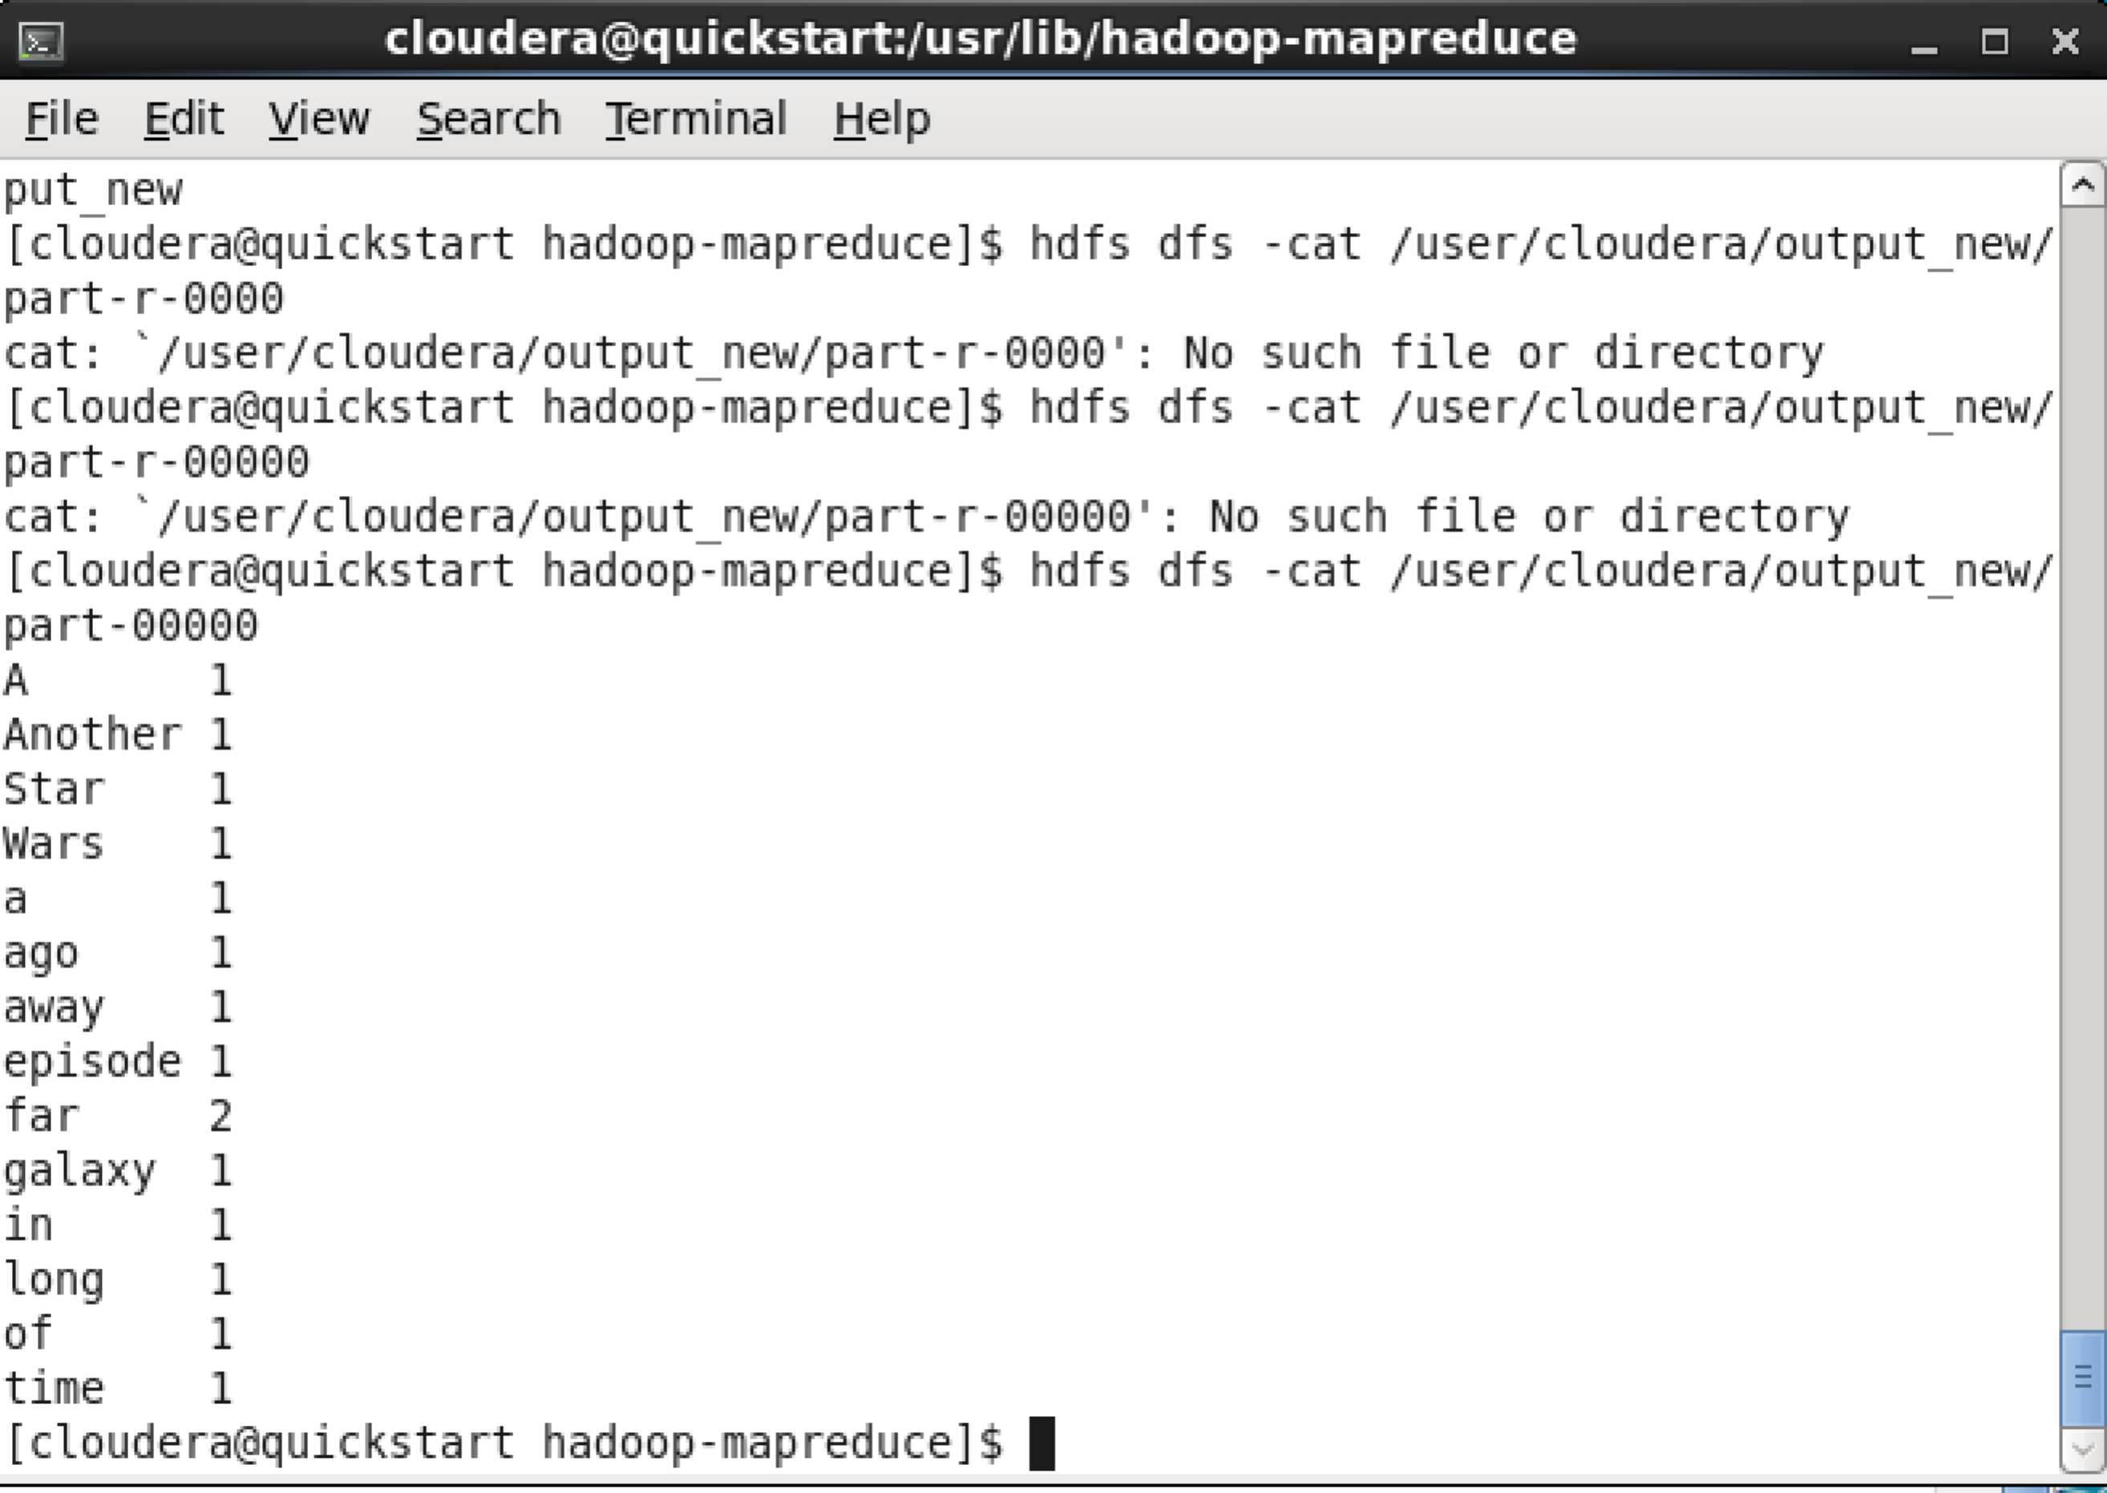

When change reduce tasks to 0, the output will just count every single word one time.

