24SJPBERT504 - DATABASE MANAGEMENT SYSTEM
COURSE PROJECT REPORT ON

AGRICONNECT – Marketplace and Crop Advisor
In partial fulfilment of the requirements for the award of the degree of

BACHELOR OF TECHNOLOGY
in
ELECTRONICS & COMPUTER ENGINEERING



Submitted by

JOSEPH BOBY [Reg.No: SJC24ECE046]
KURIAKOSE SEBASTIAN [Reg.No: SJC24ECE049]
NIRANJANA S KUMAR [Reg.No: SJC24ECE055]
SUJITH S [Reg.No: SJC24ECE066]

Guide Name : Mrs. Ancy Mathew
Course Coordinator : Mrs. Pinky M S
Submission Date : 23 / 10 / 2026

ST. JOSEPH’S COLLEGE OF ENGINEERING & TECHNOLOGY
(AUTONOMOUS)
CHOONDACHERRY P.O., PALAI – 686579
DEPARTMENT OF ELECTRONICS & COMPUTER ENGINEERING
OCTOBER 2026

ST. JOSEPH’S COLLEGE OF ENGINEERING & TECHNOLOGY
PALAI (AUTONOMOUS)
CHOONDACHERRY P.O., PALAI – 686579
DEPARTMENT OF ELECTRONICS & COMPUTER ENGINEERING
(An ISO 9001:2015 Certified Institution)
Certificate
This is to certify that the course project report of 24SJPBERT504 - Database Management System, entitled ‘AgriConnect – Marketplace and Crop Advisor’ is the bonafide work of Mr. Joseph Boby (Reg.No: SJC24ECE046), Mr. Kuriakose Sebastian (Reg.No: SJC24ECE049), Ms. Niranjana S Kumar (Reg.No: SJC24ECE055) and Mr. Sujith S (Reg.No: SJC24ECE066) of the Department of Electronics & Computer Engineering, St. Joseph’s College of Engineering & Technology, Palai, in partial fulfilment of the requirements for the Degree of Bachelor of Technology in Electronics & Computer Engineering from APJ Abdul Kalam Technological University, Kerala, carried out under our supervision and guidance.
We hereby certify that the work reported in this project is original and has been carried out by the students mentioned above under our supervision.
Place: Palai
Date: 23 / 10 / 2026
Mrs. Ancy Mathew  Mrs. Pinky M S  Asst. Professors, Dept. of ECE  Course Project Coordinators | Dr. Giby Jose  HoD - ECE  Dept. of Electronics & Computer Engineering

ACKNOWLEDGEMENT
First and foremost, we thank God Almighty for giving us the inner strength, resources, and ability to complete this work successfully, without which all our efforts would have been in vain.
We are grateful to Dr. Giby Jose, Head of the Department of Electronics & Computer Engineering, for his valuable advice and motivation throughout the course of our project.
We sincerely thank our Course Project Coordinators, Mrs. Ancy Mathew and Mrs. Pinky M S (Assistant Professors, Department of Electronics & Computer Engineering), for their constant guidance, valuable advice, and support during the project.
We also record our appreciation for the faculty members of the department and for the technical support extended during the deployment and testing of the application.
Finally, we express our heartfelt gratitude to our parents and friends for their continuous support, and to all those who have directly or indirectly contributed to the successful completion of this project.

ABSTRACT
AgriConnect is a web-based agricultural marketplace backed by a relational PostgreSQL database hosted on Supabase. It connects farmers directly with buyers, reducing dependence on intermediaries and improving price transparency. Farmers can register, publish crop listings with quantity, unit, price and harvest date, monitor stock, and manage incoming orders through a status-based lifecycle. An AFTER INSERT trigger automatically reduces the listed quantity and marks a listing sold out when the stock reaches zero. Buyers can browse, search and filter produce by crop, village and price, and place orders directly with farmers. The database records payments, order-status history, order-linked ratings, government schemes and market price history, and exposes the information through views and stored functions for monthly sales, most-active buyers, farmer ratings, inventory, low-stock alerts, pending payments and farmer revenue. A Crop Advisor function scores crops from a knowledge base against soil pH, moisture, N/P/K, temperature and season, returning match percentages, expected revenue ranges and market outlook. Aadhaar-based login stores only a salted SHA-256 hash, so the raw identity number is never stored or returned. The project demonstrates normalisation, primary and foreign keys, CHECK constraints, triggers, views, stored functions, aggregate queries and role-aware application flow in a working agricultural marketplace.

CONTENTS
SECTION NO. | Title | Page No.
 | CERTIFICATE | ii
 | ACKNOWLEDGEMENT | iii
 | ABSTRACT | iv
 | LIST OF FIGURES | vi
 | LIST OF TABLES | vii
 | LIST OF ABBREVIATIONS | viii
SECTION 1 | PROJECT OVERVIEW | 1
1.1 | Introduction | 1
1.2 | Problem Statement | 1
1.3 | Existing System | 2
1.4 | Proposed System | 3
1.5 | Objectives | 4
1.6 | Scope | 4
1.7 | System Requirements | 5
1.7.1 | Hardware Requirements | 5
1.7.2 | Software Requirements | 5
SECTION 2 | METHODOLOGY | 7
2.1 | Approach Taken | 7
2.2 | Tools and Technologies Used | 7
2.3 | System Architecture | 8
2.4 | Database Design | 9
2.4.1 | Entity-Relationship Diagram | 10
2.4.2 | Table Descriptions | 11
2.4.3 | Views | 13
2.4.4 | Stored Functions | 13
2.4.5 | Triggers and Integrity Constraints | 14
2.5 | Block Diagram | 15
2.6 | Component Descriptions | 16
i. | Frontend (Next.js) | 16
ii. | Backend (FastAPI) | 16
iii. | Database (Supabase / PostgreSQL) | 17
iv. | Authentication Module | 17
v. | Crop Advisor Engine | 17
vi. | Orders, Stock and Reporting | 17
2.7 | Workflow | 18
SECTION 3 | RESULT | 20
3.1 | Implementation Screenshots | 20
3.2 | Test Results | 25
SECTION 4 | REFLECTION AND LEARNING | 28
4.1 | Challenges Faced | 28
4.2 | Key Learnings | 28
4.3 | Suggestions for Improvement | 29
4.4 | Programme Outcomes, PSOs and SDGs | 30
4.5 | Conclusion | 31
SECTION 5 | REFERENCES | 32

LIST OF FIGURES
Fig No. | Title | Page No.
2.1 | System Architecture | 9
2.2 | Entity-Relationship Diagram | 10
2.3 | Block Diagram | 16
2.4 | Authentication Flow | 18
2.5 | Order Lifecycle | 19
3.1 | Login Page | 20
3.2 | Home Dashboard (Guest) | 21
3.3 | Active Listings and Search | 22
3.4 | Order Tracker | 23
3.5 | Reports and Analytics | 23
3.6 | Crop Advisor Recommendations | 24
3.7 | Profit Calculator | 25

LIST OF TABLES
Table No. | Title | Page No.
1.1 | Hardware Requirements | 5
1.2 | Software Requirements | 5
2.1 | Entity-Relationship Summary | 11
2.2 | Database Tables | 11
2.3 | Column-Level Table Structures | 11
2.4 | Reporting Views | 13
2.5 | Stored Functions and RPCs | 14
2.6 | Integrity Constraints and Triggers | 15
3.1 | Authentication and Access Test Cases | 25
3.2 | Listings and Marketplace Test Cases | 26
3.3 | Orders and Stock Test Cases | 26
3.4 | Crop Advisor Test Cases | 26
3.5 | Reports and Tools Test Cases | 27
4.1 | Programme Outcome Mapping | 30
4.2 | Programme Specific Outcome Mapping | 30
4.3 | Sustainable Development Goal Mapping | 31

LIST OF ABBREVIATIONS
Abbreviation | Expansion
API | Application Programming Interface
CRUD | Create, Read, Update, Delete
CSV | Comma-Separated Values
DBMS | Database Management System
ER | Entity-Relationship
FK | Foreign Key
HTTP | Hypertext Transfer Protocol
JSON | JavaScript Object Notation
PDF | Portable Document Format
PK | Primary Key
RDBMS | Relational Database Management System
RLS | Row-Level Security
RPC | Remote Procedure Call
SHA | Secure Hash Algorithm
SQL | Structured Query Language
UI | User Interface
URL | Uniform Resource Locator
3NF | Third Normal Form

SECTION 1

PROJECT OVERVIEW

1.1 Introduction
Agriculture is the backbone of the Indian economy, yet small and marginal farmers often struggle to obtain a fair price for their produce. Long supply chains, limited access to buyers and scattered market information reduce bargaining power and make it difficult to plan cultivation, stock and sales. AgriConnect was developed as a database-centred web application that addresses these problems by providing a direct, transparent marketplace for farmers and buyers, together with advisory and reporting tools.
The application allows a farmer to publish produce listings with quantity, unit, price and harvest date, monitor stock and manage incoming orders. A buyer can browse the live marketplace, search and filter listings by crop, village and price, and place orders. Orders move through a controlled lifecycle (pending, confirmed, delivered, paid or cancelled), and an audit trail records every status change. A database trigger keeps stock consistent by reducing the listed quantity automatically whenever an order is inserted and marking the listing sold out when the quantity reaches zero.
The system is implemented as a three-tier application. A Next.js front end provides the user interface, a FastAPI back end exposes the business operations as REST endpoints, and Supabase hosts the PostgreSQL database. The database contains ten tables, ten reporting views, nine stored functions and one trigger. Row-level scoping is applied in the application queries and views, and Aadhaar-based authentication compares a salted SHA-256 hash rather than storing the raw identity number.
In addition to trading, AgriConnect offers a Crop Advisor that scores crops against soil and climate inputs, a price-history and market-watch module, a profit-and-yield calculator, a scheme explorer, live weather information and downloadable CSV and PDF reports. Together these features demonstrate how a well-designed relational schema, constraints, triggers, views and stored functions can support a practical, data-driven web application.

1.2 Problem Statement
Farmers depend heavily on intermediaries and local traders to sell their produce. This reduces the share of the final price that reaches the farmer, hides market information and makes transactions difficult to verify. Stock is often tracked manually, so quantities become inconsistent after sales, and there is no reliable record of which order was confirmed, delivered or paid. Buyers face the opposite problem: they have no single place to compare available produce, quality signals and prices.
Agricultural guidance is equally fragmented. Soil-test values, weather, season and crop suitability are usually interpreted separately, while government subsidy and pension information is difficult to locate. Existing general-purpose marketplaces do not combine direct trading with a transactional order lifecycle, auditable status changes, database-generated reports and crop advisory in one platform.
The project therefore addresses the following requirements:
• Provide a single platform where farmers and buyers can trade directly without intermediaries.
• Maintain accurate stock by updating listing quantities automatically when orders are placed.
• Enforce a valid order lifecycle and preserve a complete audit trail of status changes.
• Generate reliable sales, inventory, buyer, rating and revenue reports from the database.
• Offer crop recommendations based on soil, climate and season rather than guesswork.
• Expose price history, government schemes, calculators and weather information in one place.
• Protect identity data by storing only a one-way hash of the Aadhaar number.

1.3 Existing System
In the existing agricultural marketing system, farmers usually sell through local traders, commission agents or weekly markets. Records are maintained in notebooks or spreadsheets, and buyers obtain produce through several layers of distribution. Communication takes place through phone calls and informal messages, so prices and availability are not visible to all participants.
The main limitations of this approach are:
• Dependence on intermediaries reduces the farmer's realisations and weakens price transparency.
• Stock and order records are manual, duplicated and difficult to reconcile after a sale.
• There is no validated order lifecycle or audit trail, so disputes cannot be resolved reliably.
• Market prices, crop suitability and scheme information are scattered across unrelated sources.
• Reporting requires manual compilation and is rarely available at the point of decision-making.
• Identity and contact data are handled informally, without a consistent privacy mechanism.
These limitations point to the need for a transaction-safe, database-backed platform that combines direct trade with structured records, validation, reporting and advisory services.

1.4 Proposed System
AgriConnect is proposed as a web-based marketplace with three user roles: guest, farmer and buyer. Guests may browse listings, reports, the Crop Advisor, the profit calculator, the scheme explorer and weather information, but cannot buy or sell. A farmer can create and update listings, view incoming orders and advance their status. A buyer can search the marketplace, place orders and follow their progress. Access is established through an Aadhaar-based login that resolves the role automatically.
The proposed system combines the following functional modules:
1. User registration and Aadhaar-based authentication with automatic role detection.
2. Farmer and buyer profiles with contact, location and crop information.
3. Marketplace listings with search, crop and village filters, price range and card/table views.
4. Order placement, stock reduction through a database trigger and a validated status lifecycle.
5. Crop Advisor that scores crops against pH, moisture, N, P, K, temperature and season.
6. Price-history tracking, market watch, profit-and-yield calculator and live weather.
7. Government scheme explorer with eligibility information for each farmer.
8. Reporting module with monthly sales, active buyers, farmer ratings, inventory, low-stock and pending-payment views.
9. CSV and PDF export of listings and reports.
Every module reads from or writes to the same PostgreSQL database. Referential integrity, CHECK constraints, triggers, views and stored functions keep the data consistent, while the API layer prevents invalid operations such as over-ordering or an illegal status jump.

1.5 Objectives
The main objective of the project is to design and implement AgriConnect, a relational-database-backed marketplace that connects farmers directly with buyers and demonstrates the practical use of triggers, views, stored functions and aggregate queries in a working application.
The specific objectives are:
1. To design a normalised relational schema for farmers, buyers, listings, orders, payments, ratings, schemes, price history, crops and order-status history.
2. To enforce data integrity using primary keys, foreign keys, CHECK constraints, defaults and unique Aadhaar hashes.
3. To automate stock reduction and sold-out detection with an AFTER INSERT trigger.
4. To validate order-status transitions in the database and record every change in an audit table.
5. To provide reporting views and stored functions for sales, revenue, ratings, inventory and buyer activity.
6. To implement a rule-based Crop Advisor that ranks crops against soil, climate and season.
7. To build a responsive web interface with role-aware access for guests, farmers and buyers.
8. To verify the system with functional, negative and database-level tests and to document the results.

1.6 Scope
The project covers the analysis, database design, implementation, integration, testing and deployment of the AgriConnect web application. It includes the complete SQL schema, seed data, the FastAPI service, the Next.js interface and the analytical features described above. The database is hosted on Supabase and the application is deployed on a NAS and exposed through a secure tunnel.
The scope is deliberately limited to a course project. Payments are recorded for tracking only and are not processed through a payment gateway. There is no real-time chat, notification service, mobile application or machine-learning model; the Crop Advisor is a deterministic scoring function over a curated knowledge base. Market price history is seeded demonstration data rather than a live mandi feed. Identity verification uses a hash comparison inside the application database and is not integrated with the UIDAI Aadhaar API.

1.7 System Requirements
The application is lightweight on the client and runs in a modern browser. The server requires Python, Node.js and network access to Supabase and the external weather and geocoding services. The minimum development and demonstration requirements are listed below.

1.7.1 Hardware Requirements
Table 1.1: Hardware Requirements
Component | Minimum Requirement
Processor | Intel Core i3 or equivalent
Memory | 4 GB RAM
Storage | 10 GB of available space
Display | Standard monitor (1366 × 768 or higher)
Input devices | Keyboard and mouse
Network | Stable internet connection
Client devices | Desktop, laptop or tablet with a modern browser

Higher specifications improve performance when the development server, database tools and browser are used simultaneously.

1.7.2 Software Requirements
Table 1.2: Software Requirements
Software / Technology | Purpose
Operating system | Windows, Linux or macOS
Front end | Next.js 16, React 19, TypeScript, Tailwind CSS
Back end | FastAPI (Python 3.13), Uvicorn
Database | PostgreSQL hosted on Supabase
Database access | Supabase Python client (PostgREST and RPC)
Authentication | Aadhaar-based login with salted SHA-256 hashes
External services | Open-Meteo weather API, Nominatim geocoding
Code editor | Visual Studio Code
Browser | Google Chrome, Firefox or Microsoft Edge
Version control | Git and GitHub
Reporting | CSV export, fpdf2 PDF generation, pandas

The software stack is intentionally open source and reproducible, so the project can be rebuilt from the schema and source repository without proprietary components.
SECTION 2

METHODOLOGY

2.1 Approach Taken
The project followed an iterative, database-first approach. The first phase identified the actors and use cases, derived the entities and relationships, and normalised the schema. The second phase implemented the tables, constraints, trigger, views and stored functions in PostgreSQL and verified them directly with SQL. The third phase exposed the database through a FastAPI service and built the Next.js interface. The final phase integrated the layers, seeded representative data, tested the roles and negative cases, and deployed the application on the NAS.
The schema was normalised to third normal form. Each table represents one entity, every non-key attribute depends on the whole primary key, and transitive dependencies are removed. Derived values such as an order's value are computed from quantity and price instead of being stored, which avoids update anomalies. Reference data such as crops and market prices is isolated in standalone tables so that it can evolve independently of transactional records.
Database logic was implemented close to the data. The stock update is a trigger rather than application code, so it applies to every insert regardless of which client performs it. Order transitions are validated inside update_order_status(), and every accepted transition is written to order_status_history. Reporting is implemented as views and set-returning functions, which keeps the API thin and ensures that all clients see the same calculations.
The application was then built in layers. The API validates request data, applies role checks and calls Supabase through the server-side key. The front end consumes JSON endpoints and renders role-aware pages. Seed data was used to exercise the marketplace, reports and Crop Advisor, and each page was checked at desktop and mobile widths. Deployment followed a repeatable recipe: copy the source, install dependencies, configure environment variables, start the API and web processes, and expose the site through a secure tunnel.

2.2 Tools and Technologies Used
The implementation uses a modern JavaScript front end, a Python API and a hosted PostgreSQL database. The choice of Supabase allowed the team to work with a real relational database while avoiding local database administration during the course project.
• Next.js 16 with React 19 and TypeScript for the responsive single-page interface.
• Tailwind CSS and custom CSS for the visual system, layout and mobile breakpoints.
• FastAPI and Uvicorn for typed REST endpoints, request validation and background execution.
• Supabase (PostgreSQL) for tables, constraints, views, stored functions, triggers and RLS policies.
• supabase-py with PostgREST for table queries and RPC calls from the API.
• Open-Meteo for live weather and Nominatim for place-name geocoding.
• fpdf2 and Python's csv module for report downloads; pandas for tabular processing.
• Playwright for browser-level verification at desktop and mobile widths.
• Git and GitHub for version control; Visual Studio Code as the editor.
• A NAS with a secure tunnel for hosting the API and web build.

2.3 System Architecture
AgriConnect follows a three-tier architecture. The presentation tier is a Next.js application that runs in the browser and communicates with the API over HTTPS. The application tier is a FastAPI service that validates requests, applies role rules and performs reads and writes through the Supabase client. The data tier is a PostgreSQL database hosted on Supabase, containing the schema, views, functions and trigger described in this report. External weather and geocoding services are called only by the application tier.
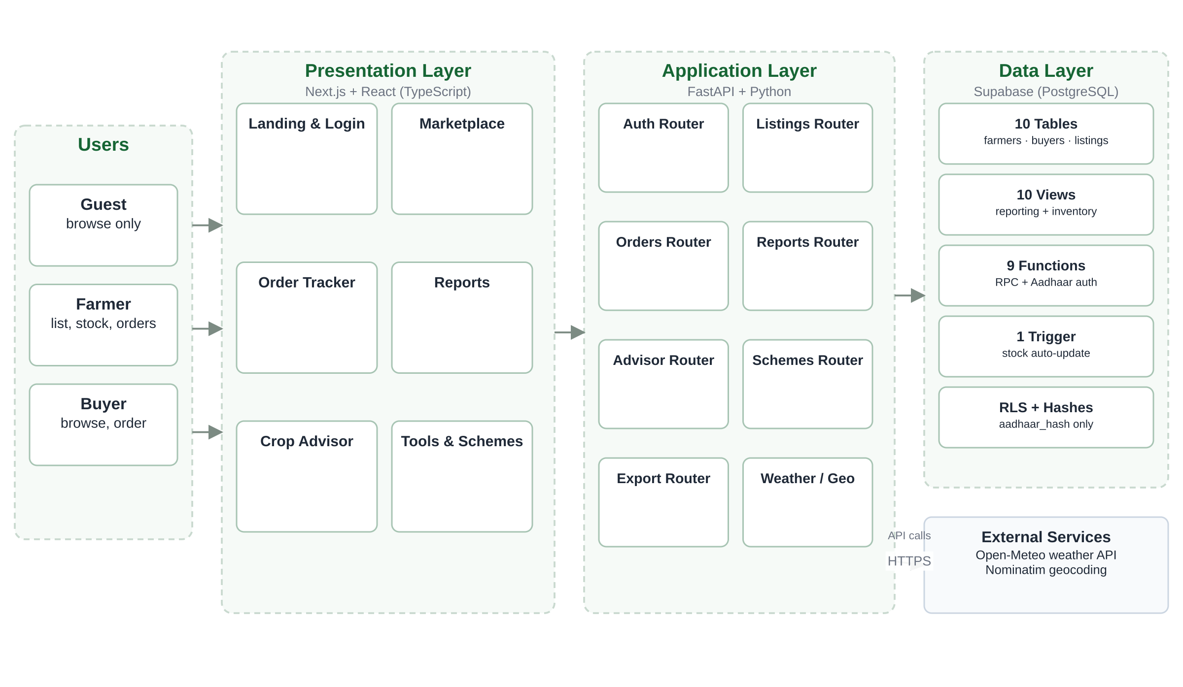
Fig. 2.1: System Architecture
A typical request begins in the browser. The front end sends a JSON request to a FastAPI route, which validates the payload and resolves the current role from the session context. The route then queries a table or view, or calls a stored function through Supabase RPC. The database enforces constraints and triggers before returning the result. The API transforms the result into the response shape expected by the page, and the front end renders it without exposing database credentials.
Separating the tiers provides clear security and maintenance boundaries. The database secret key remains on the server, so it is never shipped to the browser. Reporting logic lives in views and functions rather than being duplicated across pages. The front end can be rebuilt or replaced without changing the schema, and the schema can be tested independently of the interface.

2.4 Database Design
The database is the core of the project. It contains ten tables, ten views, nine stored functions and one trigger. Seven core foreign-key relationships link eight application tables; crops and price_history are standalone reference tables. Primary keys are surrogate identifiers named after the entity (for example, farmer_id and order_id), and every foreign key uses the same naming convention, which makes joins and the ER diagram easy to read.
The schema is normalised to 3NF. Listings store the offered quantity and unit price; order value is derived from quantity_ordered and price_per_unit when needed. Payments and ratings reference orders rather than duplicating buyer or listing data. The order_status_history table is append-only and records the previous status, the new status, the actor and the timestamp. CHECK constraints restrict statuses, buyer types and rating scores, while UNIQUE constraints protect Aadhaar hashes.

2.4.1 Entity-Relationship Diagram
The entity-relationship diagram below shows the ten entities, their key attributes and the seven foreign-key relationships. Crow's-foot cardinality is one-to-many in every relationship: one farmer has many listings and scheme records, one buyer places many orders, one listing is ordered many times, and one order can have multiple payment, rating and status-history records. The crops and price_history tables are reference data and have no foreign keys.
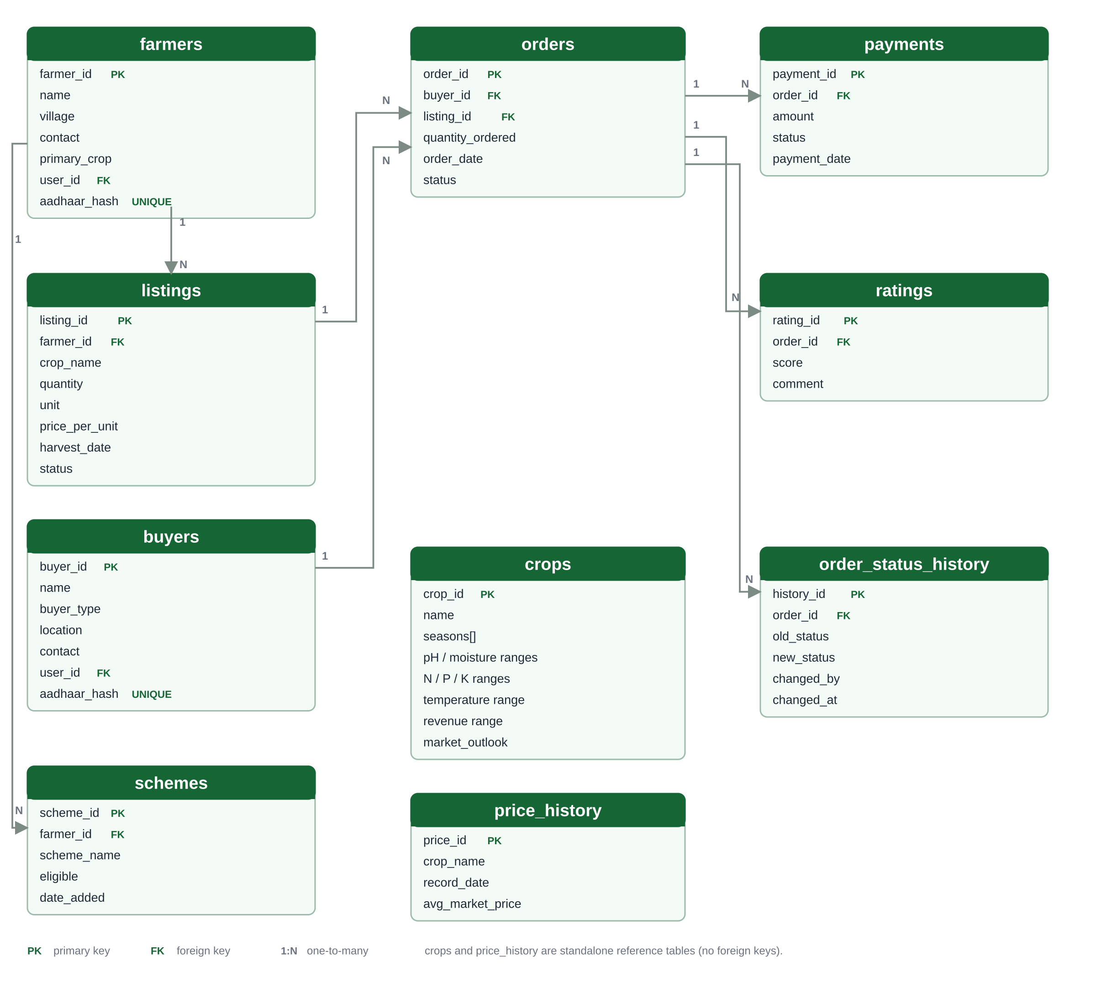
Fig. 2.2: Entity-Relationship Diagram
Table 2.1: Entity-Relationship Summary
Parent | Child | Foreign Key | Cardinality | Description
farmers | listings | listings.farmer_id | 1 : N | A farmer publishes many listings.
farmers | schemes | schemes.farmer_id | 1 : N | A farmer may have several scheme records.
buyers | orders | orders.buyer_id | 1 : N | A buyer places many orders.
listings | orders | orders.listing_id | 1 : N | A listing can be ordered many times.
orders | payments | payments.order_id | 1 : N | An order can have payment records.
orders | ratings | ratings.order_id | 1 : N | A rating is tied to a delivered order.
orders | order_status_history | order_status_history.order_id | 1 : N | Audit trail of status transitions.

Standalone reference tables: crops (agronomy knowledge base) and price_history (market prices); neither has a foreign key.

2.4.2 Table Descriptions
Table 2.2 summarises the purpose of each table, and Table 2.3 lists the columns, data types and important constraints. All tables use a SERIAL primary key, and all foreign keys reference the parent primary key. The schema is applied to Supabase as a single SQL script, followed by the seed script that loads demonstration data and the crop knowledge base.
Table 2.2: Database Tables
Table | Purpose
farmers | Registered sellers with name, village, contact, primary crop, optional auth user link and Aadhaar hash.
buyers | Registered purchasers with name, buyer type, location, contact, optional auth user link and Aadhaar hash.
listings | Produce offered for sale: crop, quantity, unit, price per unit, harvest date and availability status.
orders | Purchase transactions linking a buyer and a listing, with quantity, date and lifecycle status.
payments | Payment records for orders, including amount, status and payment date.
ratings | Buyer feedback (1 to 5) linked to an order, with an optional comment.
schemes | Government subsidy or pension schemes associated with a farmer and eligibility status.
price_history | Historical market prices for each crop and record date.
crops | Agronomy knowledge base with season, soil, nutrient, temperature and revenue ranges.
order_status_history | Append-only audit trail of every order status transition.

Table 2.3: Column-Level Table Structures
Table | Column | Data Type | Constraints / Description
farmers | farmer_id | SERIAL | Primary key
farmers | name | VARCHAR(100) | NOT NULL
farmers | village | VARCHAR(100) | Farmer village
farmers | contact | VARCHAR(15) | Contact number
farmers | primary_crop | VARCHAR(50) | Main crop
farmers | user_id | UUID | FK to auth.users(id)
farmers | aadhaar_hash | TEXT | UNIQUE; salted SHA-256 hash
buyers | buyer_id | SERIAL | Primary key
buyers | name | VARCHAR(100) | NOT NULL
buyers | buyer_type | VARCHAR(20) | NOT NULL; CHECK retailer / wholesaler / consumer
buyers | location | VARCHAR(100) | Buyer location
buyers | contact | VARCHAR(15) | Contact number
buyers | user_id | UUID | FK to auth.users(id)
buyers | aadhaar_hash | TEXT | UNIQUE; salted SHA-256 hash
listings | listing_id | SERIAL | Primary key
listings | farmer_id | INT | FK to farmers
listings | crop_name | VARCHAR(50) | NOT NULL
listings | quantity | DECIMAL(10,2) | NOT NULL; CHECK >= 0
listings | unit | VARCHAR(10) | DEFAULT 'kg'
listings | price_per_unit | DECIMAL(10,2) | NOT NULL
listings | harvest_date | DATE | Date of harvest
listings | status | VARCHAR(20) | DEFAULT 'available'; CHECK available / sold_out
orders | order_id | SERIAL | Primary key
orders | buyer_id | INT | FK to buyers
orders | listing_id | INT | FK to listings
orders | quantity_ordered | DECIMAL(10,2) | NOT NULL
orders | order_date | DATE | DEFAULT CURRENT_DATE
orders | status | VARCHAR(20) | DEFAULT 'pending'; CHECK pending / confirmed / delivered / cancelled / paid
payments | payment_id | SERIAL | Primary key
payments | order_id | INT | FK to orders
payments | amount | DECIMAL(10,2) | NOT NULL
payments | status | VARCHAR(20) | DEFAULT 'pending'; CHECK pending / paid
payments | payment_date | DATE | Date of payment
ratings | rating_id | SERIAL | Primary key
ratings | order_id | INT | FK to orders
ratings | score | INT | CHECK BETWEEN 1 AND 5
ratings | comment | VARCHAR(255) | Optional feedback
schemes | scheme_id | SERIAL | Primary key
schemes | farmer_id | INT | FK to farmers
schemes | scheme_name | VARCHAR(100) | Name of scheme
schemes | eligible | BOOLEAN | DEFAULT FALSE
schemes | date_added | DATE | DEFAULT CURRENT_DATE
price_history | price_id | SERIAL | Primary key
price_history | crop_name | VARCHAR(50) | NOT NULL
price_history | record_date | DATE | NOT NULL
price_history | avg_market_price | DECIMAL(10,2) | NOT NULL
crops | crop_id | SERIAL | Primary key
crops | name | VARCHAR(50) | NOT NULL
crops | seasons | TEXT[] | NOT NULL; Kharif / Rabi / Summer
crops | ph_min, ph_max | NUMERIC(4,1) | Optimal soil pH range
crops | moisture_min, moisture_max | NUMERIC(5,2) | Optimal moisture range
crops | n_min, n_max | NUMERIC(4,1) | Nitrogen range
crops | p_min, p_max | NUMERIC(4,1) | Phosphorus range
crops | k_min, k_max | NUMERIC(4,1) | Potassium range
crops | temp_min, temp_max | NUMERIC(4,1) | Temperature range
crops | revenue_min, revenue_max | VARCHAR(40) | Expected revenue range
crops | market_outlook | TEXT | Advisory note
order_status_history | history_id | SERIAL | Primary key
order_status_history | order_id | INT | FK to orders; ON DELETE CASCADE
order_status_history | old_status | VARCHAR(20) | Previous status
order_status_history | new_status | VARCHAR(20) | NOT NULL
order_status_history | changed_by | VARCHAR(100) | Actor
order_status_history | changed_at | TIMESTAMPTZ | DEFAULT now()

2.4.3 Views
Views encapsulate joins and aggregations that are reused by the API and the reports page. They keep the SQL readable and ensure that every client applies the same filters and calculations. The ten views are listed below.
Table 2.4: Reporting Views
View | Purpose
active_listings_view | Available listings joined with farmer name and village, ordered for the marketplace.
most_active_buyers_view | Buyers ranked by order count and total purchased volume.
unsold_stock_view | Available stock whose harvest date is older than 15 days.
farmer_avg_rating_view | Average rating and number of ratings for each farmer.
pending_payments_view | Pending payments with buyer and order context.
order_history_view | Full order context with buyer, farmer, crop and computed order value.
order_status_audit_view | Status transition history for every order, newest first.
inventory_view | Current stock position for every listing, including farmer and village.
low_stock_view | Available listings at or below the low-stock threshold of 20 units.
monthly_sales_summary_view | Monthly order count, quantity sold and sales value.

2.4.4 Stored Functions
Stored functions are exposed as Supabase RPCs. They keep multi-step operations atomic and enforce rules that must not depend on the client. The business functions validate transitions and compute reports; the authentication functions hash, store and verify Aadhaar values without ever returning the raw number.
Table 2.5: Stored Functions and RPCs
Function | Arguments | Purpose
recommend_crops | pH, moisture, N, P, K, temperature, season | Scores each crop on six parameters and returns the top five matches with at least four matches.
update_order_status | order_id, new_status, changed_by | Validates the allowed transition, updates the order and writes the audit row.
get_farmer_revenue | farmer_id | Returns the total of paid payments for a farmer.
get_most_active_buyers | none | Ranks buyers by total order volume.
get_farmer_ratings | none | Returns average rating and rating count per farmer.
set_farmer_aadhaar | farmer_id, aadhaar | Validates the 12-digit format and stores a salted hash.
aadhaar_farmer_login | aadhaar | Hashes the input and returns farmer_id and name on a match.
set_buyer_aadhaar | buyer_id, aadhaar | Validates the 12-digit format and stores a salted hash.
aadhaar_buyer_login | aadhaar | Hashes the input and returns buyer_id and name on a match.

The Crop Advisor scoring logic is expressed directly in SQL. The excerpt below shows the six range checks and the threshold that removes weak matches.
SELECT c.name,
((CASE WHEN p_ph BETWEEN c.ph_min AND c.ph_max THEN 1 ELSE 0 END)
+ (CASE WHEN p_moisture BETWEEN c.moisture_min AND c.moisture_max THEN 1 ELSE 0 END)
+ (CASE WHEN p_n BETWEEN c.n_min AND c.n_max THEN 1 ELSE 0 END)
+ (CASE WHEN p_p BETWEEN c.p_min AND c.p_max THEN 1 ELSE 0 END)
+ (CASE WHEN p_k BETWEEN c.k_min AND c.k_max THEN 1 ELSE 0 END)
+ (CASE WHEN p_temp BETWEEN c.temp_min AND c.temp_max THEN 1 ELSE 0 END))::INT AS match_score
FROM crops c
WHERE p_season = ANY(c.seasons)
ORDER BY match_score DESC
LIMIT 5;
Listing 2.1: Crop scoring in recommend_crops()

2.4.5 Triggers and Integrity Constraints
The stock trigger is the most important automated rule in the schema. It fires after every order insert, reduces the listing quantity by the ordered quantity, and updates the status to sold_out when the remaining quantity is zero or negative. Because the rule is enforced inside PostgreSQL, it also protects data written by scripts or future clients.
CREATE OR REPLACE FUNCTION update_listing_after_order()
RETURNS TRIGGER AS $$
BEGIN
UPDATE listings
SET quantity = quantity - NEW.quantity_ordered
WHERE listing_id = NEW.listing_id;
UPDATE listings
SET status = 'sold_out'
WHERE listing_id = NEW.listing_id AND quantity <= 0;
RETURN NEW;
END; $$ LANGUAGE plpgsql;
CREATE TRIGGER after_order_insert
AFTER INSERT ON orders
FOR EACH ROW EXECUTE FUNCTION update_listing_after_order();
Listing 2.2: Automatic stock update trigger
Table 2.6: Integrity Constraints and Triggers
Mechanism | Implementation | Effect
Primary keys | SERIAL primary key on every table | Unique row identity and stable joins.
Foreign keys | Seven core relationships; optional auth user links are separate | Prevents orphan orders, listings and history rows.
CHECK constraints | Status sets, buyer_type, quantity >= 0, score 1-5 | Rejects invalid values at write time.
UNIQUE constraint | farmers.aadhaar_hash and buyers.aadhaar_hash | Prevents duplicate identity hashes.
DEFAULT values | unit kg, status available/pending, CURRENT_DATE, now() | Consistent initial values.
Stock trigger | after_order_insert -> update_listing_after_order() | Atomic stock reduction and sold-out flag.
Lifecycle guard | update_order_status() transition rules | Blocks illegal jumps such as pending to delivered.
Audit trail | order_status_history with ON DELETE CASCADE | Every accepted transition is recorded.
Row-level security | Enabled on the core tables | Policies protect access if the anon key is used.

2.5 Block Diagram
The block diagram presents the functional view of the system. Users interact with the authentication, marketplace, order and stock, Crop Advisor, reports, and schemes-and-tools blocks. All blocks read from or write to the AgriConnect database, which acts as the single source of truth. The external weather and geocoding services are used only by the advisory and calculator features.
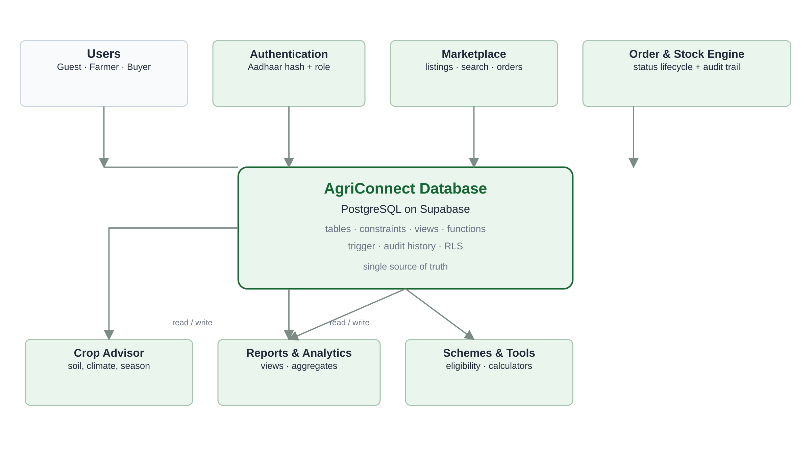
Fig. 2.3: Block Diagram
The authentication block hashes the Aadhaar input and resolves the role. The marketplace block creates listings and performs search and filtering. The order and stock block inserts orders and invokes the stock trigger, then applies validated status transitions. The Crop Advisor block calls recommend_crops() with soil and climate values. The reports block queries the reporting views and functions, and the schemes-and-tools block reads scheme and price data and performs calculator operations.

2.6 Component Descriptions

i. Frontend (Next.js)
The front end is a Next.js application written in TypeScript. It provides the landing and login screen, the marketplace, the order and listing tracker, the reports dashboard, the Crop Advisor, the profit calculator and the scheme explorer. A shared dock allows navigation between these pages, while reusable card, table and form components keep the interface consistent. The layout adapts to desktop and mobile widths, and the application shows role-specific actions for guests, farmers and buyers.

ii. Backend (FastAPI)
The back end is a FastAPI service. Each domain has a router: authentication, farmers, buyers, listings, orders, reports, Crop Advisor, schemes, weather, geocoding, export and marketplace statistics. Routers validate request payloads with Pydantic models, apply role and ownership checks, call Supabase, and return JSON responses. A small TTL cache reduces repeated database round-trips for statistics and listings.

iii. Database (Supabase / PostgreSQL)
Supabase hosts a PostgreSQL database that stores all transactional and reference data. The schema defines ten tables, constraints, one trigger, ten views and nine functions. The API uses the server-side secret key, so database credentials never reach the browser. Row-level security is enabled on the core tables, and the Aadhaar hash columns are unique and never exposed in query results.

iv. Authentication Module
The authentication module accepts a 12-digit Aadhaar number, validates its format, appends the application salt and computes a SHA-256 hash. It then calls aadhaar_farmer_login and, if no farmer matches, aadhaar_buyer_login. A successful call returns only the entity identifier and name, which the front end stores as the active session. The raw number and the stored hash are never returned or displayed. On registration, set_farmer_aadhaar or set_buyer_aadhaar performs the same validation and stores the hash.

v. Crop Advisor Engine
The Crop Advisor is a rule-based engine, not a machine-learning model. It reads the crops knowledge base and scores each crop against six parameters: pH, moisture, nitrogen, phosphorus, potassium and temperature. The season is applied as a filter. A crop must match at least four of the six parameters to be returned, and results are ranked by match score and limited to five. Each result includes the match percentage, an expected revenue range and a market outlook. Live weather from Open-Meteo and place-name geocoding from Nominatim help the user fill in the climate inputs.

vi. Orders, Stock and Reporting
Orders link a buyer, a listing and a quantity. On insertion, the trigger reduces stock and, if necessary, marks the listing sold out. The API checks that the requested quantity is positive and does not exceed the available stock. Status changes are applied through update_order_status(), which permits only pending to confirmed or cancelled, confirmed to delivered or cancelled, and delivered to paid. Every accepted change is written to the audit table. The reporting module reads the views and functions to produce monthly sales, active buyers, farmer ratings, inventory, low-stock alerts, pending payments and revenue figures, with CSV and PDF export.

2.7 Workflow
The end-to-end workflow begins with registration and login. A farmer publishes a listing, which immediately appears in the marketplace. A buyer searches or filters the active listings, selects a quantity and places an order. The order insert triggers the stock update, and the farmer advances the order through confirmation and delivery. Once payment is recorded, the order is marked paid. Ratings can then be associated with the order, and all activity feeds the reporting views.
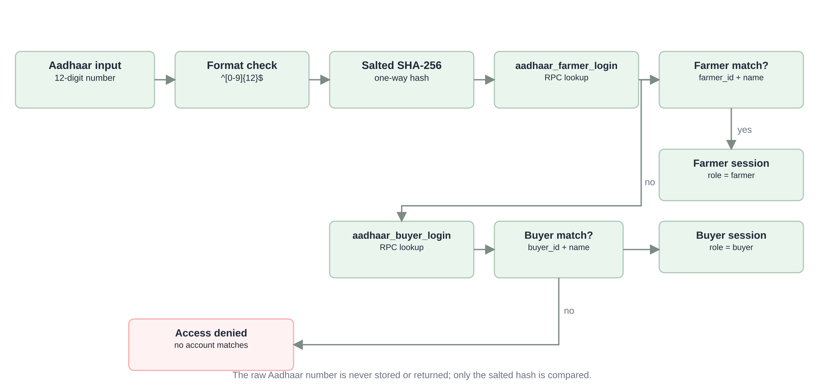
Fig. 2.4: Authentication Flow
Authentication is deliberately simple for the user but strict in the database. The input is validated before any lookup, and the comparison is performed against a hash. The role is resolved without asking the user to choose it, which prevents a user from claiming the wrong role. A failed lookup returns a single generic message, so the response does not reveal whether a hash exists.
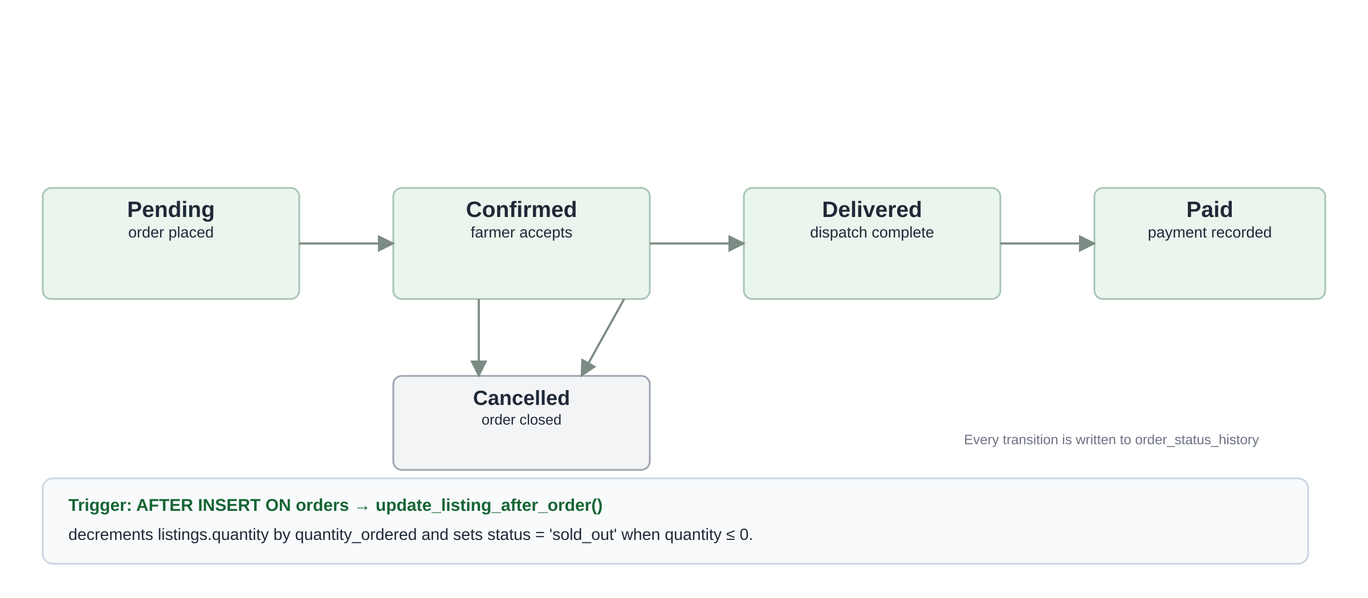
Fig. 2.5: Order Lifecycle
The order lifecycle is a directed graph with a guarded transition function. Only the transitions shown in the figure are accepted; an attempt to move directly from pending to delivered raises an error. The cancelled state closes the order without restoring stock automatically, which is a deliberate limitation of the current implementation and a candidate for future work. The trigger records stock movement at the moment of order insertion, and the audit table records who changed the status and when.
SECTION 3

RESULT

3.1 Implementation Screenshots
The application was implemented and deployed with a seeded dataset of ten farmers, nine buyers, twenty-three listings and twenty orders. The screenshots below show the principal pages at a desktop resolution of 1440 pixels. The interface uses a restrained green palette, rounded cards and a persistent bottom dock so that the marketplace and analytical tools remain one click away.
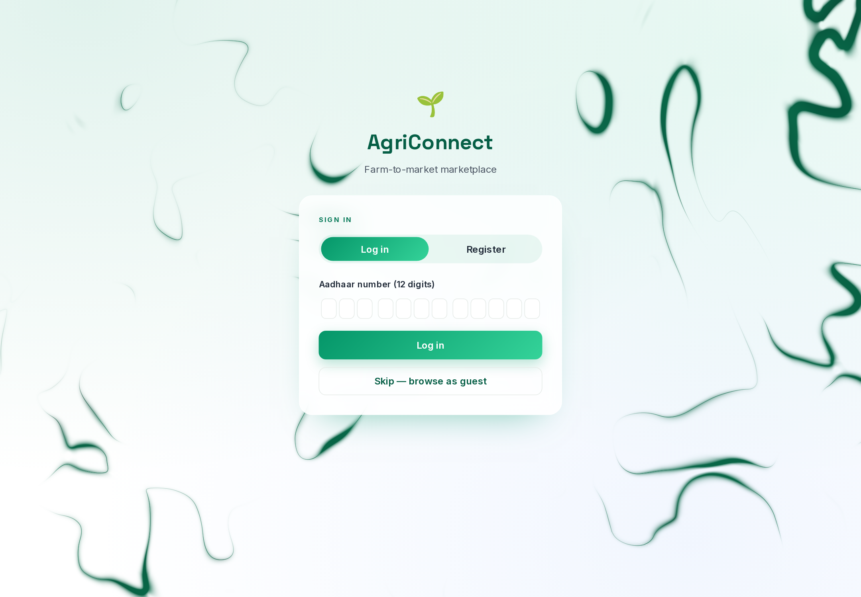
Fig. 3.1: Login Page
The login page offers a twelve-digit Aadhaar input, an explicit registration tab and a guest-browsing option. Guests can explore public listings, reports and tools, but buying and selling actions remain disabled until a farmer or buyer signs in. The guest option was added so that evaluators and first-time visitors can inspect the application without creating accounts.
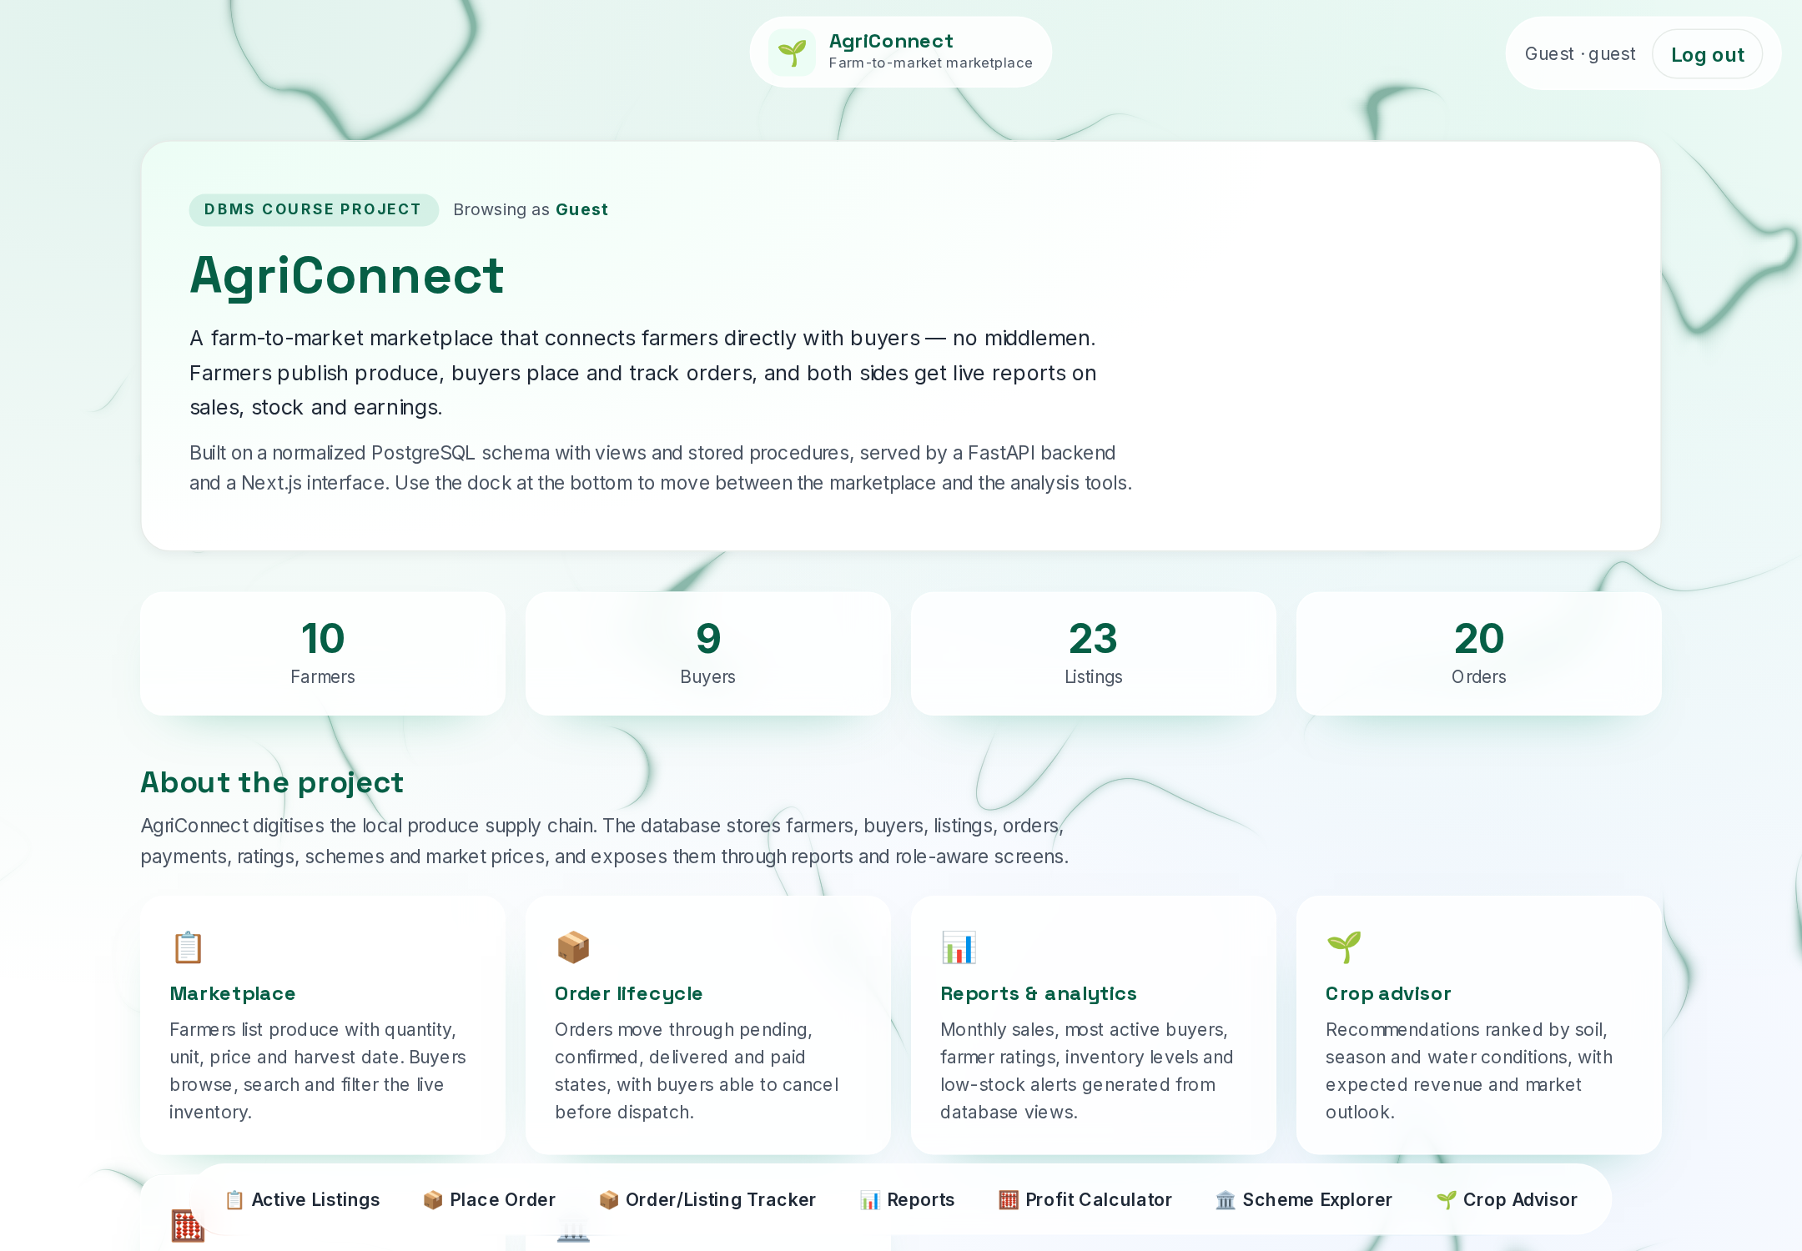
Fig. 3.2: Home Dashboard (Guest)
The home page summarises the project and shows live counts of farmers, buyers, listings and orders. The cards explain the marketplace, order lifecycle, reports and Crop Advisor. The dock at the bottom provides access to every module and highlights the current page.
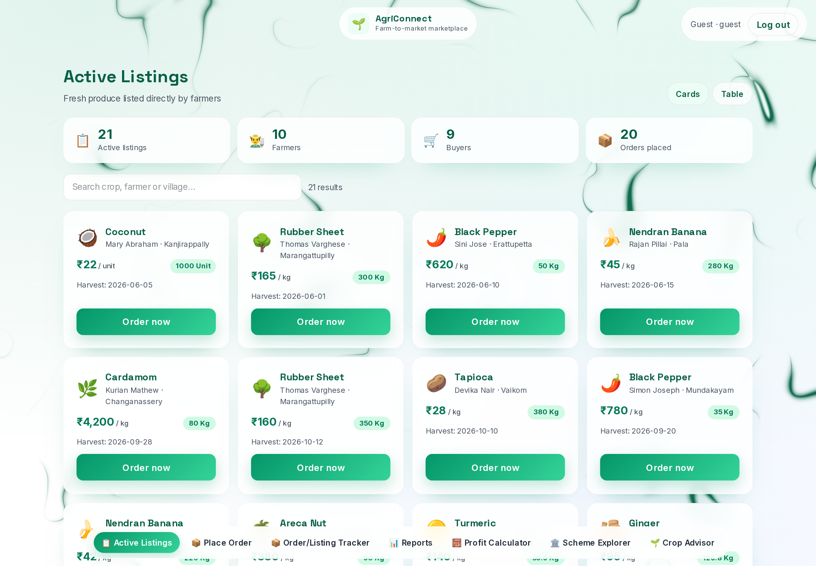
Fig. 3.3: Active Listings and Search
The marketplace displays live listings with crop, farmer, village, price, available quantity and harvest date. Users can switch between card and table views, search by crop, farmer or village, filter by crop and village, restrict the price range and export the current result set to CSV. The page shown here contains twenty-one active listings drawn from the seeded database.
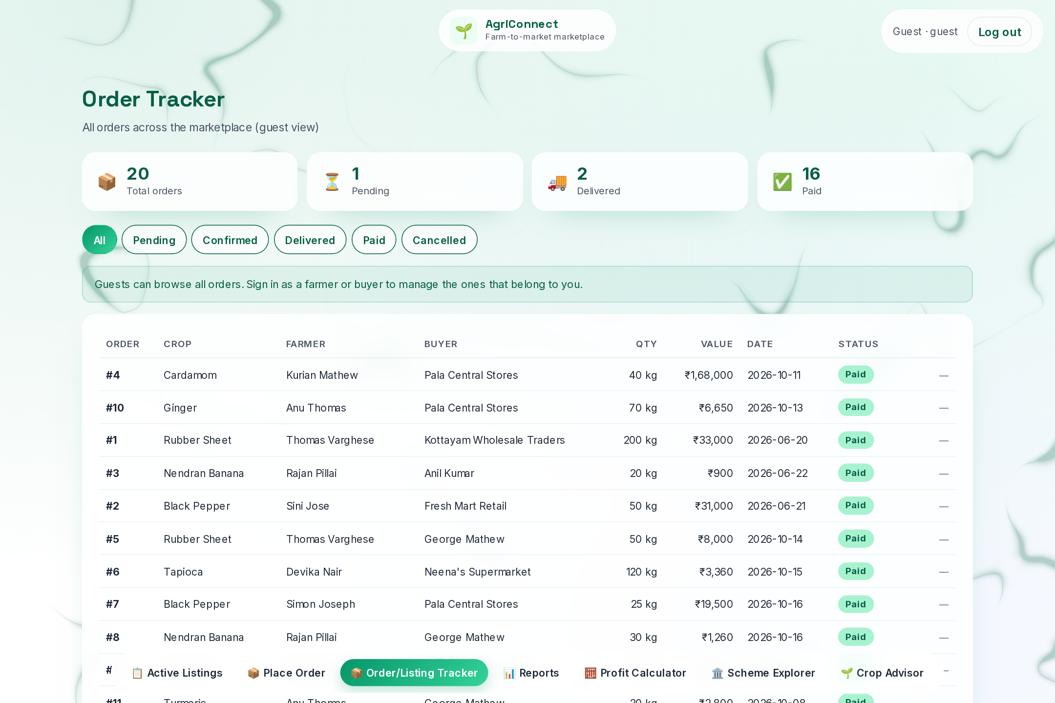
Fig. 3.4: Order Tracker
The order tracker lists orders with crop, farmer, buyer, quantity, value, date and status. Status chips filter the list, and role-aware actions appear only for the farmer or buyer who owns the order. The guest view shown here is read-only and includes a note explaining the restriction.
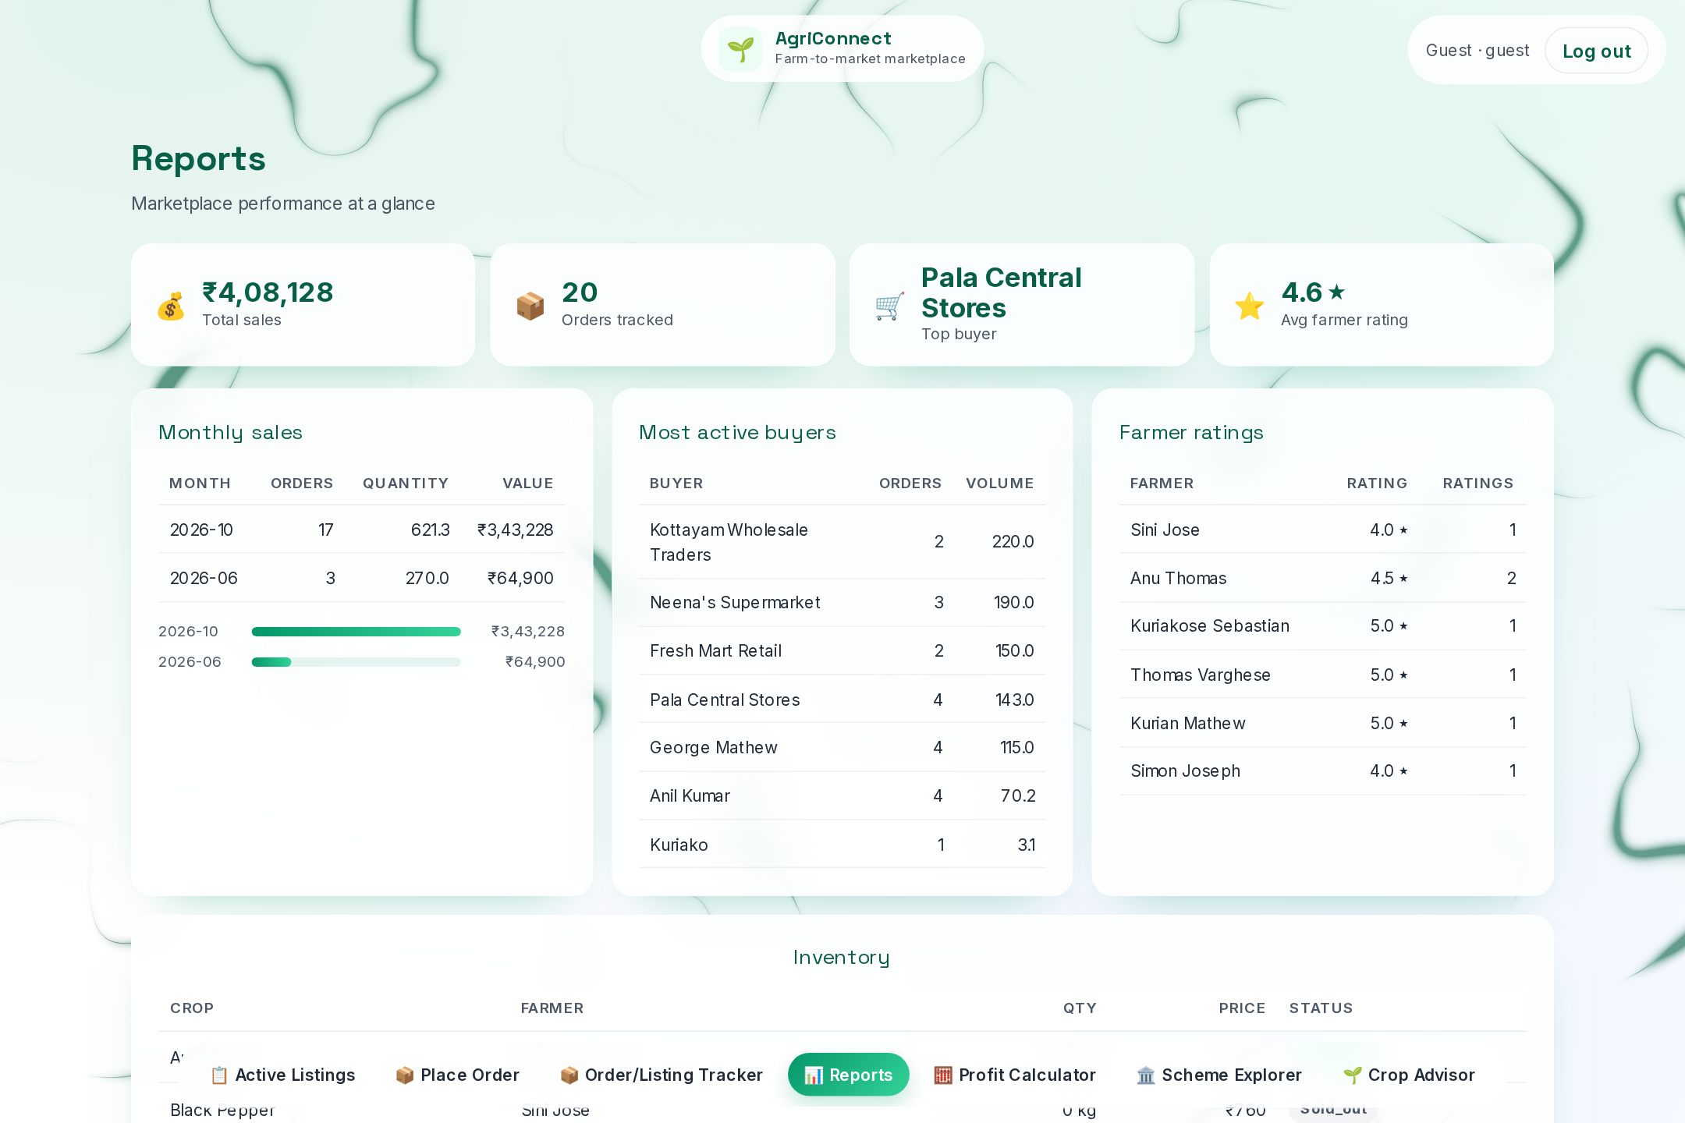
Fig. 3.5: Reports and Analytics
The reports page consolidates monthly sales, most-active buyers, farmer ratings and current inventory, with a low-stock panel below. The figures are produced by the reporting views and functions rather than by client-side aggregation, so the same numbers are available to every consumer of the database.
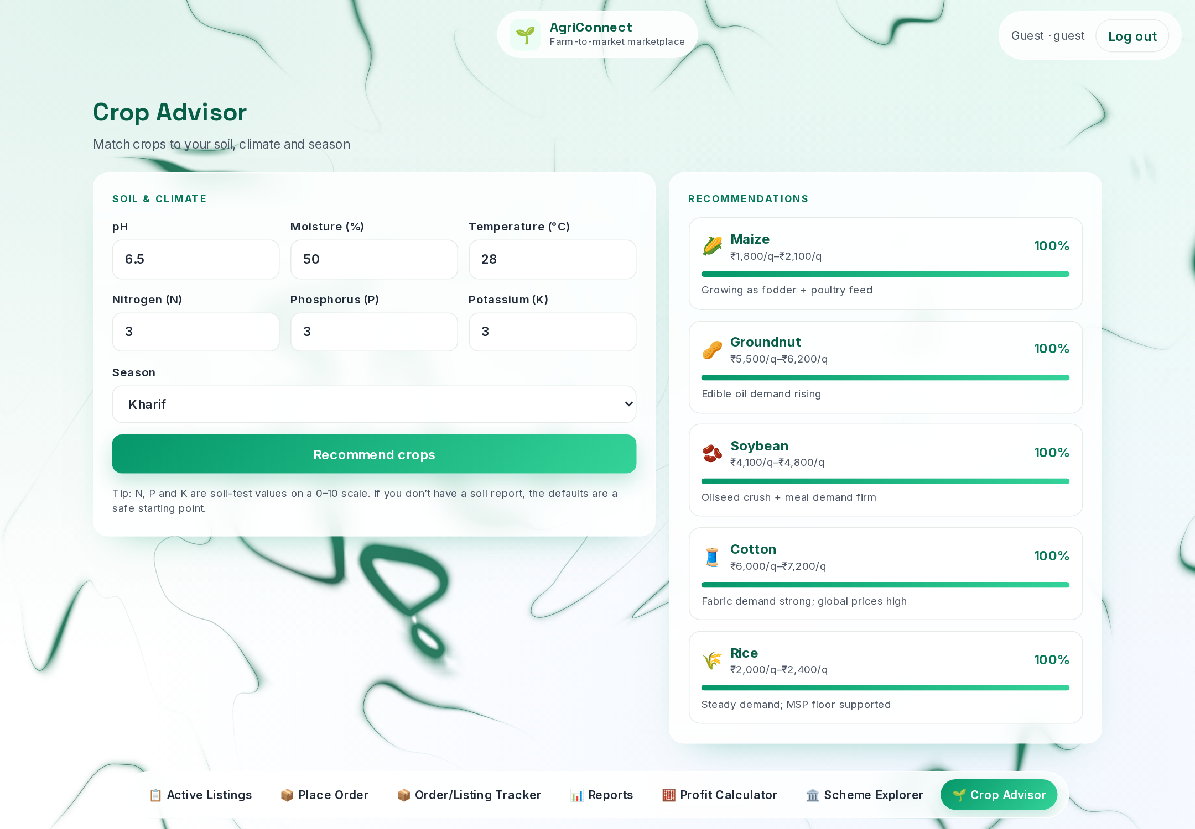
Fig. 3.6: Crop Advisor Recommendations
The Crop Advisor accepts pH, moisture, temperature, nitrogen, phosphorus, potassium and season. The example uses pH 6.5, moisture 50, temperature 28 and N/P/K values of 3 for the Kharif season. The function returns ranked crops with a match percentage, an expected revenue range and a market outlook. Live weather and geocoding can populate the climate inputs.
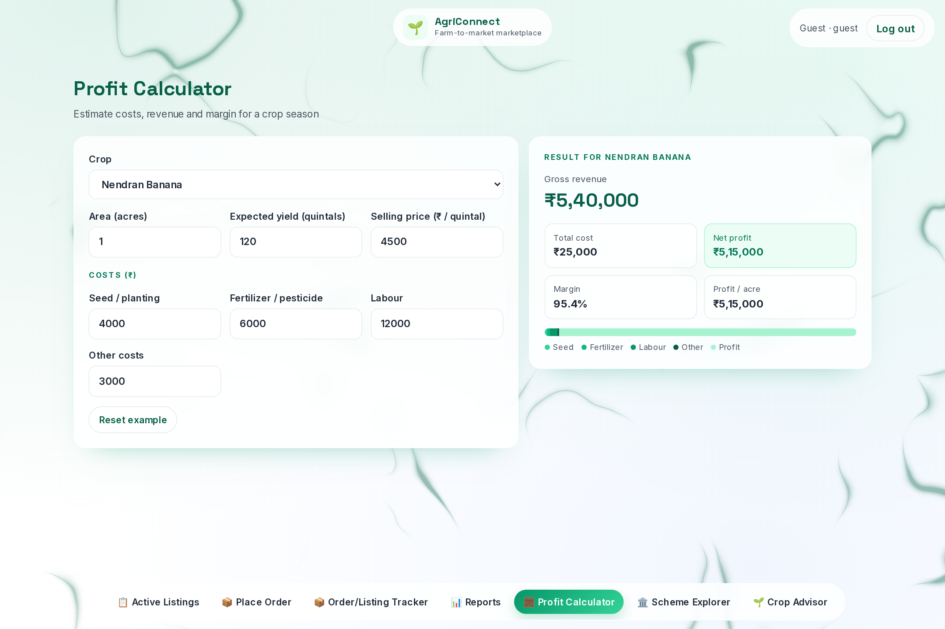
Fig. 3.7: Profit Calculator
The profit calculator combines area, expected yield, selling price and cost components to produce gross revenue, net profit, margin and profit per acre. It is a planning aid, not a database transaction, and it uses the same crop list as the marketplace and the Crop Advisor.

3.2 Test Results
Testing was carried out at three levels. Database logic was verified with SQL checks for the stock trigger, the order transition function, the reporting views and the authentication functions. Page-level functional testing covered guest, farmer and buyer workflows, including negative cases such as an invalid Aadhaar format, over-ordering and illegal status jumps. Finally, the interface was checked with Playwright at desktop and mobile widths (320, 360 and 390 pixels) for layout overflow, console errors and session behaviour.
The tables below record the principal test cases and their outcomes. All 43 cases passed on the deployed build.
Table 3.1: Authentication and Access Test Cases
ID | Test Case | Expected Result | Status
A1 | Farmer login with a registered Aadhaar | Logs in with role farmer and shows the name | Pass
A2 | Buyer login with a registered Aadhaar | Logs in with role buyer | Pass
A3 | Role auto-detection | Correct role resolved without a role picker | Pass
A4 | Aadhaar with fewer than 12 digits or non-numeric characters | Message: Enter a valid 12-digit Aadhaar number. | Pass
A5 | Aadhaar not present in the database | Message: No account matches that Aadhaar. Please register first. | Pass
A6 | Guest access | Public pages visible; buy and sell actions blocked | Pass
A7 | Raw Aadhaar exposure | Raw number never shown in the UI or logs | Pass
A8 | Session persistence after reload | Session restored and re-validated against the database | Pass

Table 3.2: Listings and Marketplace Test Cases
ID | Test Case | Expected Result | Status
B1 | Farmer adds a listing | Listing appears in Active Listings | Pass
B2 | Guest or buyer tries to add a listing | Action blocked or disabled | Pass
B3 | Search for Rice | Only matching crop, farmer or village rows | Pass
B4 | Filter by crop Tomato | Only Tomato listings | Pass
B5 | Filter by village | Only listings from that village | Pass
B6 | Filter by price range | Only listings within the selected range | Pass
B7 | Default card view | Product cards with price per unit | Pass
B8 | Switch to table view | Tabular data with formatted prices | Pass
B9 | Export listings to CSV | CSV file downloaded with current results | Pass

Table 3.3: Orders and Stock Test Cases
ID | Test Case | Expected Result | Status
C1 | Buyer places a valid order | Order row created | Pass
C2 | Stock decrement after an order | Listing quantity reduced by the ordered quantity | Pass
C3 | Order reduces stock to zero | Listing status changed to sold_out | Pass
C4 | Order exceeds available stock | Error: Insufficient stock | Pass
C5 | Zero or negative quantity | Error: quantity must be greater than zero | Pass
C6 | Order total calculation | Total equals quantity multiplied by price | Pass
C7 | Valid transition pending to confirmed | Status updated and history row written | Pass
C8 | Invalid transition pending to delivered | Database raises Invalid status transition | Pass
C9 | Audit trail after a status change | Row in order_status_history with actor and timestamp | Pass
C10 | Two buyers view their orders | Each buyer sees only their own orders | Pass
C11 | Farmer views orders | Only orders on the farmer listings are shown | Pass

Table 3.4: Crop Advisor Test Cases
ID | Test Case | Expected Result | Status
D1 | Valid soil and climate inputs | Crops matching at least four parameters, ranked | Pass
D2 | Match percentage calculation | match_pct equals matched parameters divided by six | Pass
D3 | Season filter set to Kharif | Only crops tagged for Kharif | Pass
D4 | Inputs with no suitable crop | Empty result handled with a message | Pass
D5 | Revenue and outlook fields | Revenue range and market outlook displayed | Pass
D6 | Live weather lookup | Weather card populated for the entered place | Pass

Table 3.5: Reports and Tools Test Cases
ID | Test Case | Expected Result | Status
E1 | Revenue per farmer | Sum of paid payments for the selected farmer | Pass
E2 | Most active buyers | Buyers ranked by total volume | Pass
E3 | Price trend for a crop | Current, minimum and maximum prices with chart | Pass
E4 | Unsold stock for 15 or more days | Listings with harvest date older than fifteen days | Pass
E5 | Average farmer rating | Average score and count per farmer | Pass
E6 | Pending payments | Payments with status pending | Pass
E7 | Profit calculator | Computed profit, margin and yield | Pass
E8 | Scheme eligibility inputs | Indicative scheme matches displayed | Pass
E9 | PDF export | PDF generated and downloaded | Pass

The negative tests were particularly useful. They confirmed that invalid Aadhaar formats never reach the database, that an order cannot exceed the available quantity, and that an illegal status jump is rejected by the function rather than silently accepted. The mobile checks also exposed layout issues at narrow widths, which were corrected before the final build.
SECTION 4

REFLECTION AND LEARNING

4.1 Challenges Faced
The first challenge was migrating the data layer from a direct PostgreSQL connection to Supabase's PostgREST interface. Complex joins and interval filters that were straightforward in SQL could not be sent as arbitrary queries through the REST client. The solution was to move each reusable report into a database view or a set-returning function and call it as an RPC, which also improved consistency.
The second challenge was keeping stock correct under concurrent activity. Performing the decrement in the application would have created a race condition between two buyers. Implementing it as an AFTER INSERT trigger ensured that every order, regardless of its origin, updated the listing atomically. The order lifecycle posed a similar problem: allowing the client to set any status would have made the audit trail meaningless, so the transition rules were centralised in update_order_status().
Authentication required careful handling. Storing an Aadhaar number, even in a course project, would have been inappropriate. The team implemented a one-way salted hash, restricted the login functions to return only an identifier and a name, and verified that the raw number never appeared in the interface or in logs. A fourth challenge was deployment: exposing a locally hosted application through a public tunnel required attention to certificates, process supervision and mobile layout.
Finally, the data set itself was a challenge. The reports look convincing only when the seed data contains enough variation in dates, quantities, ratings and payments. Preparing a realistic seed script made the views and charts meaningful and exposed edge cases such as a listing whose quantity reaches zero.

4.2 Key Learnings
The project provided practical experience in designing and operating a relational database as part of a complete application. The main technical and professional lessons were:
• Normalisation is not an academic exercise: separating listings, orders, payments, ratings and history removed duplication and made the queries simpler.
• Constraints and triggers belong in the database because they protect every client, including scripts and future applications.
• Views and stored functions are an effective way to centralise reporting logic and keep the API thin.
• A clear order lifecycle and an append-only audit trail make a transactional system easier to reason about and to defend.
• Security requirements such as hashing and least-privilege access must be designed at the start, not added after the interface is built.
• Testing negative cases is as important as testing the happy path; most defects appeared in invalid input and illegal transitions.
• Responsive design and deployment are part of the engineering work, not an afterthought.
• Version control, seed data and a repeatable deployment recipe make the project reproducible.

4.3 Suggestions for Improvement
Several improvements would make the system more complete and closer to a production marketplace:
• Integrate a payment gateway and reconcile payment status with the order lifecycle.
• Restore stock when an order is cancelled, using a second trigger or an explicit compensating transaction.
• Add notifications and a messaging channel so that farmers and buyers can coordinate delivery.
• Allow ratings only for delivered orders and add seller ratings for buyers.
• Replace seeded price history with a scheduled feed from a real market-price source.
• Introduce a scheduled job for backups, data retention and archival of old orders.
• Add an administrative dashboard for scheme verification, dispute handling and catalogue moderation.
• Improve the mobile experience with a progressive web app and offline-friendly caching.
• Expand the automated test suite to cover every route and function in continuous integration.

4.4 Programme Outcomes, PSOs and SDGs
The following tables map the project to the outcomes it directly addresses. The mapping is limited to the POs, PSOs and SDGs for which there is direct evidence in the implementation or documentation.
Table 4.1: Programme Outcome Mapping
PO | Outcome | How the project addresses it
PO1 | Engineering Knowledge | Applies database and software engineering concepts through a normalised schema, triggers, views, stored functions and a working Next.js/FastAPI application.
PO2 | Problem Analysis | Analyses farmer market-access and crop-selection problems, then converts them into role-based requirements and test cases.
PO3 | Design/Development of Solutions | Designs an integrated marketplace with listings, orders, stock automation, reports, Crop Advisor and scheme explorer.
PO5 | Engineering Tool Usage | Uses Next.js, React, TypeScript, FastAPI, Python, Supabase and Playwright for development, testing and documentation.
PO6 | The Engineer and Society | Addresses agricultural marketing and farmer access through direct trading, price transparency and scheme information.
PO8 | Ethics | Protects identity data by storing only a salted SHA-256 hash, applying role checks and never returning raw Aadhaar values.

Table 4.2: Programme Specific Outcome Mapping
PSO | Outcome | How the project addresses it
PSO1 | Analyse and design database-backed systems | Implements a normalised relational schema with triggers, views, stored functions and reporting logic.
PSO2 | Use modern tools to design and communicate | Applies Next.js, React, TypeScript, FastAPI, Python, Supabase and Playwright, and documents the design and tests.

Table 4.3: Sustainable Development Goal Mapping
SDG | Target | Project contribution
SDG 2 | Zero Hunger (2.3, 2.c) | Direct farmer-to-buyer marketplace, price transparency, price history and crop advisory support better farmer income and market information.
SDG 8 | Decent Work and Economic Growth (8.3) | Digital listings, orders, payment tracking, revenue reporting and scheme discovery support rural entrepreneurship.
SDG 9 | Industry, Innovation and Infrastructure (9.3, 9.c) | Low-cost digital marketplace infrastructure built with Next.js, FastAPI and PostgreSQL improves rural access to ICT.
SDG 10 | Reduced Inequalities (10.1, 10.2) | Focus on small and marginal farmers, local buyers and transparent market data reduces information asymmetry.
SDG 1 | No Poverty (supporting) | Better market access and income tracking support farmer livelihoods.
SDG 12 | Responsible Consumption and Production (supporting) | Inventory, low-stock and sales reporting support more efficient stock planning.
SDG 13 | Climate Action (supporting) | Crop advisory uses soil, moisture and season inputs to support informed, climate-sensitive crop selection.

4.5 Conclusion
AgriConnect demonstrates how a carefully designed relational database can support a practical agricultural marketplace. Farmers can list produce, manage stock and process orders; buyers can search, compare and purchase directly; and both roles receive transparent reports and advisory tools. The database enforces the rules that matter: primary and foreign keys preserve relationships, CHECK constraints reject invalid data, a trigger keeps stock consistent, a stored function guards the order lifecycle, and views and functions produce the reports.
The project also shows the value of separating concerns. The Next.js interface, the FastAPI service and the PostgreSQL schema can evolve independently while sharing one source of truth. Aadhaar authentication, although simplified for a course project, follows the correct principle of storing a one-way hash rather than the raw identity number. The result is a coherent, testable and reproducible application that meets its objectives and provides a solid foundation for the improvements listed above.
SECTION 5

REFERENCES
[1] PostgreSQL Global Development Group, PostgreSQL 16 Documentation, 2024. Available: https://www.postgresql.org/docs/
[2] Supabase, Supabase Documentation: Database, Auth and PostgREST, 2025. Available: https://supabase.com/docs
[3] PostgREST, PostgREST Documentation, 2025. Available: https://postgrest.org/
[4] FastAPI, FastAPI Documentation, 2025. Available: https://fastapi.tiangolo.com/
[5] Vercel, Next.js Documentation, 2025. Available: https://nextjs.org/docs
[6] Open-Meteo, Open-Meteo Weather API Documentation, 2025. Available: https://open-meteo.com/en/docs
[7] OpenStreetMap Foundation, Nominatim Search API Documentation, 2025. Available: https://nominatim.org/release-docs/latest/api/Overview/
[8] National Informatics Centre, eNAM: National Agriculture Market, Government of India. Available: https://enam.gov.in/
[9] Department of Agriculture & Farmers Welfare, Government of India. Available: https://agricoops.nic.in/
[10] National Institute of Standards and Technology, FIPS PUB 180-4: Secure Hash Standard (SHS), 2015.
[11] R. Elmasri and S. B. Navathe, Fundamentals of Database Systems, 7th ed., Pearson, 2017.
[12] A. Silberschatz, H. F. Korth and S. Sudarshan, Database System Concepts, 7th ed., McGraw-Hill, 2019.
[13] Python Software Foundation, Python 3 Documentation, 2025. Available: https://docs.python.org/3/
[14] fpdf2, fpdf2 Documentation, 2025. Available: https://pyfpdf.github.io/fpdf2/

