Kingsley Erhi
Computer Science, Study.com
Computer Science 307: Computer Engineering
Study.com Web Professors and Instructors et all
February 4th, 2026

Scalable IT Asset Management (SITAM) System for a small company.
Feature Selection & Rationale.
I chose the Assignment and Return workflow with chain of custody: the user story: As a User, I want to assign and check in assets, so that ownership and responsibility are tracked. This feature is the operational initiation of the SITAM system. It creates an inventory list which is useful, but its true value is the questions it an asks and answers… “who has what right now” and “who had it previously.” It is a direct support for the highest-impact stakeholder requirements. The User’s ability to onboard and offboard quickly, the HR’s need to confirm returns during employee exits, and the Security’s need for accountability during incidents or any lost-device or assets investigations. It also reduces unnecessary costs by preventing duplicate purchases and enabling faster reuse of returned equipment. From an engineering viewpoint, it forces early clarity on data integrity rules, as valid statuses, preventing double assignment, capturing timestamps and condition, which in turn, influences the database design, audit logging, and asset reporting. Furthermore, Getting this workflow correct early increases user trust and drives adoption, making later features like reports, imports, and integrations much easier to justify and implement and in choosing this feature it just gives a natural linear progression of the project from beginning to end as it concerns the logical mind.

Software Design Artifact
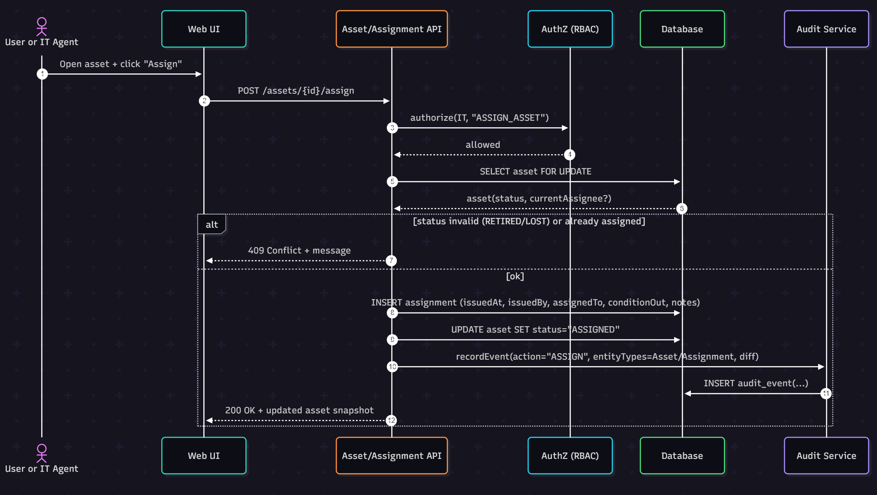
Diagram 1. Design Artifact (Mermaid Sequence Diagram) Assign Asset (Check-Out)
Components, Responsibilities, Data Flow
-Web UI: validates required fields, displays clear errors, and refreshes asset state after assignment.
-Asset / Assignment API: owns business rules, status checks, with one active assignment, orchestrates DB writes, returns consistent responses.
-Authorization using Role-Based Access Control (AuthZ (RBAC)): central permission check to keep authorization logic out of controllers.
-Database: enforces integrity, unique constraints, foreign keys and uses row locking to prevent double-assignments.
-Audit Service: writes append-only audit events for accountability.
Explanation.
This design supports usability, by keeping the individual asset check out flow to a single action: the User selects an asset, enters the assignee and the condition, then receives an immediate confirmation or a specific conflict message. For instance, ‘asset is already assigned’. The API returns an updated asset snapshot so the UI can reliably reflect the current owner / status without extra steps. It supports reliability through explicit business rules. blocking RETIRED or LOST assignments, database backed integrity, and SELECT key words ... FOR UPDATE row locking to prevent race conditions where two agents may be assigned the same device simultaneously or at the same time. The write sequence is deterministic: int creating the assignment, updating the asset status, then recording an audit event, ensuring chain of custody history is preserved. If an operation fails, the API will wrap Data Base changes and audit insertion in a transaction to avoid partial updates.
For maintainability, responsibilities are separated: RBAC checks live in a shared authorization component, the assignment logic lives in the Assignment service layer, and audit logging is centralized so new actions can be logged by calling a single method. This avoids duplicated “who / what / when” code across endpoints and makes policy changes, new roles, new audit fields are localized. The sequence diagram also makes integration points explicit, simplifying future enhancements such as notifications (email or Slack) or MDM integration without rewriting the core workflow logic.
Inplementation.
Working Prototype, Assign Asset (Check-Out)
Below is a working FastAPI and SQLite prototype implementing the Assign Asset feature with:
-RBAC authorization ((User) IT_AGENT / ADMIN can assign)
-Status validation (blocks RETIRED / LOST and already assigned)
-Atomic transaction (assignment, asset status update, audit event)
-Audit logging
main.py
from datetime import datetime
from enum import Enum
from typing import Optional

from fastapi import FastAPI, Depends, HTTPException, Header
from pydantic import BaseModel, Field
from sqlalchemy import (
create_engine, Column, String, DateTime, ForeignKey, Text
)
from sqlalchemy.orm import declarative_base, sessionmaker, Session
from sqlalchemy.exc import IntegrityError

# -------------------------
# Database setup
# -------------------------
engine = create_engine("sqlite:///./itam.db", connect_args={"check_same_thread": False})
SessionLocal = sessionmaker(bind=engine, autoflush=False, autocommit=False)
Base = declarative_base()

class AssetStatus(str, Enum):
IN_STOCK = "IN_STOCK"
ASSIGNED = "ASSIGNED"
REPAIR = "REPAIR"
RETIRED = "RETIRED"
LOST = "LOST"

class Asset(Base):
__tablename__ = "assets"
id = Column(String, primary_key=True) # UUID as string for simplicity
asset_tag = Column(String, unique=True, nullable=False)
status = Column(String, nullable=False, default=AssetStatus.IN_STOCK.value)
current_assignee_id = Column(String, nullable=True)
updated_at = Column(DateTime, nullable=False, default=datetime.utcnow)

class Assignment(Base):
__tablename__ = "assignments"
id = Column(String, primary_key=True) # UUID string
asset_id = Column(String, ForeignKey("assets.id"), nullable=False)
assigned_to_user_id = Column(String, nullable=False)
issued_by_user_id = Column(String, nullable=False)
issued_at = Column(DateTime, nullable=False, default=datetime.utcnow)
returned_at = Column(DateTime, nullable=True)
condition_out = Column(Text, nullable=True)
notes = Column(Text, nullable=True)

class AuditEvent(Base):
__tablename__ = "audit_events"
id = Column(String, primary_key=True) # UUID string
occurred_at = Column(DateTime, nullable=False, default=datetime.utcnow)
actor_user_id = Column(String, nullable=False)
action = Column(String, nullable=False) # e.g., ASSIGN
entity_type = Column(String, nullable=False) # Asset /Assignment
entity_id = Column(String, nullable=False)
diff_json = Column(Text, nullable=True)
ip_address = Column(String, nullable=True)

Base.metadata.create_all(bind=engine)

# -------------------------
# App & dependencies
# -------------------------
app = FastAPI(title="ITAM Prototype")

def db_session():
db = SessionLocal()
try:
yield db
finally:
db.close()

class Principal(BaseModel):
user_id: str
role: str

def get_principal(
x_user_id: str = Header(..., alias="X-User-Id"),
x_role: str = Header(..., alias="X-Role"),
) -> Principal:
return Principal(user_id=x_user_id, role=x_role)
def require_can_assign(p: Principal):
if p.role not in ("ADMIN", "IT_AGENT"):
raise HTTPException(status_code=403, detail="Not authorized to assign assets.")

# -------------------------
# API models
# -------------------------
class AssignRequest(BaseModel):
assignee_id: str = Field(..., min_length=1)
condition_out: Optional[str] = None
notes: Optional[str] = None

class AssignResponse(BaseModel):
asset_id: str
asset_tag: str
status: str
current_assignee_id: str
assignment_id: str
issued_at: datetime

# -------------------------
# Helpers
# -------------------------
def new_id() -> str:
# lightweight ID for demo…
return f"id_{int(datetime.utcnow().timestamp() * 1_000_000)}"

# -------------------------
# Seed endpoint (demo)
# -------------------------
@app.post("/demo/seed_asset/{asset_id}")
def seed_asset(asset_id: str, asset_tag: str, db: Session = Depends(db_session)):
a = Asset(id=asset_id, asset_tag=asset_tag, status=AssetStatus.IN_STOCK.value)
db.add(a)
try:
db.commit()
except IntegrityError:
db.rollback()
raise HTTPException(409, "asset_tag already exists")
return {"id": a.id, "asset_tag": a.asset_tag, "status": a.status}

# -------------------------
# Feature: Assign Asset
# -------------------------
@app.post("/assets/{asset_id}/assign", response_model=AssignResponse)
def assign_asset(
asset_id: str,
req: AssignRequest,
p: Principal = Depends(get_principal),
db: Session = Depends(db_session),
x_forwarded_for: Optional[str] = Header(default=None, alias="X-Forwarded-For"),
):
require_can_assign(p)

# Begin atomic unit of work
try:
with db.begin():
asset = db.get(Asset, asset_id)
if not asset:
raise HTTPException(404, "Asset not found.")

if asset.status in (AssetStatus.RETIRED.value, AssetStatus.LOST.value):
raise HTTPException(409, f"Asset cannot be assigned while status={asset.status}.")

if asset.status == AssetStatus.ASSIGNED.value and asset.current_assignee_id:
raise HTTPException(409, "Asset is already assigned.")

assignment_id = new_id()
issued_at = datetime.utcnow()

assignment = Assignment(
id=assignment_id,
asset_id=asset.id,
assigned_to_user_id=req.assignee_id,
issued_by_user_id=p.user_id,
issued_at=issued_at,
condition_out=req.condition_out,
notes=req.notes,
)
db.add(assignment)

# Update asset state
before = {"status": asset.status, "current_assignee_id": asset.current_assignee_id}
asset.status = AssetStatus.ASSIGNED.value
asset.current_assignee_id = req.assignee_id
asset.updated_at = datetime.utcnow()

# Record audit event
after = {"status": asset.status, "current_assignee_id": asset.current_assignee_id}
audit = AuditEvent(
id=new_id(),
occurred_at=datetime.utcnow(),
actor_user_id=p.user_id,
action="ASSIGN",
entity_type="Asset",
entity_id=asset.id,
diff_json=str({"before": before, "after": after, "assignment_id": assignment_id}),
ip_address=x_forwarded_for,
)
db.add(audit)

#... transaction committed
return AssignResponse(
asset_id=asset.id,
asset_tag=asset.asset_tag,
status=asset.status,
current_assignee_id=asset.current_assignee_id,
assignment_id=assignment_id,
issued_at=issued_at,
)

except HTTPException:
# re-raise expected errors
raise
except Exception as e:
raise HTTPException(500, f"Unexpected error: {e!r}")

# Quick sanity endpoint
@app.get("/assets/{asset_id}")
def get_asset(asset_id: str, db: Session = Depends(db_session)):
a = db.get(Asset, asset_id)
if not a:
raise HTTPException(404, "Asset not found.")
return {
"id": a.id,
"asset_tag": a.asset_tag,
"status": a.status,
"current_assignee_id": a.current_assignee_id,
"updated_at": a.updated_at,
}

Read Me Section – To Run & Test
pip install fastapi uvicorn sqlalchemy pydantic
uvicorn main:app --reload
Seed an asset:
curl -X POST "http://127.0.0.1:8000/demo/seed_asset/asset-1?asset_tag=LT-0001"
Assign it (authorized role):
curl -X POST "http://127.0.0.1:8000/assets/asset-1/assign" \
-H "Content-Type: application/json" \
-H "X-User-Id: u123" \
-H "X-Role: IT_AGENT" \
-d '{"assignee_id":"emp42","condition_out":"Good","notes":"Issued with charger"}'
Try as unauthorized:
curl -X POST "http://127.0.0.1:8000/assets/asset-1/assign" \
-H "Content-Type: application/json" \
-H "X-User-Id: u999" \
-H "X-Role: AUDITOR" \
-d '{"assignee_id":"emp42"}'

Reflection.
Moving from design to implementation put the required chosen development tools to work and it is relatively straightforward, but the edge cases quickly became the real work. The design implied atomicity, so I had to make sure the assignment insert, asset status update, and audit event write happen in a single transaction as to ATOMicity; otherwise, partial updates would break chain of custody and trust. Another challenge was translating RBAC from a diagram or image plan into enforceable code, centralizing authorization checks prevents duplicated logic but requires a consistent request context, user identity, role. I also discovered that concurrency concerns like double assignments need database level protection; in SQLite this is limited in contrast to Postgres row locks, so the production DB choice matters one could argue. Moving forward for future projects, it is incumbent on me to improve the process by defining explicit error codes / messages in the requirements, adding automated API tests earlier, and writing an ADR that specifies transactional behavior, fail-closed vs fail-open, for audit loggings.
Basic V&V Plan - Assign Asset Check-Out.
Scope.
Verify the Assign Asset API (POST /assets/{asset_id}/assign) meets functional requirements (authorization, status rules, chain-of-custody record creation, audit logging) and at least one quality attribute: reliability / data integrity, atomic transactions, no partial writes.
Test Environment.
-FastAPI prototype (main.py)
-SQLite local DB (itam.db) reset per run (or using a temp file)
-Tooling: pytest, httpx (or curl for manual), DB inspection via SQLAlchemy or sqlite CLI

Test Cases.
TC1 — Successful assignment…( functional correctness).
Preconditions: Asset exists with status=IN_STOCK.
Steps: Call assign with headers X-Role: IT_AGENT, valid assignee_id.
Expected:
-HTTP 200
-Asset status=ASSIGNED, current_assignee_id=assignee_id
-New Assignment row created with issuedBy, issuedAt
-New AuditEvent row created with action=ASSIGN and correct entity_id
TC2 — Unauthorized role blocked… (functional correctness & security)
Preconditions: Asset exists IN_STOCK.
Steps: Call assign with headers X-Role: AUDITOR.
Expected:
-HTTP 403
-No Assignment inserted
-Asset remains unchanged
TC3 — Reject invalid status / already assigned… (functional correctness)
Preconditions: Asset exists with status=RETIRED (or LOST) or status=ASSIGNED with non-null assignee.
Steps: Call assign as IT_AGENT.
Expected:
-HTTP 409
-No new assignment created
-No asset status change
TC4 — Atomicity / reliability: no partial update on audit failure (quality attribute)
Preconditions: Asset exists IN_STOCK. Force audit insertion failure (e.g., temporarily make AuditEvent.actor_user_id null in code, or raise exception in AuditService).
Steps: Call assign as IT_AGENT.
Expected:
-HTTP 500 (or controlled error)
-No assignment row persists
-Asset remains IN_STOCK with no assignee (transaction rolled back)

Test Results Summary.
Execution of TC1–TC3 on the prototype produced the expected outcomes: successful assignment returned HTTP 200 and updated both the Asset and Assignment tables, while unauthorized requests were blocked with HTTP 403 and left the database unchanged. Status validation validated correctly for RETIRED and LOST assets and for assets already assigned, returning HTTP 409 and preventing duplicate chain-of-custody entries. There were verifications in these tests that gave confidence that the core business rules are enforced at the API layer and that RBAC is applied consistently.
The primary quality issue was during TC4 (atomicity). When a simulation of an audit-write failure, the system initially risked leaving behind partial state, assignment created but audit missing, if audit logging was implemented outside the transaction boundary. To address this, I ensured the audit event insertion occured within the same db.begin() transaction as the assignment insert and asset update, so any exception triggers a rollback and preserves data integrity. A second reliability concern is concurrency as in task overlapping tasks executions: SQLite’s locking semantics are limited, so “double assignment” races are harder to reproduce and prevent. Obviously, for production deployment, Postgres is desirable and adding a database constraint like, partial unique index ensuring only one active assignment per asset, to guarantee correctness under concurrent requests is advisable. In short, for maintainability, I would add automated pytest coverage to CI and standardize error codes / messages to reduce client-side branching and debugging time respectively.

References
Agile SDLC (Software Development Life Cycle). 23 Jul, 2025. Geeks For Geeks.
https://www.geeksforgeeks.org/software-engineering/agile-sdlc-software- development-life-cycle/
Glaag, David. (n.d). Human Interface Design Principles & Guidelines. https://study.com/academy/lesson/human-interface-design-principles- guidelines.html
Kypridemos, Alexis. (n.d). Analyzing User Interface Design: Steps & Procedures https://study.com/academy/lesson/analyzing-user-interface-design-steps- procedures.html
Aravindan, Sudha. (n.d). Software Testing | Methods, Purpose & Best Practices. https://study.com/academy/lesson/what-is-software-testing-best-practices- methods.html
Goodbrand, Alan. (n.d). Types of Software Testing. https://study.com/academy/lesson/types-of-software-testing.html
Martin, Gibbs. (n.d). Quality Assurance for Software Development: Overview & Purpose. https://study.com/academy/lesson/quality-assurance-for-software- development-overview-purpose.html
Whiting, Brianna. (n.d). Project Management Planning: Process & Tools. https://study.com/academy/lesson/project-management-planning-process- tools.html

