CHRIST (Deemed to be University), Bangalore
School of Engineering and Technology
Department of Electronics and Communication Engineering
Activity Report

General Information
Type of Activity
Title of the Activity
Date/s
Time
Venue

Speaker Details
Name
Title/Position
Organization
Title of Presentation | .

Participants profile
Type of Participants

Highlights of the
Activity

Summary of the Activities:

Key Takeaways

Report prepared by:

Name of the Organiser
Designation/Title
Signature

Speaker Profile:

Annexure:
- Photos of Activity – image need to uploaded

- Attendance list of participants – image need to be uploaded

- poster image should be uploade

- Poster:
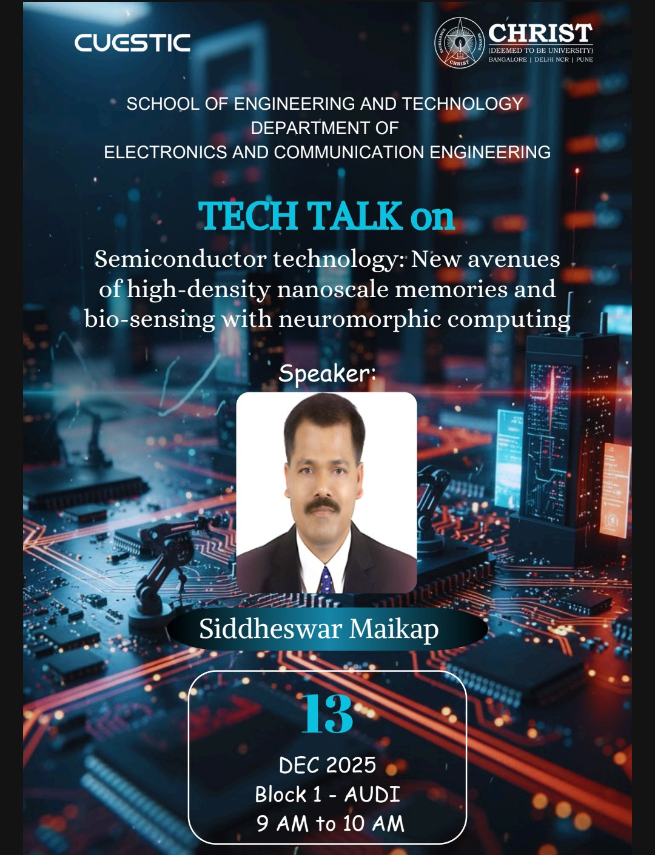

- Sample E-Certificate:
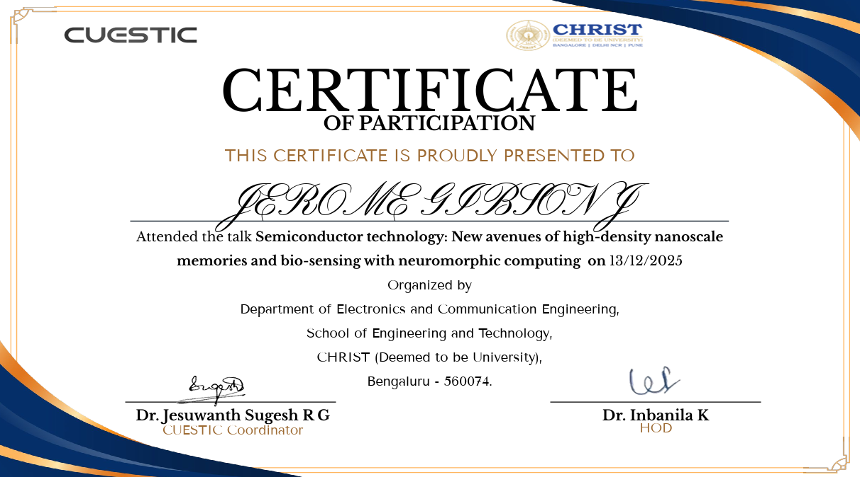

- Feedback Analysis:
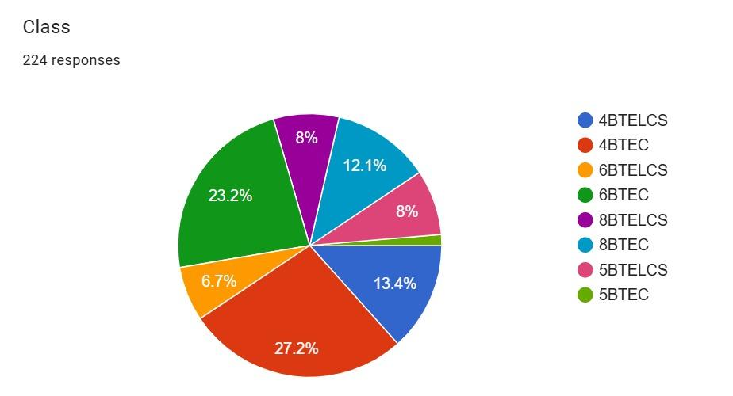

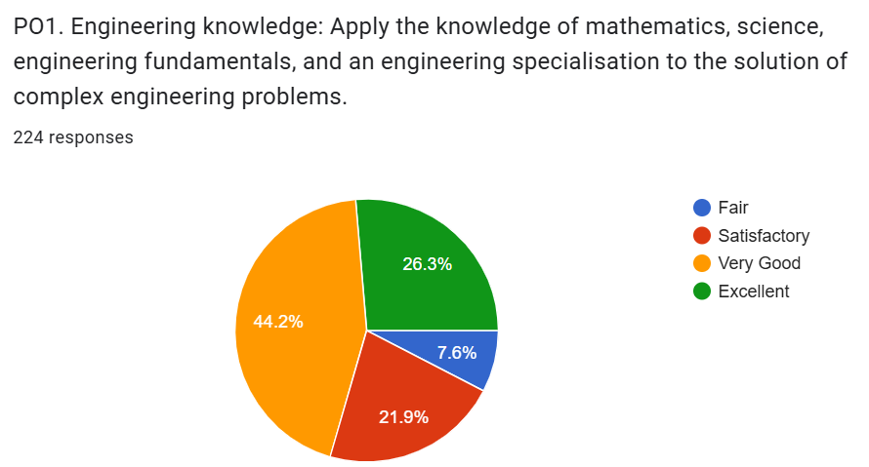
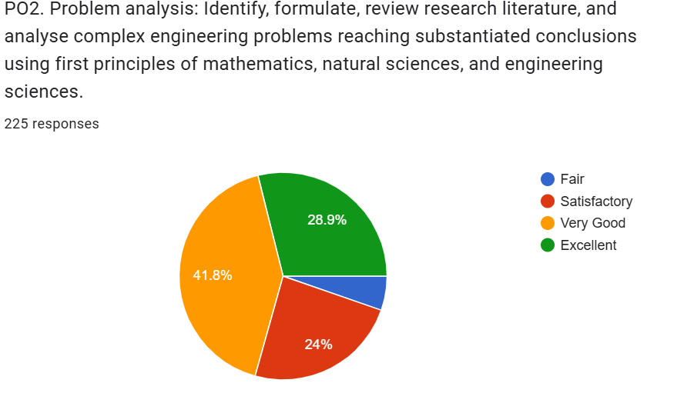

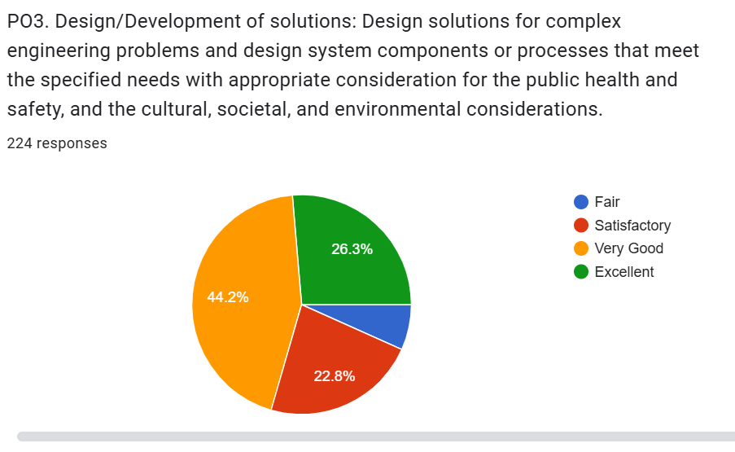
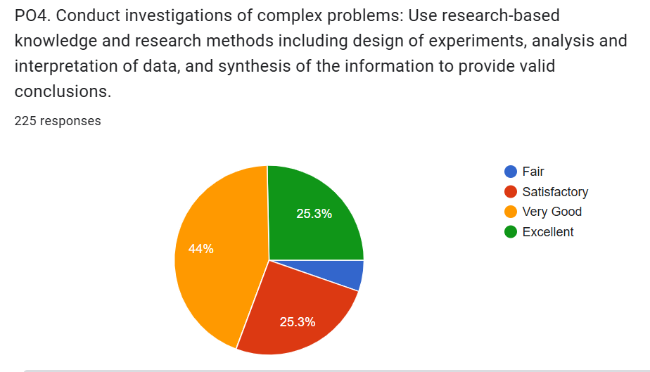

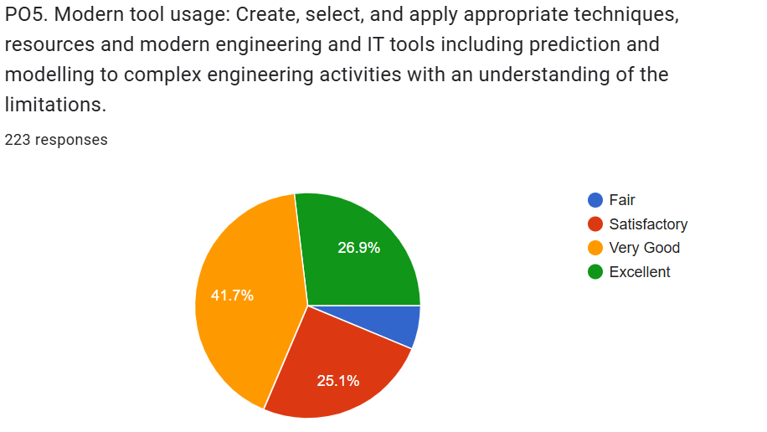

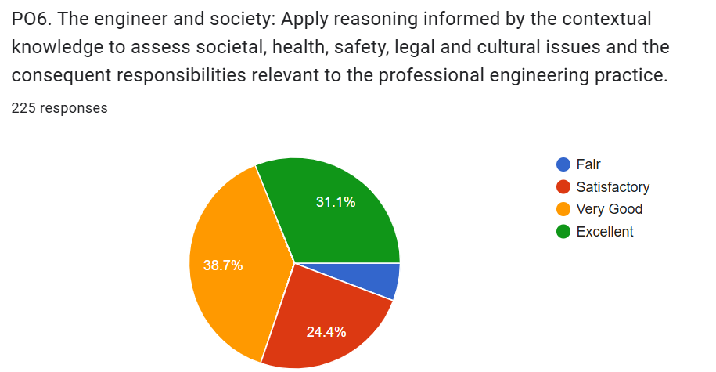

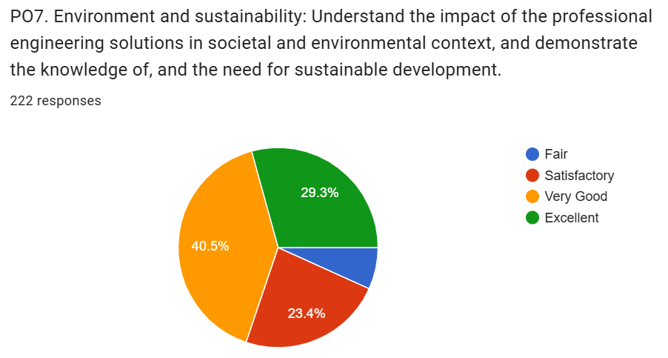

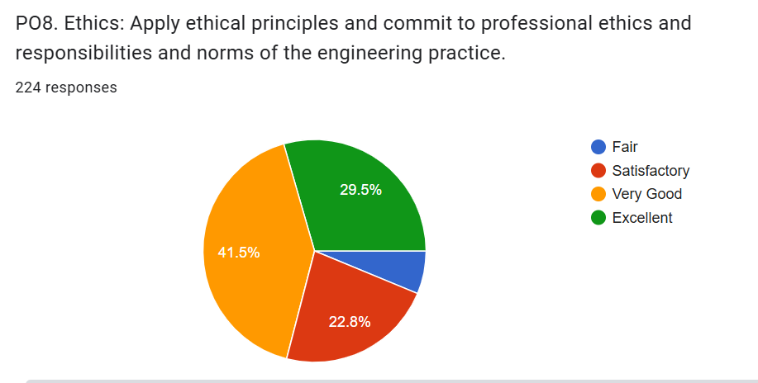

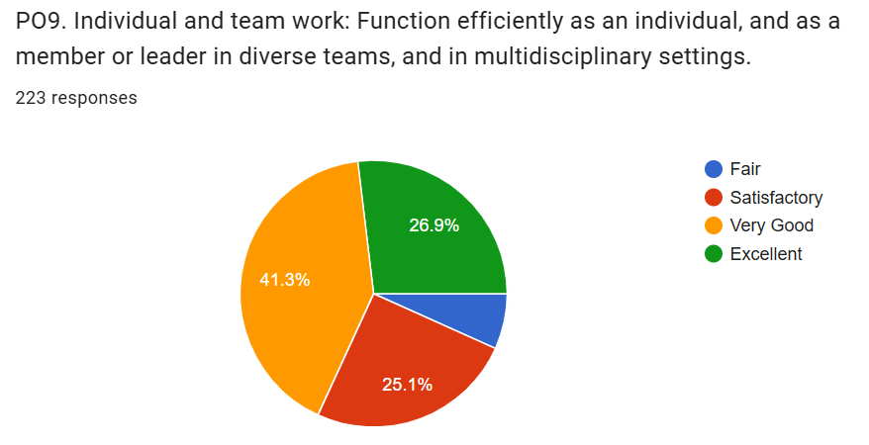

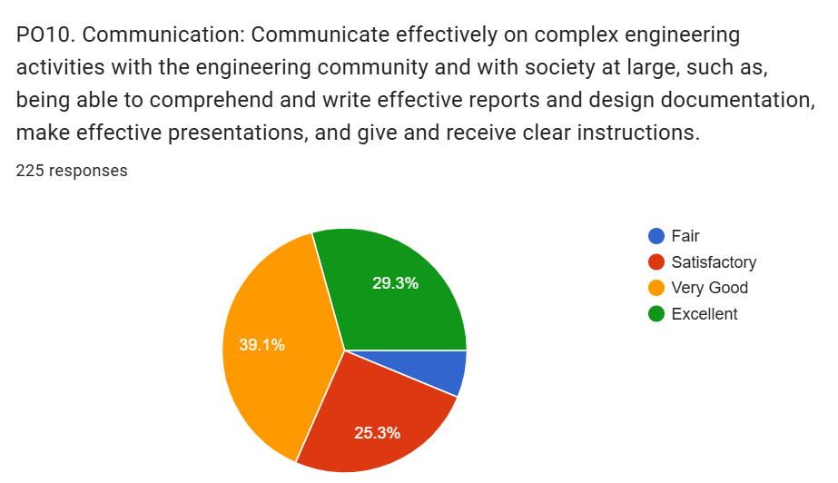
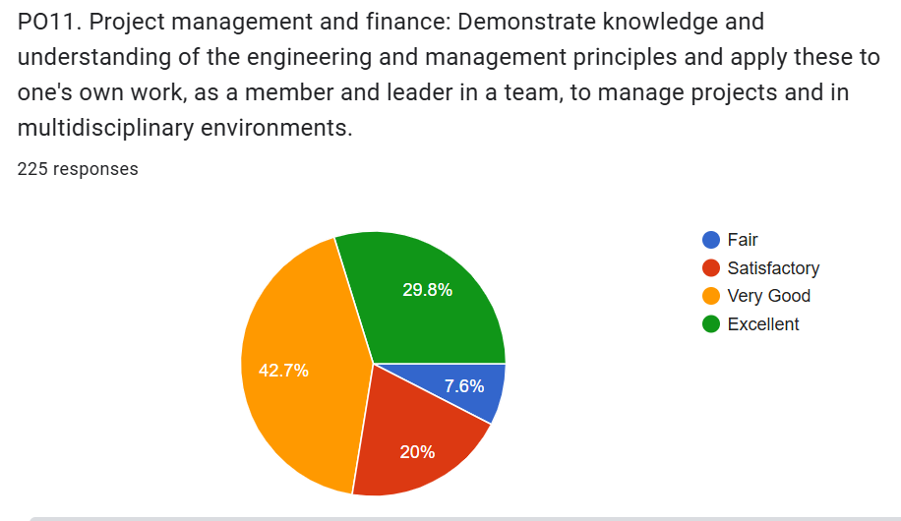

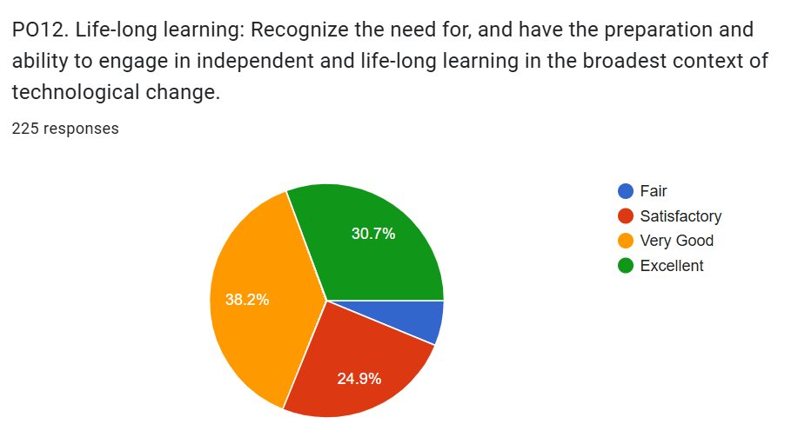

- Impact Analysis:

The technical talk significantly enhanced participants’ understanding of emerging trends in semiconductor technology, particularly in the areas of high-density nanoscale memories, bio-sensing, and neuromorphic computing. By connecting theoretical concepts with ongoing research and real-world applications, the session helped bridge the gap between academic learning and industry-driven innovation. Participants gained exposure to cutting-edge developments that are shaping the future of electronics, computing, and interdisciplinary research.
Furthermore, the talk inspired critical thinking and research-oriented perspectives among students by highlighting the convergence of semiconductor devices, biological systems, and brain-inspired computing architectures. It encouraged participants to explore advanced domains such as nanoscale fabrication, intelligent memory systems, and neuromorphic design. Overall, the session contributed to broadening technical awareness, fostering innovation-driven mindsets, and motivating students toward careers and research in next-generation semiconductor technologies.

Report submitted by,
Dr Jesuwanth Sugesh R G,
Assistant Professor,
Department of Electronics and Communication Engineering, SoET.

Approved by,
Dr Inbanila K,
HoD,
Department of Electronics and Communication Engineering, SoET.

