Technology: Internet of Things Name: kingslin.P

Title: Smart Parking project Date: 10/09/2023

**Phase 1: Problem Definition and Design Thinking**

## What is Smart Parking?

Smart parking system using IoT has smartphones and other sensors added into an interconnected system to determine parking space or level and provide real-time feedback. It is accomplished by using cameras, counters on the doors or gates of parking lots, sensors embedded in the paved area of ​​individual parking lots, among other locations, depending on the deployment.

### Solutions using IoT-based parking

IoT-based smart parking system transmits available and occupied parking spaces via a web/mobile application.

Each parking space has an IoT gadget, which includes [sensors and microcontrollers](https://www.airtel.in/blog/business/iot-sensors/). The user gets real-time updates on the availability of all parking spaces and, therefore, an option to choose the best one. This solution alone initiates a chain-reaction of benefits, from lesser traffic congestion to reduced fuel efficiency, in urban areas where parking is often painstaking.

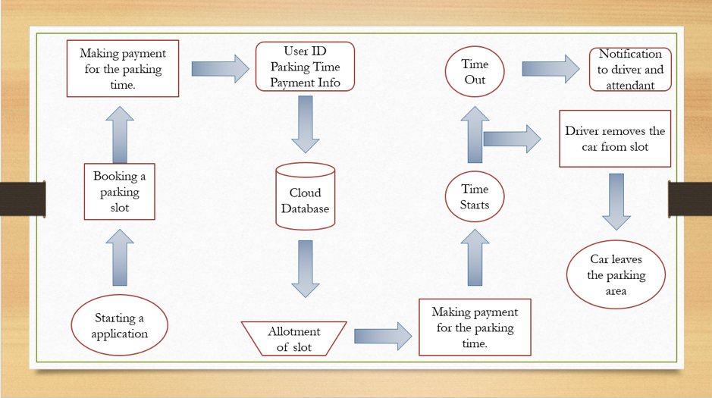

Smart Parking is a parking solution that can include in-ground Smart Parking sensors, cameras or counting sensors. These devices are usually embedded into parking spots or positioned next to them to detect whether parking bays are free or occupied.  This happens through real-time data collection. The data is then transmitted to a smart parking mobile application or website, which communicates the availability to its users. Some companies also offer other in-app information, such as parking prices and locations. This gives you the possibility to explore every parking option available to you.

Smart Parking and its Smart Parking Sensors can be seen as a part of smart cities. These smart cities are cities that are driven by an IT infrastructure and by using this infrastructure, cities can enhance the quality of life and improve economic development for its inhabitants. Becoming a smart city can be a good way to collect historical data in a relatively easy way. By collecting this data, cities can analyze how processes, like parking can be optimized.

As a result of using Smart Parking, people who are looking to find a parking spot will find it in the most efficient way possible and companies or municipalities can optimize their parking territories. It also makes cities more livable, safer and less congested.

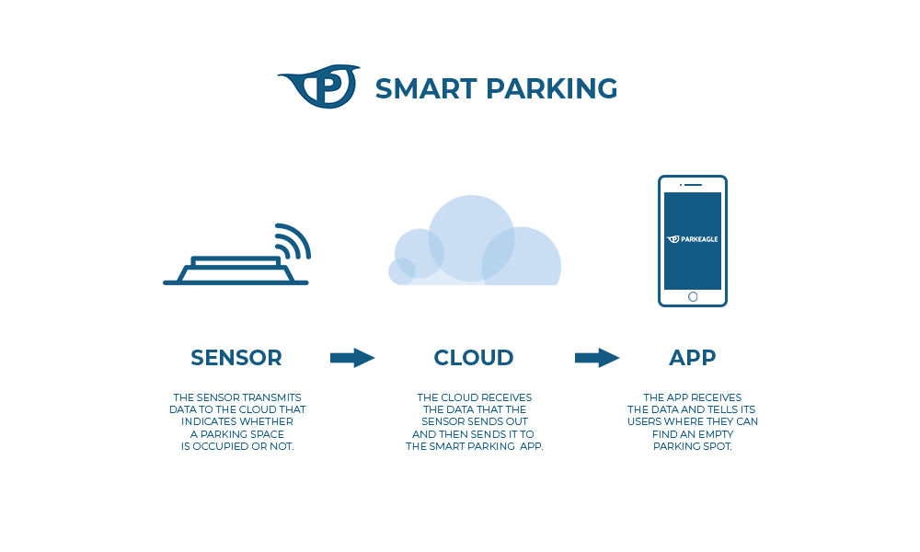

Advantages of Smart Parking for Drivers

**Optimizing the driving experience:** using a Smart Parking system [saves a lot of time for drivers](https://parkeagle.com/2019/03/19/what-are-the-benefits-of-smart-parking-for-drivers/) since they know where to find a vacant parking spot. The amount of time you spend while looking for a parking spot will be minimized. By using the [Parkeagle technology](https://parkeagle.com/2018/05/12/what-is-smart-parking/www.parkeagle.com/our-technology) of the Smart Parking sensors, you will be able to find the parking spot you are looking for, without having to browse through the streets.

Advantages for Cities

* **Less pollution:** Smart Parking contributes to a cleaner environment. Reducing the time that is necessary to find a parking spot will reduce the amount of fuel that is used when looking for a parking space. This makes the process of finding a parking spot contribute to less pollution, which is beneficial for everyone.
* **The space of a municipality will be utilized more efficiently:** because Smart Parking sensors transmit live-data, drivers will have a real-time overview of the occupancy of parking bays. This means that free spots can be filled quicker, which will reduce the time that a parking spot is empty.
* **Safety:** The use of Smart Parking Sensors can optimize safety within cities. As a result of placing, for instance, on-ground sensors on parking bays, people will not be as stressed as when they are looking for parking spaces. Because these people will know where they are going, they can simply navigate to their parking spot and they will not have to stress out about it.
* **Real-time parking analytics for cities:** Parking space will become intelligent by use of the [smart parking sensors](https://parkeagle.com/2018/05/12/what-is-smart-parking/www.parkeagle.com/our-technology) on the parking bays. This means that as a city you’re able to see historical data which is stored and you’re able to make data driven decision and predictions based on the parking sensor data.

**Introduction:**

The idea of creating a Smart City is now becoming possible with the emergence of the Internet of Things. One of the key issues that smart cities relate to are car parking facilities and traffic management systems[1]. In a recent research it has been found thatfinding an available parking spot is always difficult for drivers. Ittends to become harder with the increasing number of private car users. This concern attracted strategic investments from dedicated industry sectors to boost parking revenues through technology-enabled solutions like reduction in searching times, traffic congestion and road accidents. Problems related to parking and traffic congestion can be solved if the drivers can be informed in advance about the availability of parking spaces before reaching to their intended destination. Researchers [2] show that more than 66% of drivers are willing to pay for car parking during working hours. This directly adds value to the car parking business. It is stimulus for the development of intelligent car parkingservices for smart cities. The system helps a user know the availability of parking spaces. The parking systems aims at providing facilities to users like find, allocate, and reserve the „best‟ available car parking lot for a user in a particular area, providing navigation instructions for reaching this lot.

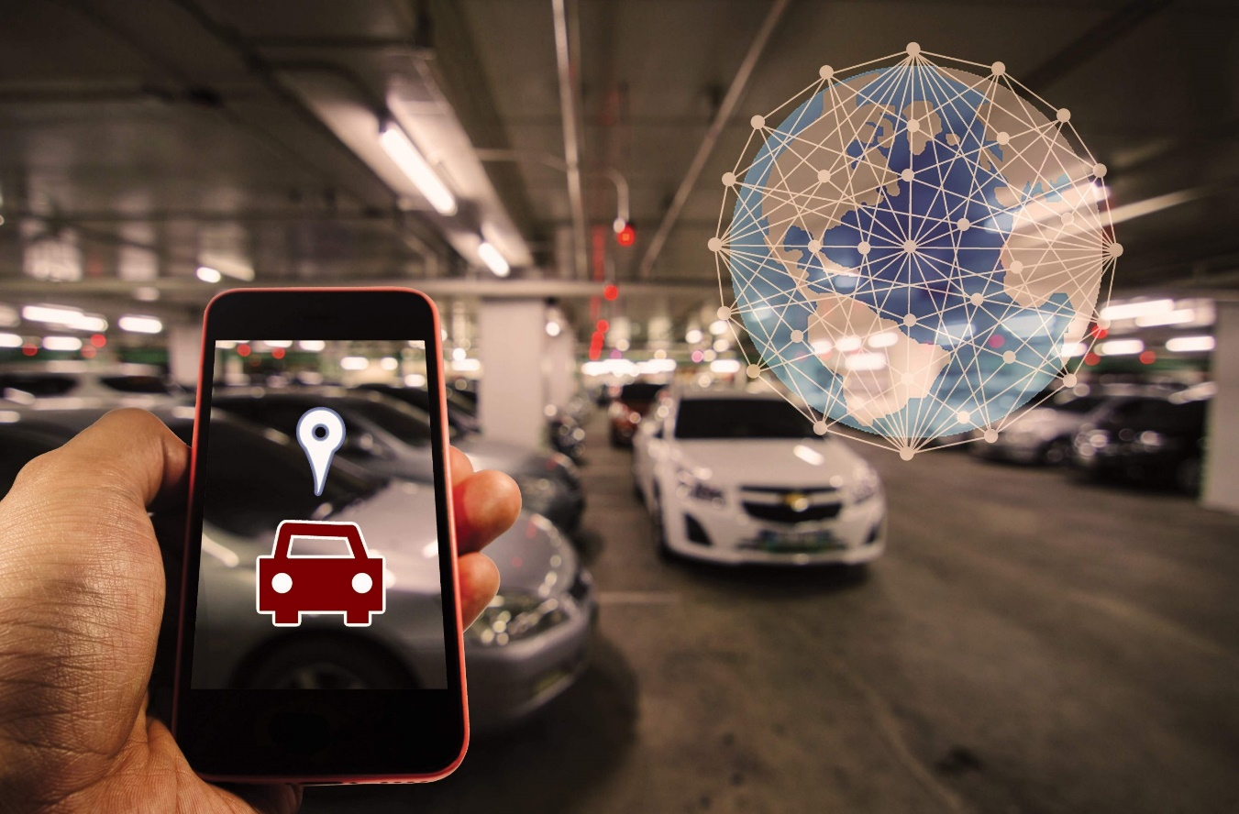

**Applications of Smart Parking Systems using IoT**

Smart cities offer better use of space, less traffic, clean air, and more efficient public services, increasing the quality of life. In addition, smart cities provide many jobs and economic opportunities, and strong social connections.

Smart parking IoT project will help in:

* **The seamless flowing of traffic**

Public transport routes can be adjusted in real-time according to need, and smart traffic lights systems can improve congestion. cse smartparking

* **Energy efficiency can  be improved**

One can easily track down the power consumption & energy consumption by monitoring in real-time.

* **Cities can be made safer**

Cities can use technology to improve residents’ safety and improve response times with the widespread use of Wi-Fi communications and IoT technology.

* **Encouragement of greater citizen engagement**

Citizens can respond to daily problems enabling neighbors to connect and share resources to improve communities and neighborhoods.