James Hahn

Artificial Intelligence

Dr. Diane Litman

1.

**A.** 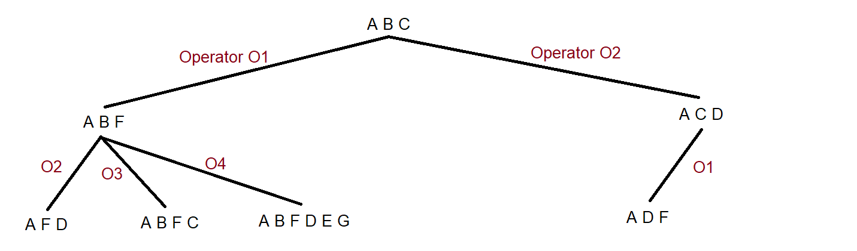

This search does not find a plan to achieve the goal of [C, D, E]. Intuitively, this cannot happen with a depth limit of two and our project specifications. For example, we need E in our goal state. However, the only way to obtain E is to perform the O4 operator. In order to perform the O4 operator, we must acquire F first. To acquire F, we must execute operator O1. The problem here is that O1 deletes C, which is also required for our goal state. So, in order to obtain C again, we must do operator O3. Only at this point do we have the three required effects for our goal state (C, D, E). This alone required three operations. As a result, with a limited depth of two, our search was unable to find a successful plan.

**B.**

The approach described above is relatively similar to partial-order regression planning. Keep in mind we are assuming the goal state must include (C, D, E), but can also include other Effects. Also note our below plan prioritizes operators from initial state to goal state as a logical keepsake, but the regression planning (start at goal state, end at initial state) would basically start at O3, O4 and then look at completing O1 next. A partial-order regression plan is as follows:

O1 < O3, O4 **(notation is found in lecture notes 10b page 19 slide 37)**

Here is another graphical representation:

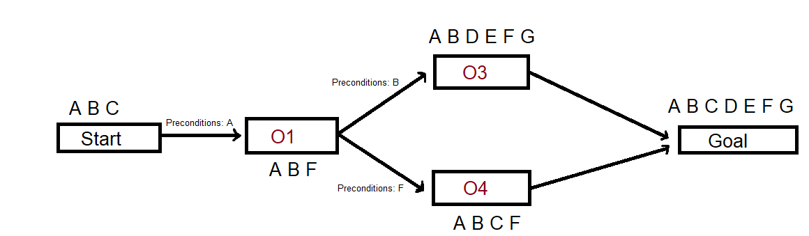

And an example linearization is below:



2.

**A.** P(toothache) = 0.2

**B.** P(Cavity) = 0.2

**C.** P(Toothache | cavity) = 0.6

**D.** P(Cavity | toothache V catch) = 0.46

3.

P( disease(Z) | positive ) = [ P( positive | disease(Z) ) * P(disease(Z)) ] / P(positive)

P(positive | disease(Z)) = .94

P(disease(Z)) = .02

P(positive ^ disease) = P(positive | disease) * P(disease) = .94 * .02 = .0188

P(positive ^ ~disease) = P(positive | ~disease) * P(~disease) = .09 * .98 = .0882

P(positive) = P(positive ^ disease) + P(positive ^ ~disease) = .0188 + .0882 = .107

Therefore, P(disease(Z) | positive) = (.94*.02) / .107 = .176

4.

**A.**

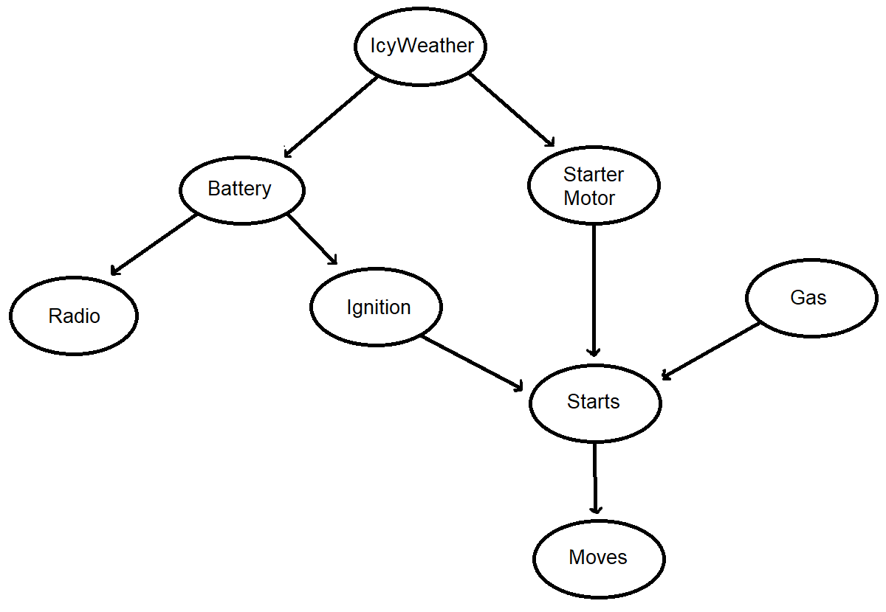

**B.**

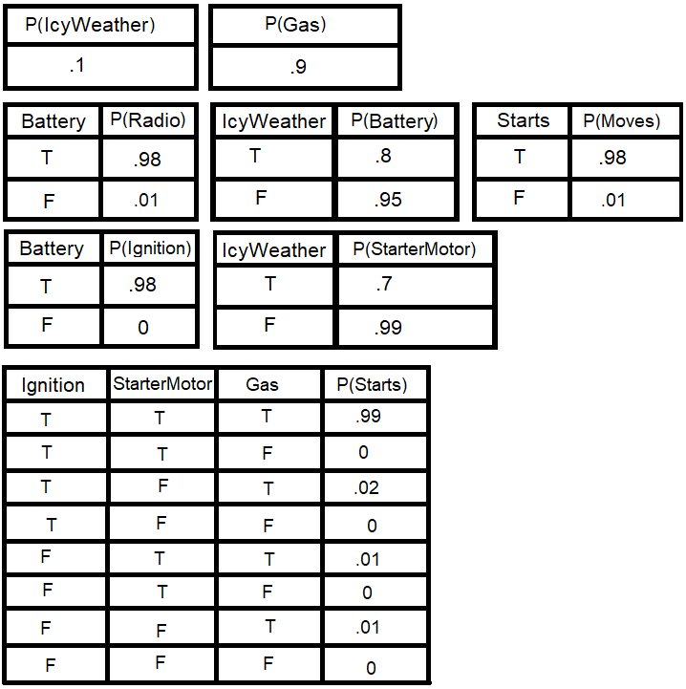

**C.**  Since each variable can be true or false, there are 28 = 256 values.

**D.** My tables contain 20 independent probability values.

Additional questions:

**E.** Give the expression for the full joint probability for: Battery=T, Radio=T, Ignition=T, Gas=F, Starts=T, Moves=F. The expression can be found below:

P(Battery ^ Radio ^ Ignition ^ ~Gas ^ Starts ^ ~Moves) =

P(Battery) * P(Radio | Battery) * P(Ignition | Battery) * P(~Gas) * P(Starts | Ignition, ~Gas) * P(~Moves | Starts) =

P(Battery) * P(Radio | Battery) * P(Ignition | Battery) * (1 - P(Gas)) * P(Starts | Ignition, ~Gas) * (1 - P(Moves | Starts))

**F.** Assume we want to compute the probability of the car not moving, that is P(Moves = False). Write down the expression for computing the probability from conditionals:

P(~Moves) = P(~Moves | Starts) + P(~Moves | ~Starts) =

P(~Moves | Starts) * [ P(Starts | Ignition, Gas) + P(Starts | ~Ignition, Gas) + P(Starts | Ignition, ~Gas) + P(Starts | ~Ignition, ~Gas) ] + P(~Moves | ~Starts) * [ P(~Starts | Ignition, Gas) + P(~Starts | ~Ignition, Gas) + P(~Starts | Ignition, ~Gas) + P(~Starts | ~Ignition, ~Gas) ] =

P(~Moves | Starts) * [ P(Starts | Ignition, Gas) + P(Starts | ~Ignition, Gas) + P(Starts | Ignition, ~Gas) + P(Starts | ~Ignition, ~Gas) ] + P(~Moves | ~Starts) * [ P(~Starts | Ignition, Gas) + P(~Starts | ~Ignition, Gas) + P(~Starts | Ignition, ~Gas) + P(~Starts | ~Ignition, ~Gas) ] =

P(~Moves | Starts) * [ P(Starts | Ignition, Gas) * (P(Gas) * [ P(Ignition | Battery) + P(Ignition | ~Battery) ]) + P(Starts | ~Ignition, Gas) * (P(Gas) * [ P(~Ignition | Battery) + P(~Ignition | ~Battery) ]) + P(Starts | Ignition, ~Gas) * (P(~Gas) * [ P(Ignition | Battery) + P(Ignition | ~Battery) ]) + P(Starts | ~Ignition, ~Gas) * (P(~Gas) * [ P(~Ignition | Battery) + P(~Ignition | ~Battery) ]) ] + P(~Moves | ~Starts) * [ P(~Starts | Ignition, Gas) + P(~Starts | ~Ignition, Gas) + P(~Starts | Ignition, ~Gas) + P(~Starts | ~Ignition, ~Gas) ] =

P(~Moves | Starts) * [ P(Starts | Ignition, Gas) * (P(Gas) * [ P(Ignition | Battery) + P(Ignition | ~Battery) ]) + P(Starts | ~Ignition, Gas) * (P(Gas) * [ P(~Ignition | Battery) + P(~Ignition | ~Battery) ]) + P(Starts | Ignition, ~Gas) * (P(~Gas) * [ P(Ignition | Battery) + P(Ignition | ~Battery) ]) + P(Starts | ~Ignition, ~Gas) * (P(~Gas) * [ P(~Ignition | Battery) + P(~Ignition | ~Battery) ]) ] + P(~Moves | ~Starts) * [ P(~Starts | Ignition, Gas) * (P(Gas) * [ P(Ignition | Battery) + P(Ignition | ~Battery) ]) + P(~Starts | ~Ignition, Gas) * (P(Gas) * [ P(~Ignition | Battery) + P(~Ignition | ~Battery) ]) + P(~Starts | Ignition, ~Gas) * (P(~Gas) * [ P(Ignition | Battery) + P(Ignition | ~Battery) ]) + P(~Starts | ~Ignition, ~Gas) * (P(~Gas) * [ P(~Ignition | Battery) + P(~Ignition | ~Battery) ]) ] =

P(~Moves | Starts) * [ P(Starts | Ignition, Gas) * (P(Gas) * [ P(Ignition | Battery) * P(Battery) + P(Ignition | ~Battery) * P(~Battery) ]) + P(Starts | ~Ignition, Gas) * (P(Gas) * [ P(~Ignition | Battery) * P(Battery) + P(~Ignition | ~Battery) * P(~Battery) ]) + P(Starts | Ignition, ~Gas) * (P(~Gas) * [ P(Ignition | Battery) * P(Battery) + P(Ignition | ~Battery) * P(~Battery) ]) + P(Starts | ~Ignition, ~Gas) * (P(~Gas) * [ P(~Ignition | Battery) * P(Battery) + P(~Ignition | ~Battery) * P(~Battery) ]) ] + P(~Moves | ~Starts) * [ P(~Starts | Ignition, Gas) * (P(Gas) * [ P(Ignition | Battery) * P(Battery) + P(Ignition | ~Battery) * P(~Battery) ]) + P(~Starts | ~Ignition, Gas) * (P(Gas) * [ P(~Ignition | Battery) * P(Battery) + P(~Ignition | ~Battery) * P(~Battery) ]) + P(~Starts | Ignition, ~Gas) * (P(~Gas) * [ P(Ignition | Battery) * P(Battery) + P(Ignition | ~Battery) * P(~Battery) ]) + P(~Starts | ~Ignition, ~Gas) * (P(~Gas) * [ P(~Ignition | Battery) * P(Battery) + P(~Ignition | ~Battery) * P(~Battery) ]) ] =

(1 - P(Moves | Starts)) * [ P(Starts | Ignition, Gas) * (P(Gas) * [ P(Ignition | Battery) * P(Battery) + P(Ignition | ~Battery) * (1 - P(Battery)) ]) + P(Starts | ~Ignition, Gas) * (P(Gas) * [ (1- P(Ignition | Battery)) * P(Battery) + (1 - P(Ignition | ~Battery)) * (1 - P(Battery)) ]) + P(Starts | Ignition, ~Gas) * ((1 - P(Gas)) * [ P(Ignition | Battery) * P(Battery) + P(Ignition | ~Battery) * (1 - P(Battery)) ]) + P(Starts | ~Ignition, ~Gas) * ((1 - P(Gas)) * [ (1 - P(Ignition | Battery)) * P(Battery) + (1 - P(Ignition | ~Battery)) * (1 - P(Battery)) ]) ] + (1 - P(Moves | ~Starts)) * [ (1 - P(Starts | Ignition, Gas)) * (P(Gas) * [ P(Ignition | Battery) * P(Battery) + P(Ignition | ~Battery) * (1 - P(Battery)) ]) + (1 - P(Starts | ~Ignition, Gas)) * (P(Gas) * [ (1 - P(Ignition | Battery)) * P(Battery) + (1 - P(Ignition | ~Battery)) * (1 - P(Battery)) ]) + (1 - P(Starts | Ignition, ~Gas)) * ((1 - P(Gas)) * [ P(Ignition | Battery) * P(Battery) + P(Ignition | ~Battery) * (1 - P(Battery)) ]) + (1 - P(Starts | ~Ignition, ~Gas)) * ((1 - P(Gas)) * [ (1 - P(Ignition | Battery)) * P(Battery) + (1 - P(Ignition | ~Battery)) * (1 - P(Battery)) ]) ]

5.

Pn = Pneumonia

F = Fever

Pa = Paleness

C = Cough

H = HighWBCcount

P(Pn | F, ~Pa, C, ~H) =

[ P(F, ~Pa, C, ~H | Pn) * P(Pn) ] / P(F, ~Pa, C, ~H) =

[ P(F, ~Pa, C, ~H | Pn) * P(Pn) ] / [ P(F, ~Pa, C, ~H, Pn) + P(F, ~Pa, C, ~H, ~Pn ] =

[ P(F | Pn) * P(~Pa | Pn) * P(C | Pn) * P(~H | Pn) * P(Pn) ] / [ P(F, ~Pa, C, ~H, Pn) + P(F, ~Pa, C, ~H, ~Pn ] =

[ P(F | Pn) * (1 - P(Pa | Pn)) * P(C | Pn) * (1 - P(H | Pn)) * P(Pn) ] / [ P(F, ~Pa, C, ~H, Pn) + P(F, ~Pa, C, ~H, ~Pn ] =

[ P(F | Pn) * (1 - P(Pa | Pn)) * P(C | Pn) * (1 - P(H | Pn)) * P(Pn) ] / [ P(F | Pn)*P(~Pa | Pn)*P(C | Pn)*P(~H | Pn)*P(Pn) + P(F | ~Pn)*P(~Pa | ~Pn)*P(C | ~Pn)*P(~H | ~Pn)*P(~Pn) ] =

[ P(F | Pn) * (1 - P(Pa | Pn)) * P(C | Pn) * (1 - P(H | Pn)) * P(Pn) ] / [ P(F | Pn)*(1 - P(Pa | Pn))*P(C | Pn)*(1 - P(H | Pn))*P(Pn) + P(F | ~Pn)*(1 - P(Pa | ~Pn))*P(C | ~Pn)*(1 - P(H | ~Pn))*P(~Pn) ] =

[ .9 * .3 * .9 * .2 * .02 ] / [ P(F | Pn)*(1 - P(Pa | Pn))*P(C | Pn)*(1 - P(H | Pn))*P(Pn) + P(F | ~Pn)*(1 - P(Pa | ~Pn))*P(C | ~Pn)*(1 - P(H | ~Pn))*P(~Pn) ] =

[ .9 * .3 * .9 * .2 * .02 ] / [ (.9 * .3 * .9 * .2 * .02) + (.6 * .5 * .1 * .5 * .98) ] =

.000972 / ( .000972 + .0147) = .000972 / .015672 = .062