CS 1632 – DELIVERABLE 4:

Performance Testing Using VisualVM

James Hahn & Ahmed Abdelsalam

Summary

* For the summary, describe how you profiled the application and determined the methods to refactor, and why you changed what you did. The summary should not be more than a few paragraphs - definitely less than a page.

Refactored getFirstMonkey()

Refactored stringifyResults()

Screenshots

* After this, include screenshots of VisualVM (or another profiler, if you use that) both before and after the refactor. These screenshots should include the relevant sections that let you see what method to refactor.

**getFirstMonkey() :**

**BEFORE (gave up after 200 seconds for 37 rounds because I wasn’t going**

**to waste my entire day waiting for this thing):**

average time: 11.671s

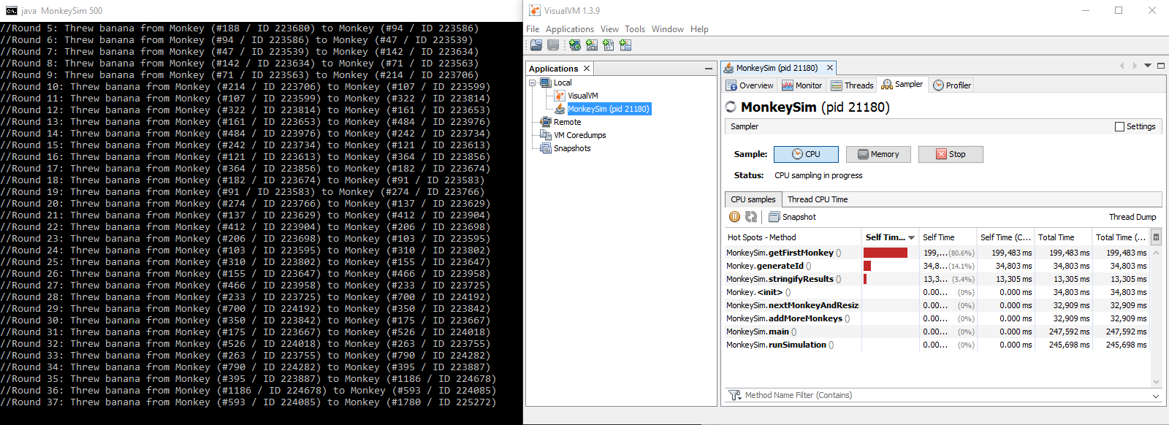 longest time: 11.851s

**AFTER (simulated with 500 monkeys, hotspot is no longer existent):**

average time: 10.324s

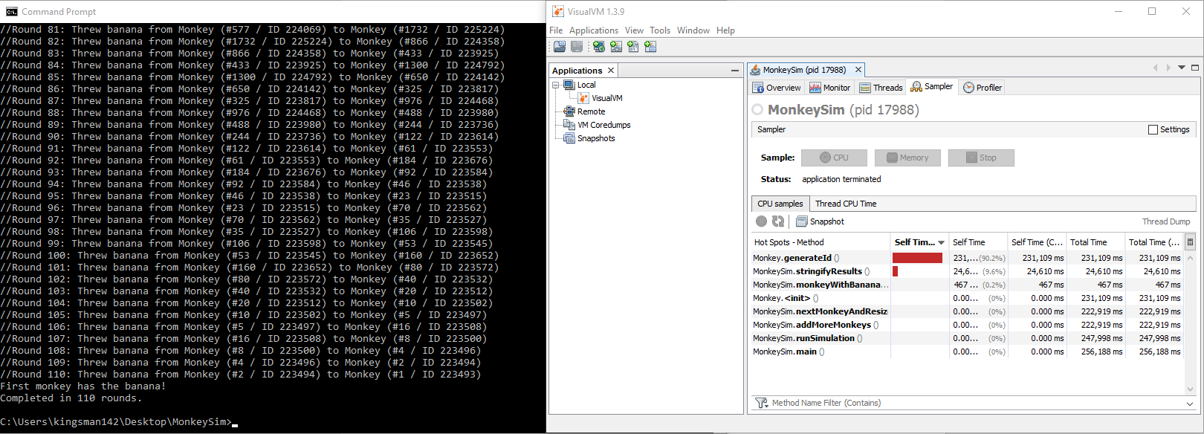 longest time: 10.465s

**stringifyResults():**

**BEFORE (300 monkeys):**

average time: 10.581s

longest time: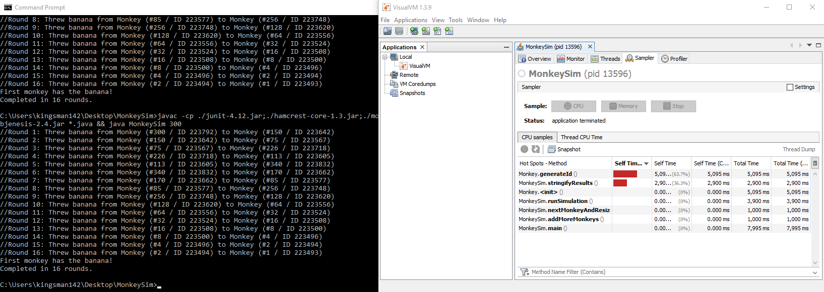 10.767s

**AFTER (300 monkeys):**

average time: 4.30s

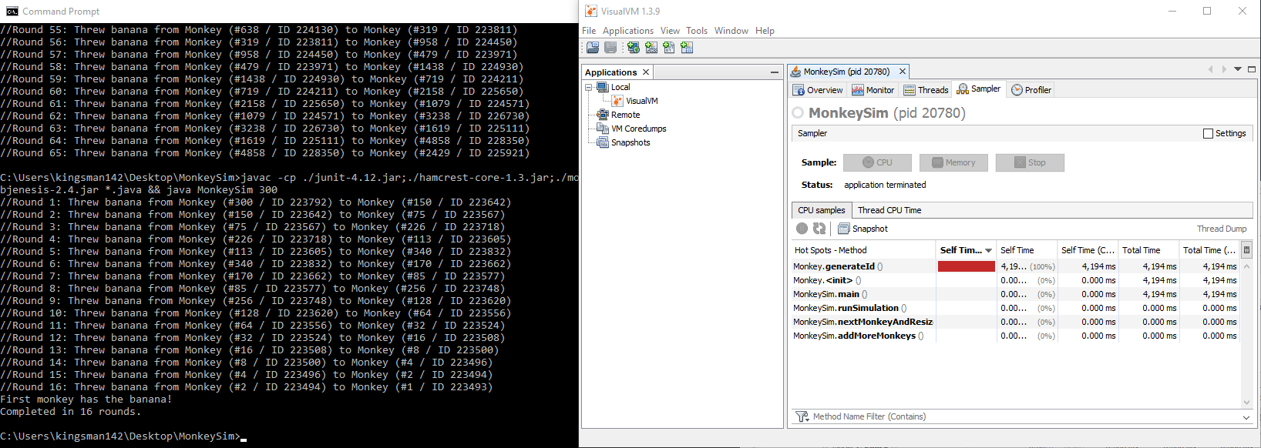 longest time: 4.502s