James Hahn

CS1645

Homework #1

1. Below are the answers to A, B, and C:

A.

|  |  |  |
| --- | --- | --- |
| Machine Type | Number of Processors | Location |
| [**Summit** - IBM Power System AC922, IBM POWER9 22C 3.07GHz, NVIDIA Volta GV100, Dual-rail Mellanox EDR Infiniband](https://www.top500.org/system/179397) | 2,282,544 | Oak Ridge National Laboratory, USA |
| [**Sunway TaihuLight** - Sunway MPP, Sunway SW26010 260C 1.45GHz, Sunway](https://www.top500.org/system/178764) | 10,649,600 | National Supercomputing Center in Wuxi, China |
| [**Sierra** - IBM Power System S922LC, IBM POWER9 22C 3.1GHz, NVIDIA Volta GV100, Dual-rail Mellanox EDR Infiniband](https://www.top500.org/system/179398) | 1,572,480 | DOE/NNSA/LLNL, United States |
| [**Tianhe-2A** - TH-IVB-FEP Cluster, Intel Xeon E5-2692v2 12C 2.2GHz, TH Express-2, Matrix-2000](https://www.top500.org/system/177999) | 4,981,760 | National Super Computer Center in Guangzhou, China |
| [**AI Bridging Cloud Infrastructure (ABCI)** - PRIMERGY CX2550 M4, Xeon Gold 6148 20C 2.4GHz, NVIDIA Tesla V100 SXM2, Infiniband EDR](https://www.top500.org/system/179393) | 391,680 | National Institute of Advanced Industrial Science and Technology, Japan |

B.

|  |  |  |
| --- | --- | --- |
| Machine Type | Number of Processors | Location |
| [**Oakforest-PACS** - PRIMERGY CX1640 M1, Intel Xeon Phi 7250 68C 1.4GHz, Intel Omni-Path](https://www.top500.org/system/178932) | 556,104 | Joint Center for Advanced High Performance Computing  , Japan |
| [**Stampede2** - PowerEdge C6320P/C6420, Intel Xeon Phi 7250 68C 1.4GHz/Platinum 8160, Intel Omni-Path](https://www.top500.org/system/179045) | 367,024 | [Texas Advanced Computing Center/Univ. of Texas](https://www.top500.org/site/48958), United States |
| [**Marconi Intel Xeon Phi** - CINECA Cluster, Lenovo SD530/S720AP, Intel Xeon Phi 7250 68C 1.4GHz/Platinum 8160, Intel Omni-Path](https://www.top500.org/system/178937) | 312,936 | [CINECA](https://www.top500.org/site/47495), Italy |
| [**TSUBAME3.0** - SGI ICE XA, IP139-SXM2, Xeon E5-2680v4 14C 2.4GHz, Intel Omni-Path, NVIDIA Tesla P100 SXM2](https://www.top500.org/system/179093) | 135,828 | [GSIC Center, Tokyo Institute of Technology](https://www.top500.org/site/47912), Japan |
| [**MareNostrum** - Lenovo SD530, Xeon Platinum 8160 24C 2.1GHz, Intel Omni-Path](https://www.top500.org/system/179067) | 153,216 | [Barcelona Supercomputing Center](https://www.top500.org/site/49748)  , Spain |

C. 122300 / 8162 = 14.98, or about **15x faster**

1. Below are the results:
2. Speedup = 62 / 17 = **3.65**

Efficiency = 62 / (17*4) = 62 / 68 = **91.18%**

1. Speedup = 242 / 62 = **3.90**

Efficiency = 242 / (62*4) = 242 / 248 = **97.58%**

1. Maximum speedup for 1GB = 62 / 2 = **31**

Maximum speedup for 10GB = 242 / 2 = **121**

1. Efficiency( 1000 processors ) = 242 / (2.24 * 1000) = 242 / 2240 = 10.80%

Efficiency( 3000 processors ) = 242 / (2.08 * 3000) = 242 / 6240 = 3.88%

Efficiency gain = 10.80 – 3.88 = **6.92%**

1. 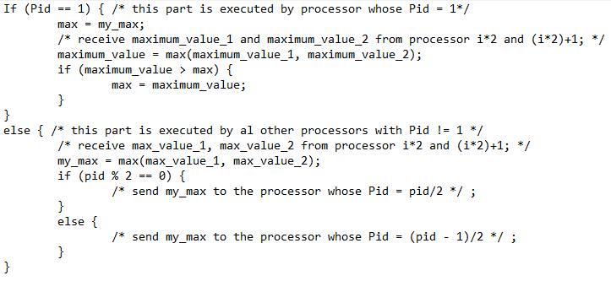Below is the pseudocode **(NOTE: I swapped out Pid == 0 with Pid == 1 for ease of calculations in the pseudocode)**:
2. Below is the pseudocode **(NOTE: I swapped out Pid == 0 with Pid == 1 for ease of calculations in the pseudocode)**:

