James Hahn

CS1675 Machine Learning

Dr. Adriana Kovashka

In the below figures, several iterations of the SVM weight updates are shown. In iteration 0, the weights are [0.328814, 0.653812] with 0% accuracy (Figure 1). Iteration 1 has weights [-0.171186, 0.353812] with an accuracy of 30% (Figure 2). Iteration 2 uses weights [-0.671186, 0.053812] to gather 100% accuracy on the dataset (Figure 3). Finally, to show convergence, in iteration 10, after all misclassified data points have been identified and used to update the weights, we show the line of maximum margin (passing through the origin, since we do not use a bias in this project) converges with weights [-4.171186, -2.046188] and 100% accuracy, clearly (Figure 4).

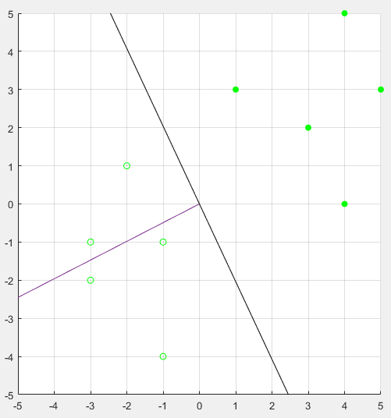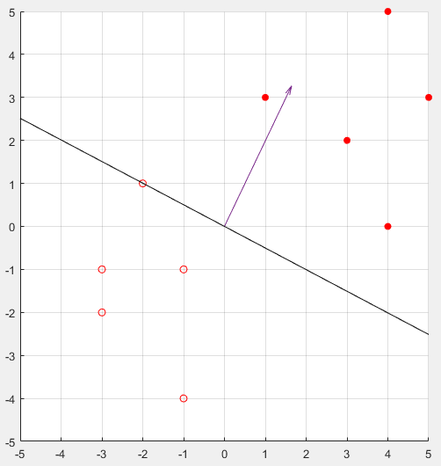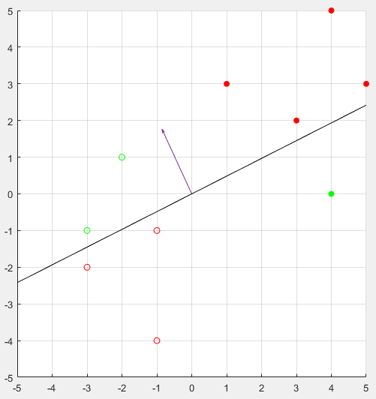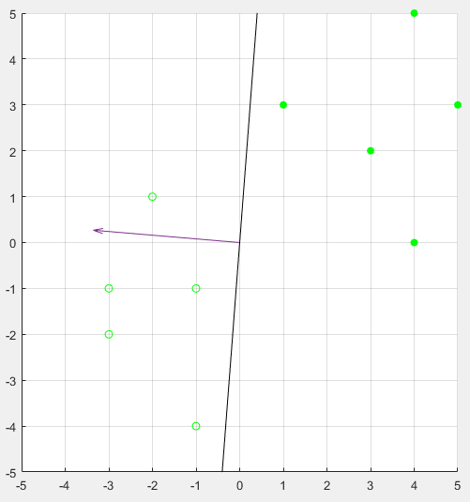

**Figure 4**

Iteration 9

**Figure 1**

Iteration 0

**Figure 2**

Iteration 1

**Figure 3**

Iteration 2