James Hahn

MATH1101

Homework #1

1. Feasible region is colored in purple below:

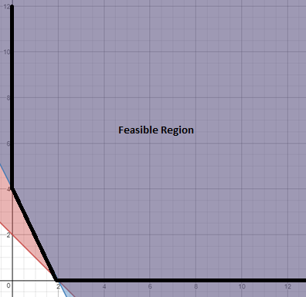

I. Corner points = (2, 0) and (0, 4)

P(2, 0) = 5*2 + 2*0 = 10

P(0, 4) = 5*0 + 2*4 = 8

**Minimum exists at (0, 4)**

**Maximum does not exist due to unbounded feasible region**

II. Minimize and Maximize P(x, y) = 5x + 2y

Subject to:

x + y – s­1 = 2

2x + y – s2 = 4

x, y, s1, s2 ≥ 0

This is a dual problem, so the initial tableau’s transpose acts as the initial simplex tableau. Also, by Remark 4.1.3, since the feasible region is unbounded and coefficients of the objective function are positive, there exists a minimum, but no maximum, so below are the tableaus to solve *only* the minimization problem. There exists no maximal solution.

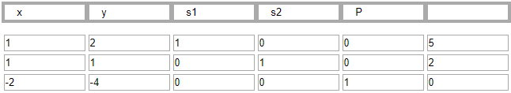

Pivot: **pivot column: 2nd, pivot row: 2nd, pivot element: 1**

Basic variables: **s1, s2, P**

Objective function **= 0**

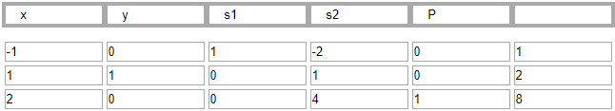

No more negative entries in bottom row. The tableau has converged to a minimum at (0, 4).

Basic variables: **x, y, P**

Objective function **= 8**

III. I used Excel’s Solver add-in to solve this problem. Below is the answer report:

Results when solving for the **maximum** (not found):

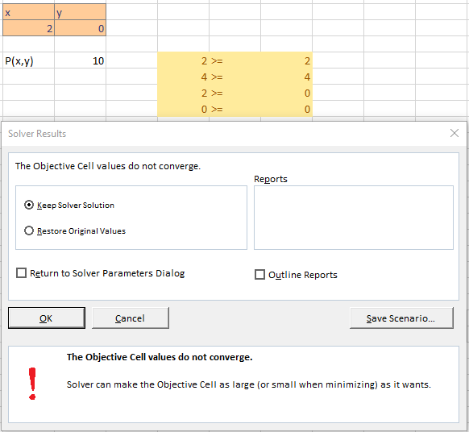

Results when solving for the **minimum**:

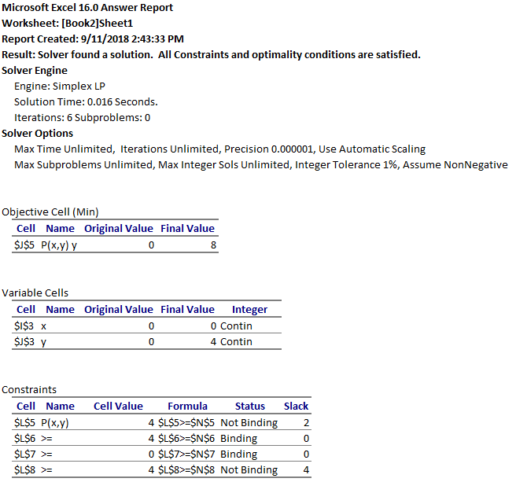

1. Feasible region is marked on the graph below:

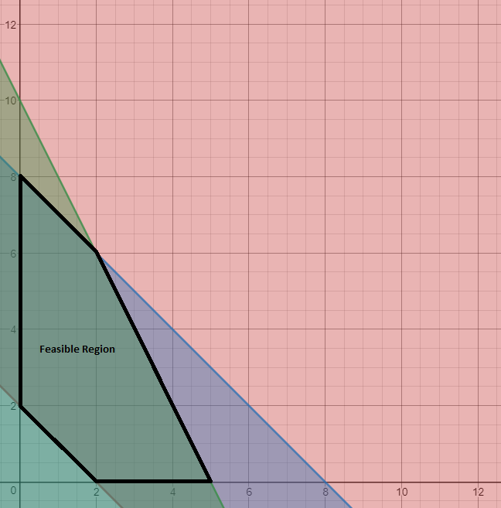

1. Corner points = (0, 2) and (2, 0) and (5, 0) and (2, 6) and (0, 8)

P(0, 2) = 20

P(2, 0) = 40

P(5, 0) = 100

P(2, 6) = 100

P(0, 8) = 80

There are two corner points with maximum values. Therefore, the solution is the line connecting both points. So, the solution **S = { (x, y) | y = 2x + 10 for 2 ≤ x ≤ 5 }.**

1. Maximize P(x, y) = 20x + 10y

Subject to:

x + y – s1 + a1 = 2

x + y + s2 = 8

2x + y + s3 = 10

x, y, s1, s2, s3, a1 ≥ 0

Let M = 50 in the initial tableau calculations:

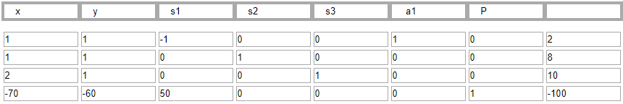

Pivot column: 1st column, Pivot row: 1st row, Pivot element: 1

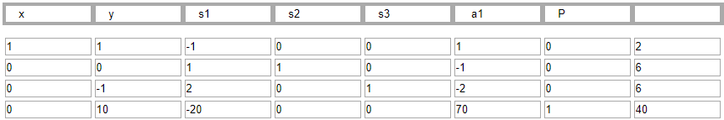

Pivot column: 3rd column, Pivot row: 3rd row, Pivot element: 2

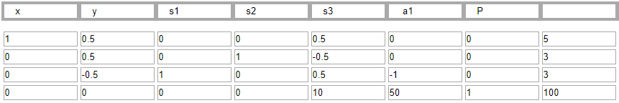

There are no more negative elements on the last row. We have converged to the **maximum objective function value of 100 at (5, 0)**.

1. I used Excel’s Solver add-in to solve this problem. Below is the answer report:

Results when solving for the **maximum**:

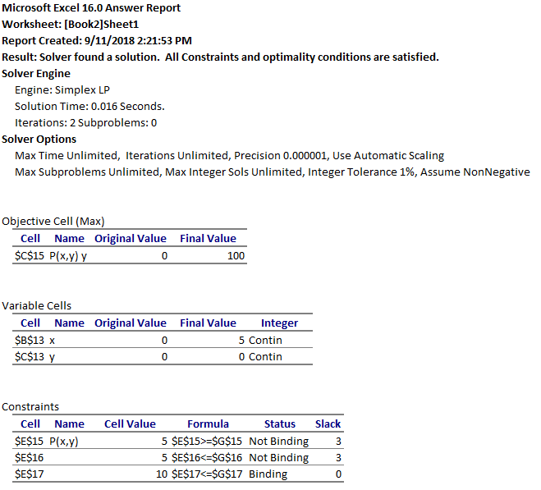

1. Feasible region is marked on the graph below:

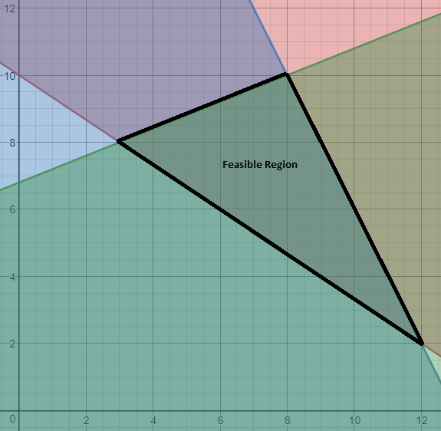

1. Corner points = (3, 8) and (8, 10) and (12, 2)

P(3, 8) = 140

P(8, 10) = 260

P(12, 2) = 260

There are two coordinates with maximum values. Therefore, the **maximal solution** is the line connecting them. So, the solution **S = { (x, y) | y = -2x + 26 }**.

The **minimum solution is located at (3, 8)**.

1. Maximize and Minimize P(x, y) = 20x + 10y

Subject to:

2x + 3y – s1 + a1 = 30

2x + y + s2 = 26

-2x + 5y + s3 = 34

x, y, s1, s2, s3, a1 ≥ 0

Iterations of the tableaus for the maximization problem (let M = 50):

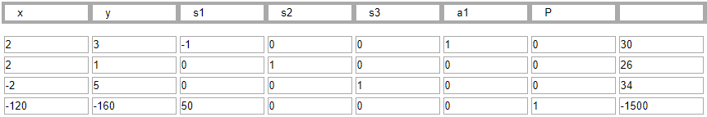

Pivot column: 2nd column, Pivot row: 3rd row, Pivot element: 5

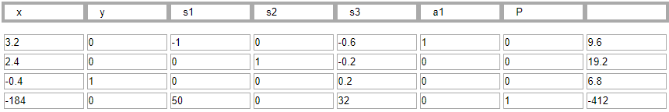

Pivot column: 1st column, Pivot row: 1st row, Pivot element: 3.2

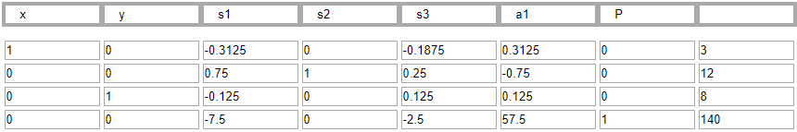

Pivot column: 3rd column, Pivot row: 2nd row, Pivot element; 0.75

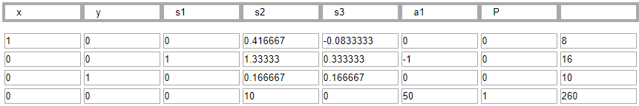

The tableau has converged to a **maximum objective function value of 260 at (8, 10).**

Iterations of the tableaus for the minimization problem can be found below. We need to maximize the negative objective function, so maximize -P(x, y) = -20x – 10y :

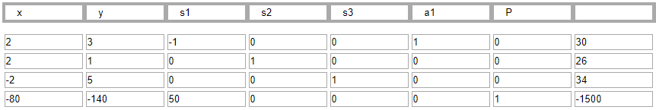

Pivot column: 2nd column, Pivot row: 3rd row, Pivot element: 5

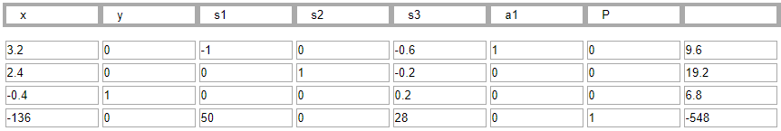

Pivot column: 1st column, Pivot row: 1st row, Pivot element: 3.2

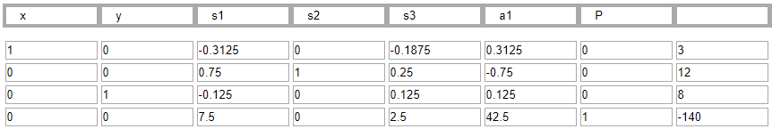

There are no more negative entries on the last row. We have converged to an optimal solution for the original minimization problem with objective function value = -140 = -P(x, y), so **P(x, y) = 140 at (3, 8).**

1. I used Excel’s Solver add-in to solve this problem. Below are the answer reports:

For the maximization problem:

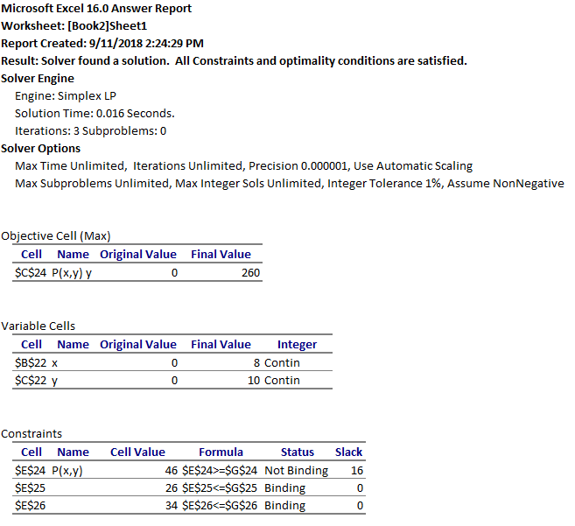

For the minimization problem:

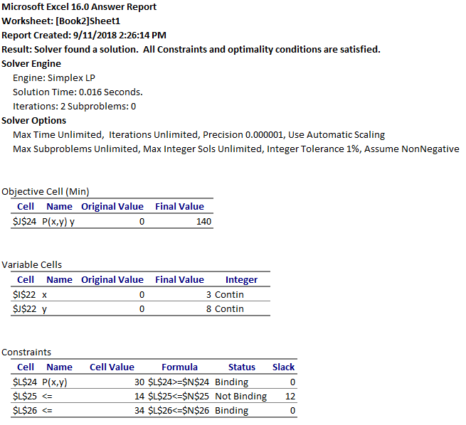

1. Solving by choosing column 1 as the first pivot column:

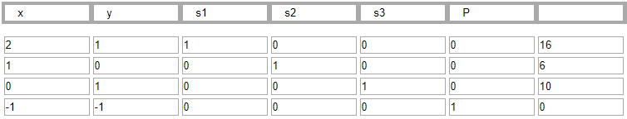

Pivot column: 1st column, Pivot row: 2nd row, Pivot element: 1

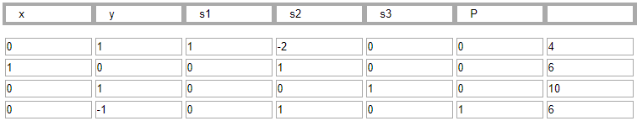

Pivot column: 2nd column, Pivot row, 1st row, Pivot element: 1

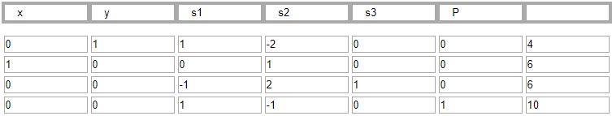

Pivot column: 4th column, Pivot row: 3rd row, Pivot element: 2

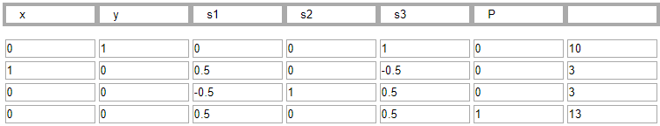

We have arrived at a solution of **P = 13 at (3, 10)**.

Solving by choosing column 2 as the first pivot column:

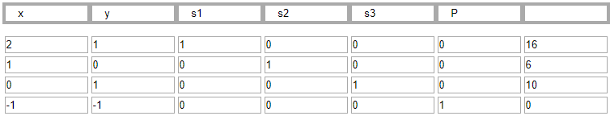

Pivot column: 2nd column, Pivot row: 3rd row, Pivot element: 1

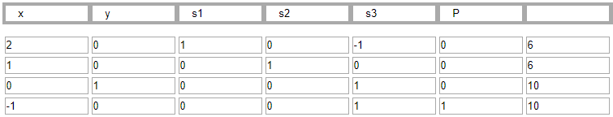

Pivot column: 1st column, Pivot row: 1st row, Pivot element: 2

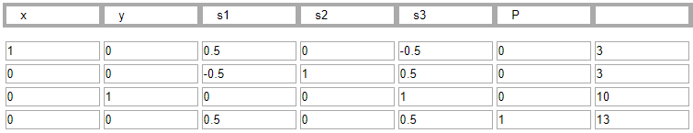

We have arrived at a solution of **P = 13 at (3, 10)**.

1. The dual problem becomes:

Maximize C(y1, y2) = 20y1 + 30y2

Subject to:

y1 + 2y2 + x1 ≤ 20

y1 + y2 + x2 ≤ 12

5y1 + y2 + x3 ≤ 40

y1, y2, x1, x2, x3 ≥ 0

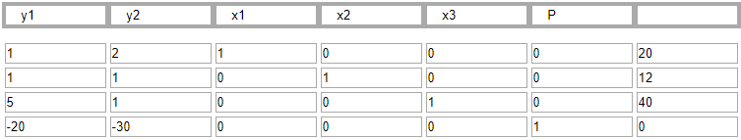

Pivot column: 2nd column, Pivot row: 1st row, Pivot element: 2

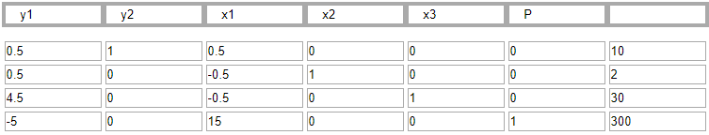

Pivot column: 1st column, Pivot row: 2nd row, Pivot element: 0.5

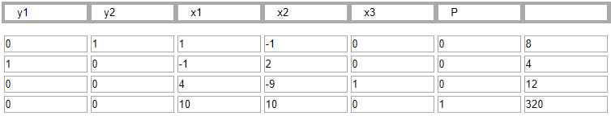

We have converged to a maximum. The values for the final solution are of **x1 = 10, x2 = 10, and x3 = 0 with C = 320**. The objective function value is the same as we obtained in class, C = 320. However, the final solution values are different. In class, we obtained x1 = 5, x2 = 10, and x3 = 0. As such, by changing the first constraint in the dual problem, we reached different solution parameter values. Lastly, note if we plug x1 = 10, x2 = 10, and x3 into the original objective function, C = 520, which provides us with an incorrect minimum as well. This perfectly illustrates the warning described in the notes.