James Hahn

MATH1101

Homework #2

2. 1) 0.016 seconds

2) 0.017 seconds

3) 0.017 seconds (tolerance = 0.5%)

All simulations were ran on my desktop computer, so these times are almost indistinguishable.

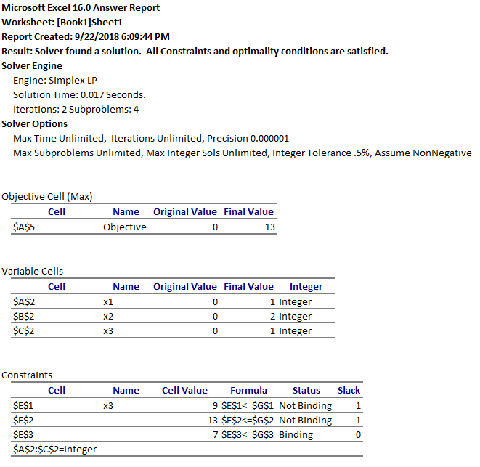

3. i) Minimize P = x – y => Maximize P = y - x

Subject to:

3x + 4y + s­1 = 6

x – y + s2 = 1

x, y, s1, s2 >= 0

ii) 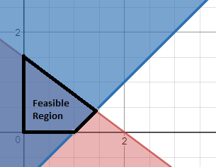

iii) Initial simplex tableau:

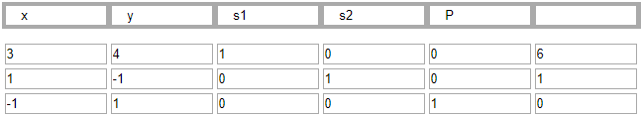

iv) Solution to initial LP problem; x = 0, y = 3/2, P = 3/2 :

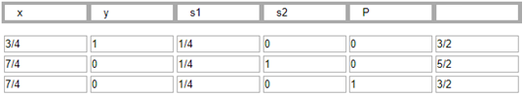

Choose 2nd row as the next cut plane since it has the largest RHS:

3/4x + y – ¼ s1 = 3/2

(0 + ¾)x + (1+0)y + (0 + ¼)s1 = (1 + ½)

1 – 3/4x – 1/4s1 = -1/2

-3/4x – 1/4s1 + ½ <= 0 is our new constraint, which converts to:

-3/4x – 1/4s1 + t1 = -1/2

New problem

Maximize y - x

Subject to:

3x + 4y + s­1 = 6

x – y + s2 = 1

-3/4x – 1/4s1 + t1 = -1/2

x, y, s1, s2, t1 >= 0

Initial simplex tableau:

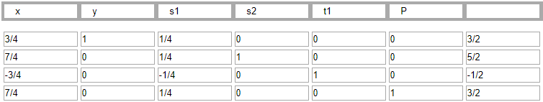

Feasible Region:

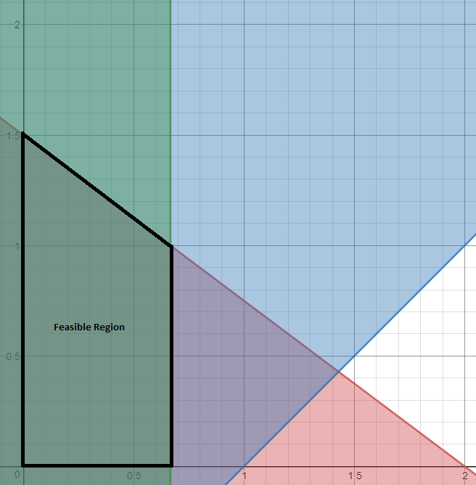

Tableau after solving the LP problem:

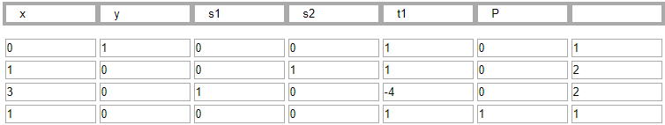

x is not a basic variable and we cannot reduce the tableau, so x = 0 (reasoning for this is on page 48 of the notes) and y = 1 with P = 1. Thus, we have an integer solution and we do not need anymore cuts. To convert this into the solution for the minimization problem, negate the P value. So, the final solution is: **x = 0, y = 1, P = -1**.

4.

Maximize P = 4x1 + 3x2 + 3x3

Subject to:

4x1 + 2x2 + 1x3 + s1 = 10

3x1 + 4x2 + 2x3 + s2 = 14

2x1 + 1x2 + 3x3 + s3 = 7

x1, x2, x3, s1, s2, s3 >= 0

Initial simplex tableau:

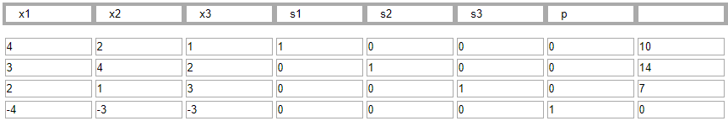

Tableau at end of LP iteration:

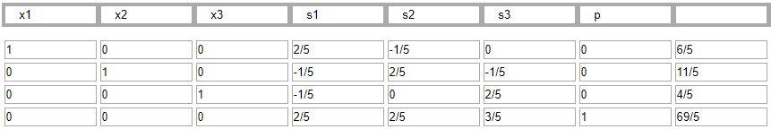

We get a solution at x1 = 6/5, x2 = 11/5, x3 = 4/5 with P = 69/5 .

Choose the 1st row as the next cut plane since we just need to choose one at random:

x1 + 2/5s1 – 1/5s2 = 6/5

(1 + 0)x1 + (0 + 2/5)s1 + (-1 + 4/5)s2 = (1 + 1/5)

-2/5s1 – 4/5s2 + 1/5 <= 0

-2/5s1 – 4/5s2 + t1 = -1/5 is the new constraint

New problem

Maximize P = 4x1 + 3x2 + 3x3

Subject to:

4x1 + 2x2 + 1x3 + s1 = 10

3x1 + 4x2 + 2x3 + s2 = 14

2x1 + 1x2 + 3x3 + s3 = 7

-2/5s1 – 4/5s2 + t1 = -1/5

x1, x2, x3, s1, s2, s3, t1 >= 0

Initial simplex tableau:

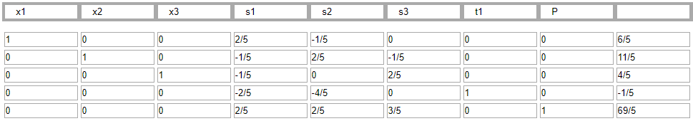

Tableau at end of LP iteration:

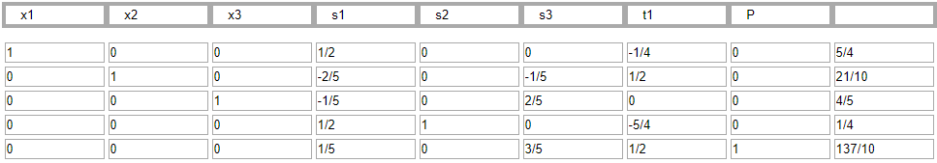

We get a solution at x1 = 5/4, x2 = 21/10, x3 = 4/5 with P = 137/10

Choose the 2nd row as the next cut plane at random:

x2 – 2/5s1 – 1/5s3 + 1/2t1 = 21/10

(1 + 0)x2 + (-1 + 3/5)s1 + (-1 + 4/5)s3 + (0 + ½)t1 = (2 + 1/10)

-3/5s1 – 4/5s3 – 1/2t1 + 1/10 <= 0

-3/5s1 – 4/5s3 – 1/2t1 + t2 = -1/10 is the new constraint

New problem

Maximize P = 4x1 + 3x2 + 3x3

Subject to:

4x1 + 2x2 + 1x3 + s1 = 10

3x1 + 4x2 + 2x3 + s2 = 14

2x1 + 1x2 + 3x3 + s3 = 7

-2/5s1 – 4/5s2 + t1 = -1/5

-3/5s1 – 4/5s3 – 1/2t1 + t2 = -1/10

x1, x2, x3, s1, s2, s3, t1, t2 >= 0

Initial simplex tableau:

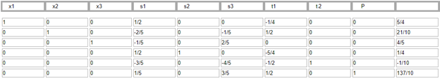

Tableau at end of LP iteration:

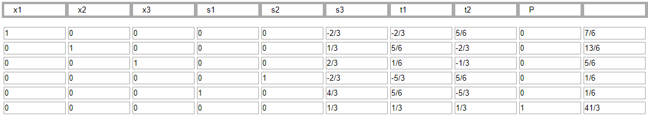

We get a solution at x1 = 7/6, x2 = 13/6, x3 = 5/6 with P = 41/3

Choose the 1st row as the next cut plane at random:

x1 – 2/3s3 – 2/3t1 + 5/6t2 = 7/6

(1 + 0)x1 + (-1 + 1/3)s3 + (-1 + 1/3)t1 + (0 + 5/6)t2 = (1 + 1/6)

-1/3s3 – 1/3t1 – 5/6t2 + 1/6 <= 0

-1/3s3 – 1/3t1 – 5/6t2 + t3 = -1/6 is the new constraint

New problem

Maximize P = 4x1 + 3x2 + 3x3

Subject to:

4x1 + 2x2 + 1x3 + s1 = 10

3x1 + 4x2 + 2x3 + s2 = 14

2x1 + 1x2 + 3x3 + s3 = 7

-2/5s1 – 4/5s2 + t1 = -1/5

-3/5s1 – 4/5s3 – 1/2t1 + t2 = -1/10

-1/3s3 – 1/3t1 – 5/6t2 + t3 = -1/6

x1, x2, x3, s1, s2, s3, t1, t2, t3 >= 0

Initial simplex tableau:

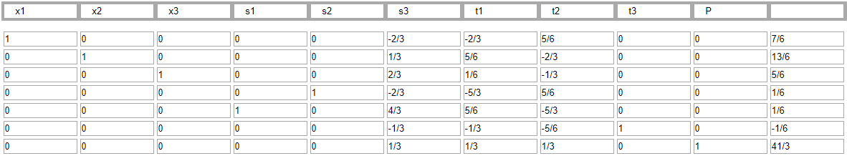

Tableau at end of LP iteration:

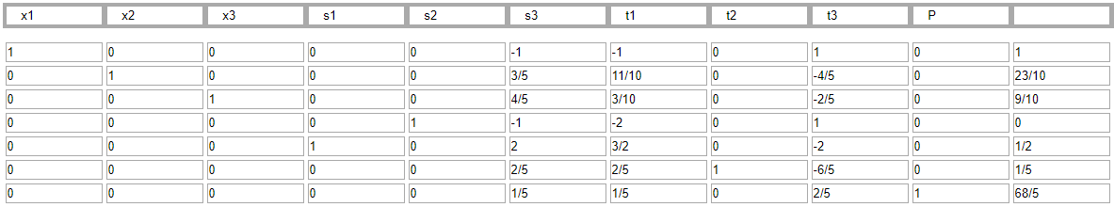

We get a solution at x1 = 1, x2 = 23/10, x3 = 9/10 with P = 68/5

Choose the 2nd row as the next cut plane at random:

x2 + 3/5s3 + 11/10t1 – 4/5t3 = 23/10

(1 + 0)x2 + (0 + 3/5)s3 + (1 + 1/10)t1 + (-1 + 1/5)t3 = (2 + 3/10)

-3/5s3 - 1/10t1 - 1/5t3 + 3/10 <= 0

-3/5s3 - 1/10t1 - 1/5t3 + t4 = -3/10 is the new constraint

New problem

Maximize P = 4x1 + 3x2 + 3x3

Subject to:

4x1 + 2x2 + 1x3 + s1 = 10

3x1 + 4x2 + 2x3 + s2 = 14

2x1 + 1x2 + 3x3 + s3 = 7

-2/5s1 – 4/5s2 + t1 = -1/5

-3/5s1 – 4/5s3 – 1/2t1 + t2 = -1/10

-1/3s3 – 1/3t1 – 5/6t2 + t3 = -1/6

-3/5s3 - 1/10t1 - 1/5t3 + t4 = -3/10

x1, x2, x3, s1, s2, s3, t1, t2, t3, t4 >= 0

Initial simplex tableau:

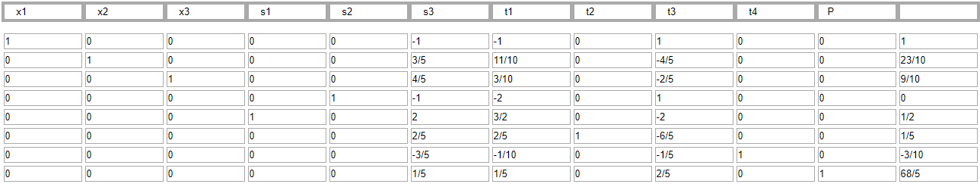

Tableau at end of LP iteration:

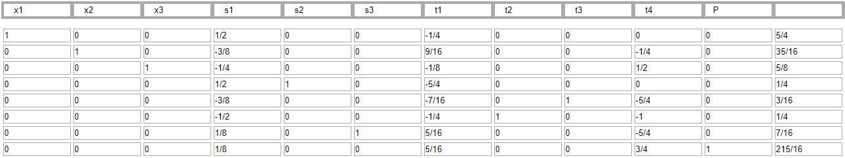

We get a solution at x1 = 5/4, x2 = 35/16, x3 = 5/8 with P = 215/16

Choose the 2nd row as the next cut plane at random:

x2 – 3/8s1 + 9/16t1 – 1/4t4 = 35/16

(1 + 0)x2 + (-1 + 5/8)s1 + (0 + 9/16)t1 + (-1 + ¾)t4 = (2 + 3/16)

-5/8s1 – 9/16t1 – 3/4t4 + 3/16 <= 0

-5/8s1 – 9/16t1 – 3/4t4 + t5 = -3/16 is the new constraint

New problem

Maximize P = 4x1 + 3x2 + 3x3

Subject to:

4x1 + 2x2 + 1x3 + s1 = 10

3x1 + 4x2 + 2x3 + s2 = 14

2x1 + 1x2 + 3x3 + s3 = 7

-2/5s1 – 4/5s2 + t1 = -1/5

-3/5s1 – 4/5s3 – 1/2t1 + t2 = -1/10

-1/3s3 – 1/3t1 – 5/6t2 + t3 = -1/6

-3/5s3 - 1/10t1 - 1/5t3 + t4 = -3/10

-5/8s1 – 9/16t1 – 3/4t4 + t5 = -3/16

x1, x2, x3, s1, s2, s3, t1, t2, t3, t4, t5 >= 0

Initial simplex tableau:

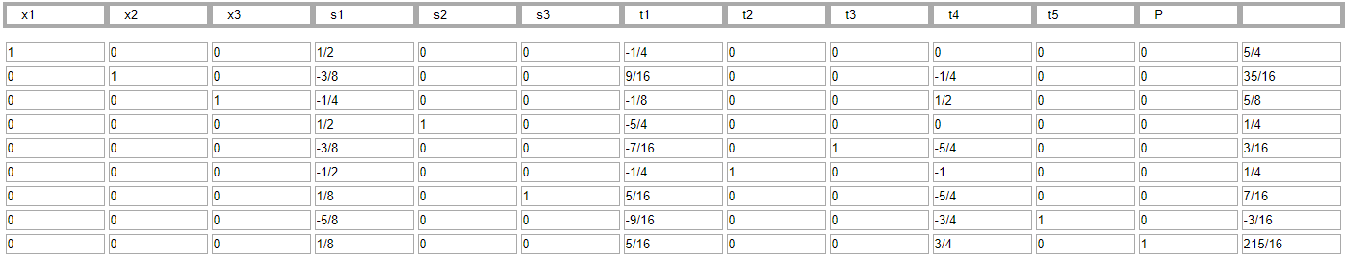

Tableau at end of LP iteration:

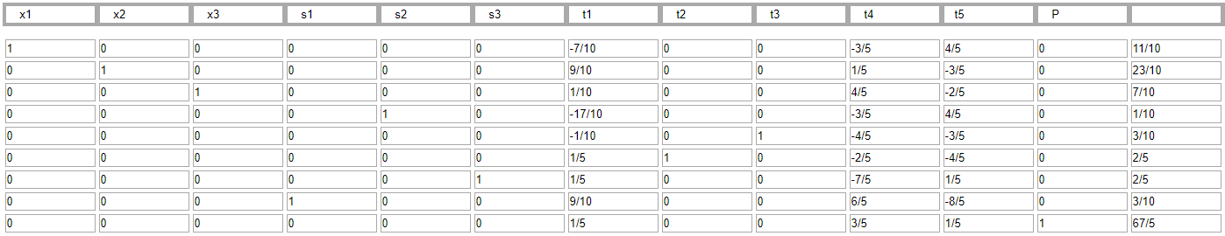

We get a solution at x1 = 11/10, x2 = 23/10, x3 = 7/10 with P = 67/5

Choose the 1st row as the next cut plane at random:

x1 – 7/10t1 – 3/5t4 + 4/5t5 = 11/10

(1 + 0)x1 + (-1 + 3/10)t1 + (-1 + 2/5)t4 + (0 + 4/5)t5 = (1 + 1/10)

-3/10t1 – 2/5t4 – 4/5t5 + 1/10 <= 0

-3/10t1 – 2/5t4 – 4/5t5 + t6 <= -1/10

New problem

Maximize P = 4x1 + 3x2 + 3x3

Subject to:

4x1 + 2x2 + 1x3 + s1 = 10

3x1 + 4x2 + 2x3 + s2 = 14

2x1 + 1x2 + 3x3 + s3 = 7

-2/5s1 – 4/5s2 + t1 = -1/5

-3/5s1 – 4/5s3 – 1/2t1 + t2 = -1/10

-1/3s3 – 1/3t1 – 5/6t2 + t3 = -1/6

-3/5s3 - 1/10t1 - 1/5t3 + t4 = -3/10

-5/8s1 – 9/16t1 – 3/4t4 + t5 = -3/16

-3/10t1 – 2/5t4 – 4/5t5 + t6 <= -1/10

x1, x2, x3, s1, s2, s3, t1, t2, t3, t4, t5, t6 >= 0

Initial simplex tableau:

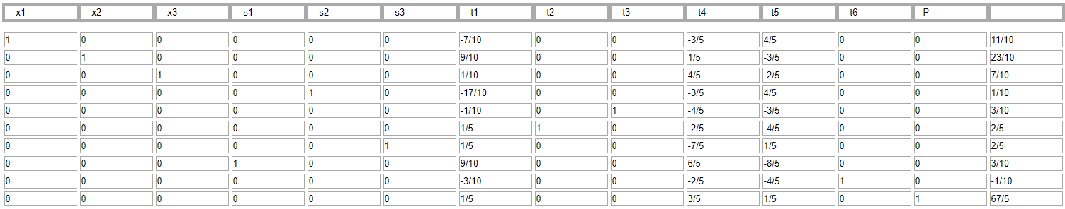

Tableau at end of LP iteration:

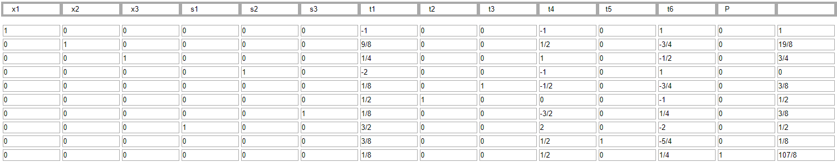

We get a solution at x1 = 1, x2 = 19/8, x3 = 3/4 with P = 107/8

Choose the 2nd row as the next cut plane at random:

x2 + 9/8t1 + 1/2t4 – 3/4t6 = 19/8

(1 + 0)x2 + (1 + 1/8)t1 + (0 + ½)t4 + (-1 + ¼)t6 = (2 + 3/8)

-1/8t1 – 1/2t4 – 1/4t6 + 3/8 <= 0

-1/8t1 – 1/2t4 – 1/4t6 + t7 = -3/8 is the new constraint

New problem

Maximize P = 4x1 + 3x2 + 3x3

Subject to:

4x1 + 2x2 + 1x3 + s1 = 10

3x1 + 4x2 + 2x3 + s2 = 14

2x1 + 1x2 + 3x3 + s3 = 7

-2/5s1 – 4/5s2 + t1 = -1/5

-3/5s1 – 4/5s3 – 1/2t1 + t2 = -1/10

-1/3s3 – 1/3t1 – 5/6t2 + t3 = -1/6

-3/5s3 - 1/10t1 - 1/5t3 + t4 = -3/10

-5/8s1 – 9/16t1 – 3/4t4 + t5 = -3/16

-3/10t1 – 2/5t4 – 4/5t5 + t6 <= -1/10

-1/8t1 – 1/2t4 – 1/4t6 + t7 = -3/8

x1, x2, x3, s1, s2, s3, t1, t2, t3, t4, t5, t6, t7 >= 0

Initial simplex tableau:

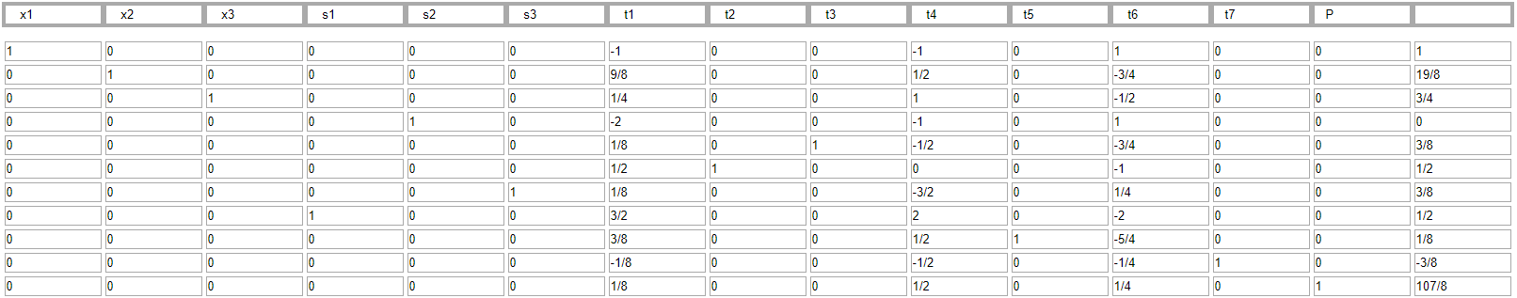

Tableau at end of LP iteration:

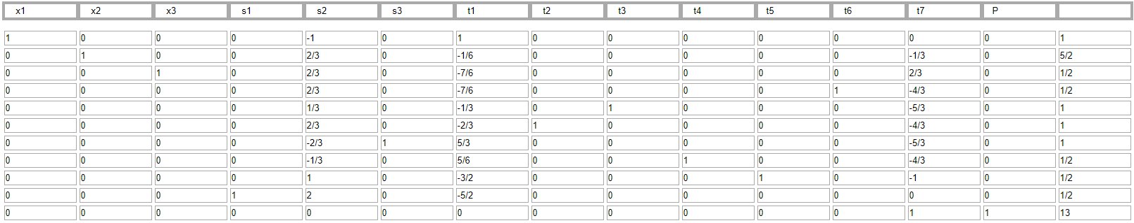

We get a solution at x1 = 1, x2 = 5/2, x3 = 1/2 with P = 13

It was at this point the online matrix calculator ran out of columns. It began with 15 columns, and after 7 cuts, there are not enough columns to continue further cuts unless I decided to do all the row operations by hand. However, by best judgement, that is not completely necessary. Through these 7 cuts, we have noticed several unique patterns:

1. x1 has been hovering around the value of 1 for six cuts now and has even reached the value of 1 on several iterations. We can estimate the true integer value of x1 is 1.
2. x2 has been hovering around the value of 2 for five cuts now. We can estimate the true integer value of x1 is 2.
3. Our objective function, P, began at a value of 13.6, hovered around that number, and has slowly decreased since, slowly plateauing around the value of 13. We can estimate this may be one of the possibilities for the ground-truth objective function value for this integer linear programming problem.
4. With the above estimates, we notice x3 has been hovering around the value of 1 on and off for iterations. With moderate to low confidence, we can conclude at this point that x3 converges to integer 1. However, undergoing many more cuts should unveil its true value of 1, as we have learned in question #1 of this homework.
5. With some confidence, we can safely predict the solution to this integer linear programming problem is **x1 = 1, x2 = 2, x3 = 1 with P = 13**. Undergoing a countless number of further cuts will require much more computational time, handwritten work to discover new constraints, and a large matrix calculator. However, due to the limits of all three variables showing themselves across 7 cuts/iterations, we can assume to an extent this is a safe maximum solution to our integer linear programming problem.

5.

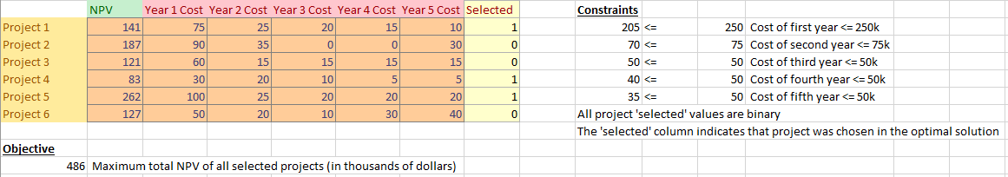

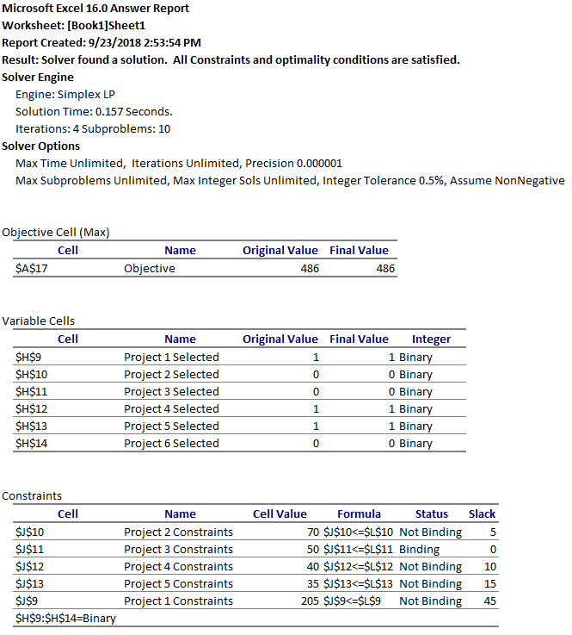

In this problem, we have several variables to consider. For the objective function, it is simply the sum of the all NPV revenue from the selected R&D projects. In addition, there are six main constraints: the total cost per year of the projects for years 1 through 5, as well as each project being selected or not (i.e. project 1 is selected = 1, project 1 is **not** selected = 0), so it’s a binary possibility of whether a project is selected in the end. Finally, a table was created to monitor all costs and revenues for all five years, as well as the final maximum NPV brought into the company. The results can be found below:

Selected projects are **Project 1**, **Project 4**,and **Project 5**.

Total cost for the first year investment is $205k, which is $45k under the $250k limit.

Total cost for the second year investment is $70k, which is $5k under the $75k limit.

Total cost for the third year investment is $50k, which matches the $50k limit.

Total cost for the fourth year is $40k, which is $10k under the $50k limit.

Total cost for the fifth year is $35k, which is $15k under the $50k limit.

The total NPV generated from these three selected projects is $486k.

As such, Project 1, 4, and 5 will require a total investment of $400k across all five years, while bringing in an NPV of $486k. These three projects also fit within the money constraints of all five year investments, so the company is provided with $75k to reallocate across the rest of the company.