James Hahn

MATH1101 Optimization

Dr. Wheeler

1. a. Max P(x, y) = 50x0.4y0.6

Subject to 100x + 200y – 20000 = 0

We see the constraint can be transformed into:

x = 200 – 2y

y = 100 – 1/2x

So we have two forms of the equation:

P(x, y) = 50*(200-2y)0.4y0.6

Py =

P(x, y) = 50x0.4(100-1/2x)0.6

Px =

Therefore:

Pyy =

And

Pxx = 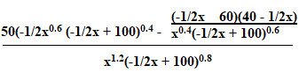

Finally:

Pxy = Pyx = 0

We reach critical points of Py = 0 at y = 60, 0, 100 and Px = 0 at x = 200, 80, 0. We know x, y ≠ 0, and out of the remaining four values (y = 60, 100 and x = 200, 80), only the pair (80, 60) satisfies the constraints. As such:

D(80, 60) = (-.35061)(-1.40244) – 02 > 0 and Pxx = -.35061 < 0, so this is a maximum

As such, the solution to our problem is **(80, 60), or x = 80 and y = 60**.

b. ▽f(x) = < 20x-0.6y0.6, 30x0.4y-0.4 >

▽g(x) = < 100, 200 >

20x-0.6y0.6 = 100λ

30x0.4y-0.4 = 200λ

100x + 200y – 20000 = 0

1/5x-0.6y0.6 = λ

30x0.4y-0.4 = 40x-0.6y0.6

x/y = 4/3

(*) y = 3/4x

Substitute (*) into the constraint:

100x + 200y – 20000 = 0

100x + 150x – 20000 = 0

250x = 20000

x = 80

By (*), y = (3/4)*80 = 60

Therefore, the **solution is (80, 60)**.

2. a. Max Q = xyz

Subject to 3x + 4y + 12z = 96

x, y, z > 0

96 = 3(3x/3 + 4y/3 + 12z/3)

≥ 3*(3x)1/3 * (4y)1/3 * (12z)1/3

96 = 3 * 31/3 * 41/3 * 121/3 * Q1/3

Therefore, 2048/9 = Q

We reach this max when:

3x = 4y = 12z = 32 (this is 96/3)

So:

x = 32/3

y = (1/4)*32 = 8

z = (1/12)*32 = 8/3

Therefore, we reach a maximum **Q of 32/3 at x = 32/3, y = 8, z = 8/3**.

b. **For starting point (4, 15, 2):**

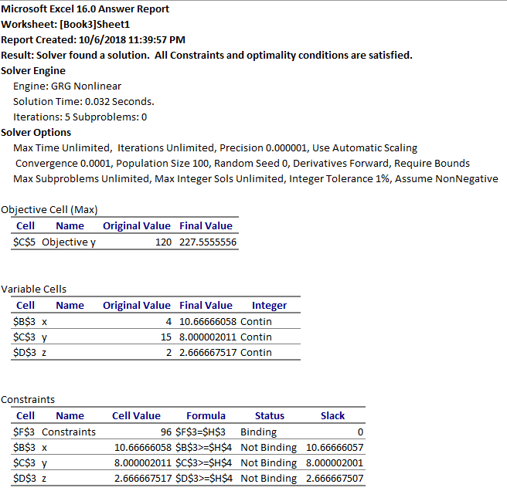

**And for starting point (31.9995, 0.0001):**

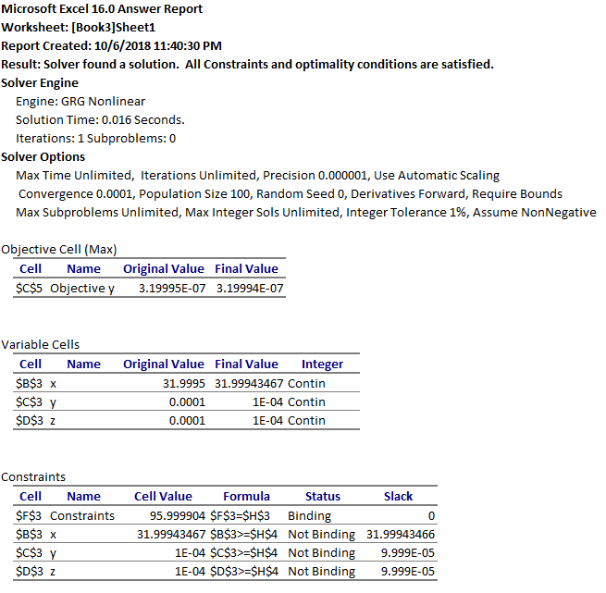

3. a. Min g(x, y) = 1000/(xy) + 2x + 2y + xy

Subject to x, y > 0

𝛿’ = < 𝛿1, 𝛿2, 𝛿3, 𝛿4 >

Max v(𝛿’) = (1000/𝛿1)𝛿1(2/𝛿2)𝛿2(2/𝛿3)𝛿3(1/𝛿4)𝛿4

Subject to 𝛿1 + 𝛿2 + 𝛿3 + 𝛿4 = 1

- 𝛿1 + 𝛿2 + 𝛿4 = 0

- 𝛿1 + 𝛿3 + 𝛿4 = 0

𝛿1, 𝛿2, 𝛿3, 𝛿4 > 0

We get:

𝛿1 = t

𝛿2 = 1-2t

𝛿3 = 1-2t

𝛿4 = 3t – 1

Max v(t) = (1000/t)t(2/(1-2t))2-4t(1/(3t-1))3t-1

t = 0.438897

𝛿1 = 0.4389

𝛿2 = 0.1222

𝛿3 = 0.1222

𝛿4 = 0.3167

By multiplying out the equations:

u1 = 𝛿1v(𝛿’) = 5.182 = x

u2 = 𝛿2v(𝛿’) = 5.182 = y

Therefore, our solution has been reached at **(5.182, 5.182) with a minimum g(x, y) = 84.8207**.

b. The following is the output from Wolfram Alpha solving the problem: 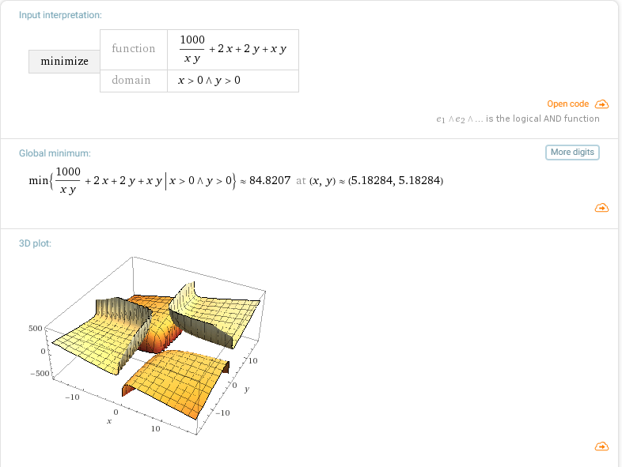

4. a. Min f(x, y) = 2x2 + y2 – 2xy at (2, 3)

▽f(x, y) = < 4x – 2y, 2y – 2x >

▽f(2, 3) = < 2, 2 >

Min Φ0(s) = f(2-2s, 3-2s)

= 4s2 – 8s + 5

Φ0’ = 8s – 8

There is a critical point at s = 1

Φ0’’ = 8 > 0, so the critical point is a minimum

x1 = < 2, 3 > - 1< 2, 2 > = < 0, 1 >

▽f(0, 1) = < -2, 2 >

Min Φ1(s) = f(2s, 1-2s)

= 20s2 – 8s + 1

Φ0’ = 40s – 8

There is a critical point at s = 1/5

Φ0’’ = 40 > 0, so the critical point is a minimum

x2 = < 0, 1 > - 1/5< -2, 2 > = **< 2/5, 3/5 >**

b. Min g(x, y) = x2 + y2 – 2x -2y -xy at (0, 0)

▽g(x, y) = < 2x – 2 – y, 2y – 2 - x >

▽g(0, 0) = < -2,-2 >

Min Φ0(s) = g(-2s, -2s)

= 12s2 + 8s

Φ0’ = 24s + 8

There is a critical point at s = -1/3

Φ0’’ = 24 > 0, so the critical point is a minimum

x1 = < 0,0 > + 1/3< -2, -2 > = < -2/3, -2/3 >

▽g(-2/3, -2/3) = < -8/3, -8/3 >

Min Φ1(s) = g(-2 + 8/3s, -2 + 8/3s)

= 64/3s2 – 128/3s + 20

Φ0’ = 128/3s – 128/3

There is a critical point at s = 1

Φ0’’ = 128/3 > 0, so the critical point is a minimum

x2 = < -2/3, -2/3 > - 1< -8/3, -8/3 > = **< 2, 2 >.**

**Comment: we have converged to the global minimum in two iterations.**

c. For part a:

**Starting point of (2, 3):**

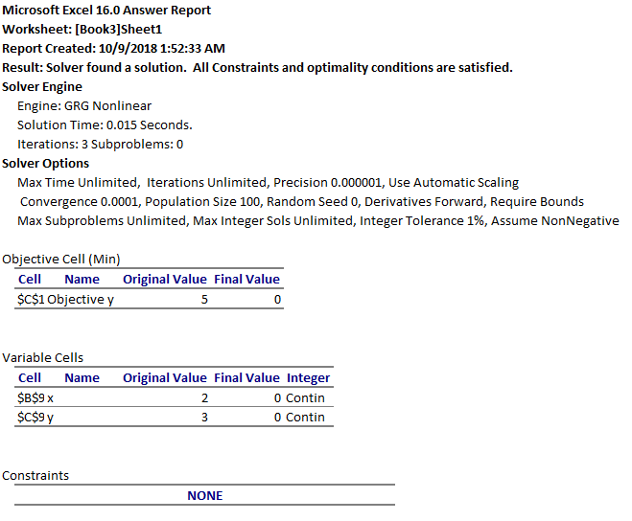

**Starting point of (-5, -5):**

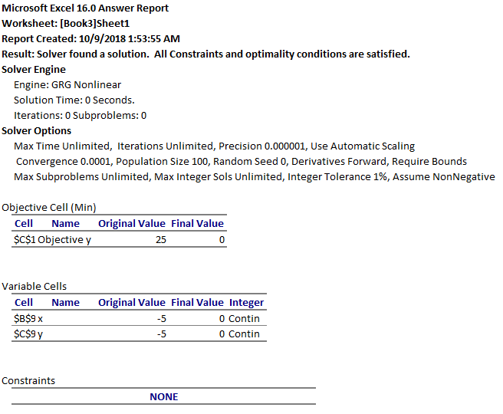

**Starting point of (-1010433, 235446):**

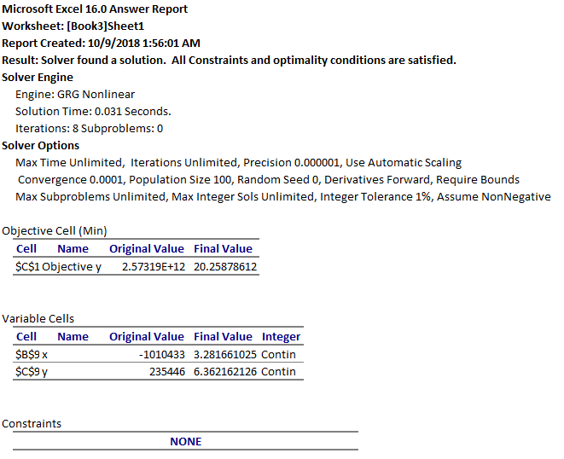

For part b:

**Starting point of (0, 0):**

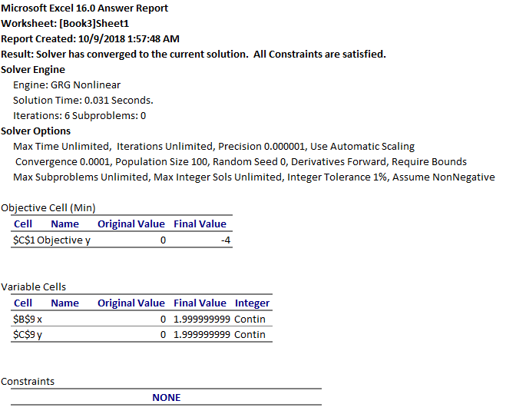

**Starting point of (-10, 10):**

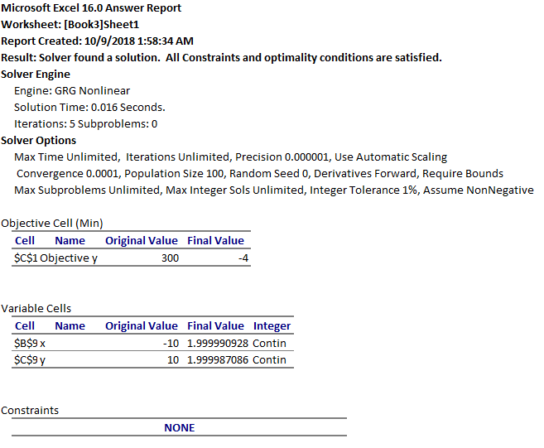

**Starting point of (84893484, -35253):**

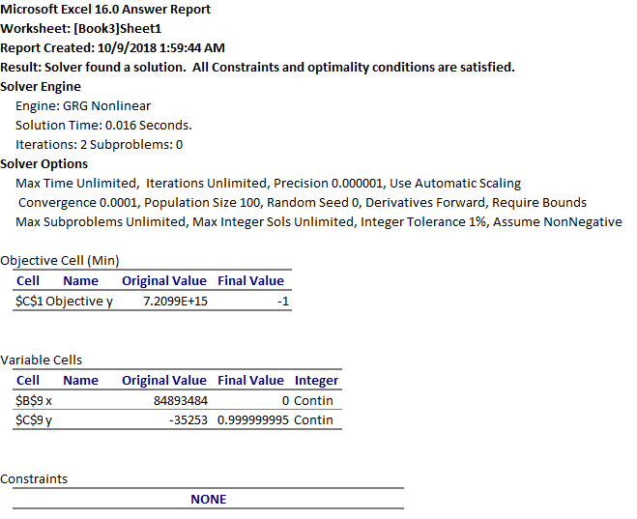

5. Min f(x, y) = 2x2 + y2 - 2xy with starting point (2, 3)

▽f(x, y) = < 4x – 2y, 2y – 2x >

▽f(2, 3) = < 2, 2 >

fxx = 4

fyy = 2

fxy = fyx = -2

Hf(x, y) = [ 4 ; -2 ]

[ -2 ; 2 ]

H-1f(x, y) = [ ½ ; ½ ]

[ ½ ; 1 ]

<xn+1, yn+1> = <2, 3> - <2, 2>[ ½ ½ ; ½ 1] = <2, 3> - <2, 3> = <0, 0>

▽f(0, 0) = < 0, 0 >

<x2, y2> = <0, 0> - <0, 0>[ ½ ½ ; ½ 1 ] = **<0, 0>, which is our final solution**.

7. The problem can be modelled as the following optimization problem:

Minimize $\sqrt{{(x-5)}^{2}+{(y-45)}^{2}} + \sqrt{{(x-12)}^{2}+{(y-21)}^{2}} + \sqrt{{(x-17)}^{2}+{(y-5)}^{2}} + \sqrt{{(x-52)}^{2}+{(y-21)}^{2}}$

Subject to $\sqrt{{(x-5)}^{2}+{(y-45)}^{2}} ≤ 40$

$\sqrt{{(x-12)}^{2}+{(y-21)}^{2}} ≤ 40$

$\sqrt{{(x-17)}^{2}+{(y-5)}^{2}} ≤ 40$

$\sqrt{{(x-52)}^{2}+{(y-21)}^{2}} ≤ 40$

This problem has four constraints, namely that the tower must be within a 40-mile transmission radius of each of the towers.

This equation is the sum of the distances from the new tower (x, y) and all of the other towers (5, 45), (12, 21), (17, 5), and (52, 21).

A heatmap of the solution can be found below. The darker the blue, the lower the value. One can easily see (12.2, 21) is the minimum value.

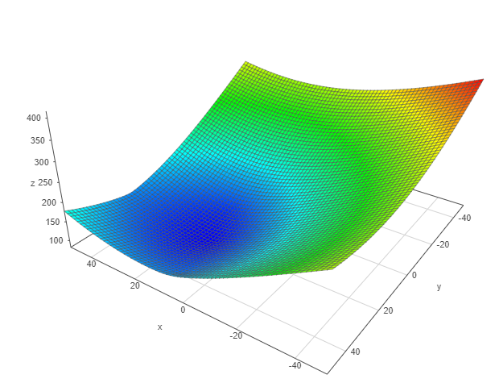

**Proposal to AllTalk Communications**

Hello ladies and gentlemen. Thank you for providing me with the necessary information for this problem, such as the locations of the existing towers and the future goal, which was to determine the position of a new tower. In addition, you informed us that the tower only has a 40 mile transmission radius. Thank you very much for that well-needed information.

After further investigation, we have decided the most optimal location for the new tower is at (12.2, 21). With this new location, we achieve a minimum distance of 81.76 miles between all of the towers! This will significantly help reduce latency between all the towers in the towns. In addition, we took into account the transmission radius of the tower and can guarantee all of the cities’ towers fit well within the 40-mile transmission radius of the new tower. You have nothing to worry about and you will be making a lot of people happy, while saving money, with this new tower!