James Hahn

MATH1101 Optimization

Dr. Wheeler

1.

Proof

First, we want to show P(x*) = max{ P(x) | x ∈ F } ⟹ -P(x*) = min{ -P(x) | x ∈ F }

Assume P(x*) = max{ P(x) | x ∈ F }

⟹ ∀x ∈ F , P(x*) ≥ P(x)

⟹ -P(x*) ≤ -P(x) which is the definition of a minimum

⟹ -P(x*) = min{ -P(x) | x ∈ F }

So, for -P(x), the given input x* is a minimum.

Next, we want to show -P(x*) = min{ -P(x) | x ∈ F } ⟹ P(x*) = max{ P(x) | x ∈ F }

Assume -P(x*) = min{ P(x) | x ∈ F }

⟹ ∀x ∈ F , -P(x*) ≤ -P(x)

⟹ P(x*) ≥ P(x) which is the definition of a maximum

⟹ P(x*) = max{ P(x) | x ∈ F }

So, for P(x), the given input x* is a maximum.

We have shown both directions of the logical statement.

Therefore, P(x*) = max{ P(x) | x ∈ F } ⟺ -P(x*) = min{ -P(x) | x ∈ F }. ∎

2.

1. 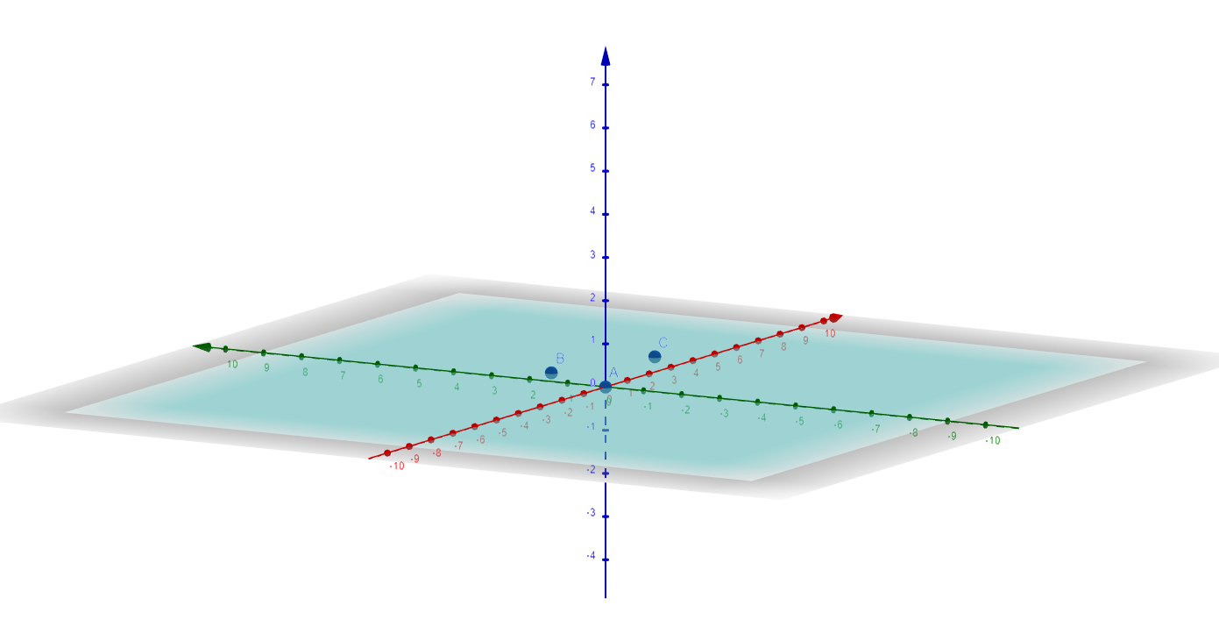

A = (0, 0)

B = (1, 2)

C = (4, 1)

The blue plane is the affine hull. It is located at z = 0. Pretend like the plane is extending outward forever.

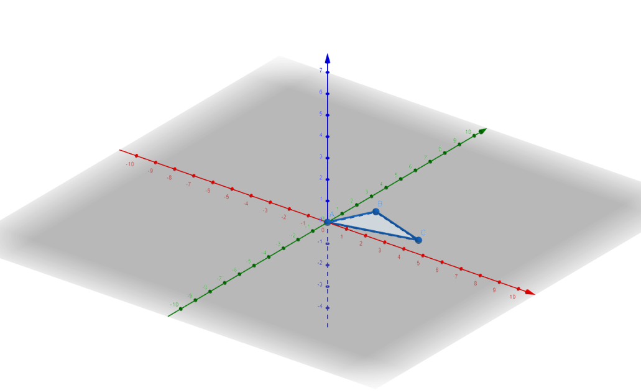

A = (0, 0)

B = (1, 2)

C = (4, 1)

The blue polygon is the convex hull. It is located at z = 0.

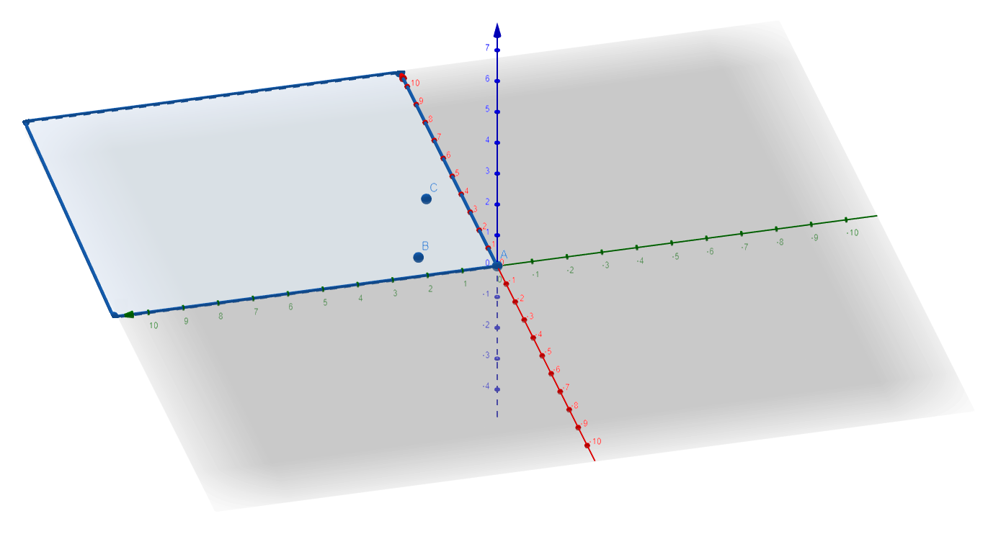

A = (0, 0)

B = (1, 2)

C = (4, 1)

The blue plane is the conical hull. It is located at z = 0 in the first quadrant. Pretend like the plane is extending outward forever in the first quadrant.

3. Affine set

For any α1,α2∈ℝ where α1+α2 = 1 and (x1, y1),(x2, y2) ∈ S, then α1(x1, y1) + α2(x2, y2) ∈ S.

Convex set

For any λ ∈ [0, 1], λ(x1, y1) + (1 – λ)(x2, y2) ∈ S

Convex cone

For any α1, α2 ∈ ℝ ≥ 0, α1(x1, y1) + α2(x2, y2) ∈ S.

Convex polyhedron

A solid in 3 dimensions with flat faces, straight edges, and sharp corners

Convex polytope

A convex set of points in n-dimensional space. It’s basically a convex polyhedron that is bounded.

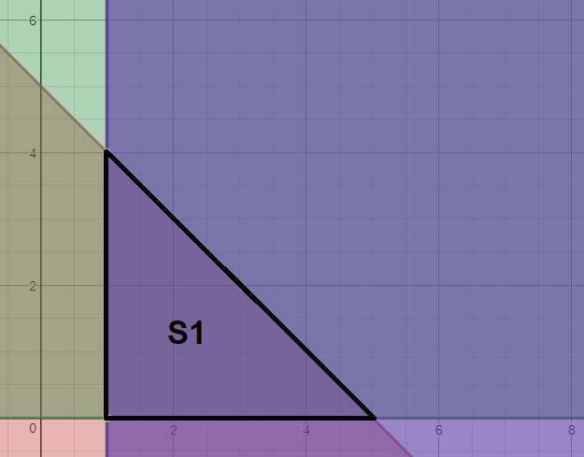

The pink region is x + y ≤ 5.

The lighter purple region is x ≥ 1.

The green region is y ≥ 0.

The region outlined in black is the region of points included in the set S1.

It **is a convex polyhedron** because in ℝ3, the value of z does not determine whether the inequality holds; only x and y matter. Also, the feasible region clearly has straight edges, sharp corners, and flat faces.

It **is also a convex polytope** because it is a convex polyhedron and bounded (1 ≤ x ≤ 5, 0 ≤ y ≤ 4).

So, for S1, (2, 2) ∈ S and (4, 1) ∈ S. Take α1 = -1/2, α2 = 3/2. Then α1 + α2 = 1.

But α1(2, 2) + α2(4, 1) = -1/2(2, 2) + 3/2(4, 1)

= (-1, -1) + (6, 3/2)

= (5, ½)

Hence (5, ½) ∉ S, as 5 + ½ > 5, so S1 is **not affine**.

Let (x1, y1), (x2, y2) ∈ S, λ ∈ (0, 1) s.t. x1 + y1 ≤ 5, x1 + y1 ≤ 5.

Then λ(x1, y1) + (1- λ)(x2, y2) = (λx1 + (1-λ)x2, λy1 + (1-λ)y2) = (x3, y3)

Then, x3 + y3 = λ(x1 + y1) + (1- λ)(x2+y2)

≤ 5λ + 5(1- λ)

≤ 5

Also, y = λy1 + (1- λ)y2 ≥ 0 since y1 ≥ 0, y2 ≥ 0, and λ ∈ (0, 1)

Also, x = λx1 + (1- λ)x2 ≥ 1 since x1 ≥ 1, x2 ≥ 1, and λ ∈ (0, 1)

Since x3 + y3 ≤ 5, x3 ≥ 1, and y3 ≥ 0, then (x3, y3) ∈ S1, so S1 is a **convex set**.

Take (2, 3), (2, 2) ∈ S1 with α1 = 3, α2 = 0.

Then α1(2, 3) = (6, 4) ∉ S1 since 6 + 9 > 5.

So, S1 is **not a convex cone**.

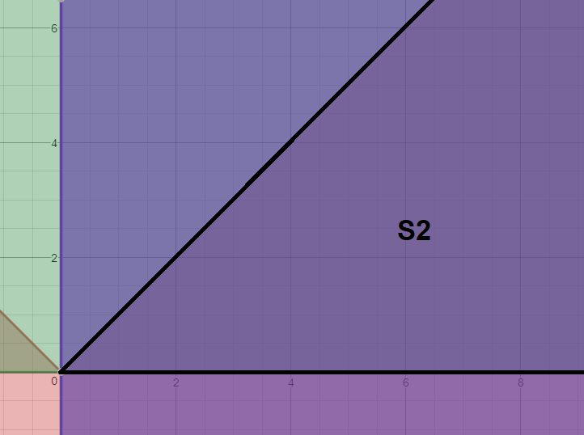

The pink region is y ≤ |x|.

The lighter purple region is x ≥ 0.

The green region is y ≥ 0.

The region outlined in black is the region of points included in set S2, which is unbounded from above on x and y.

S2 **is a convex polyhedron** because in ℝ3, the value of z does not determine whether the inequality holds; only x and y matter. Also, the feasible region has straight edges, sharp corners, and flat faces.

However, it **is not a convex polytope** because x and y are unbounded from above.

Only positive x-axis is on S2, but to be affine it will contain the whole line.

Take (10, 0), (2, 0) in S2 with α1 = -1/2, α2 = 3/2 where α1 + α2 = 1.

Then α1(10, 0) + α2(2, 0)

= (-5, 0) + (3, 0)

= (-2, 0) ∉ S2

So, S2 is **not affine**.

Let (x­1, y1), (x2, y2) ∈ S2 and λ ∈ [0, 1].

Let (x3, y3) = λ(x1, y1) + (1- λ)(x2, y2).

Then y3 = λy1 + (1- λ)y2 ≤ λ|x1| + (1- λ)|x2|.

But, x1, x2 ≥ 0, so y3 ≤ x3 and x3 ≥ 0, y3 ≥ 0.

So, S2 is a **convex set** (it contains any line segment joining any two points in S2).

S2 is a **convex cone with vertex at origin** since any line segment passing through the origin and a point of S2 lies inside S2.

If (x1, y1) ∈ S2, then for α1 ≥ 0, α1 ∈ ℝ, we have α1(x1, y1) ∈ S2 as α1y1 ≤ α1x1 and α1x1 ≥ 0, α1y1 ≥ 0.

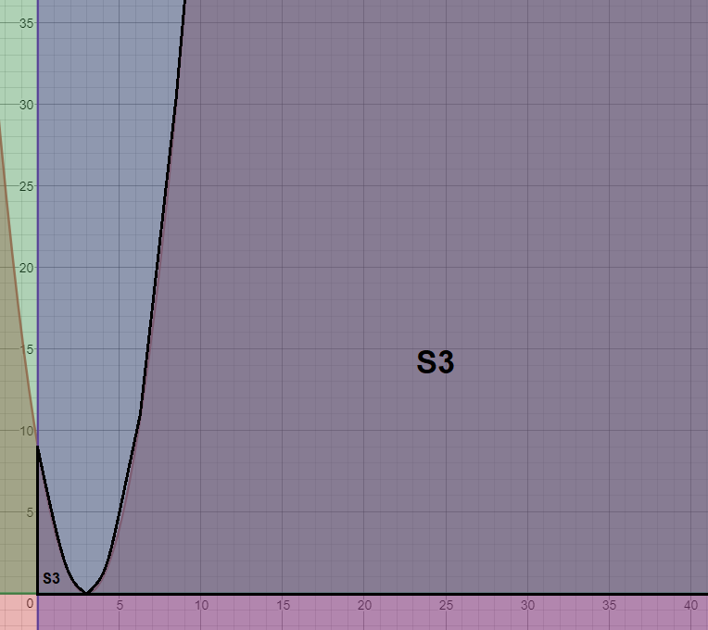

The pink region is y – x2 + 6x ≤ 9.

The lighter purple region is x ≥ 0.

The green region is y ≥ 0.

The region outlined in black is the region of points included in set S3, which is unbounded.

It **is not a convex polyhedron** because it’s a polynomial function and has curved edges.

It **is not a convex polytope** because it is not a convex polyhedron and it is not bounded (x and y are not bounded from above).

S3 = { (x, y) | y – x2 + 6x ≤ 9, y ≥ 0, x ≥ 0 }

= { (x, y) | y ≤ x2 – 6x + 9, y ≥ 0, x ≥ 0 }

= { (x, y) | y ≤ (x-3)2, y ≥ 0, x ≥ 0 }.

Let (1, 4), (1, 1) ∈ S3 with α1 = -1/2 and α2 = 3/2 so α1 + α2 = 1.

Then -1/2(1, 4) + 3/2(1, 1)

= (1, -1/2) ∉ S3 since -1/2 < 0

So, S3 is **not an affine set**.

The line segment connecting (0, 0) and (20, 20), { (x, y) | y = x, 0 ≤ x ≤ 20, 0 ≤ y ≤ 20 } traverses outside of S3.

For example, this statement is true when (x, y) = (3, 3).

In this case, x and y fit within the domain and value range of the line segment, but (3, 3) ∉ S3.

Therefore, not all line segments exist in S3 that connect arbitrary points in S3.

So, S3 is **not a convex set**.

The **convex hull** is the first quadrant of the xy plane such that { (x, y) | x ≥ 0, y ≥ 0 }.

Let (1, 1), (1, 2) ∈ S3 with α1 = 1 and α2 = 2 so α1, α2 ≥ 0.

Then α1(x1, y1) + α2(x2, y2)

= 1(1, 1) + 2(1, 2)

= (1, 1) + (2, 4)

= (3, 5) ∉ S3

Also, let (0, 0), (1, 2) ∈ S3 with α1 = 1 and α2 = 3 so α1, α2 ≥ 0.

Then α1(x1, y1) + α2(x2, y2)

= 1(0, 0) + 3(1, 2)

= (0, 0) + (3, 6)

= (3, 6) ∉ S3, which originates from the origin

S3 is **not a convex cone with vertex at origin** because the above two examples, one of which originating from the origin (origin exists in S3), produce line segments with points nonexistent in S3.

4.

The extreme points of a convex polygon are the points of intersection of the lines bounding the feasible region, which are y = |x| and y = 0 in this case.

These two lines intersect when they equal each other, so y = |x| = 0 = y.

They meet exactly and only when x = 0.

When x = 0, then y = 0 as well.

Therefore, the **only existing corner point is (0, 0)**.

Remember from Remark 4.1.4 in the book that any line segment joining corner points produces the optimal solution for a feasible region when that line segment borders the feasible region.

Technically, (∞, ∞) and (∞, 0) are also corner points since they connect to the lines passing through the origin while bordering the feasible region.

However, we exclude them from the ‘optimal solution’ since they are not feasible to reach.

Therefore, the line segment connecting (0, 0) to (∞, ∞) and the line segment connecting (0, 0) to (∞, 0) produce the basis of S2.

It is clear to see that the **two direction vectors representing these two line segments, from the origin, are [1, 1]T and [1, 0]T**.

So, the line segment from the origin through the above direction vectors will cross any possible ‘corner’/extreme/’optimal’ points of the unbounded region.

The two direction vectors, or coni(D), will produce rays from the origin covering the area that is S2 in the above picture, which is the set coni(D) = { [x, y]T | x = α1 + α2, y = α1, α1, α2 ≥ 0 } ( this is because (x, y) = α1(1, 1) + α2(1, 0) ).

The corner point will create the set conv(P) = { [0, 0]T }.

So, it is easy to see S2 = conv(P) + coni(D).