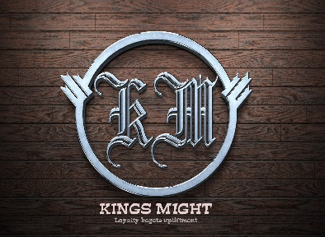

Has successfully completed the following course from Kings Might Technology

We wish him/her success in life.

Elsa Emerald

Signature

Certificate Course of Application Office

16/02/2021

Date:

**DESCRIPTION OF THE COURSE**

**ESTHER AKYE CUDJOE**

**CERTIFICATE**

Of Appreciation

Proudly Presented To