Network Threat Detection & Packet Analysis Lab

Tools:Wireshark, pfSense, Kali Linux, Nmap, SMB Tools

Objectives:
This lab focuses on network-based reconnaissance and service enumeration within a segmented environment. It simulates real-world attack scenarios to detect and analyze malicious traffic using Wireshark, Nmap, and SMB tools.
Baseline Traffic:
Normal DNS resolution, TCP handshake, and HTTPS communication were observed to establish baseline behavior.

1.  Wireshark is configured to capture network traffic on the active interface connected to the pfSense LAN (Ethernet0). | Wireshark interface selection (capture setup) 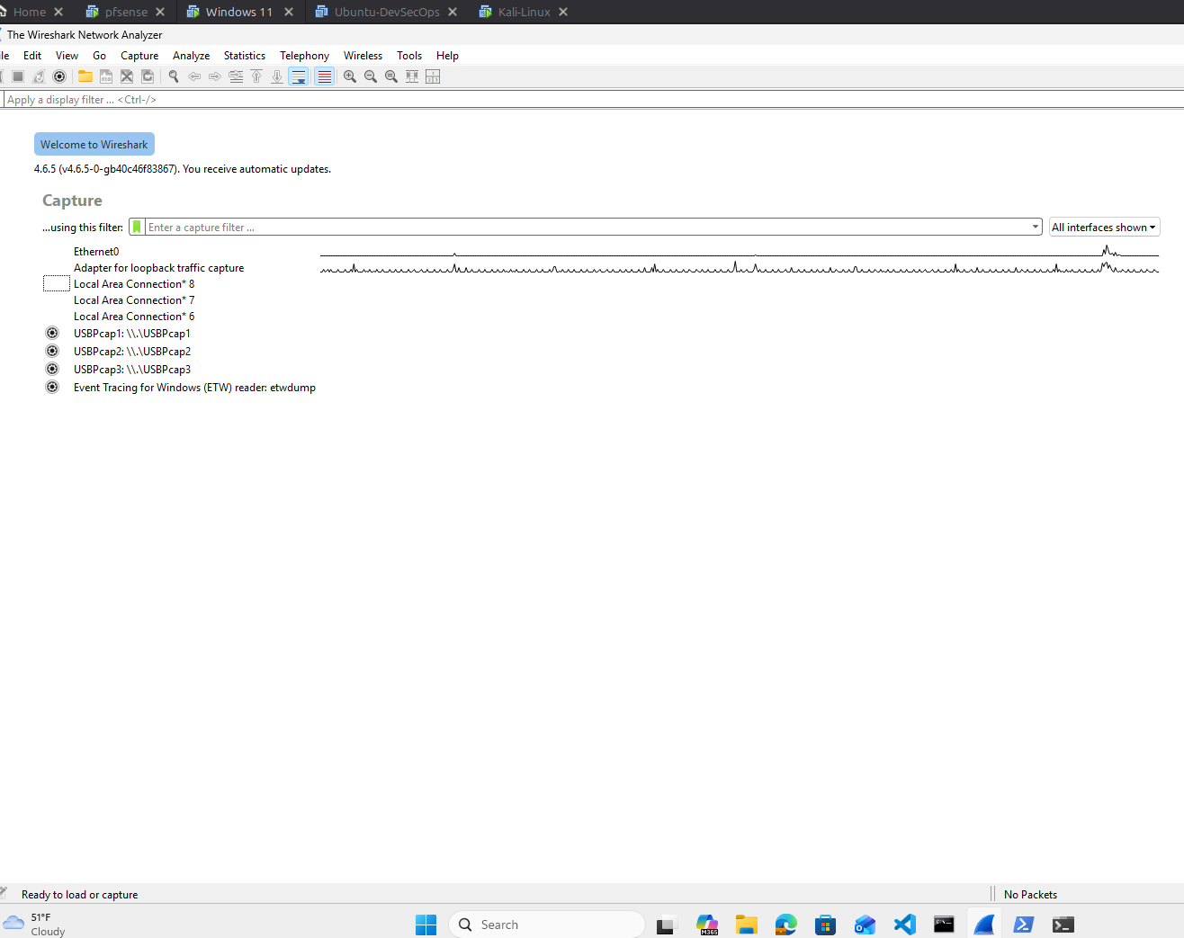
2.  This capture shows normal network activity, including DNS resolution, TCP handshake, and encrypted HTTPS communication with external servers. This baseline traffic is used to distinguish normal behavior from malicious activity during analysis. | Baseline network traffic (DNS, HTTPS, ICMP)  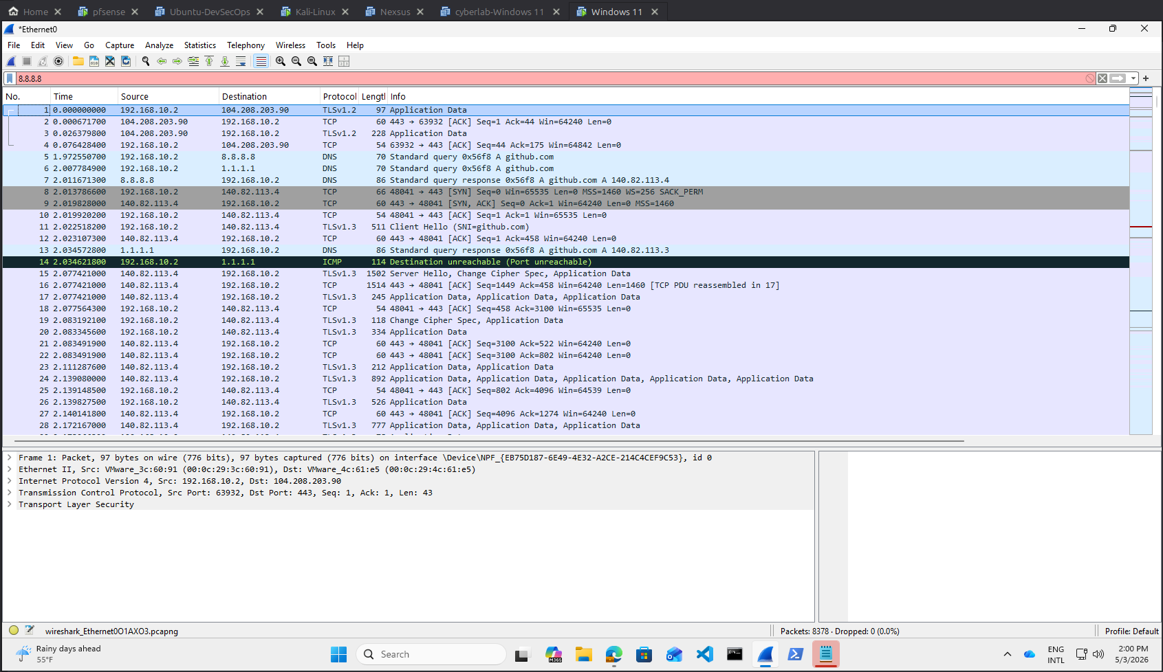
3.  Attack Simulation – Reconnaissance ( Nmap SYN Scan)  A TCP SYN scan was performed from the attacker machine to identify open services on the target system. | 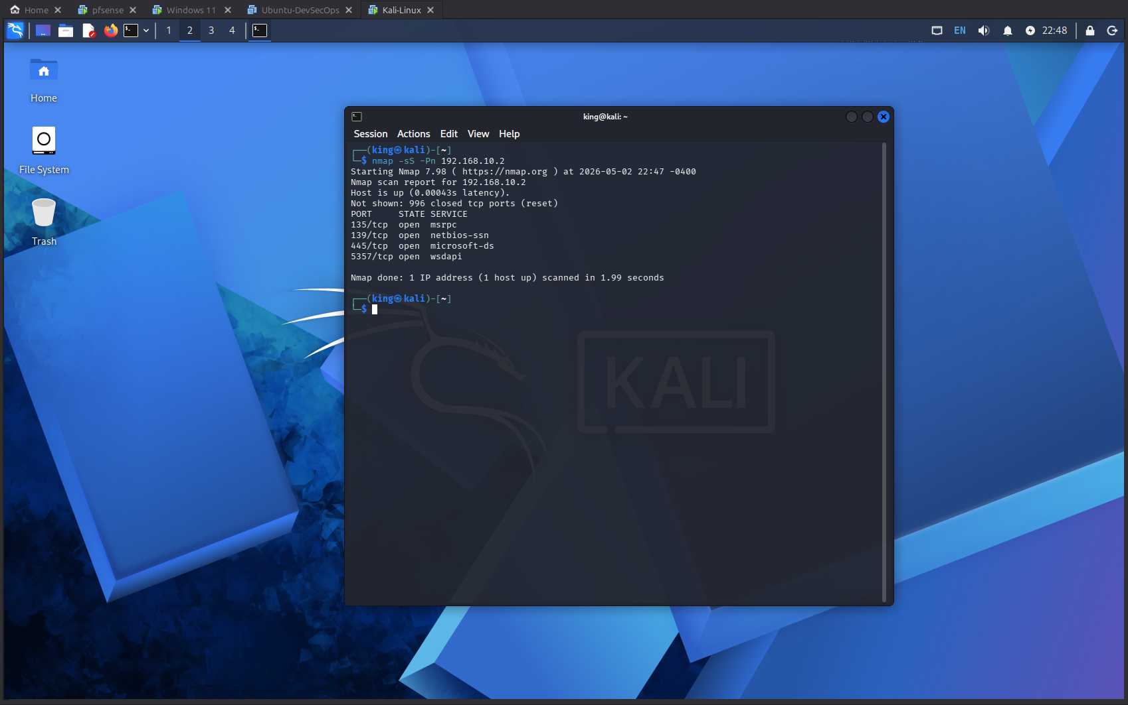  Findings:  - 135/tcp – MSRPC  - 139/tcp – NetBIOS  - 445/tcp – SMB  - 5357/tcp – WSDAPI  Key Risk:  Exposed SMB (port 445) can enable lateral movement and may be vulnerable to exploitation if misconfigured.
4.  Packet Analysis Summary  Wireshark capture shows an attacker (192.168.20.11) performing a SYN scan against the target (192.168.10.2). Most ports returned RST/ACK responses (closed), while port 445 remained open, confirming SMB exposure.  5.  Filtered Traffic Analysis  Traffic was filtered using tcp.flags.syn == 1 && tcp.flags.ack == 0, displaying only initial SYN packets. The capture shows repeated connection attempts to multiple ports, indicating active port scanning from the attacker. | 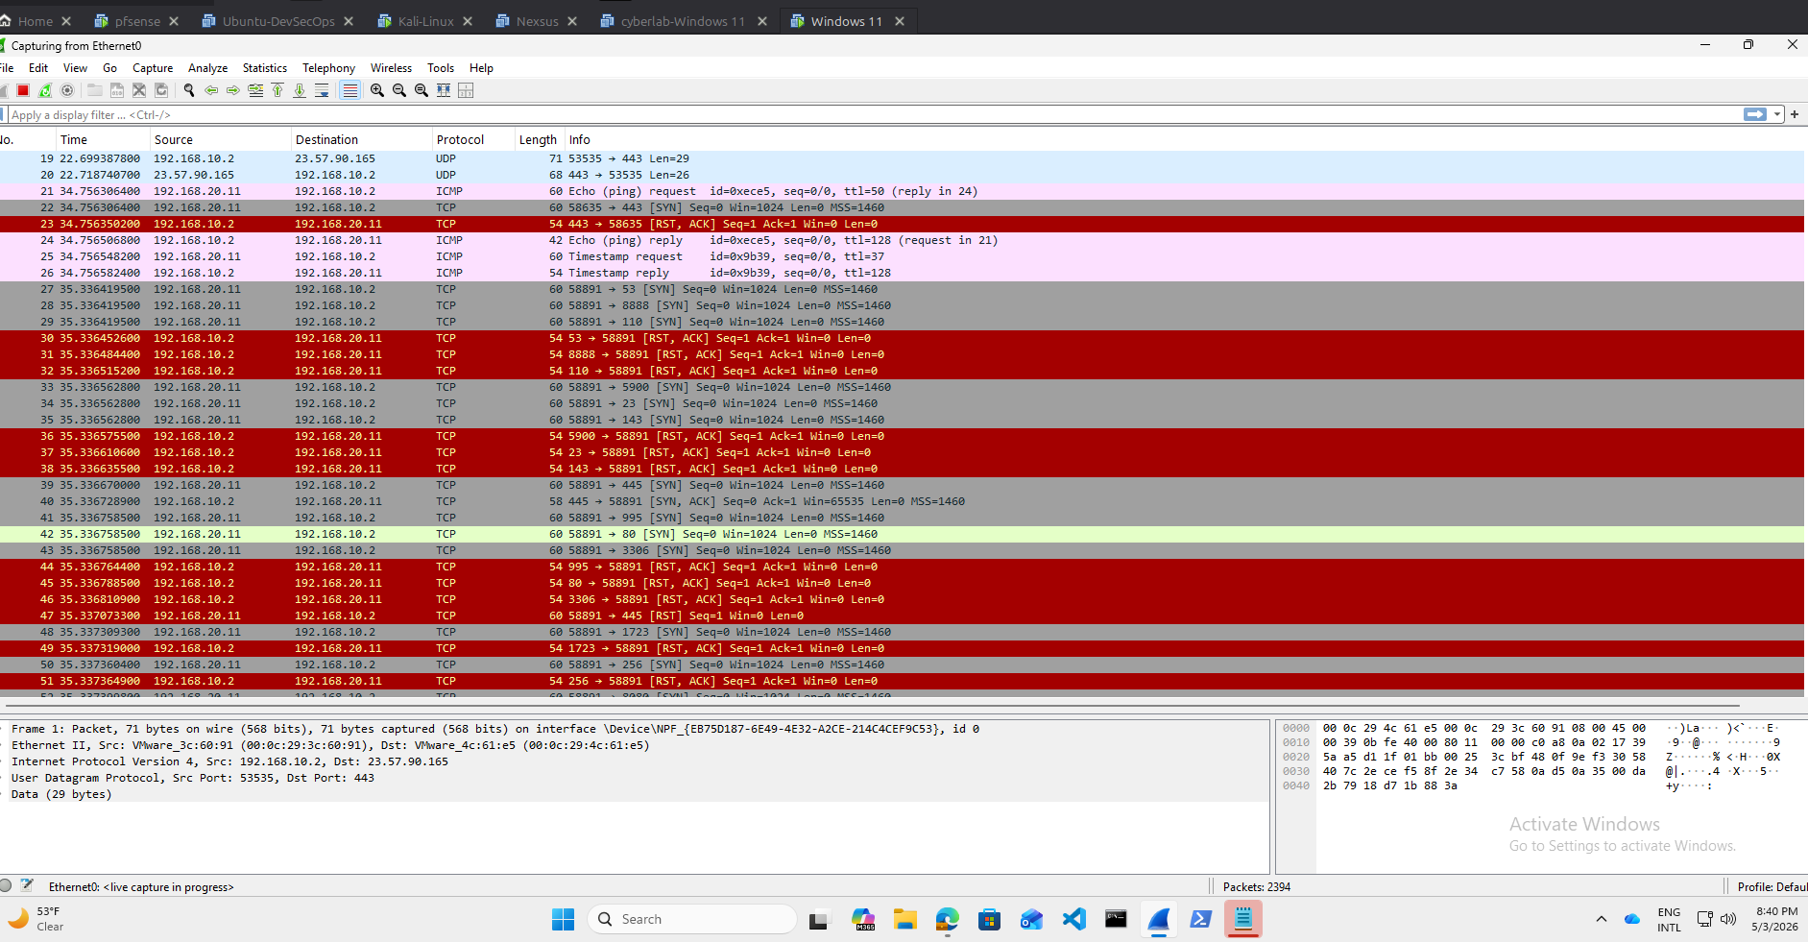  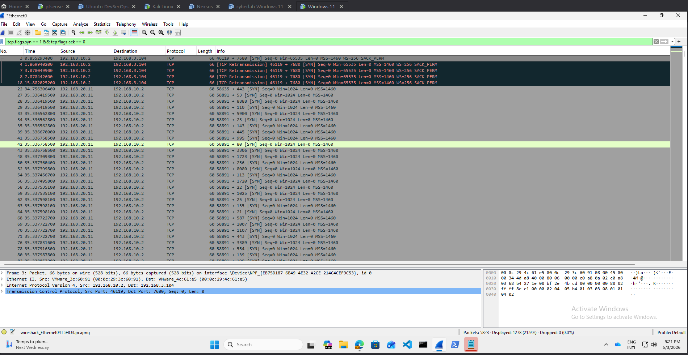
6.  Attacker Traffic Analysis  This capture is filtered using ip.src == 192.168.20.11, displaying traffic originating from the attacker. The packets show repeated connection attempts across multiple ports, confirming active reconnaissance activity. | 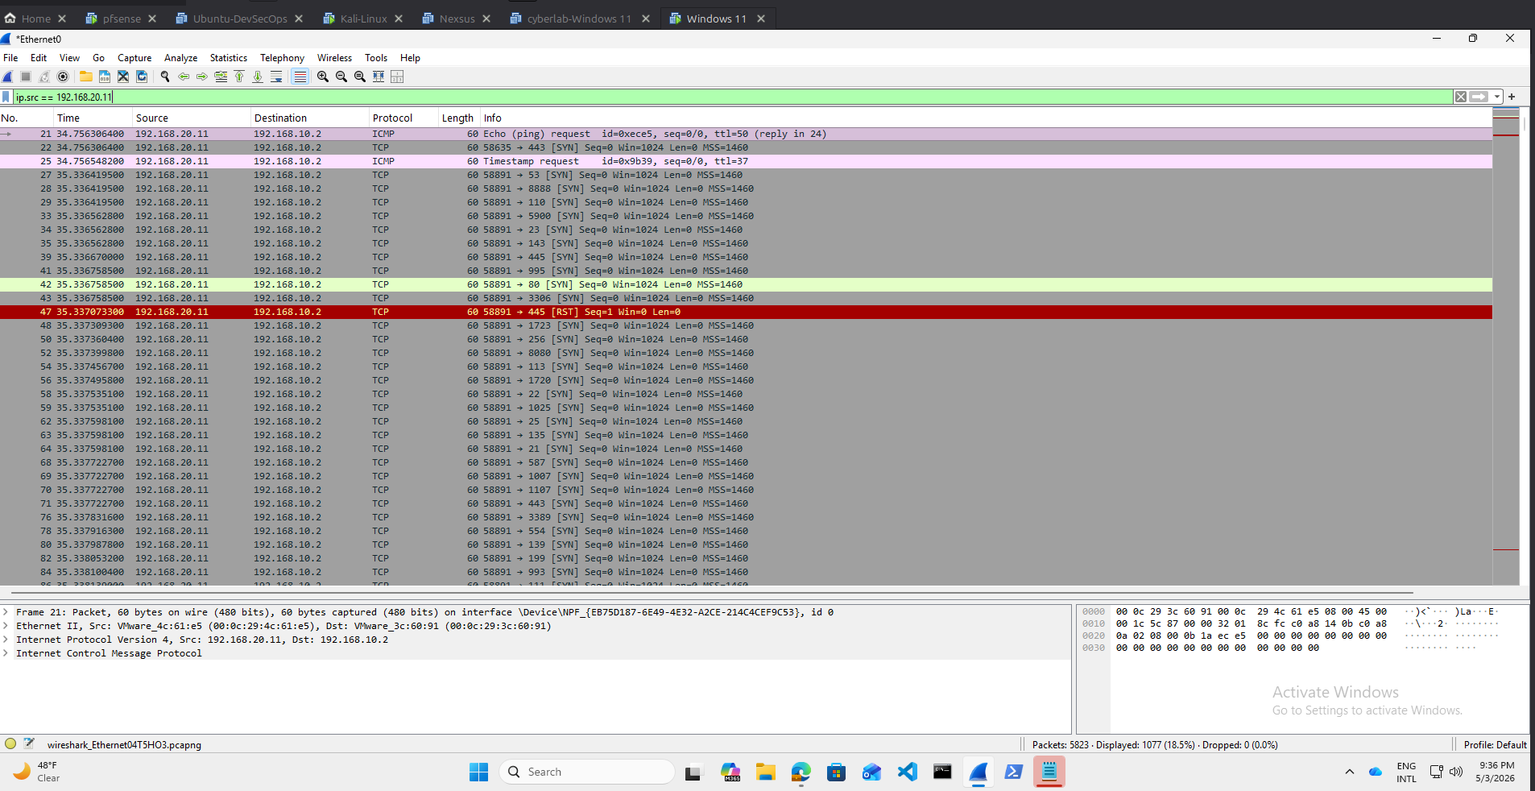
7.  SMB Enumeration Analysis  Multiple SMB enumeration attempts were performed using anonymous and guest access. All attempts were denied, indicating that authentication is enforced and unauthorized access is restricted. A follow-up scan confirmed that SMB is exposed on port 445 but properly secured. | SMB Enumeration Attempts & Access Denial  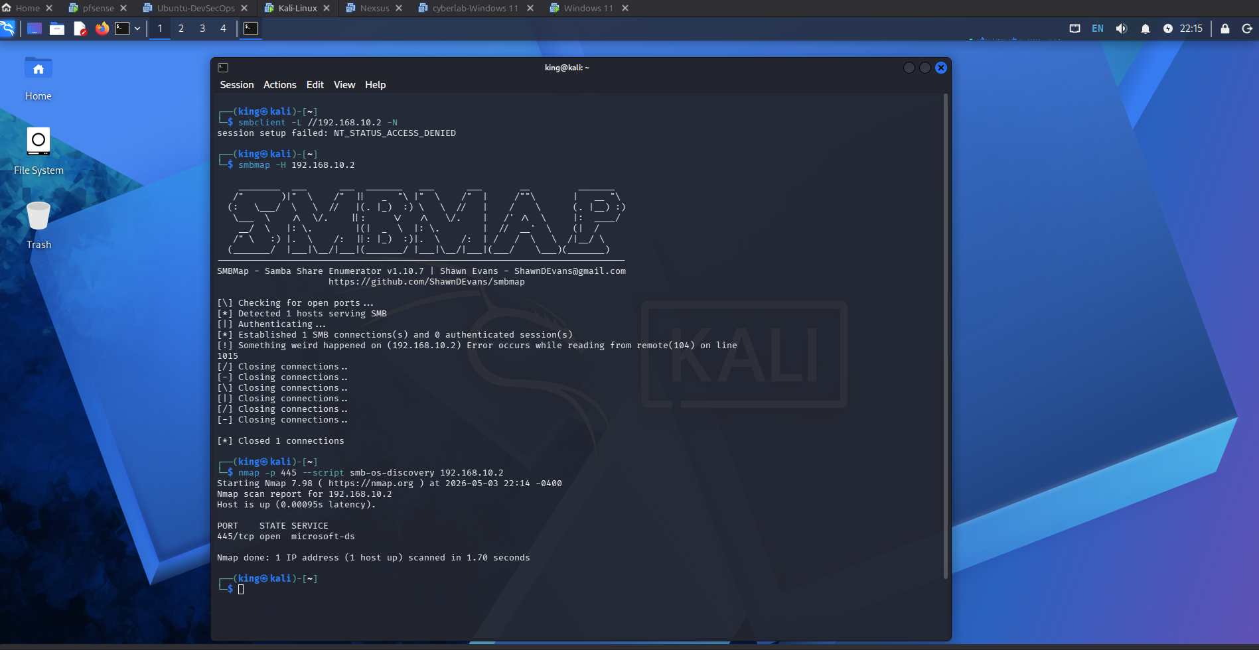
Final Findings:
- Attacker IP: 192.168.20.11
- Target IP: 192.168.10.2
- SYN scan activity detected (port scanning)
- RST/ACK responses indicate closed ports
- Port 445 open (SMB exposed)
- SMB enumeration attempts failed (authentication required)
- ICMP responses confirm host availability

Detection Strategy:
- Monitor high volumes of SYN packets
- Detect multi-port scanning patterns
- Alert on SMB enumeration attempts from a single source

Mitigation:
- Restrict SMB access to trusted hosts
- Disable guest and anonymous accounts
- Continuously monitor network traffic for suspicious activity

Conclusion
The simulation confirmed active reconnaissance activity, while security controls effectively prevented unauthorized SMB enumeration. This demonstrates the importance of monitoring and restricting access to critical services.

This lab demonstrates the ability to detect reconnaissance activity, analyze packet-level traffic, and evaluate system security posture in a controlled environment.

