After executing *create database NewHopeBaptistChurch;* I did the following: 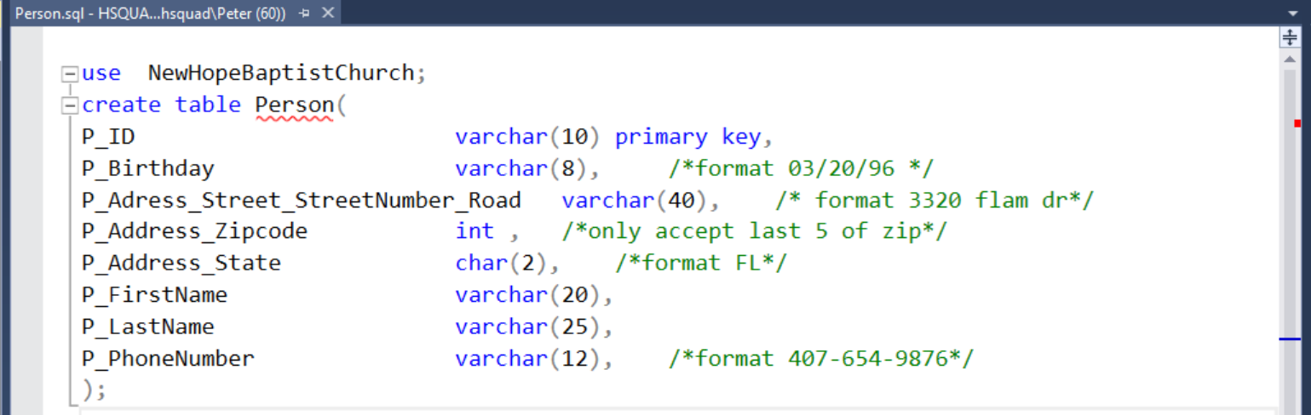

The code above created the table called person, which is the only table without a foreign key and thus is a parent to all the other entities, and all the attributes that go along with it. The person table provides basic information for all people which the church is involved with.

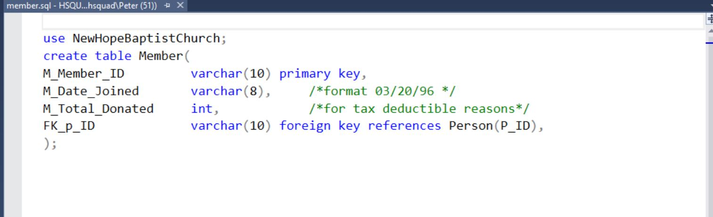

The code above creates a table for members. Members is linked to the table Person so that only member specific information will be put in this table while generic information about the members is stored in the person table

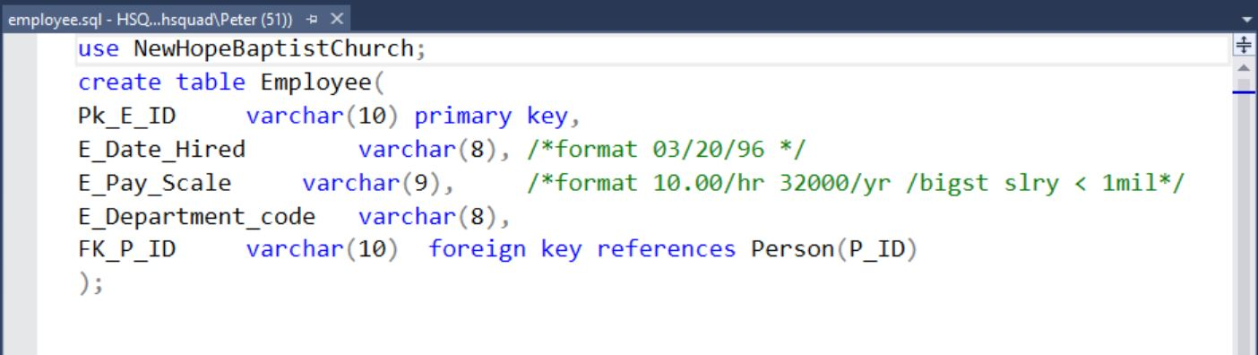

The Code above creates a table named Employee, which holds employee specific information. Like Member, Employee is also linked to person so the generic information about the employee will be stored in the person table while employment specific information pertaining to the individual will be kept in the table Employee.

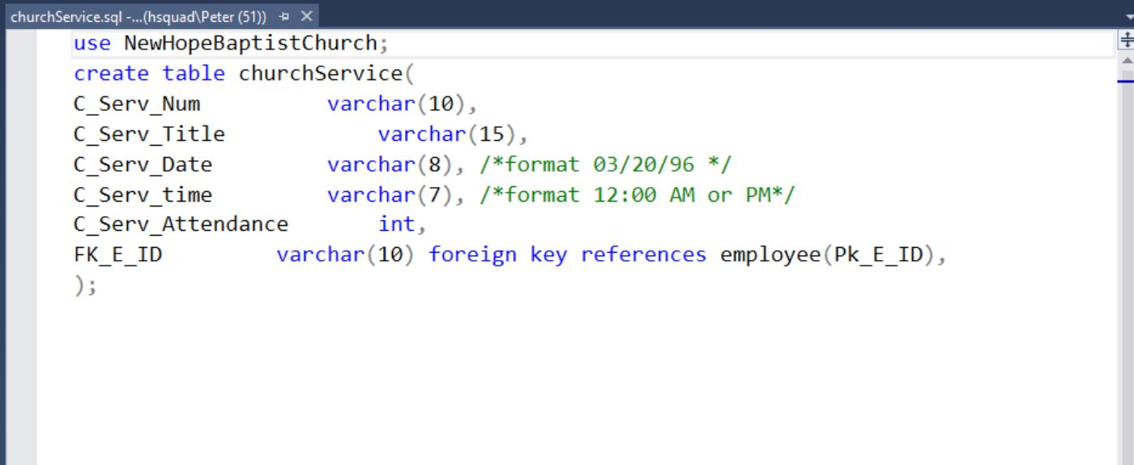

The above code creates a table named churchServices. This table holds information above service specific information. churchService is also linked to employee through the fk so that we can know who preached that specific service.

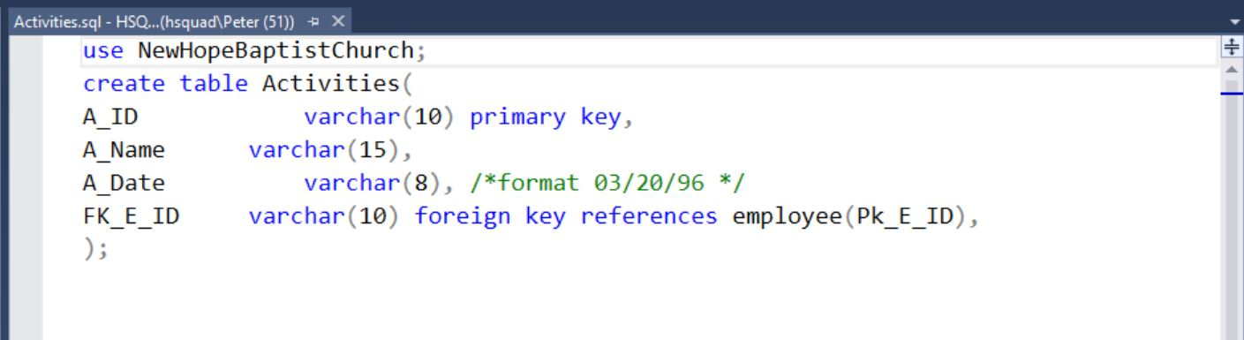

The above code creates a table named activities which holds specific information regarding activities which the church throws. The table is linked to the employee table through the foreign key that way we can know which employees worked which events.